**MODULE_4_IICS**

**EXCEL TO DB**

**MAPPING FROM ONE DB TO ANOTHER**

**RUNNING STATE**

**TARGET:**

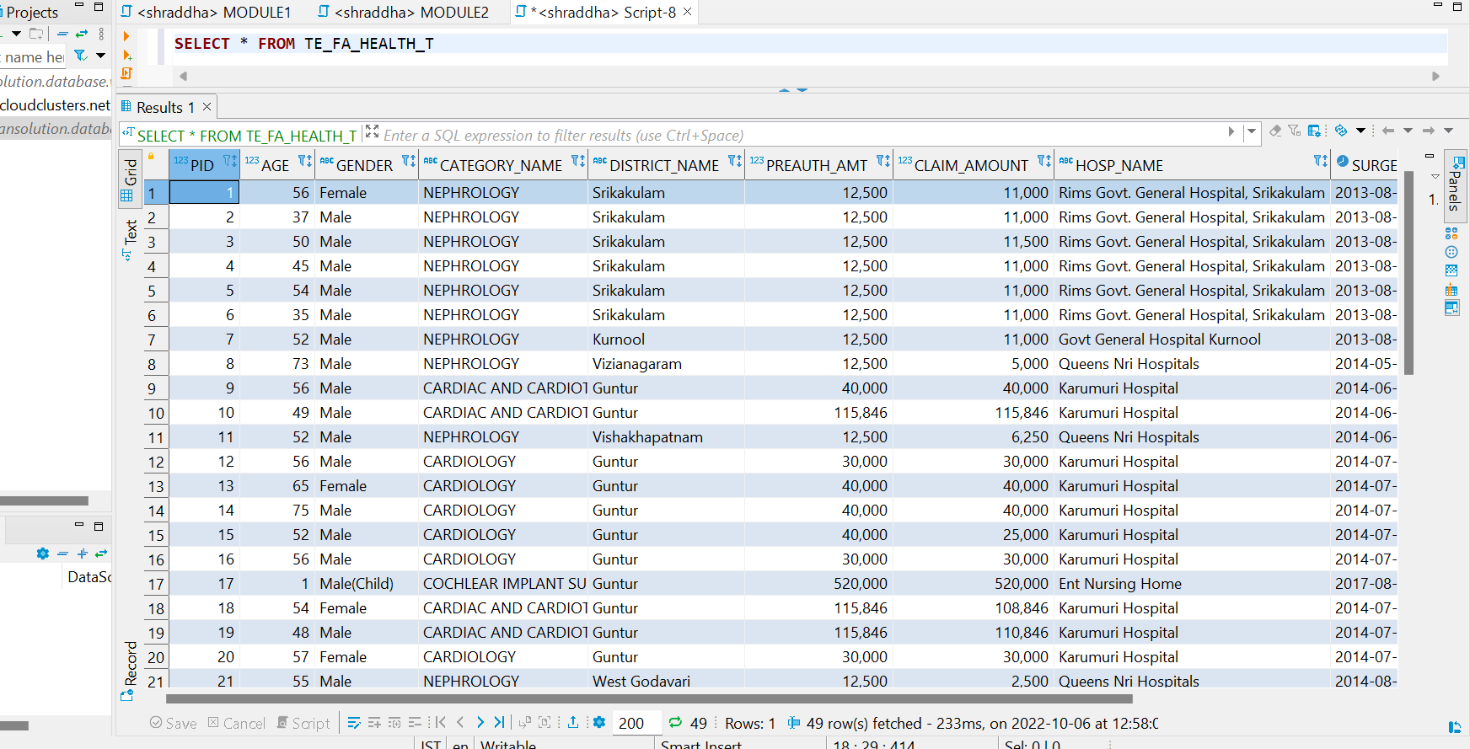

**SCD TYPE 1:**

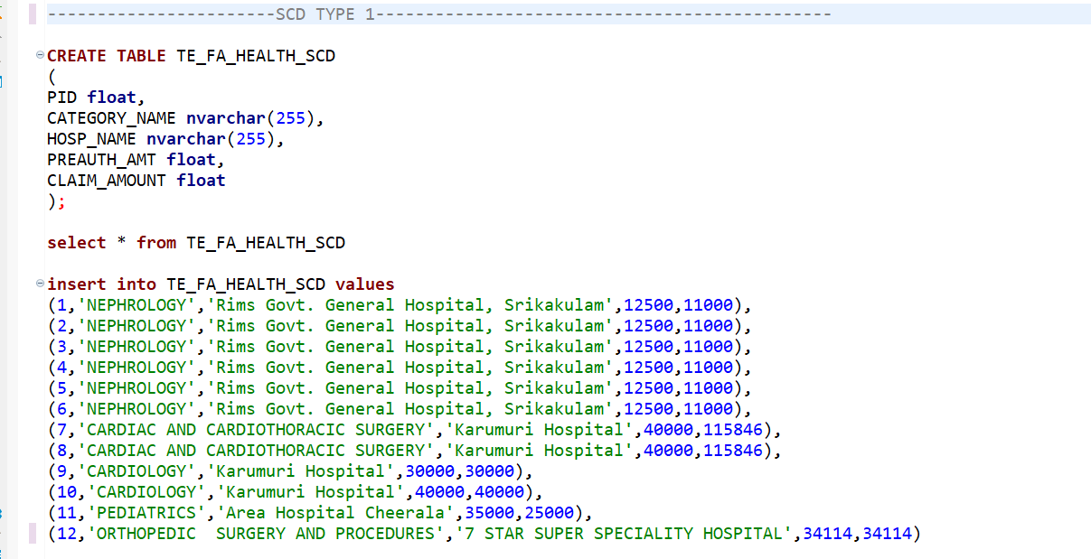

**UPDATE IN SOURCE:**

**UPDATE** TE_FA_HEALTH_SCD

**SET** CATEGORY_NAME='PEDIATRICS', HOSP_NAME='Karumuri Hospital'

**WHERE** PID=2

**CHECK IN TARGET: --IN 2ND ROW**

**SCD TYPE 2**

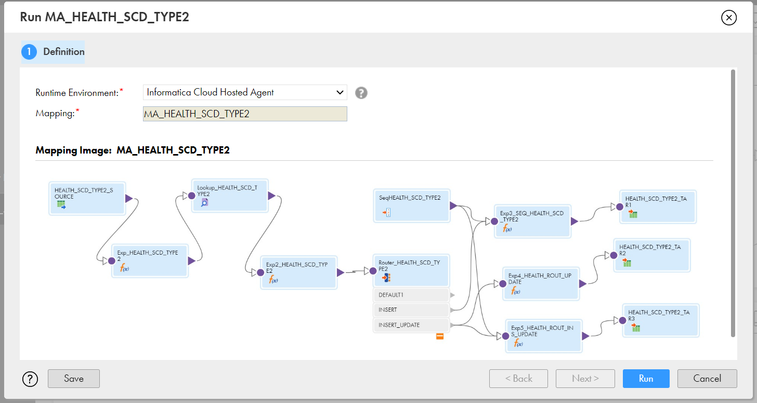

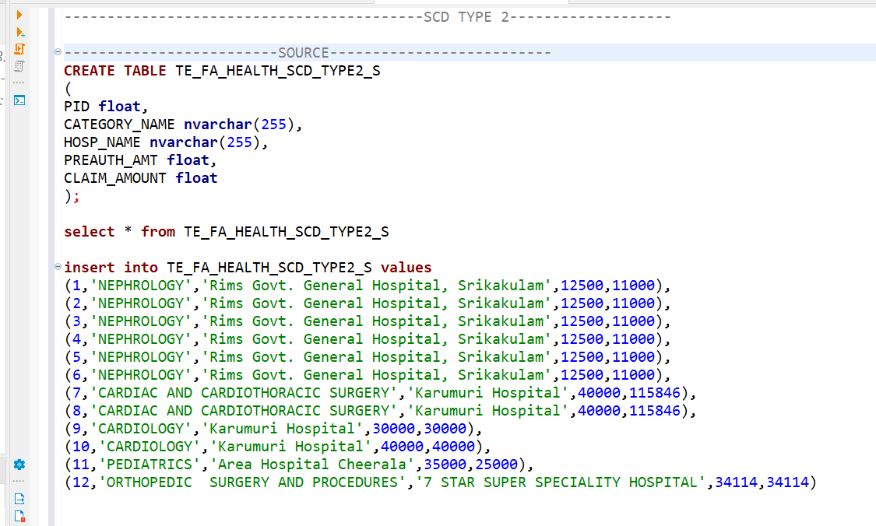

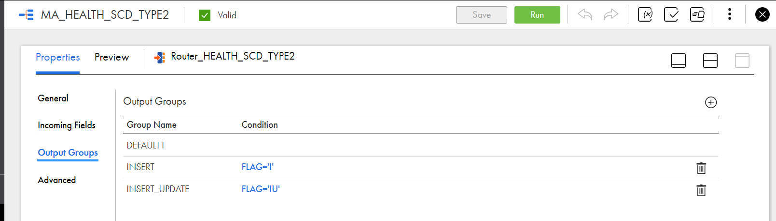

**Target:**

**UPDATE IN SOURCE:**

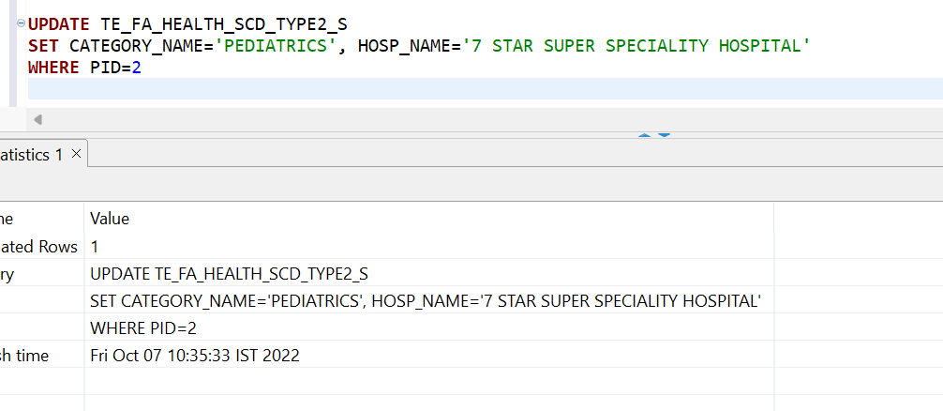

**AFTER UPDATE RUN IT AGAIN AND CHECK THE TARGET:**

**AGGREGATION**

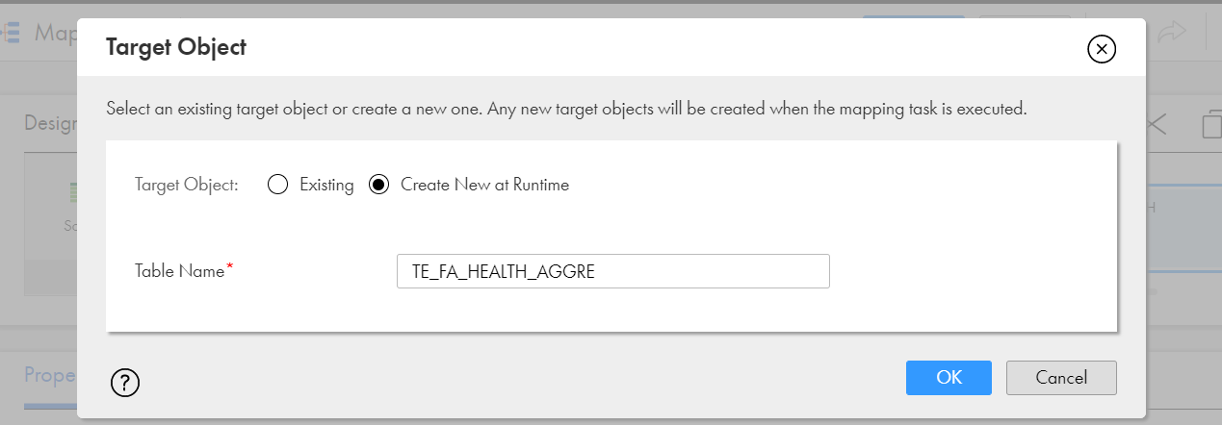

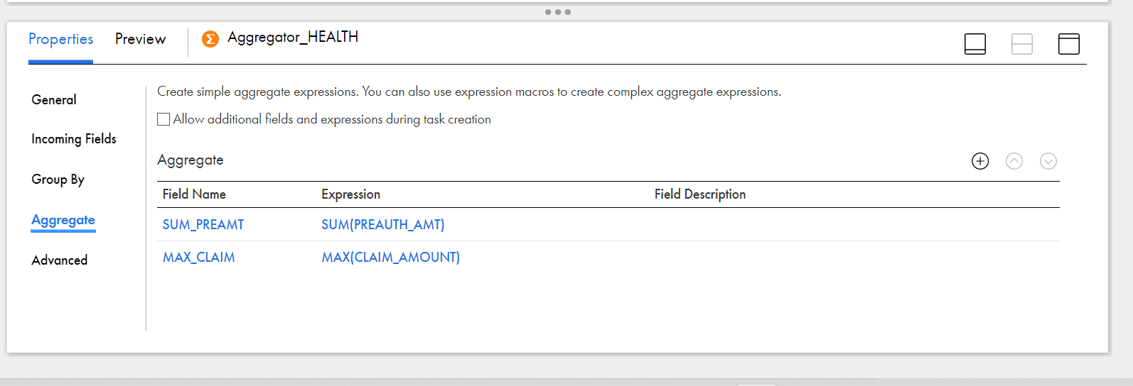

**REPLICATION TASK:**

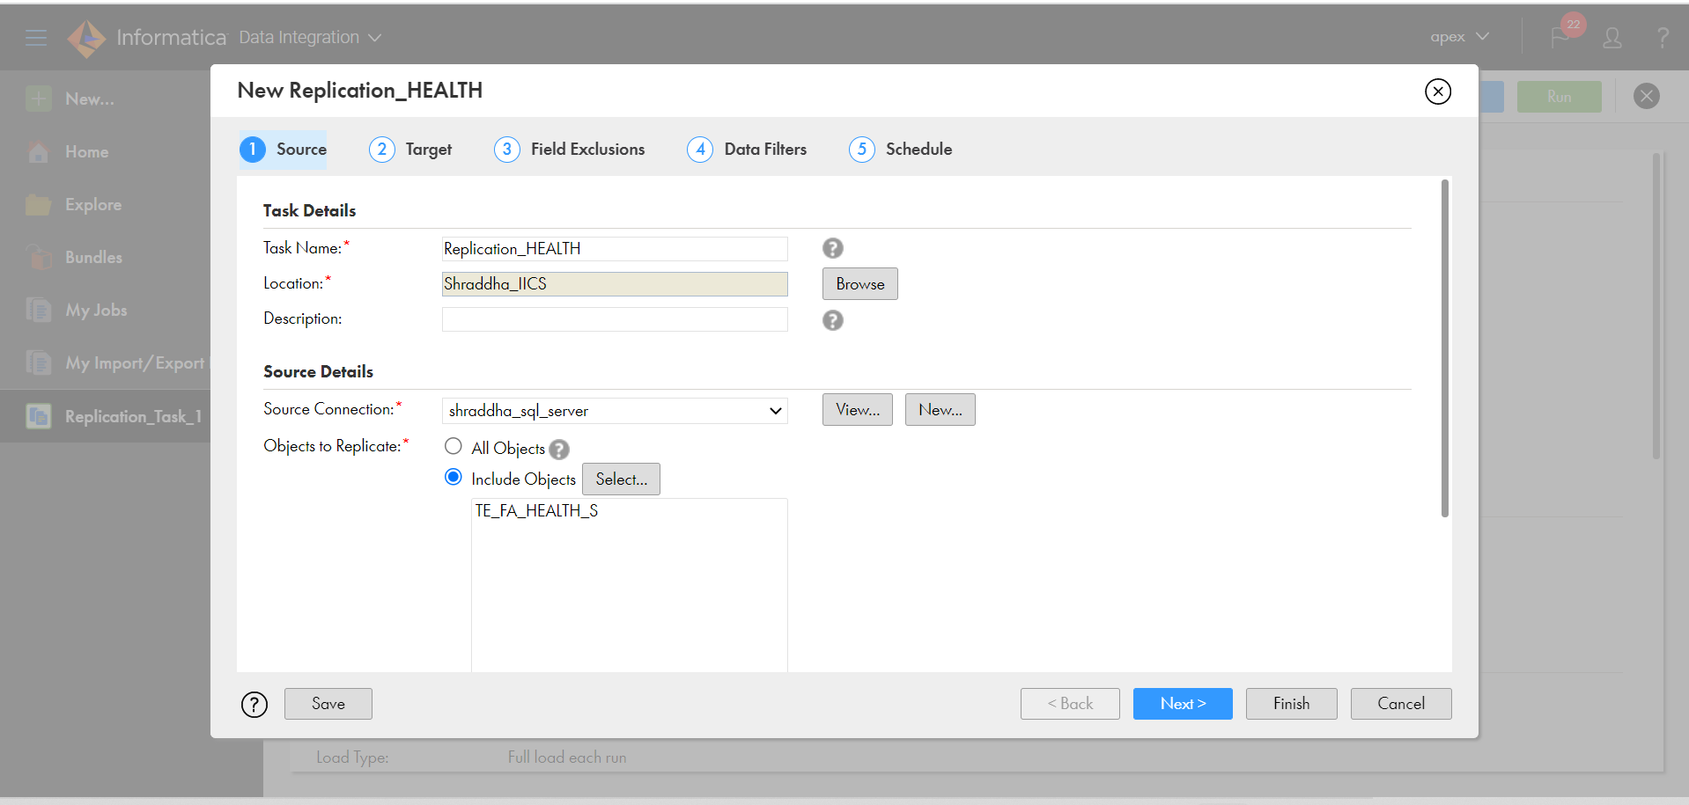

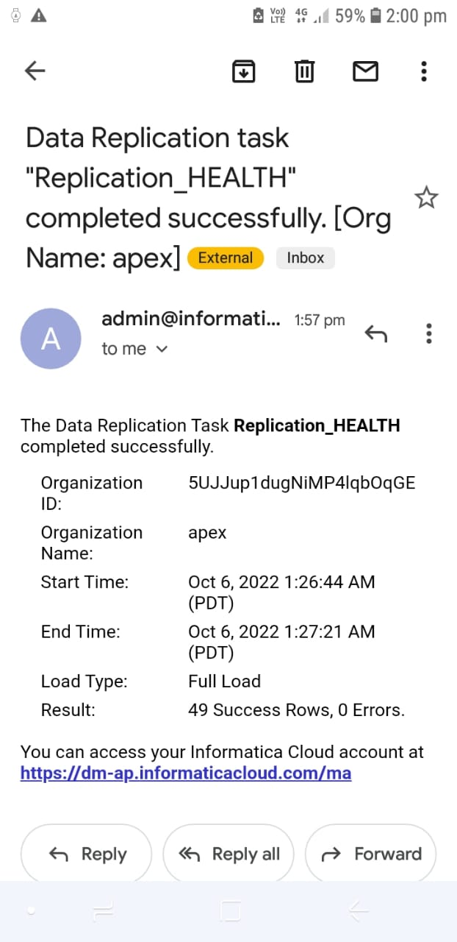

**GENDER COLUMN IS EXCLUDED**

