* **Use case**: The aim of the use case diagrams is clearly to provide the system with a high-level view and to communicate the specifications to the stakeholders in terms of the laypeople. To have a full practical and technological view of the system, additional diagrams and documentation may be used.
* **Activity diagram**: The basic aims of the task diagrams are equivalent to the four other diagrams. It catches the system's complex behaviour. Other four diagrams are used to show the message flow from one object to another, but activity diagram is used to show message flow from one activity to another.
* **Class diagram**: The aim of the class diagram is to model an application's static vision. The only diagrams that can be explicitly converted to object-oriented languages and therefore commonly used at the time of development are class diagrams. UML diagrams, such as the operation diagram, will only give the application's sequence flow, but the class diagram is a little different. It is the most common UML in the world.
* **Sequence diagram**: Business staff could use sequence diagrams to communicate how the business currently works. Diagrams can also be used to showcase the prerequisites for a future system implementation. It is during the design period that developers and architects utilize the diagram to showcase the system's object interactions.

**Assumptions:**

* Reviews of the product can be edited. The latest review would be visible to all the users.
* Sellers have already been registered on the website.
* Currently, the feature of checking shipment history and sales analysis of products for the seller has not been included.
* Existing User means someone who has logged in.
* We are assuming that every item the user searches is available.
* Each product has a unique identifier i.e., product id. Even if two products belong to the same category, such as two cameras and have the same model and company, they will have a different product id.
* The payment would always be successful.

1. **Use Case**

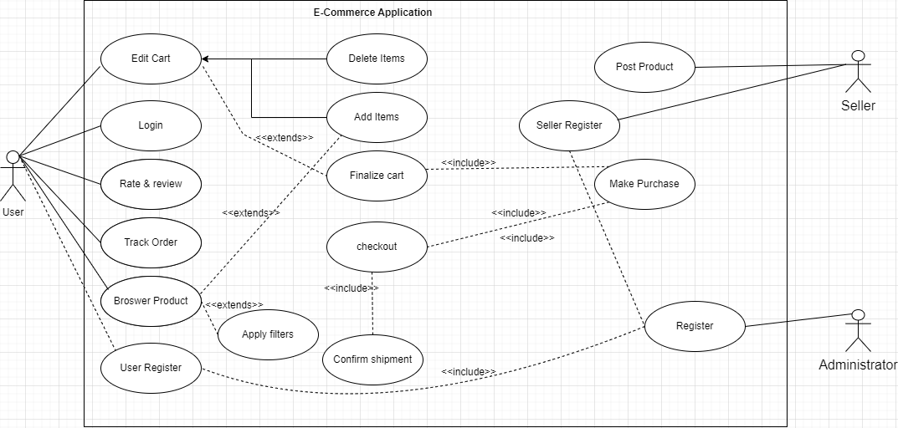

1. **Activity Diagram**

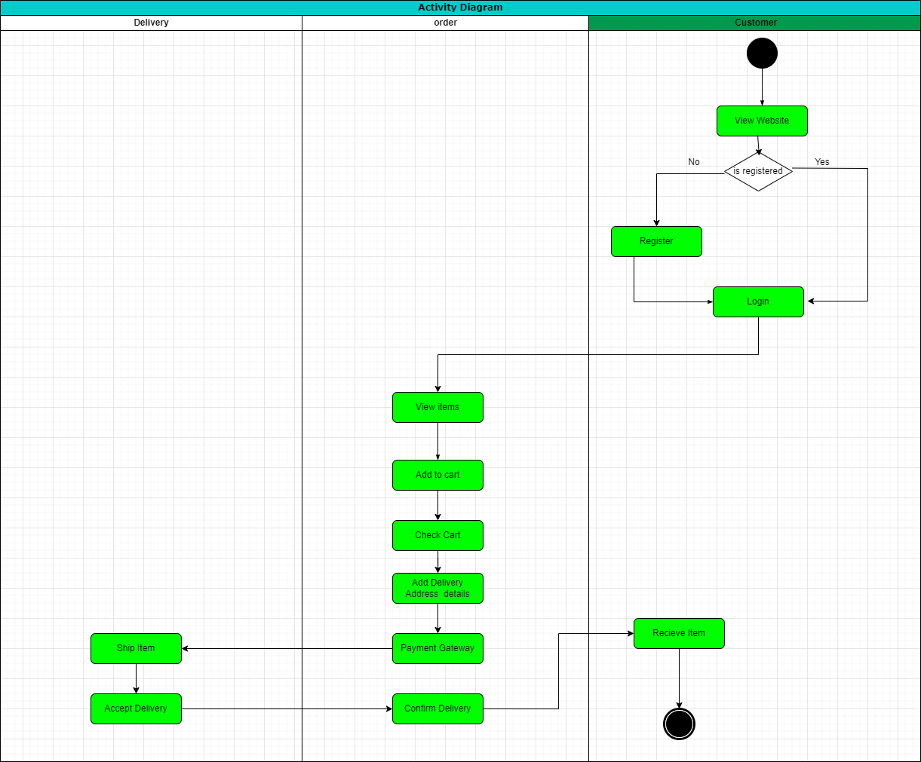

1. **Class Diagram**

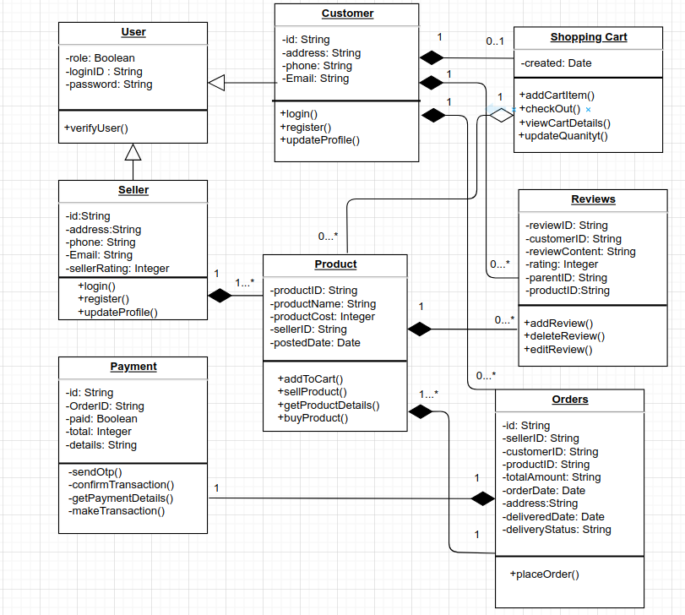

­­

1. **Sequence**

