

Throughout the Sherlock BBC series, there are countless occasions where Sherlock used technology to aide in his investigations.

To truly appreciate the Sherlock experience, one must examine the technology that aides in his methodology.

We will look at all the gadgets that help Sherlock solve

cases and how these objects can be used to better your own life.

**The Phone With All The Deductions**



The one device Sherlock is constantly on is his cell phone.

This is an interesting device because most of us have one and they are very useful.

Sherlock's methodology consist of connections and details that reveal a more generalized picture of the situation.

A cell phone can tap into that large spectrum of information and search for those connections in a faster and more adaptable way. The cell phone for Sherlock is like a pathway to more factual clues to aide in his deduction process.

He makes use of it throughout all four seasons. He actually evolves from a blackberry edition to a newly adaptable apple phone, in season 4.

**Entering A Whole New World of Deductions**

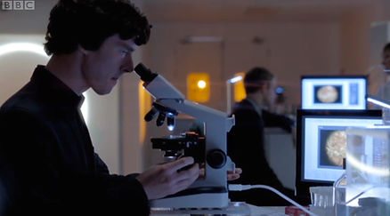

**A piece of technology Sherlock uses in the pilot episode of season 1, is the compound microscope.**

**A compound microscope uses an optical lens to view microscopic organisms, through a more focused view. He uses this to see microscopic trace elements of evidence found at crime scene.**

**This reveals key details to be used for future deductions. Compound microscopes are interesting because this allows Sherlock to expand his scope of practice. He is combining criminology, forensics, and chemistry to solve a case.**

**The compound microscope can also examine blood and see if there are any unique abnormality.**

**An example, is blood taken from a crime scene that has sickle blood cells. This would be an indicator for sickle cell anemia.**

**Sherlock would then narrow his suspect list, by talking with local Hematologist, visiting hospitals that are specialized in the disease, and determining if the person has received any treatment for the disease.**