Movie Catalogue Rest API –

1. RestAPI -MovieCatalogueService
2. EndPoints for Create/Update/Delete of Movie

->GET - /movies

->POST - /movies

🡪Patch - /movies/{movieId}

->Delete - /movies/{movieId}

1. EndPoints for Create/Update/Delete of Movie Director

->POST - /directors

🡪Patch - /directors/{directorId}

->Delete - /directors/{directorId}

1. EndPoints for Create/Update/Delete of Movie Rating

->POST - /ratings

🡪Patch - /ratings/{ ratingId}

->Delete - /ratings/{ ratingId}

1. EndPoints to search Movie by Director

->POST - /ratings

🡪Patch - /ratings/{ ratingId}

->Delete - /ratings/{ ratingId}

1. EndPoints to search Movie where rating is above a provided rating

->POST - /ratings

🡪Patch - /ratings/{ ratingId}

->Delete - /ratings/{ ratingId}

**DataBase Configuration : MySQL Database**

**Table1 : movies**

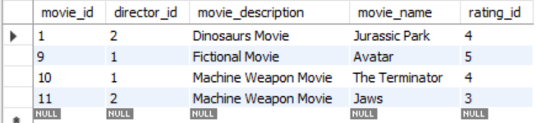

**Table2 : directors**

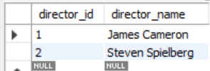

**Table3 : ratings**

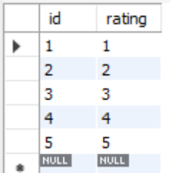

**Assumptions :**

**1.Directors and Ratings table are loaded prior to adding a Movie record as it is a predefined list with set of data initially but can be modified.**

**2.Since UI is not present ,I assume while sending a Post request for creation of Movie, the request contains the director Id and rating Id**

**Assuming UI send movie creation request as below :**

