MoneySuperMarket.com - Java Developer Technical Test Prerequisites

1. Download community edition of intellij: <https://www.jetbrains.com/idea/download/#section=mac> and open the application when the installation has completed.
2. Download the technical test project files and save locally: <https://github.com/MSMGCustomerPlatform/backend-task/archive/refs/heads/main.zip>
3. Unzip to a folder of your choice
4. Open IntelliJ
5. Select File > New > Project from Existing Sources...
   1. 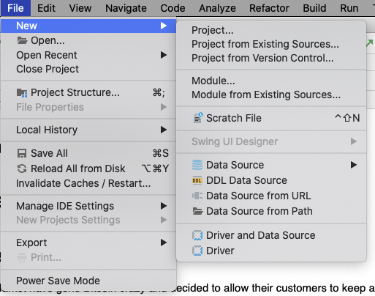
   2. When the file navigator opens select build.gradle from the route of the downloaded code folder
6. Open a terminal navigate to the ./backend-task folder
   1. execute: **./gradlew bootRun** and ensure the project builds and runs successfully
7. Open <http://localhost:8080/exchangeapp/highestprice/> in a browser and view the response from the application e.g.:  
   