**DAILY ONLINE ACTIVITIES SUMMARY**

|  |  |  |  |  |  |  |  |  |
| --- | --- | --- | --- | --- | --- | --- | --- | --- |
| **Date:** | **19/05/2020** | | | | | **Name:** | **Shraddha Acharya** | |
| **Sem & Sec** | **4th sem B sec** | | | | | **USN:** | **4al18cs079** | |
| **Online Test Summary** | | | | | | | | |
| **Subject** | | **Design and Analysis of Algoritham** | | | | | | |
| **Max. Marks** | | **30** | | **Score** | | | **11** | |
| **Certification Course Summary** | | | | | | | | |
| **Course** | **1.Python In Machine Learning**  **2.Python Workshop-By Brain O vision Solutions** | | | | | | | |
| **Certificate Provider** | | | **1.Great Learning Academy**  **2.Brain O Vision pvt.Ltd** | | **Duration** | | | **1.5 hrs**  **2.90 min** |
| **Coding Challenges** | | | | | | | | |
| **Problem Statement: 1.** A user will input two strings, and we find if one of the strings is a sub sequence of the other. Program prints “yes” if either the first string is a sub sequence of the second string or the second string is a sub sequence of the first string.  **2**.Given an array of distinct Integers .The task is to count all the triplets such that sum of two elements is equal to the third element. | | | | | | | | |
| **Status: Done** | | | | | | | | |
| **Uploaded the report in Github** | | | | | **Yes** | | | |
| **If yes Repository name** | | | | | **1.**<https://github.com/shraddhaacharya/lockdown-coding/blob/master/sequence.c>  **2.**<https://github.com/shraddhaacharya/lockdown-coding/blob/master/triplet.c> | | | |
| **Uploaded the report in slack** | | | | | **Yes** | | | |

Online Test Details: Online test of Design and Analysis of Algorithm was conducted .It was based on first module .There where 20 questions of 1mark each and 5 questions of 2marks each.

Snapshot:

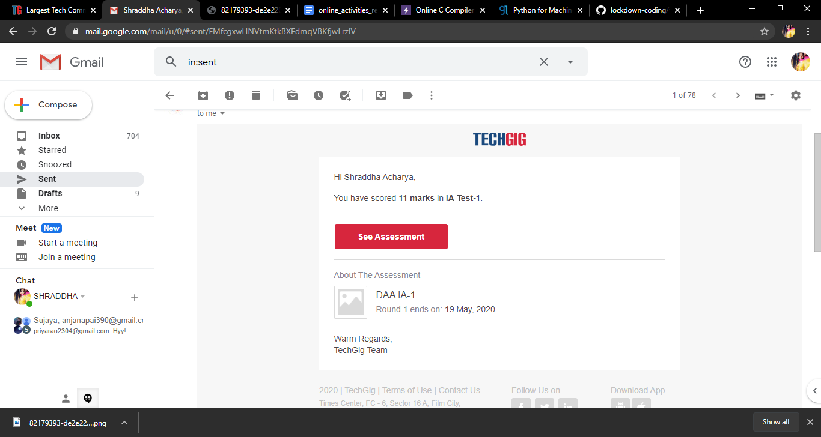

Certification Course Details: Today I have done 2 certificate courses. One is the Python IN Machine Learning in which I learnt about the **Logical operators, strings, hands on for data structures and about the conditional loops and Functions used in python.**

**And the other is the workshop on Python for Beginners.**

**Snapshot**

**1.**

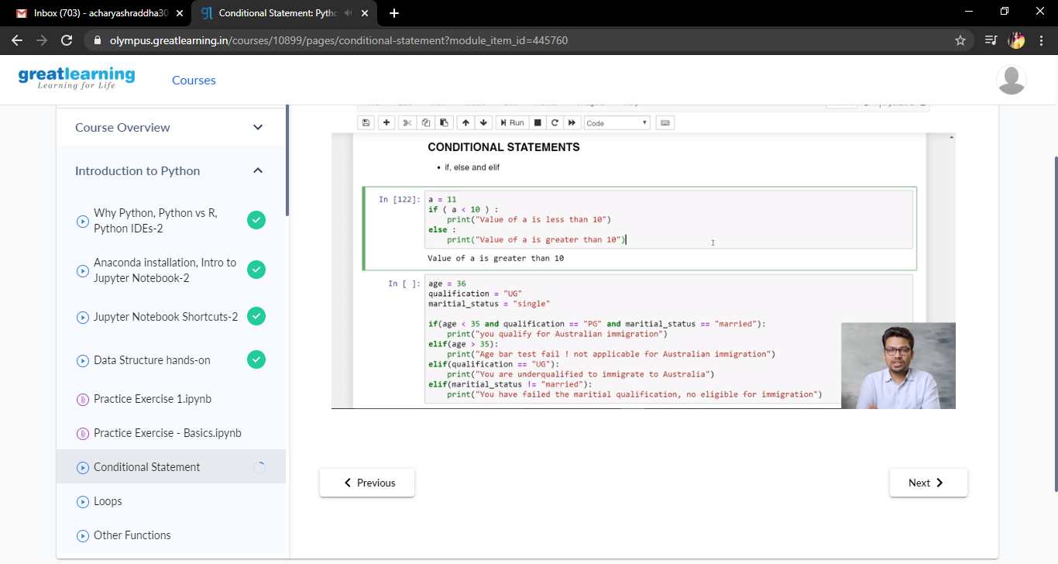

**2.**

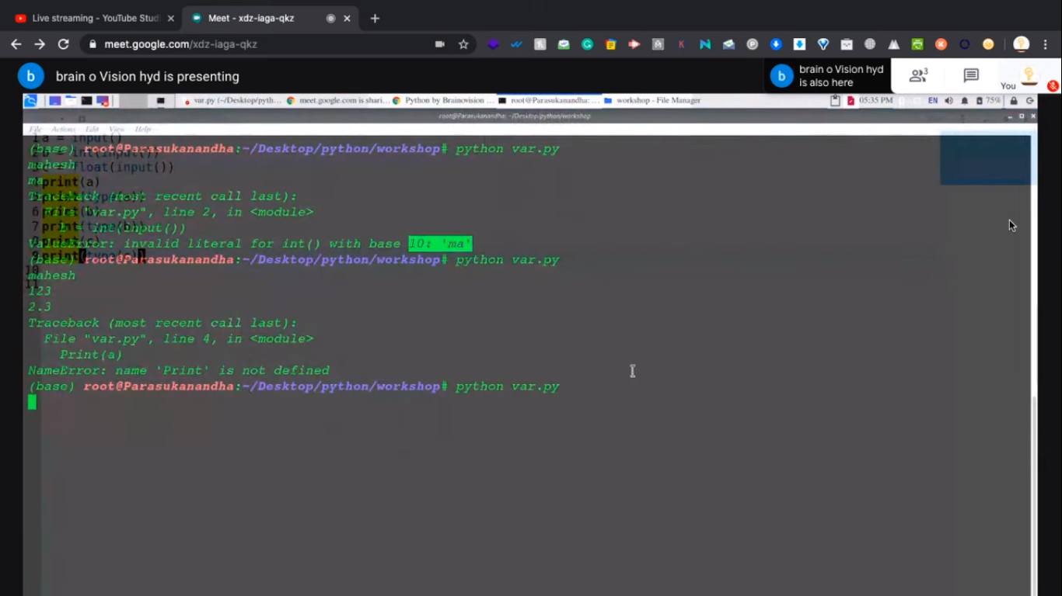

Coding Challenges Details: Problem Statements

1. **A user will input two strings, and we find if one of the strings is a sub sequence of the other. Program prints “yes” if either the first string is a sub sequence of the second string or the second string is a sub sequence of the first string**

**Solution : Uploaded in Github**

**Snapshot:**

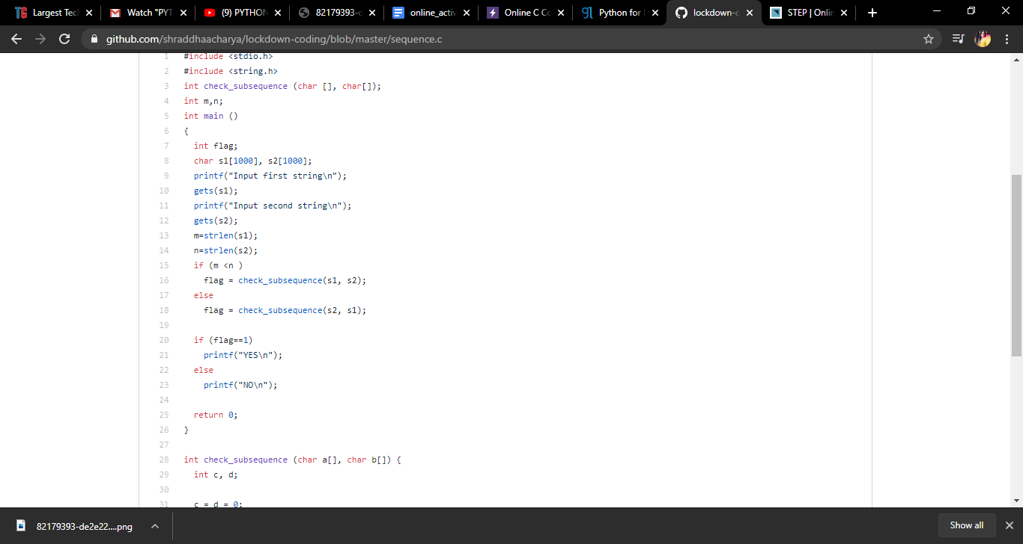

**2.** **Given an array of distinct Integers .The task is to count all the triplets such that sum of two elements is equal to the third element**

Solution: Uploaded in Github

Snapshot :

