**DAILY ONLINE ACTIVITIES SUMMARY**

|  |  |  |  |  |  |  |  |  |
| --- | --- | --- | --- | --- | --- | --- | --- | --- |
| **Date:** | **20/05/2020** | | | | | **Name:** | **Shraddha Acharya** | |
| **Sem & Sec** | **4th sem B sec** | | | | | **USN:** | **4al18cs079** | |
| **Online Test Summary** | | | | | | | | |
| **Subject** | | **Object Oriented Concepts** | | | | | | |
| **Max. Marks** | | **30** | | **Score** | | | **18** | |
| **Certification Course Summary** | | | | | | | | |
| **Course** | **1.Python In Machine Learning** | | | | | | | |
| **Certificate Provider** | | | **1.Great Learning Academy** | | **Duration** | | | **5 hrs** |
| **Coding Challenges** | | | | | | | | |
| **Problem Statement: 1.** Given an array a[] of size n which contains elements from 0 to n-1, write a program print Duplicates which prints the duplicate elements of the given array. If no duplicate element is found print -1.  **2**. Write a C Program to Reverse a Linked List (SLL) in groups of given size. | | | | | | | | |
| **Status: Done** | | | | | | | | |
| **Uploaded the report in Github** | | | | | **Yes** | | | |
| **If yes Repository name** | | | | | **1.**<https://github.com/shraddhaacharya/lockdown-coding/blob/master/duplicate.java>  **2**<https://github.com/shraddhaacharya/lockdown-coding/blob/master/Reverse_List.c> | | | |
| **Uploaded the report in slack** | | | | | **Yes** | | | |

Online Test Details: Online test of Object Oriented concepts was conducted .It was based on first module .There where 30 questions of 1mark each .

Snapshot:

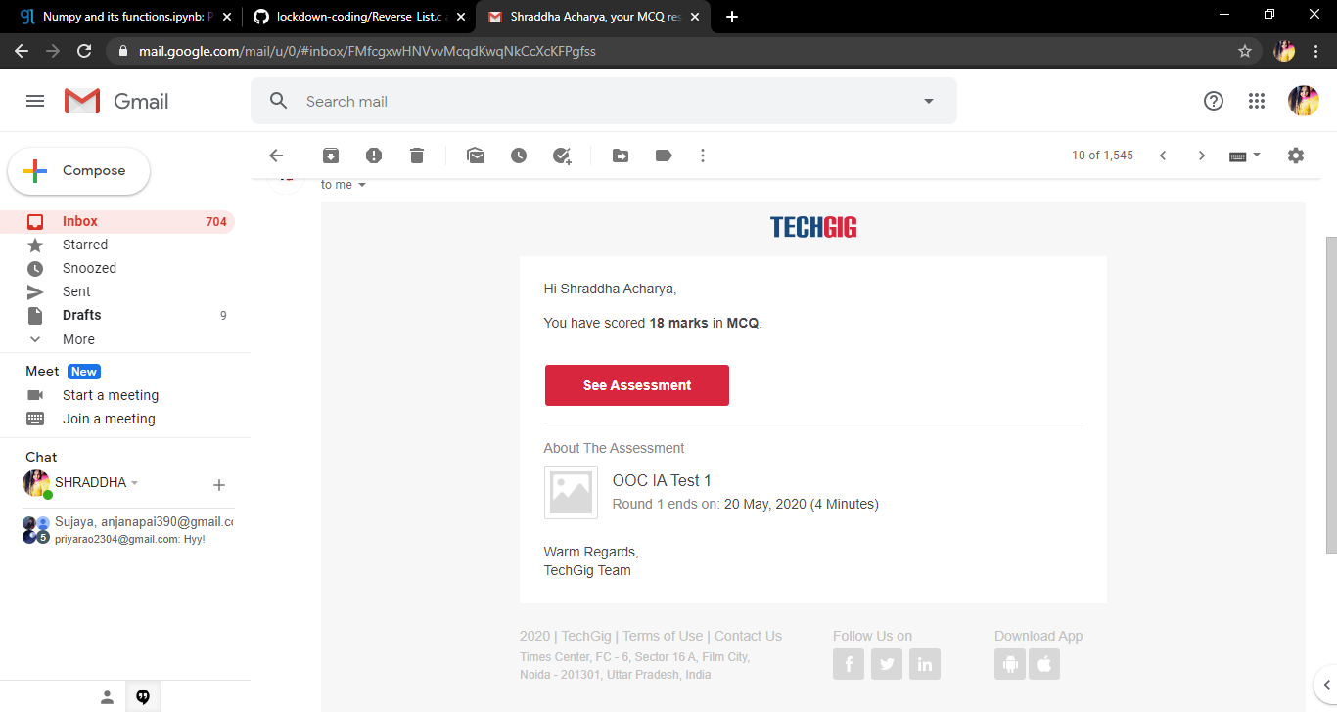

Certification Course Details: Today I have done the certificate courses of Python IN Machine Learning in which I learnt about the Numpy the one of the package of the python to perform complex mathematical operations.

**Snapshot**

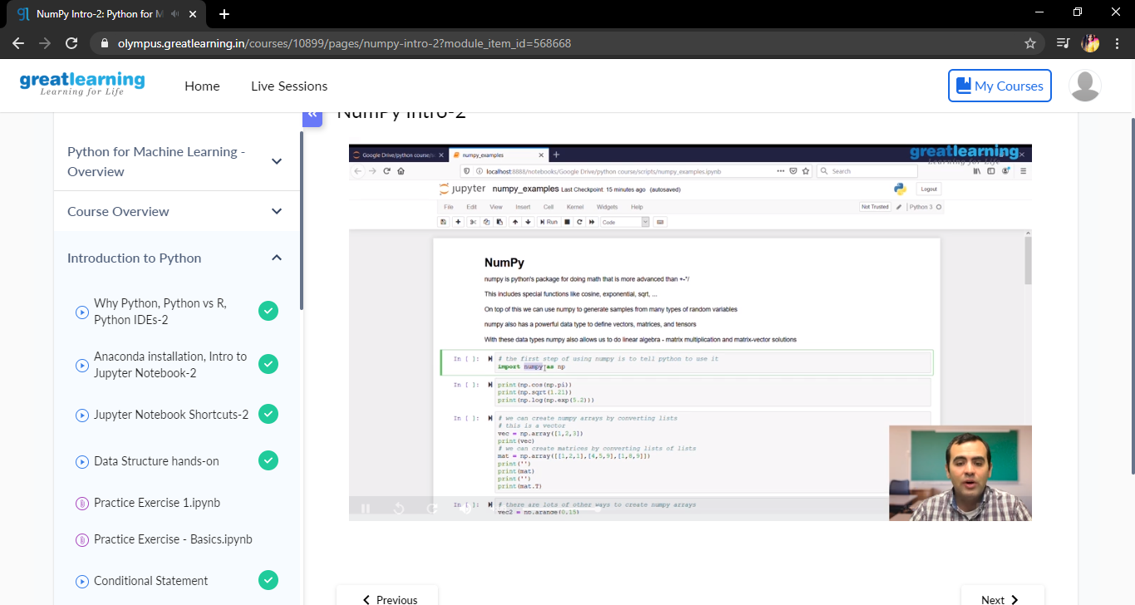

Coding Challenges Details: Problem Statements

1. Given an array a[] of size n which contains elements from 0 to n-1, write a program print Duplicates which prints the duplicate elements of the given array. If no duplicate element is found print -1.  
Input:  
 The first line of input must contains an integer n which denotes number of elements of Array. Second line contains n space separated integers denoting elements of array a[].

Output:  
 Print the duplicate elements from the given array.

**Solution : Uploaded in Github**

**Snapshot:**

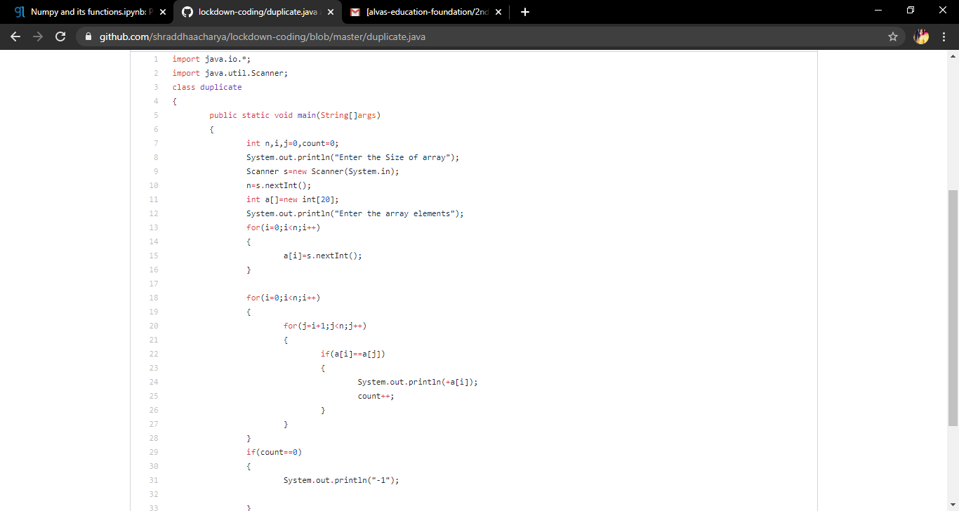

**2.** Write a C Program to Reverse a Linked List (SLL) in groups of given size.

Test Case 1:  
If a linked list is: 1 → 2 → 3 → 4 → 5 → 6 → 7 → 8  
The value of size k is 2  
Then the linked list looks like: 2 → 1 → 4 → 3 → 6 → 5 → 8 → 7

Test Case 2:  
If a linked list is: 1 → 2 → 3 → 4 → 5 → 6 → 7 → 8  
The value of size k is 3  
Then the linked list looks like: 3 → 2 → 1 → 6 → 5 → 4 → 8 → 7

Solution: Uploaded in Github

Snapshot :