**DAILY ONLINE ACTIVITIES SUMMARY**

|  |  |  |  |  |  |  |  |  |
| --- | --- | --- | --- | --- | --- | --- | --- | --- |
| **Date:** | **22/05/2020** | | | | | **Name:** | **Shraddha Acharya** | |
| **Sem & Sec** | **4th sem B sec** | | | | | **USN:** | **4al18cs079** | |
| **Online Test Summary** | | | | | | | | |
| **Subject** | | **Operating System** | | | | | | |
| **Max. Marks** | | **30** | | **Score** | | | **21** | |
| **Certification Course Summary** | | | | | | | | |
| **Course** | **1.Python In Machine Learning**  **2.Python Workshop-By Brain O vision Solutions** | | | | | | | |
| **Certificate Provider** | | | **1.Great Learning Academy** | | **Duration** | | | **5 hrs** |
| **Coding Challenges** | | | | | | | | |
| **Problem Statement: 1.** Using methods charAt() & length() of String class, write a program to print the frequency of each character in a string.  **2**. Write a simple applet java program to check whether the given number is Armstrong number or not. | | | | | | | | |
| **Status: Done** | | | | | | | | |
| **Uploaded the report in Github** | | | | | **Yes** | | | |
| **If yes Repository name** | | | | | **1.**<https://github.com/shraddhaacharya/Lockdown-JavaCodding/blob/master/Frequency.java>  **2.**<https://github.com/shraddhaacharya/Lockdown-JavaCodding/blob/master/armstrong_applet.java> | | | |
| **Uploaded the report in slack** | | | | | **Yes** | | | |

Online Test Details: Online test of Operating System was conducted .It was based on first module .There where 30 questions of 1mark each.

Snapshot:

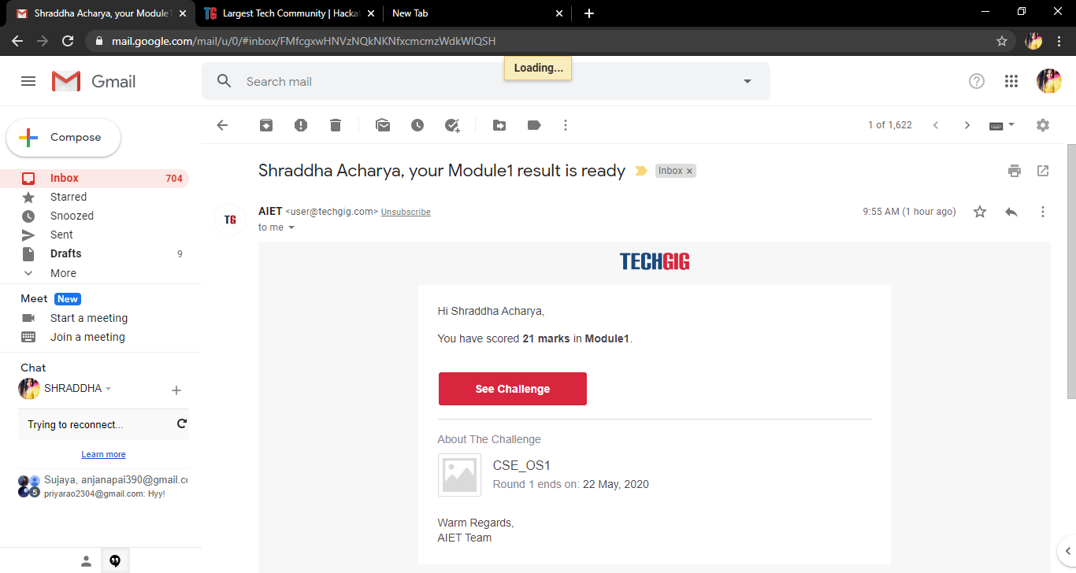

Certification Course Details: Today I have completed the course of Python in Machine Learning.

**Snapshot**

**1.**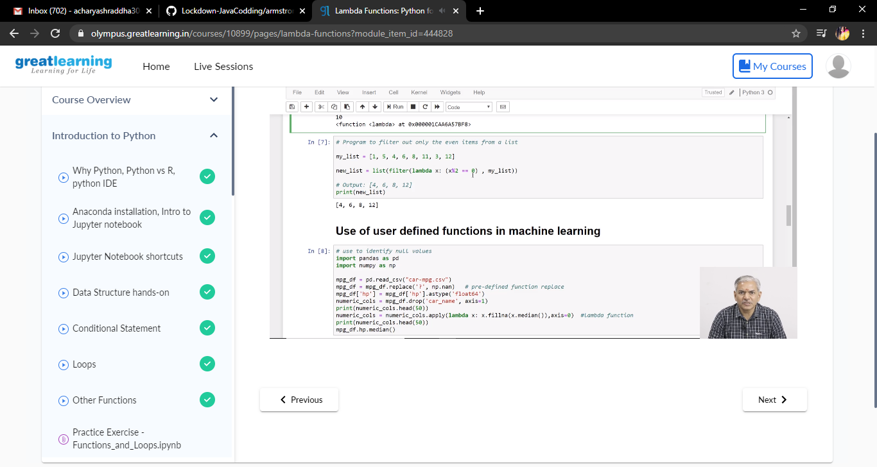

Coding Challenges Details: Problem Statements

1)Using methods charAt() & length() of String class, write a program to print the  
frequency of each character in a string.  
“Hello friend”

Output should be  
-: 1  
d: 1  
e: 2  
f: 1  
(continued for all character in the string)

**Snapshot**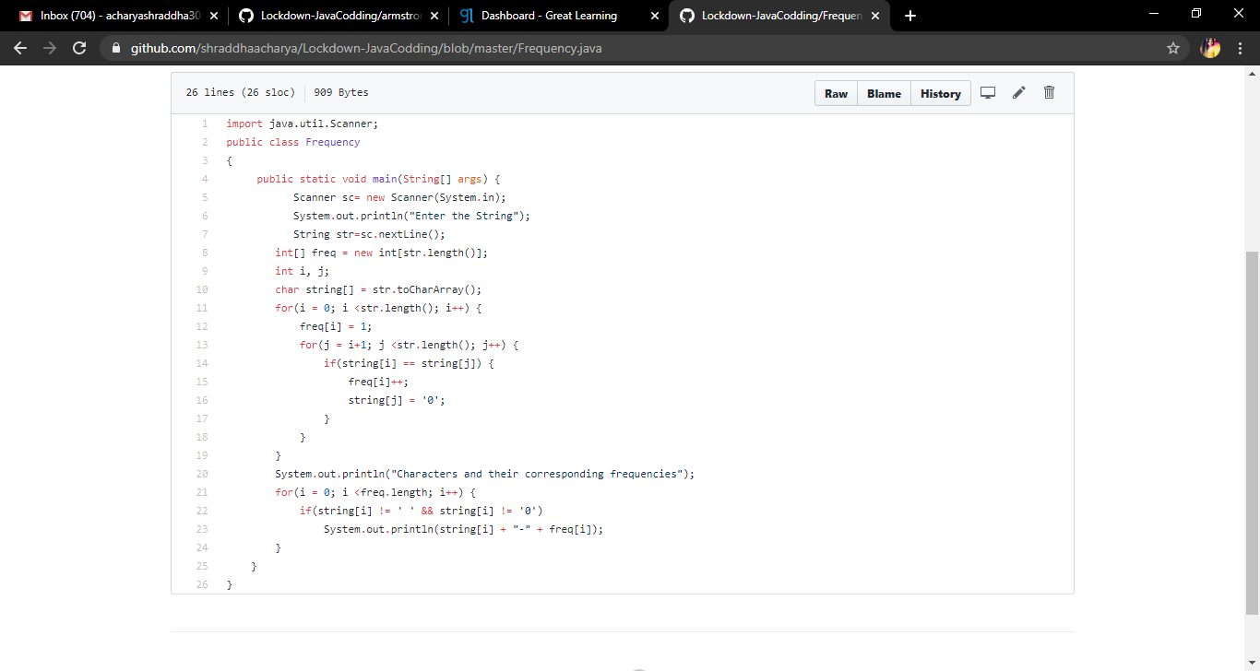

**2.** Write a simple applet java program to check whether the given number is Armstrong number or not.

Snapshot:

