**DAILY ONLINE ACTIVITIES SUMMARY**

|  |  |  |  |  |  |  |  |  |
| --- | --- | --- | --- | --- | --- | --- | --- | --- |
| **Date:** | **21/05/2020** | | | | | **Name:** | **Shraddha Acharya** | |
| **Sem & Sec** | **4th sem B sec** | | | | | **USN:** | **4al18cs079** | |
| **Online Test Summary** | | | | | | | | |
| **Subject** | | **Microcontroller and Embedded Systems** | | | | | | |
| **Max. Marks** | | **30** | | **Score** | | | **27** | |
| **Certification Course Summary** | | | | | | | | |
| **Course** | **1.Python In Machine Learning** | | | | | | | |
| **Certificate Provider** | | | **1.Great Learning Academy** | | **Duration** | | | **5 hrs** |
| **Coding Challenges** | | | | | | | | |
| 1. **Problem Statement: 1.** Write C Program to create Singly Liked List with n elements and reverse the elements using C | | | | | | | | |
| **Status: Done** | | | | | | | | |
| **Uploaded the report in Github** | | | | | **Yes** | | | |
| **If yes Repository name** | | | | | **1.**<https://github.com/shraddhaacharya/lockdown-coding/blob/master/sll_rev.c> | | | |
| **Uploaded the report in slack** | | | | | **Yes** | | | |

Online Test Details: Online test of Microcontroller and Embedded systems was conducted .It was based on first module .There where 30 questions of 1 mark each.

Snapshot: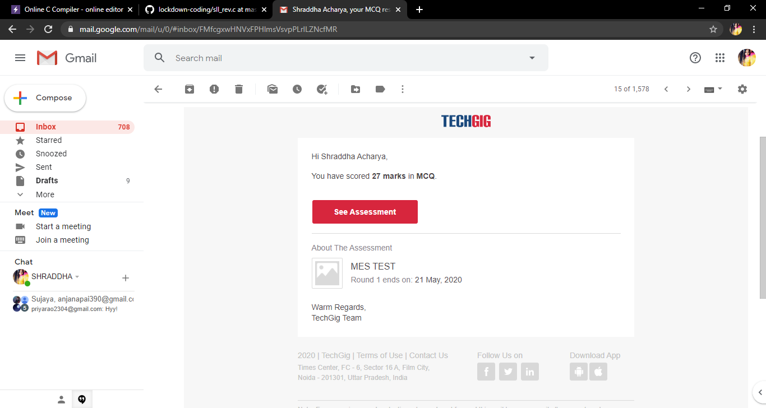

Certification Course Details: Today I have done 2 certificate courses. One is the Python IN Machine Learning in which I learnt about the Pandas and Lamda the packages of python and have completed the course .

**Snapshot**

**1.**

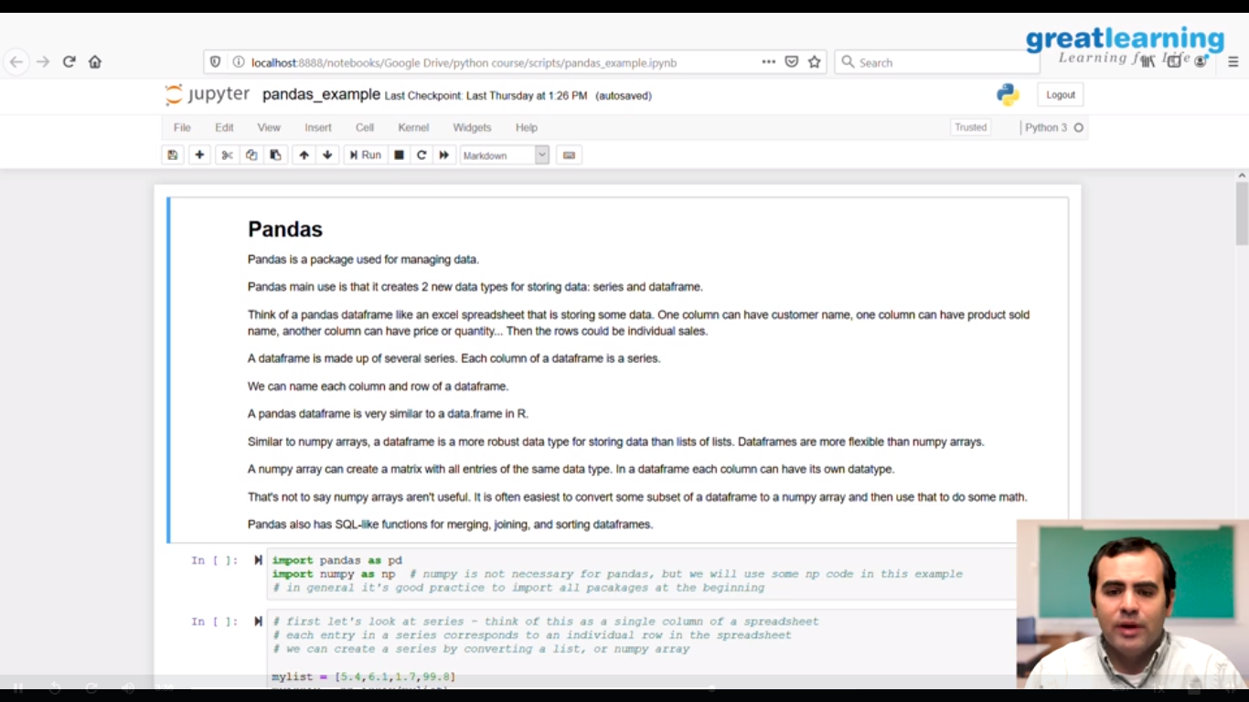

Coding Challenges Details: Problem Statements

1. Write C Program to create Singly Liked List with n elements and reverse the elements using C

**Solution : Uploaded in Github**

Snapshot :

