**DAILY ONLINE ACTIVITIES SUMMARY**

|  |  |  |  |  |  |  |  |  |
| --- | --- | --- | --- | --- | --- | --- | --- | --- |
| **Date:** | **23/05/2020** | | | | | **Name:** | **Shraddha Acharya** | |
| **Sem & Sec** | **4th sem B sec** | | | | | **USN:** | **4al18cs079** | |
| **Online Test Summary** | | | | | | | | |
| **Subject** | | **Data Communication** | | | | | | |
| **Max. Marks** | | **30** | | **Score** | | | **27** | |
| **Certification Course Summary** | | | | | | | | |
| **Course** | **1.Java Programming** | | | | | | | |
| **Certificate Provider** | | | **1.Great Learning Academy** | | **Duration** | | | **1)3.5 hrs** |
| **Coding Challenges** | | | | | | | | |
| **Problem Statement: 1.** Write a C Program to generate first N Triangular Numbers (Where N is Read from the Key board) | | | | | | | | |
| **Status: Done** | | | | | | | | |
| **Uploaded the report in Github** | | | | | **Yes** | | | |
| **If yes Repository name** | | | | | **1.**<https://github.com/shraddhaacharya/lockdown-C-coding/blob/master/triangular.c> | | | |
| **Uploaded the report in slack** | | | | | **Yes** | | | |

Online Test Details: Online test of Data Communication was conducted .It was based on first and second module .There where 30 questions of 1mark each.

Snapshot:

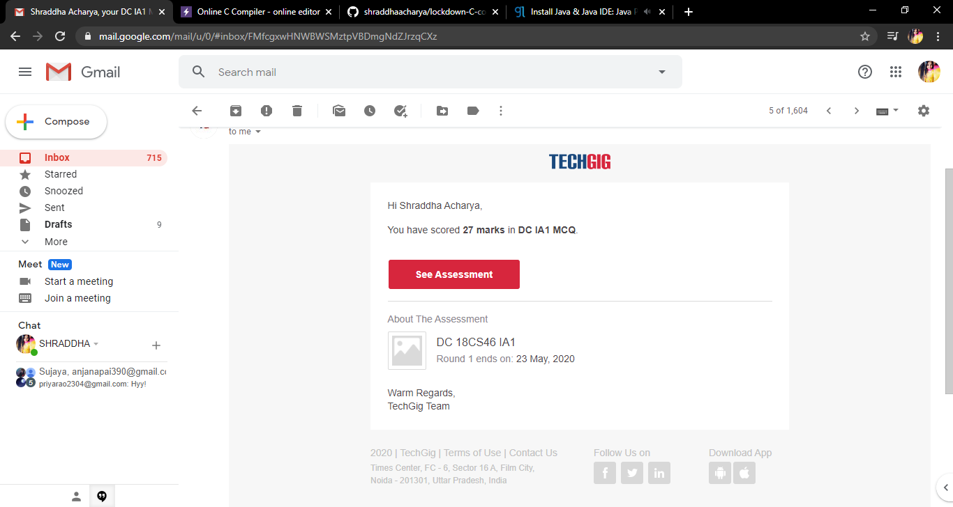

Certification Course Details: Today I have started the certificate course of Programming in Java which is about 3.5 hrs.

**Snapshot**

**1.**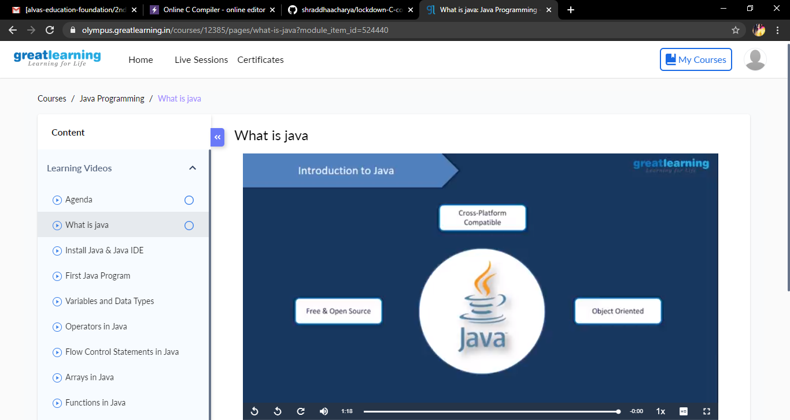

Coding Challenges Details: Problem Statements

1. Write a C Program to generate first N Triangular Numbers (Where N is Read from the Key board)

**Snapshot**

