**DAILY ONLINE ACTIVITIES SUMMARY**

|  |  |  |  |  |  |  |  |  |  |
| --- | --- | --- | --- | --- | --- | --- | --- | --- | --- |
| **Date:** | **04/06/2020** | | | | | **Name:** | | **Shraddha Acharya** | |
| **Sem & Sec** | **4th sem B sec** | | | | | **USN:** | | **4al18cs079** | |
| **Online Test Summary** | | | | | | | | | |
| **Subject** | | **Microcontroller and Embedded System** | | | | | | | |
| **Max. Marks** | | **20** | | **Score** | | | | **11** | |
| **Certification Course Summary** | | | | | | | | | |
| **Course** | **1.Introduction to Ethical Hacking** | | | | | | | | |
| **Certificate Provider** | | | **1.Great Learning Academy** | | | | **Duration** | | **1)6 hours** | |
| **Coding Challenges** | | | | | | | | | |
| **Problem Statement: 1.** write a java program to read three integer values from the keyboard and find the sum of the values. Declare a variable "sum" of type int and store the result in it.  2.Write a C++ program to find a missing number in array. | | | | | | | | | |
| **Status: Done** | | | | | | | | | |
| **Uploaded the report in Github** | | | | | **Yes** | | | | |
| **If yes Repository name** | | | | | 1. <https://github.com/shraddhaacharya/Lockdown-JavaCodding/blob/master/Sum.java> 2. <https://github.com/shraddhaacharya/Lockdown-JavaCodding/blob/master/MissingNo.cpp> | | | | |
| **Uploaded the report in slack** | | | | | **Yes** | | | | |

Online Test Details: Online test of MES was conducted .It was based on 3rd module .There where 20 questions of 1mark each.

Snapshot:

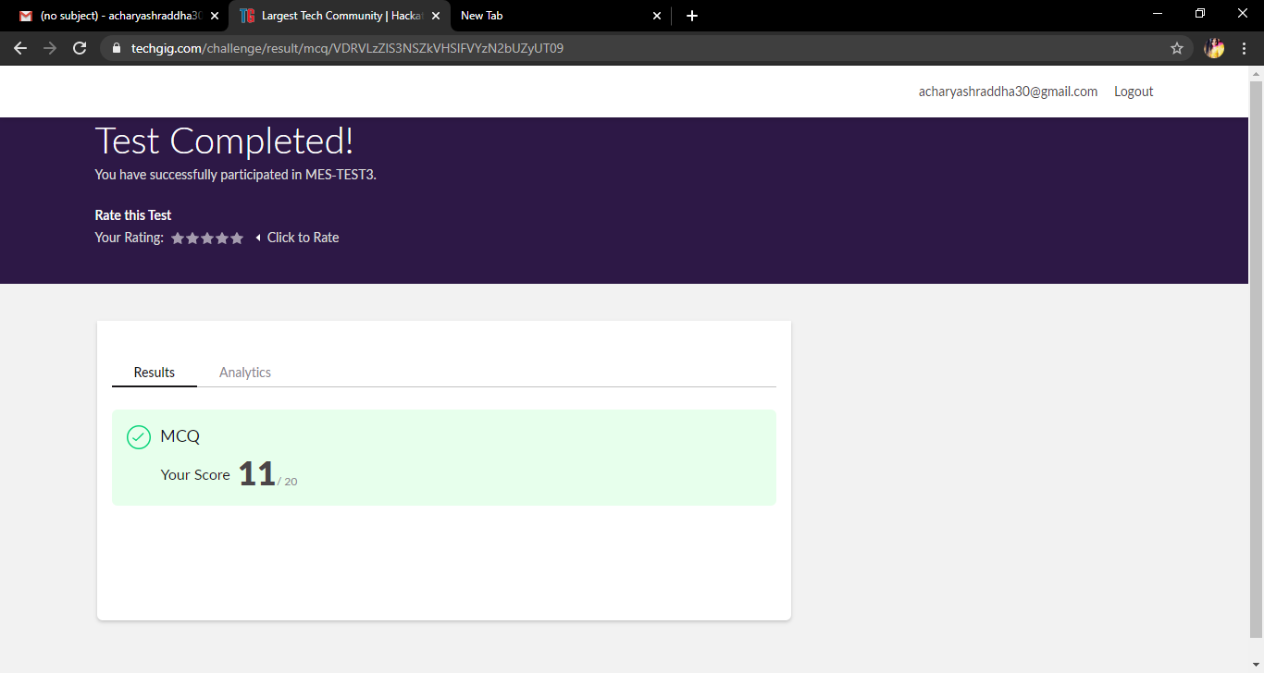

Certification Course Details: Today in the course of Introduction to Ethical Hacking Domains and learnt about Ethical Hacking in Network Architecture-Demonstration

**Snapshot**

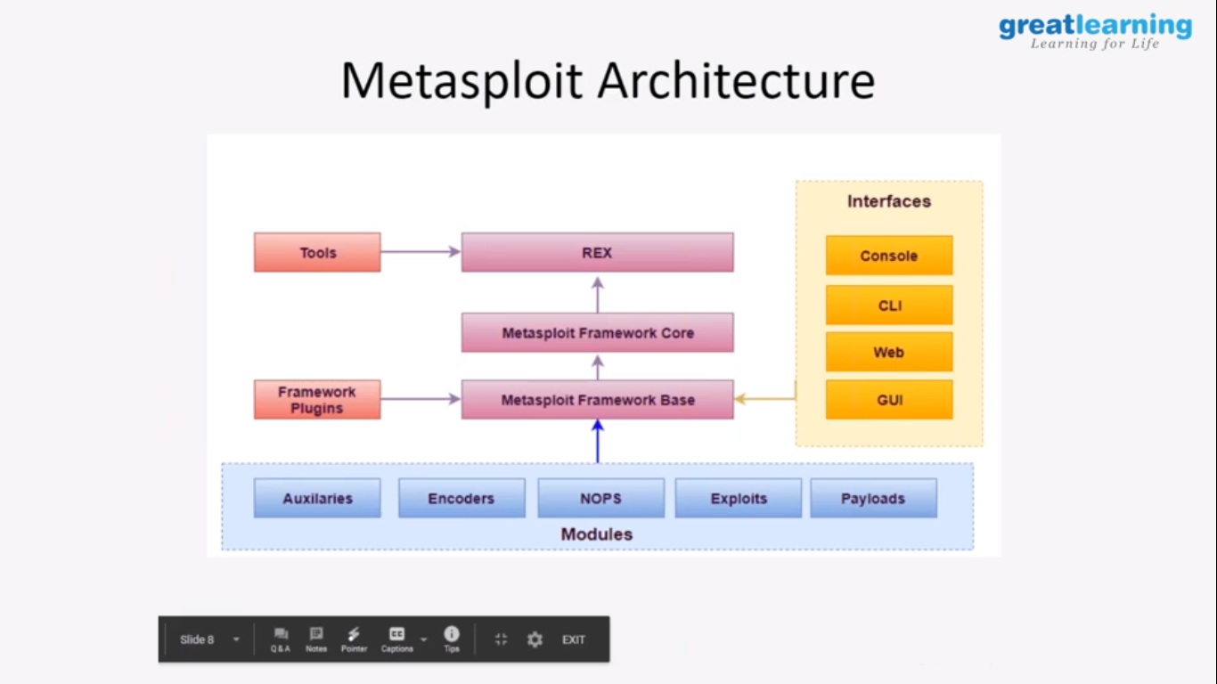

Coding Challenges Details: Problem Statements

1.write a java program to read three integer values from the keyboard and find the sum of the values. Declare a variable "sum" of type int and store the result in it.

Snapshot:

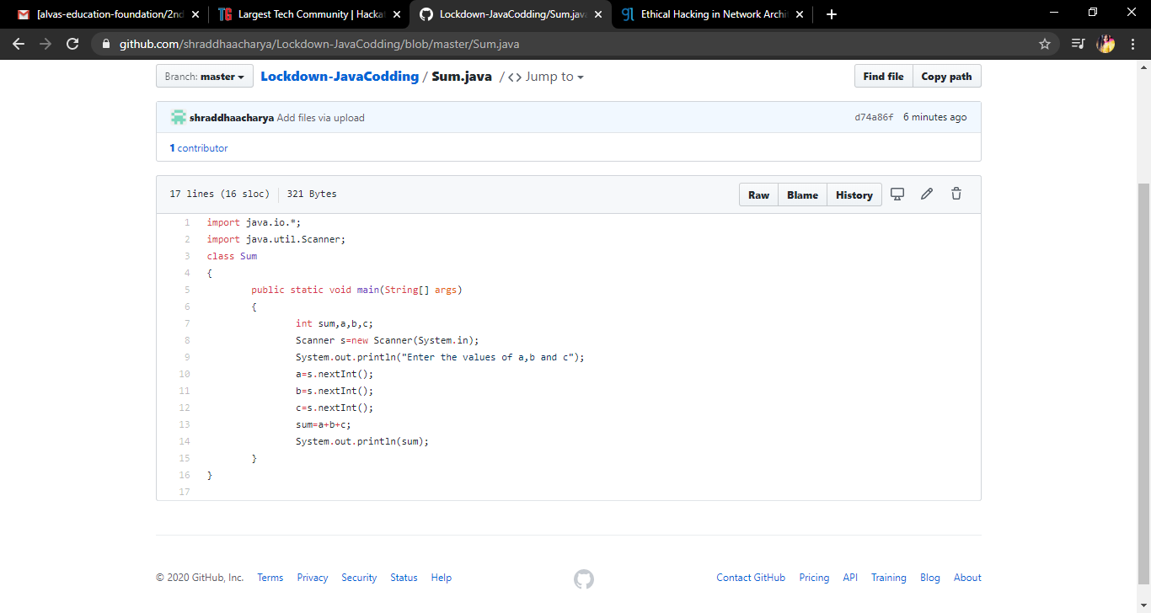

2.Write a C++ program to find a missing number in array.

Snapshot:

