**DAILY ONLINE ACTIVITIES SUMMARY**

|  |  |  |  |  |  |  |  |  |
| --- | --- | --- | --- | --- | --- | --- | --- | --- |
| **Date:** | **11/06/2020** | | | | | **Name:** | **Shraddha Acharya** | |
| **Sem & Sec** | **4th sem B sec** | | | | | **USN:** | **4al18cs079** | |
| **Online Test Summary** | | | | | | | | |
| **Subject** | | **NA** | | | | | | |
| **Max. Marks** | | **30** | | **Score** | | | **NA** | |
| **Certification Course Summary** | | | | | | | | |
| **Course** | **1)Introduction to full stack development**  **2)Webinar on Skill Development** | | | | | | | |
| **Certificate Provider** | | | **1)Great learning Academy**  **2)Brain O vision** | | **Duration** | | | **1)8 hours**  **2)2 hours** |
| **Coding Challenges** | | | | | | | | |
| **Problem Statement:**  **1.Write a C program to implement SJF process scheduling** | | | | | | | | |
| **Status: Yes** | | | | | | | | |
| **Uploaded the report in Github** | | | | | **Yes** | | | |
| **If yes Repository name** | | | | | **https://www.github.com/shraddhaacharya/lockdown-C-coding/tree/master/Shortest_job_first.c** | | | |
| **Uploaded the report in slack** | | | | | **Yes** | | | |

Certification Course Details: Today in the course of Introduction to full stack development I learnt about the paragraph tags and head tags. And also attended a webinar on Skill Development

Snapshot

1. Introduction to full stack development

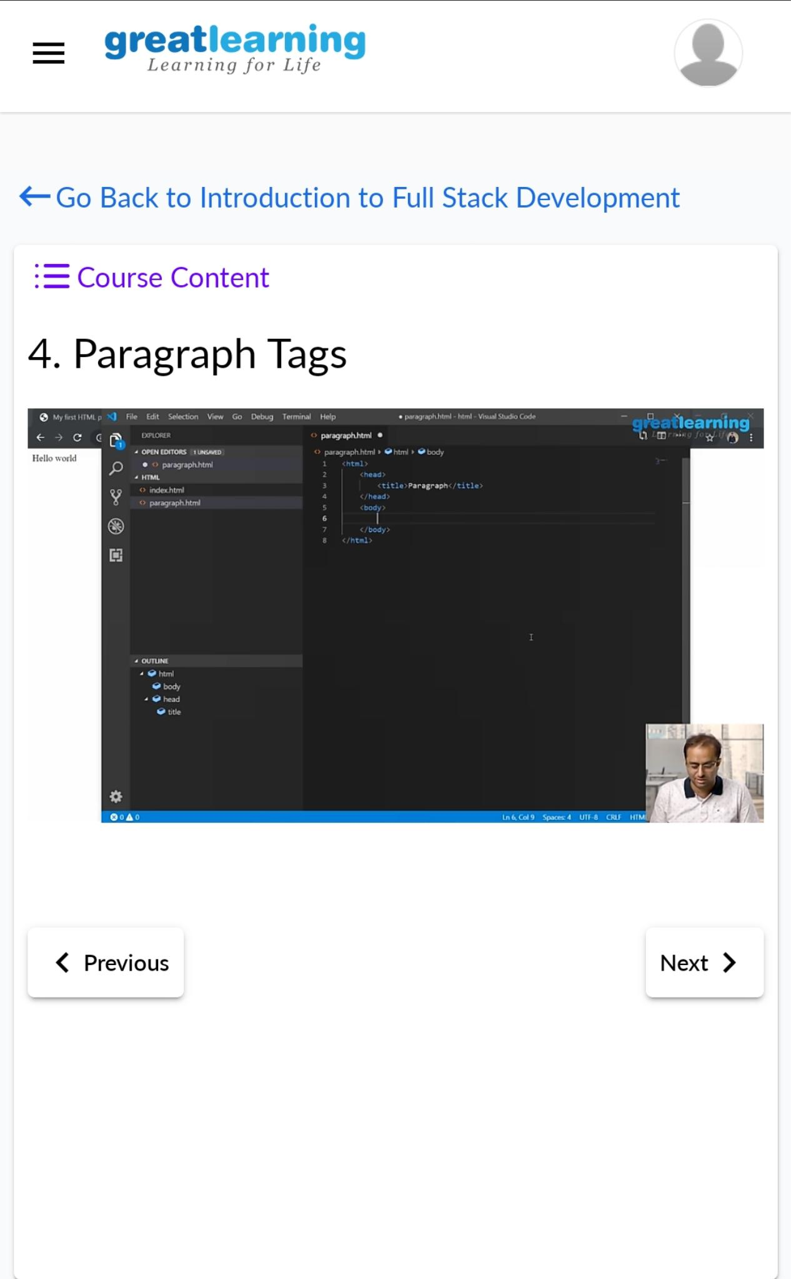

1. Webinar on skill Development

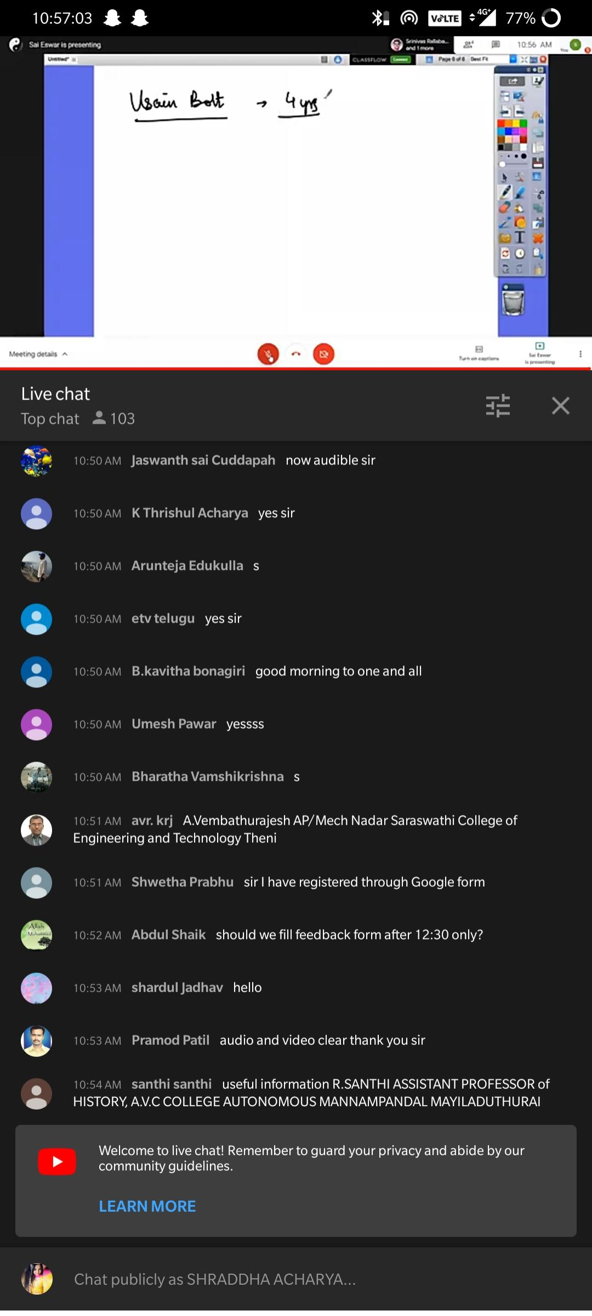

Coding Challenges Details:

1.Write a C program to implement SJF process scheduling

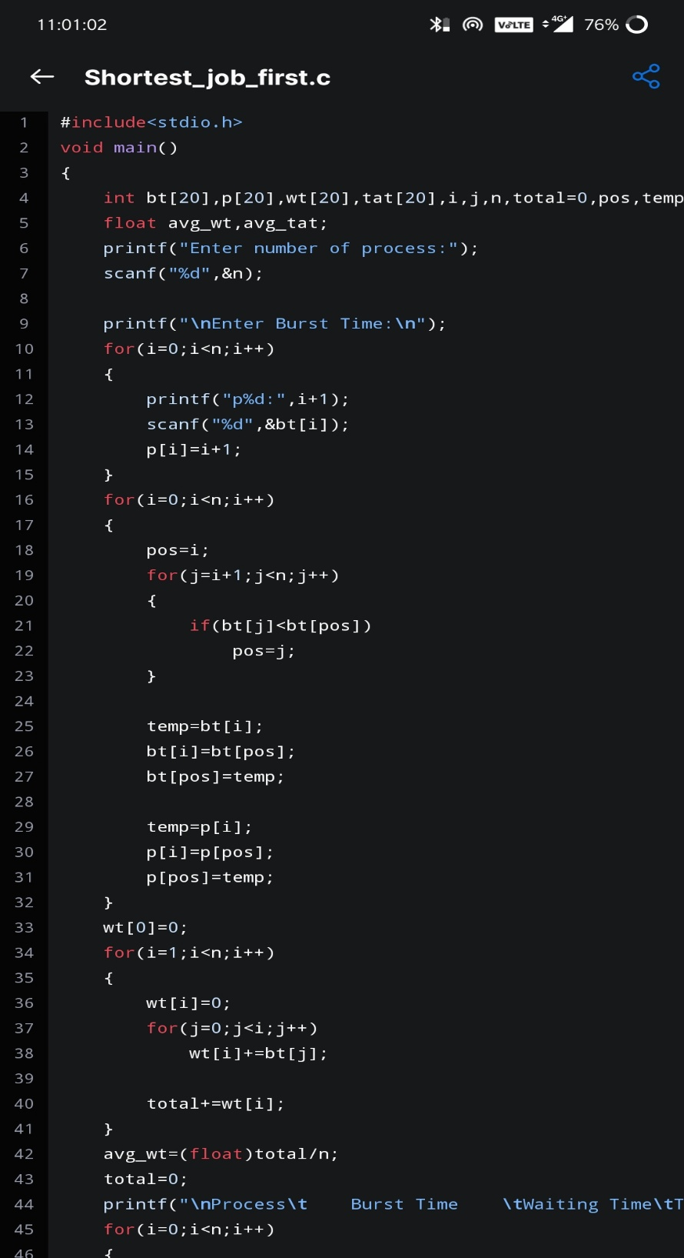Snapshot