**DAILY ONLINE ACTIVITIES SUMMARY**

|  |  |  |  |  |  |  |  |  |
| --- | --- | --- | --- | --- | --- | --- | --- | --- |
| **Date:** | **12/06/2020** | | | | | **Name:** | **Shraddha Acharya** | |
| **Sem & Sec** | **4th Sem B sec** | | | | | **USN:** | **4al18cs079** | |
| **Online Test Summary** | | | | | | | | |
| **Subject** | | **Adalitha kannada** | | | | | | |
| **Max. Marks** | | **25** | | **Score** | | | **22** | |
| **Certification Course Summary** | | | | | | | | |
| **Course** | **Introduction to full stack development** | | | | | | | |
| **Certificate Provider** | | | **Great learning Academy** | | **Duration** | | | **8 hours** |
| **Coding Challenges** | | | | | | | | |
| **Problem Statement: Write a C program to implement SRTF process scheduling.** | | | | | | | | |
| **Status:Done** | | | | | | | | |
| **Uploaded the report in Github** | | | | | **Yes** | | | |
| **If yes Repository name** | | | | | **https://www.github.com/shraddhaacharya/lockdown-C-coding/tree/master/Shortest_rem_timefirst.c** | | | |
| **Uploaded the report in slack** | | | | | **Yes** | | | |

Online Test Details: Online test of Adalitha kannada was conducted for 25 marks which carries 1 mark for each question

Snapshot

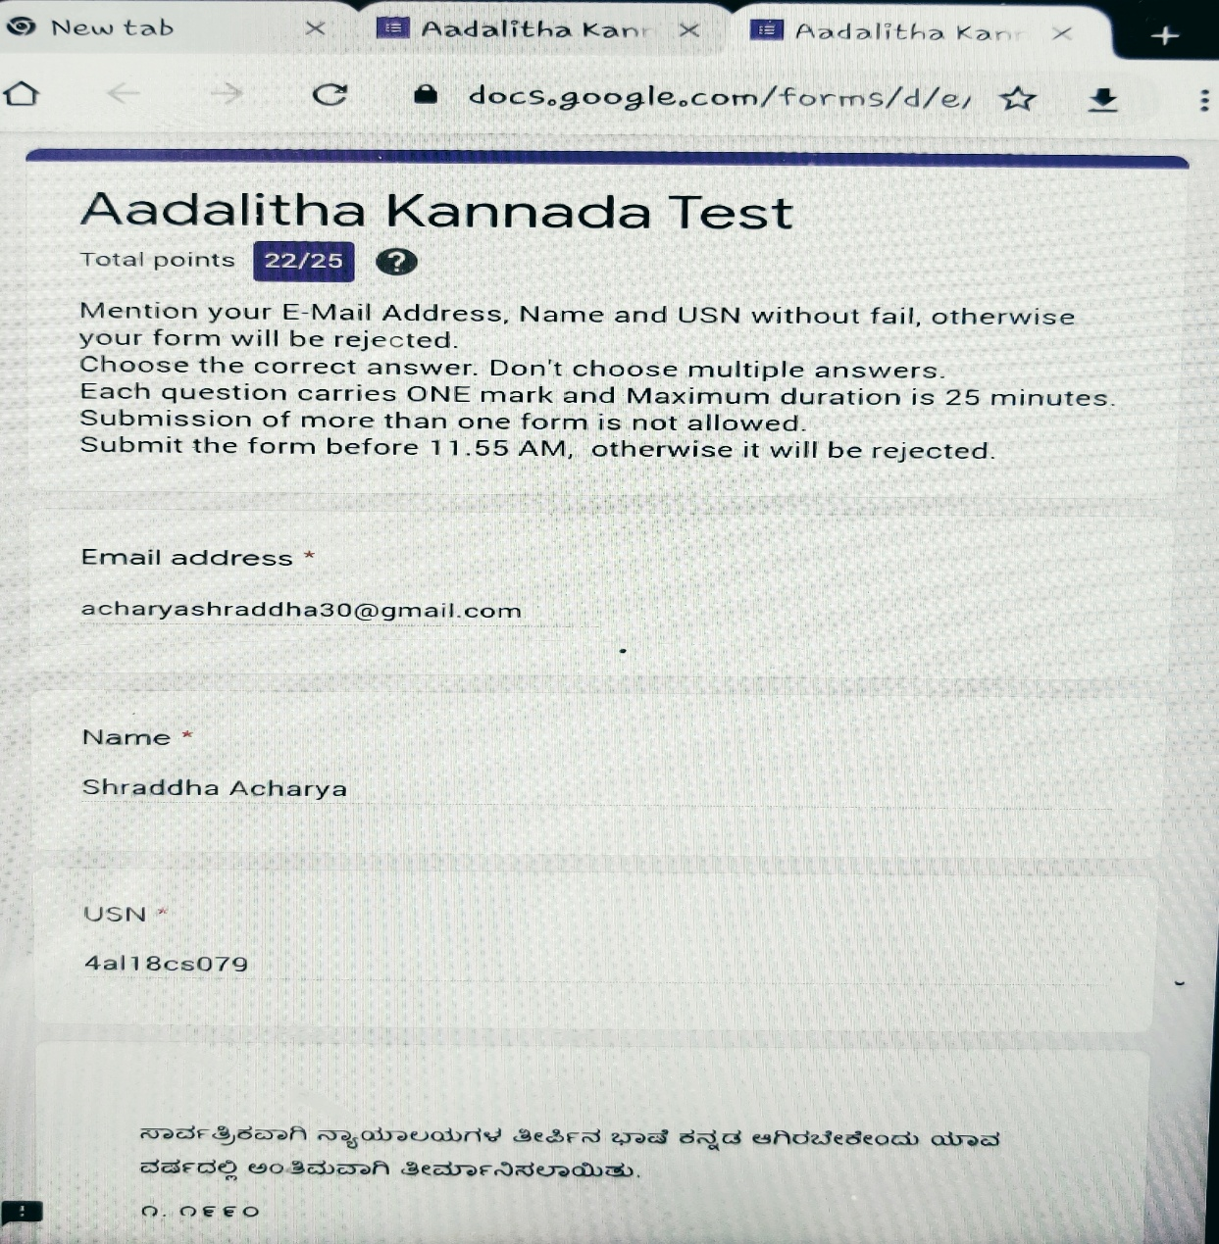

Certification Course Details: Today in the course of Introduction to Full stack development I learnt about more on head tags, heading tags,HR and BR tags.

Snapshot

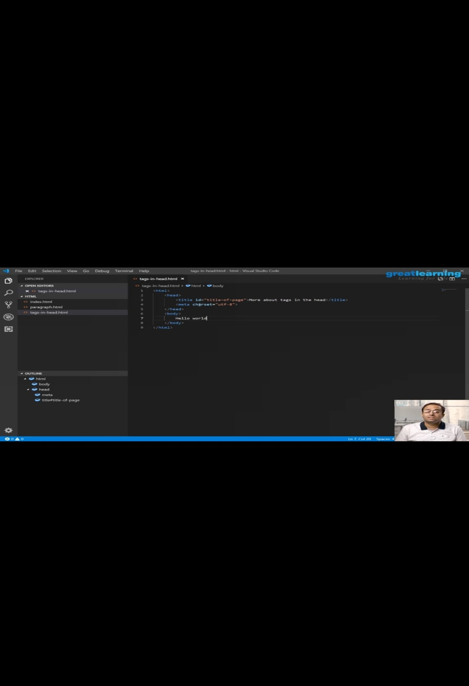

Coding Challenges Details: Write a C program to implement SRTF process scheduling.

Snapshot:

