**DAILY ONLINE ACTIVITIES SUMMARY**

|  |  |  |  |  |  |  |  |  |
| --- | --- | --- | --- | --- | --- | --- | --- | --- |
| **Date:** | **13/06/2020** | | | | | **Name:** | **Shraddha Acharya** | |
| **Sem & Sec** | **4 Sem B sec** | | | | | **USN:** | **4al18cs079** | |
| **Online Test Summary** | | | | | | | | |
| **Subject** | | **Data Communication** | | | | | | |
| **Max. Marks** | | **30** | | **Score** | | | **26** | |
| **Certification Course Summary** | | | | | | | | |
| **Course** | **1)Introduction to full stack development**  **2) Webinar on Data Science Innovation** | | | | | | | |
| **Certificate Provider** | | | **Great learning Academy** | | **Duration** | | | **8 hours** |
| **Coding Challenges** | | | | | | | | |
| **Problem Statement:1) Write a C program to calculate the Electricity bill**  **2) Write a java program to find the first non repeated characters of a given String** | | | | | | | | |
| **Status:Done** | | | | | | | | |
| **Uploaded the report in Github** | | | | | **Yes** | | | |
| **If yes Repository name** | | | | | **1)**[**https://www.github.com/shraddhaacharya/lockdown-C-coding/tree/master/Electricitybill.C**](https://www.github.com/shraddhaacharya/lockdown-C-coding/tree/master/Electricitybill.C)  **2)https://www.github.com/shraddhaacharya/Lockdown-JavaCodding/tree/master/Nonrepeating.java** | | | |
| **Uploaded the report in slack** | | | | | **Yes** | | | |

Online Test Details: Online test of Data Communication was conducted for 30 marks which carries 1 mark for each question

Snapshot

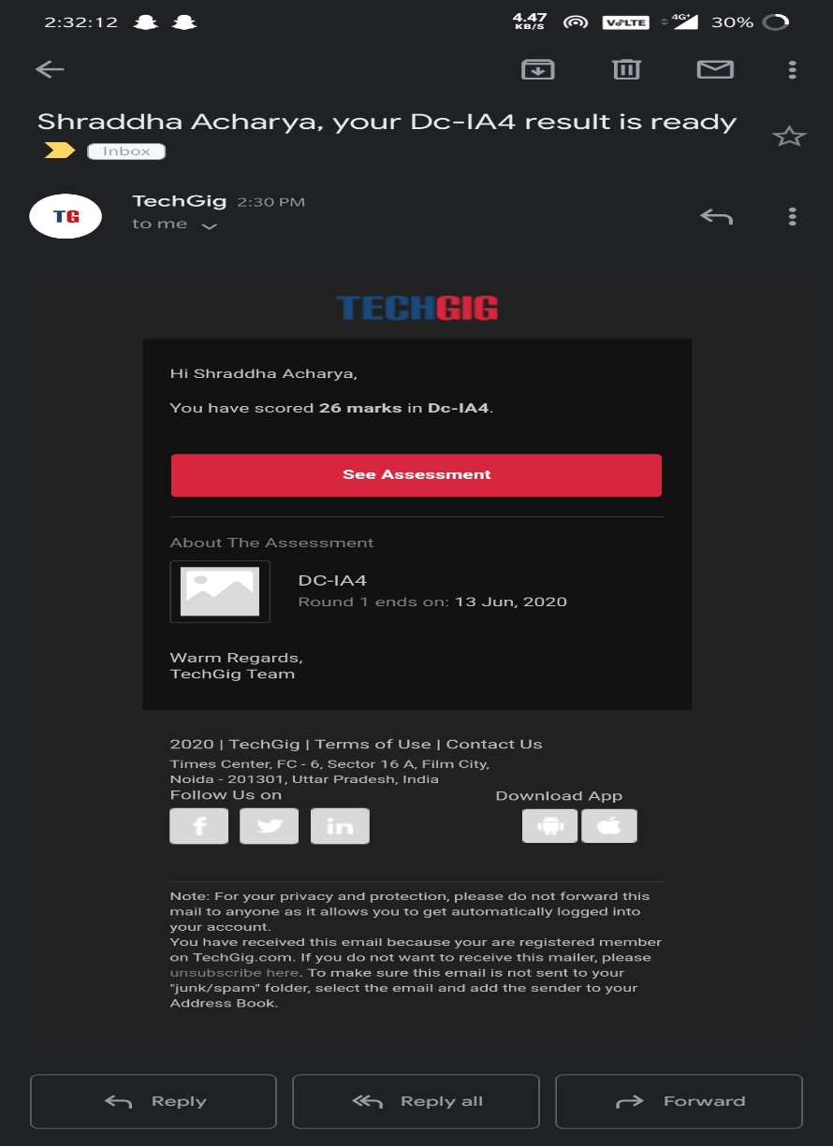

Certification Course Details: Today in the course of Introduction to Full stack development I learnt about Anchor tag.And also attended a webinar on Data Science Innovation.

Snapshot

1. Introduction to Full stack development
2. 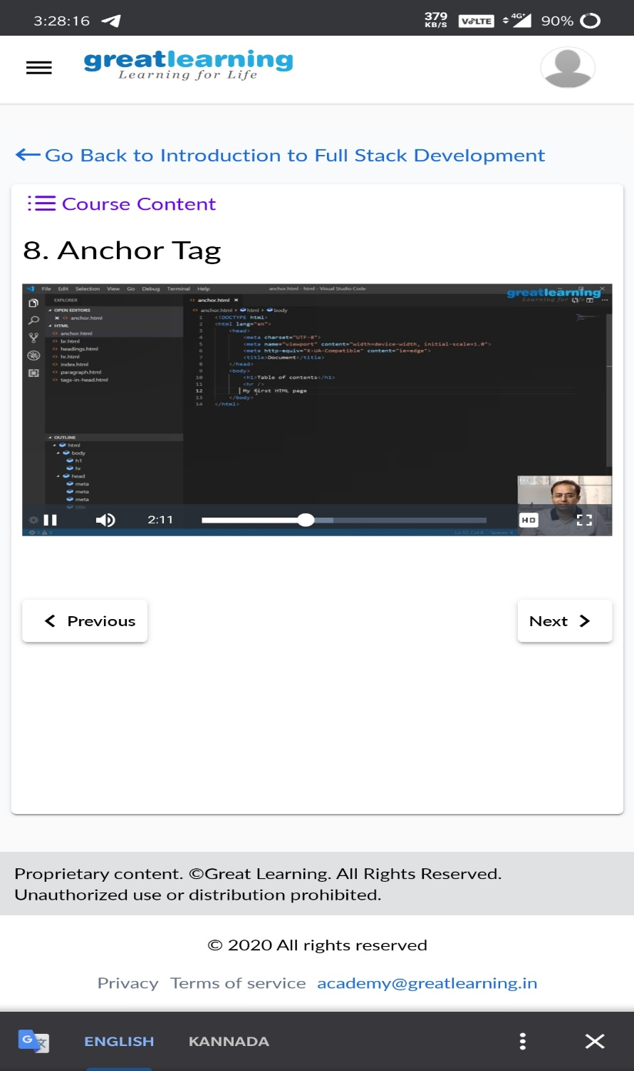Webinar on Data Science Innovation

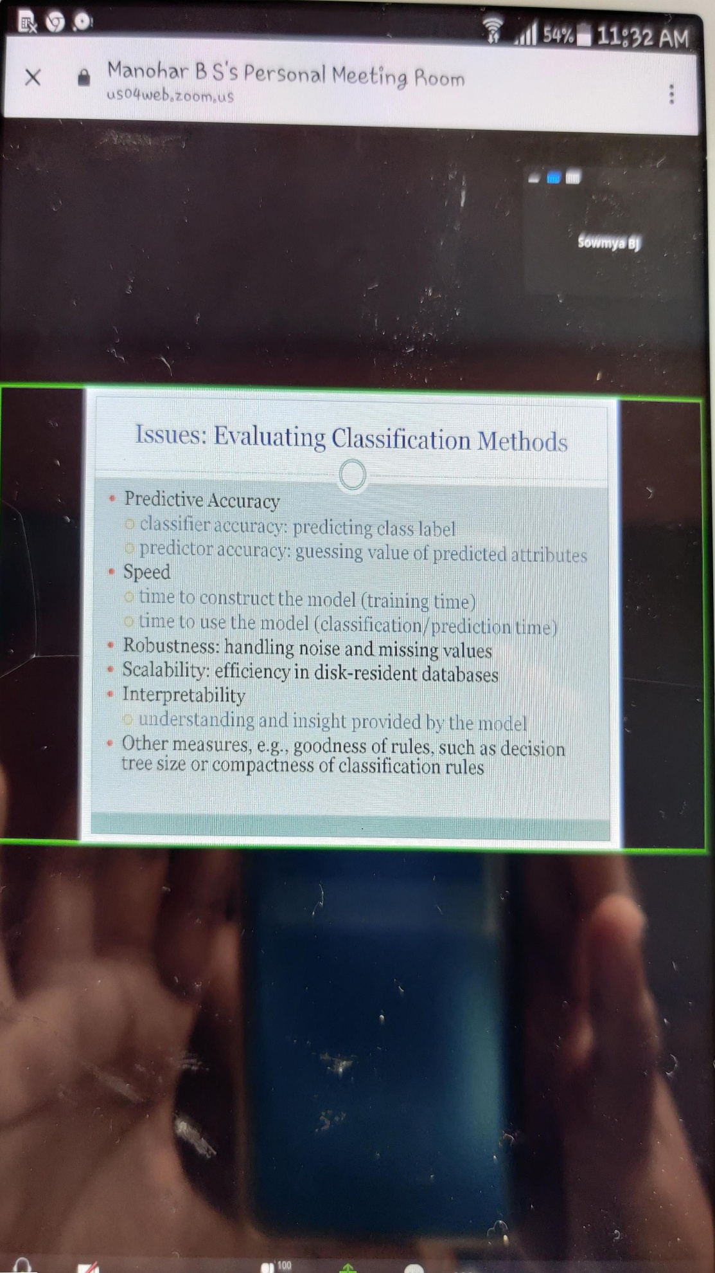

Coding Challenges Details:

1)Write a C program to calculate the Electricity bill.

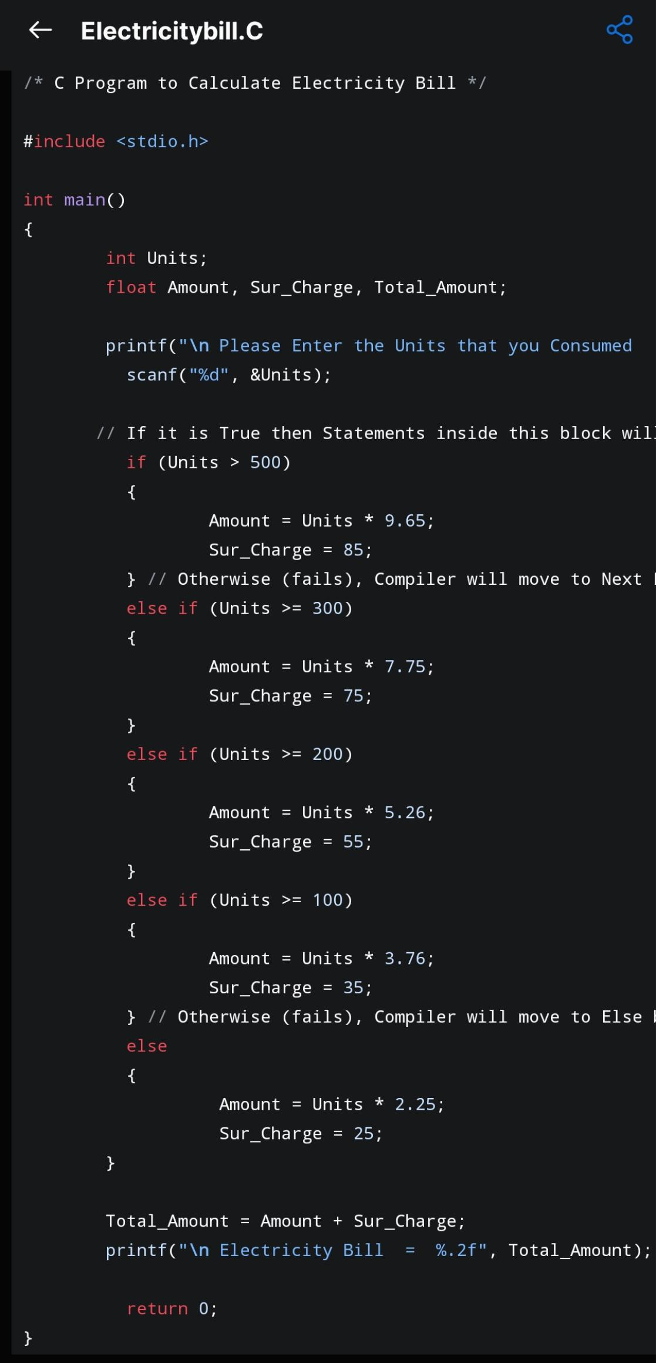Snapshot:

2)Write a java program to find out first non repeated Characters in a given String

