**DAILY ONLINE ACTIVITIES SUMMARY**

|  |  |  |  |  |  |  |  |  |
| --- | --- | --- | --- | --- | --- | --- | --- | --- |
| **Date:** | **15/06/2020** | | | | | **Name:** | **Shraddha Acharya** | |
| **Sem & Sec** | **4 Sem B sec** | | | | | **USN:** | **4al18cs079** | |
| **Online Test Summary** | | | | | | | | |
| **Subject** | | **NA** | | | | | | |
| **Max. Marks** | | **30** | | **Score** | | | **NA** | |
| **Certification Course Summary** | | | | | | | | |
| **Course** | **1)Introduction to full stack development** | | | | | | | |
| **Certificate Provider** | | | **Great learning Academy** | | **Duration** | | | **8 hours** |
| **Coding Challenges** | | | | | | | | |
| **Problem Statement:1) Write a java program to find if a string is a K palindrome or not**  **2) Write a C/C++ program to perform the operation on triply linked list.**  **3) Write a C program to implement Binary Reversal.** | | | | | | | | |
| **Status:Done** | | | | | | | | |
| **Uploaded the report in Github** | | | | | **Yes** | | | |
| **If yes Repository name** | | | | | **1)https://www.github.com/shraddhaacharya/Lockdown-JavaCodding/tree/master/Palindrome.java**  **2)**[**https://www.github.com/shraddhaacharya/Lockdown-JavaCodding/tree/master/Triplylinkedlist.cpp**](https://www.github.com/shraddhaacharya/Lockdown-JavaCodding/tree/master/Triplylinkedlist.cpp)  **3)** **https://www.github.com/shraddhaacharya/lockdown-C-coding/tree/master/Binaryreverse.c** | | | |
| **Uploaded the report in slack** | | | | | **Yes** | | | |

Certification Course Details: Today in the course of Introduction to Full stack development I learnt about image tag and Alt Attribute.

Snapshot

1. Introduction to Full stack development

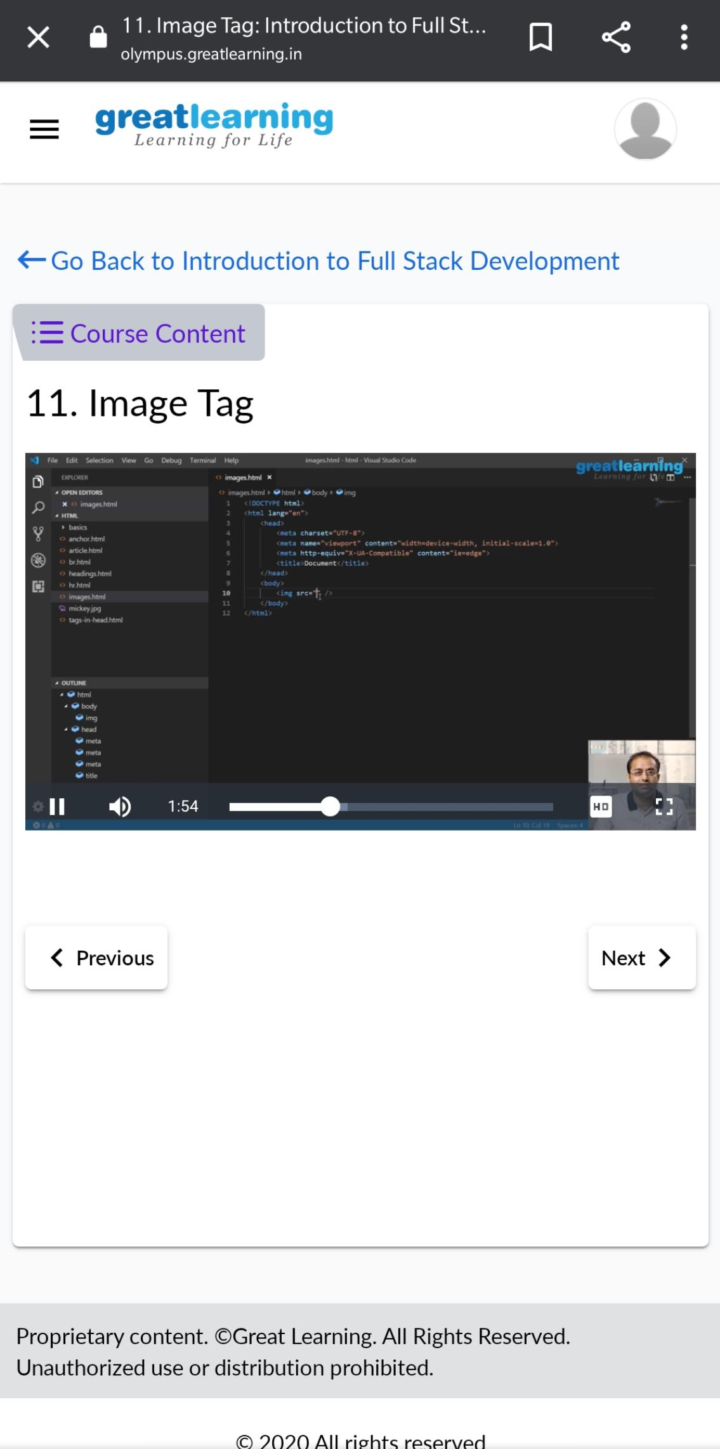

Coding Challenges Details:

1)Write a java program to find if a string is K palindrome or not.

Snapshot:

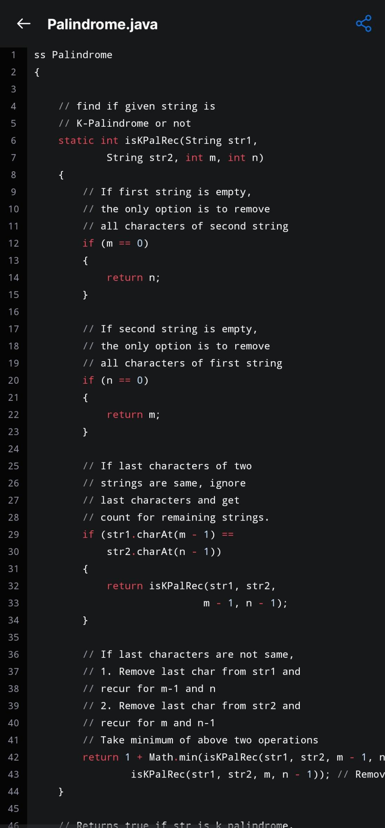

1. Write a C/C++program to perform the operation of triply linked list

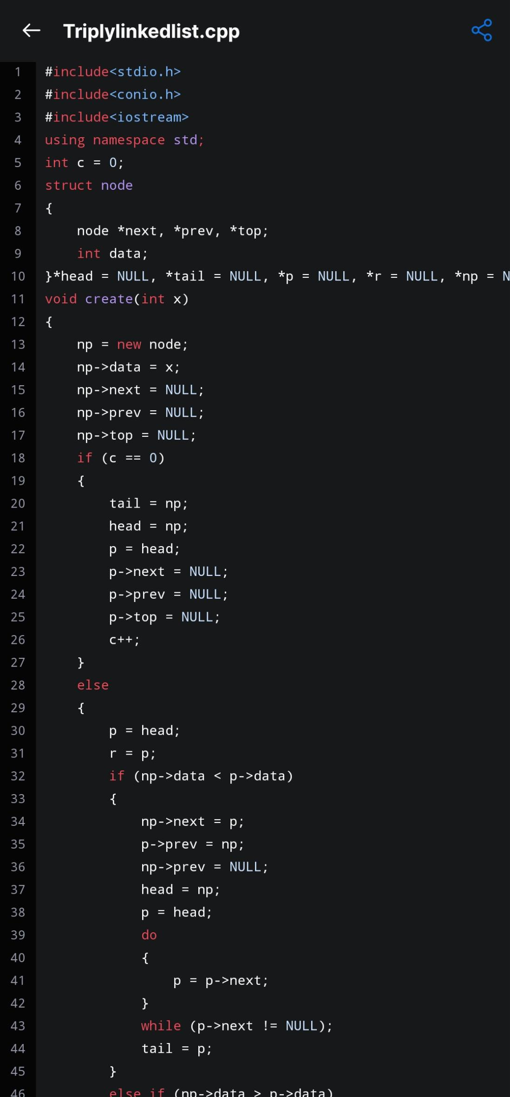

1. Write a C program to implement Binary Reversal.

