**DAILY ONLINE ACTIVITIES SUMMARY**

|  |  |  |  |  |  |  |  |  |
| --- | --- | --- | --- | --- | --- | --- | --- | --- |
| **Date:** | **19/06/2020** | | | | | **Name:** | **Shraddha Acharya** | |
| **Sem & Sec** | **4 Sem B sec** | | | | | **USN:** | **4al18cs079** | |
| **Online Test Summary** | | | | | | | | |
| **Subject** | | **Microcontroller and Embedded System** | | | | | | |
| **Max. Marks** | | **20** | | **Score** | | | **15** | |
| **Certification Course Summary** | | | | | | | | |
| **Course** | **1)Introduction to full stack development** | | | | | | | |
| **Certificate Provider** | | | **Great learning Academy** | | **Duration** | | | **8 hours** |
| **Coding Challenges** | | | | | | | | |
| **Problem Statement:1) Write a C++ program to count total set bits of all numbers from 1 to N.**  **2) Write a C++ program to rotate matrix by 90 degree in clockwise or anticlockwise direction.** | | | | | | | | |
| **Status:Done** | | | | | | | | |
| **Uploaded the report in Github** | | | | | **Yes** | | | |
| **If yes Repository name** | | | | | **1)https://www.github.com/shraddhaacharya/Lockdown-JavaCodding/tree/master/Countbits.cpp**  **2)https://www.github.com/shraddhaacharya/Lockdown-JavaCodding/tree/master/Clockrotation.cpp** | | | |
| **Uploaded the report in slack** | | | | | **Yes** | | | |

Online Exam Details: Online test of MES was conducted today afternoon at 3 pm.There where 20 questions 1 mark each.

Snapshot:

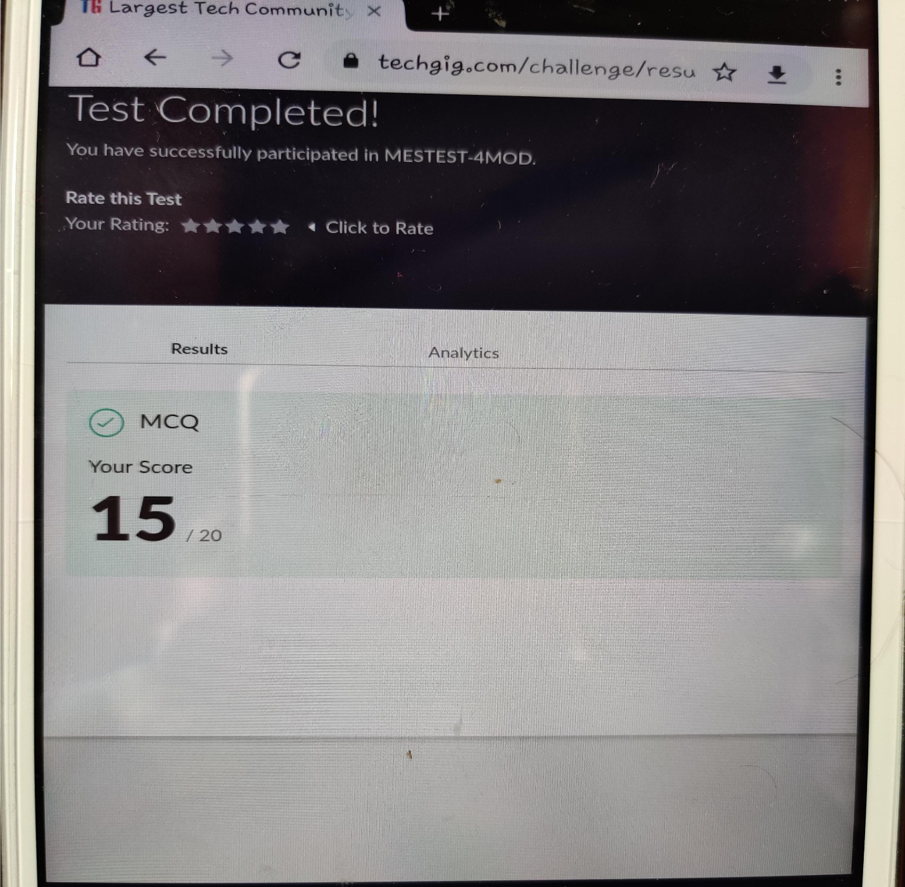

Certification Course Details: Today in the course of Introduction to Full stack development I learnt about Forms and Labels.

Snapshot

1. Introduction to Full stack development

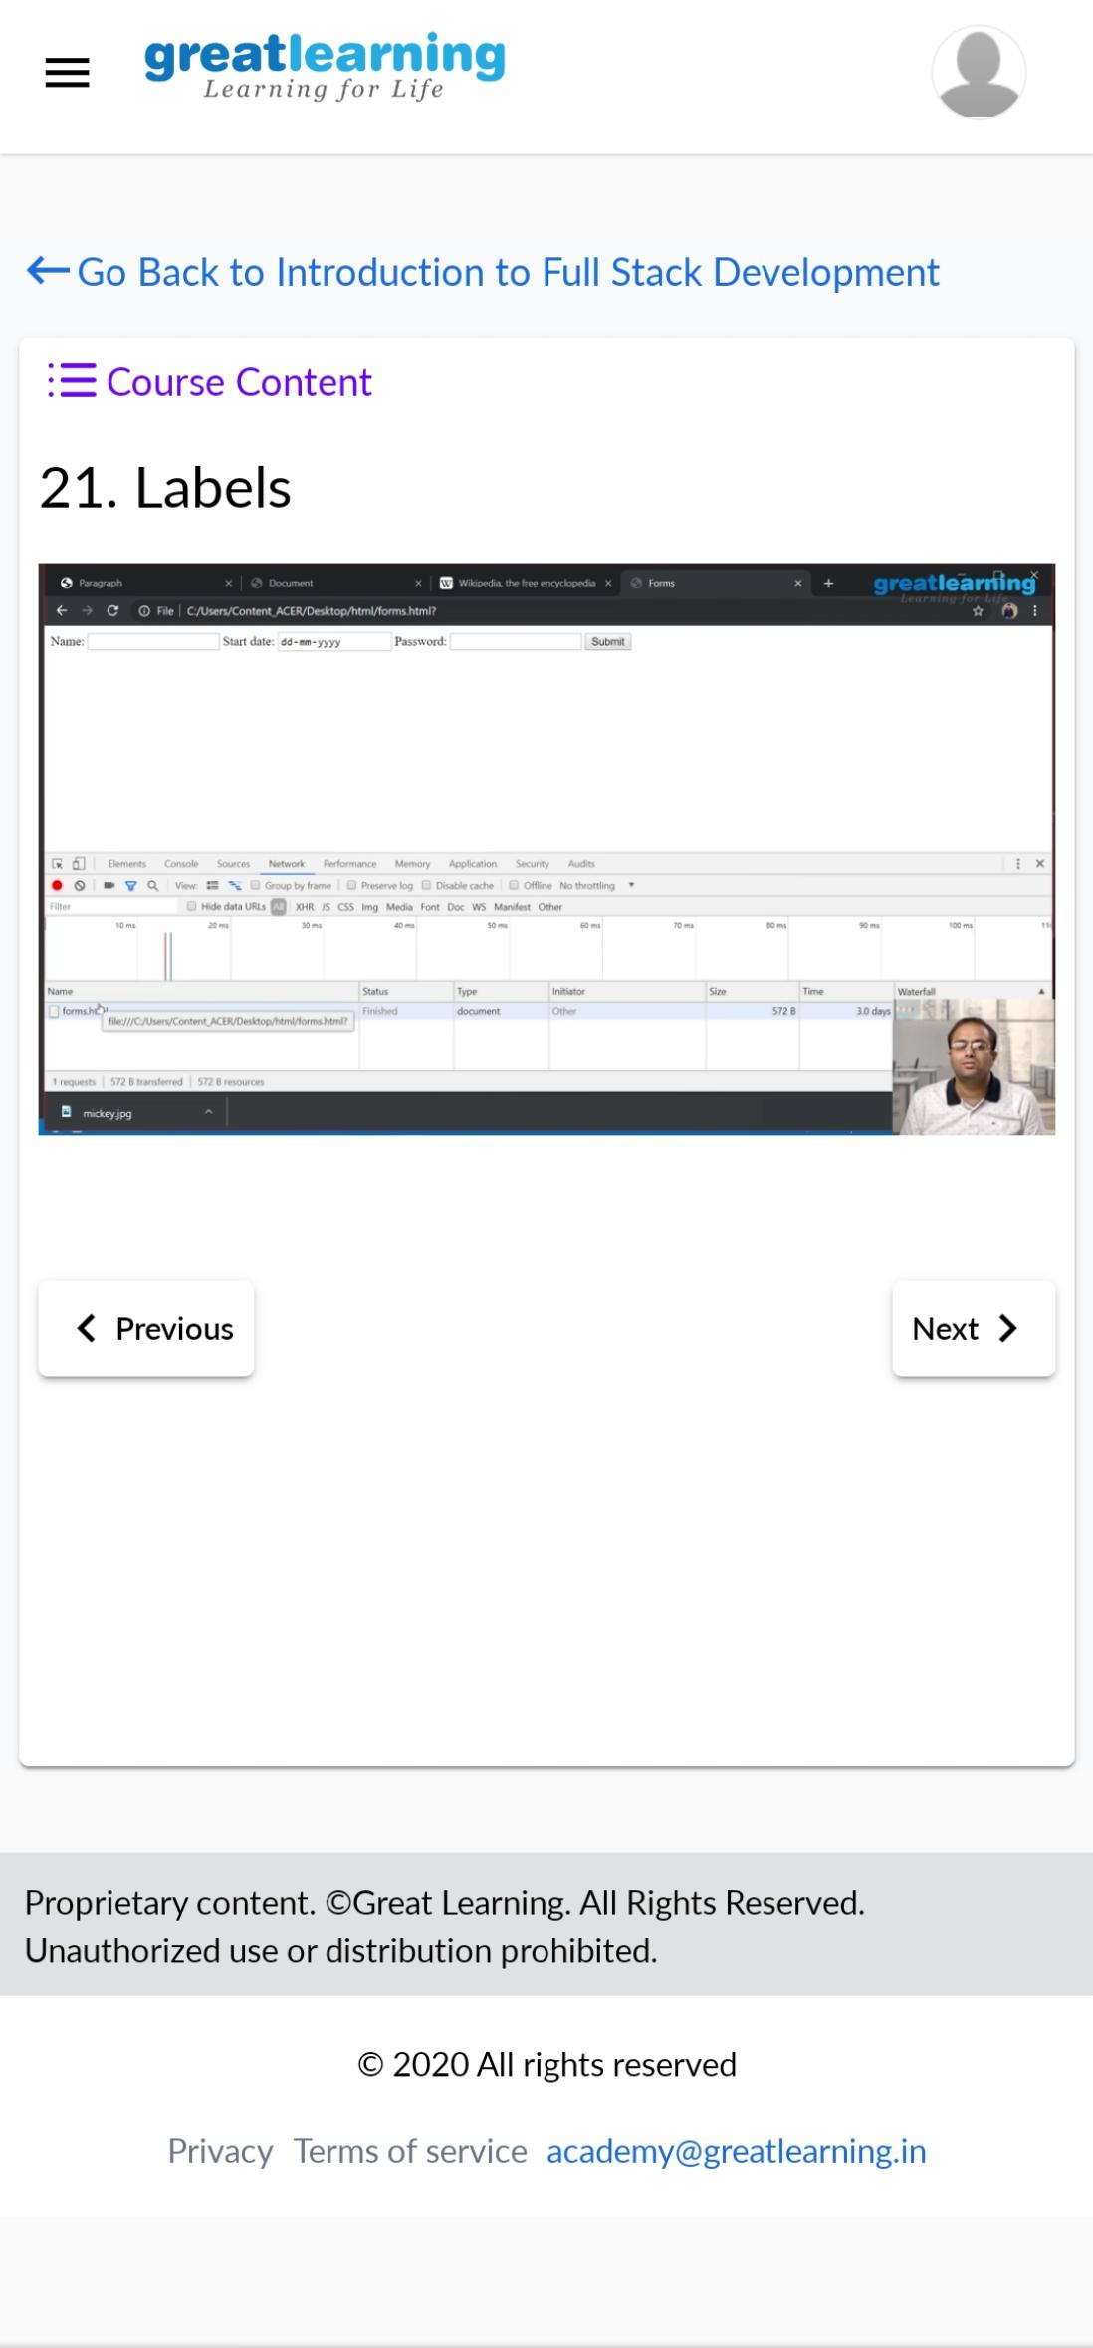

Coding Challenges Details:

1)Write a C++ program to count total set bits in all numbers from 1 to N

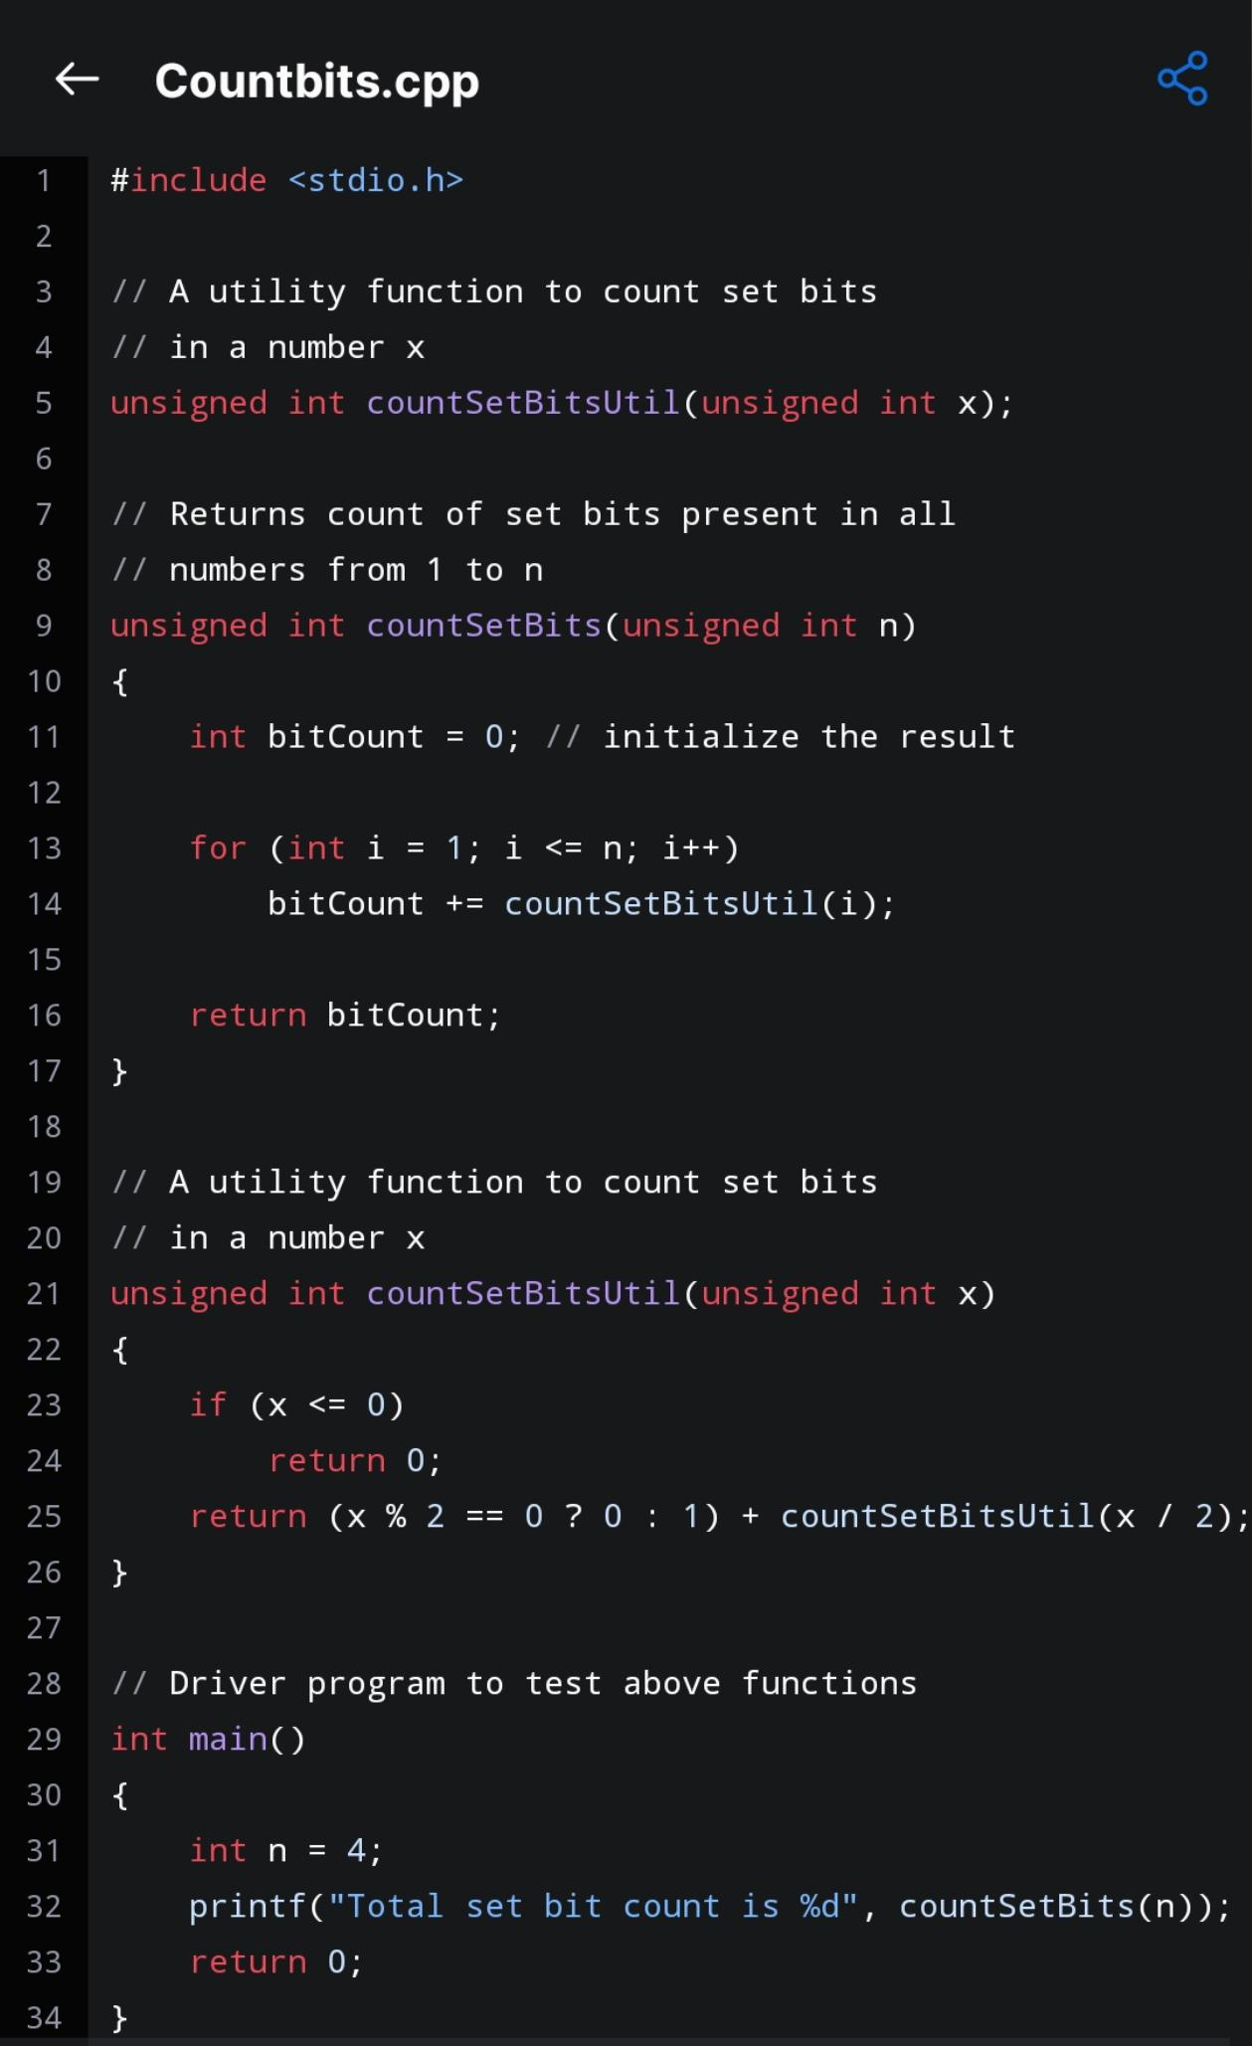Snapshot

1. Writea c++ program to rotate the matrix by 90 degree in clockwise or anticlockwise.

Snapshot

