**DAILY ONLINE ACTIVITIES SUMMARY**

|  |  |  |  |  |  |  |  |  |
| --- | --- | --- | --- | --- | --- | --- | --- | --- |
| **Date:** | **01/06/2020** | | | | | **Name:** | **Shraddha Acharya** | |
| **Sem & Sec** | **4th sem B sec** | | | | | **USN:** | **4al18cs079** | |
| **Online Test Summary** | | | | | | | | |
| **Subject** | | **Complex analysis ,Probability and Statistical Method** | | | | | | |
| **Max. Marks** | | **30** | | **Score** | | | **27** | |
| **Certification Course Summary** | | | | | | | | |
| **Course** | **1.Introduction to Cyber Security** | | | | | | | |
| **Certificate Provider** | | | **1.Great Learning Academy** | | **Duration** | | | **1)7 hours** |
| **Coding Challenges** | | | | | | | | |
| **Problem Statement: 1.Write a java program to** count of subarrays such that each subarray has exactly K distinct elements.  **2.Write a java program to find the distance between two points.** | | | | | | | | |
| **Status: Done** | | | | | | | | |
| **Uploaded the report in Github** | | | | | **Yes** | | | |
| **If yes Repository name** | | | | | 1. <https://github.com/shraddhaacharya/Lockdown-JavaCodding/blob/master/subarray_distinct_ele.java> 2. <https://github.com/shraddhaacharya/Lockdown-JavaCodding/blob/master/Point.java> | | | |
| **Uploaded the report in slack** | | | | | **Yes** | | | |

Online Test Details: Online test of Complex analysis Probability and Statistical Method was conducted .It was based on 5th module .There where 10 questions of 1mark each and 10 questions of 2 mark each.

Snapshot:

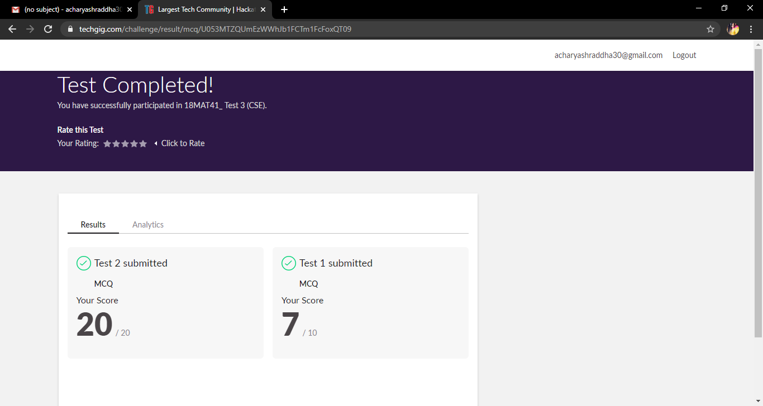

Certification Course Details: Today in the course of Introduction to Cyber Security I have learnt about What is Cyber Security.

**Snapshot**



Coding Challenges Details: Problem Statements

**1.Write a java program to** count of subarrays such that each subarray has exactly K distinct elements.

Snapshot:

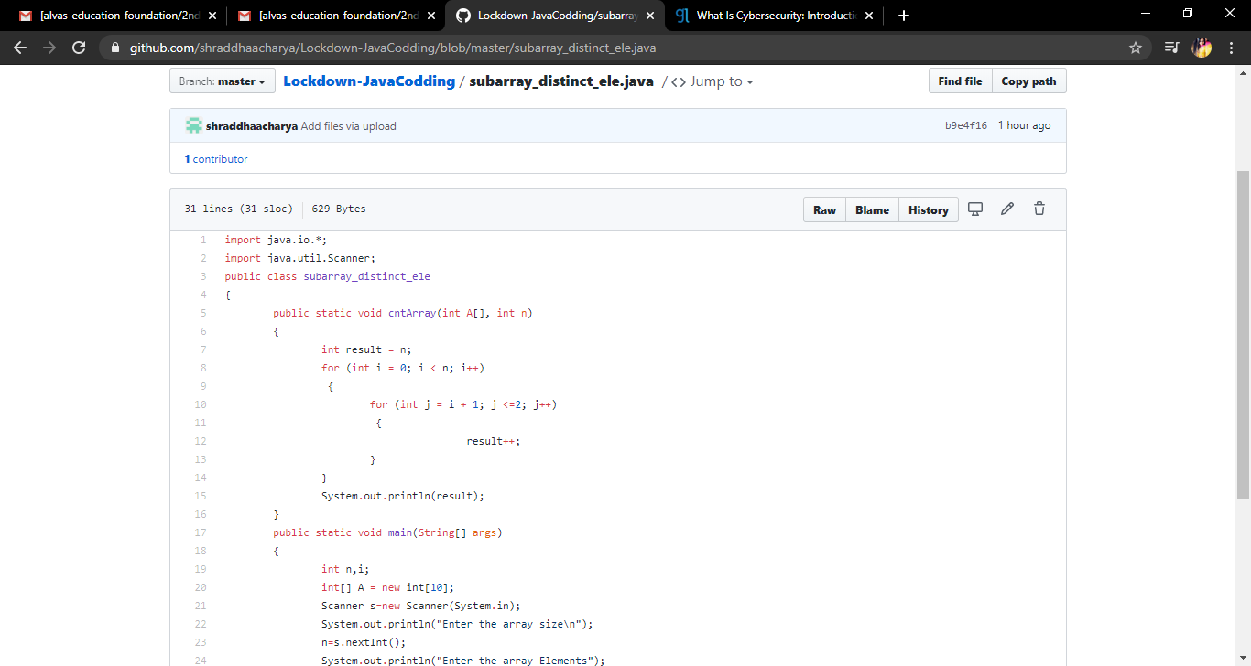

**2.Write a java program to find the distance between two points**

**Snapshot**

