**DAILY ONLINE ACTIVITIES SUMMARY**

|  |  |  |  |  |  |  |  |  |
| --- | --- | --- | --- | --- | --- | --- | --- | --- |
| **Date:** | **20/06/2020** | | | | | **Name:** | **Shraddha Acharya** | |
| **Sem & Sec** | **4 Sem B sec** | | | | | **USN:** | **4al18cs079** | |
| **Online Test Summary** | | | | | | | | |
| **Subject** | | **Data Communication** | | | | | | |
| **Max. Marks** | | **30** | | **Score** | | | **24** | |
| **Certification Course Summary** | | | | | | | | |
| **Course** | **1)Introduction to full stack development** | | | | | | | |
| **Certificate Provider** | | | **Great learning Academy** | | **Duration** | | | **8 hours** |
| **Coding Challenges** | | | | | | | | |
| **Problem Statement:1)Write a C program to rotate an array by K position.**  **2)** **Program that compares counting words in files using an ArrayList and a Map.**  **3) Write a Java program to count number of bits to be flipped to convert A to B** | | | | | | | | |
| **Status:Done** | | | | | | | | |
| **Uploaded the report in Github** | | | | | **Yes** | | | |
| **If yes Repository name** | | | | | **1)**[**https://www.github.com/shraddhaacharya/lockdown-C-coding/tree/master/Rotatearray.c**](https://www.github.com/shraddhaacharya/lockdown-C-coding/tree/master/Rotatearray.c) **https://www.github.com/shraddhaacharya/Lockdown-JavaCodding/tree/master/SimpleWordCounter%20.java https://www.github.com/shraddhaacharya/Lockdown-JavaCodding/tree/master/Flip.java** | | | |
| **Uploaded the report in slack** | | | | | **Yes** | | | |

Online Exam Details: Online test of DC was conducted today afternoon at 2 pm.There where 30 questions 1 mark each.

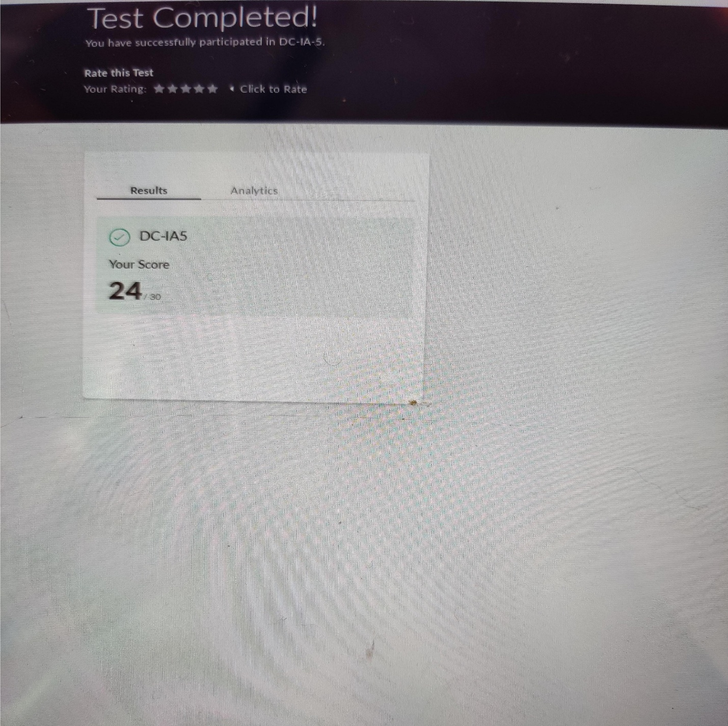Snapshot:

Certification Course Details: Today in the course of Introduction to Full stack development I learnt about Method Attributes and HTML 5 Attributes.

Snapshot

1. Introduction to Full stack development

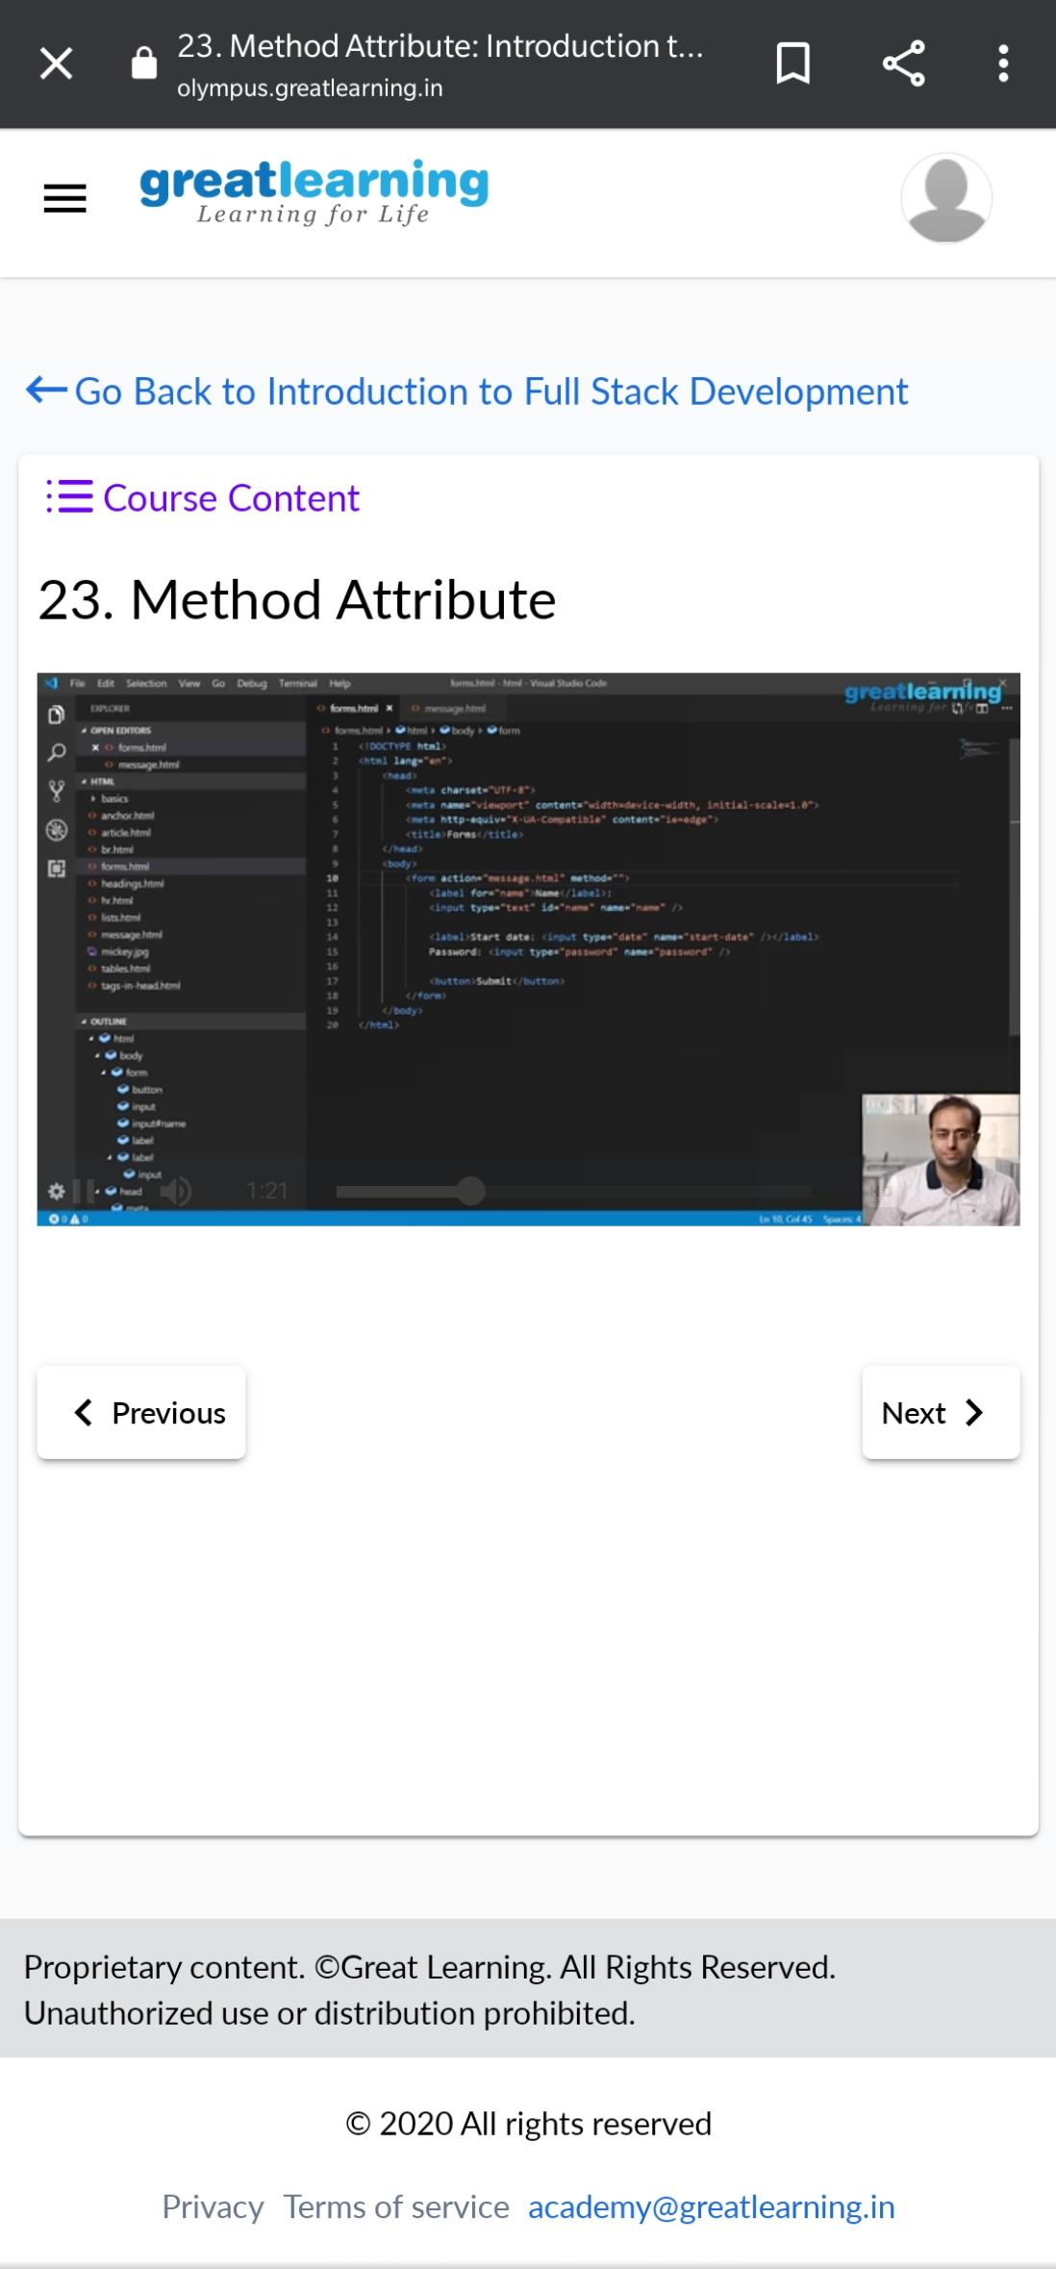

Coding Challenges Details:

1. Writea C program to rotate an array by K position.

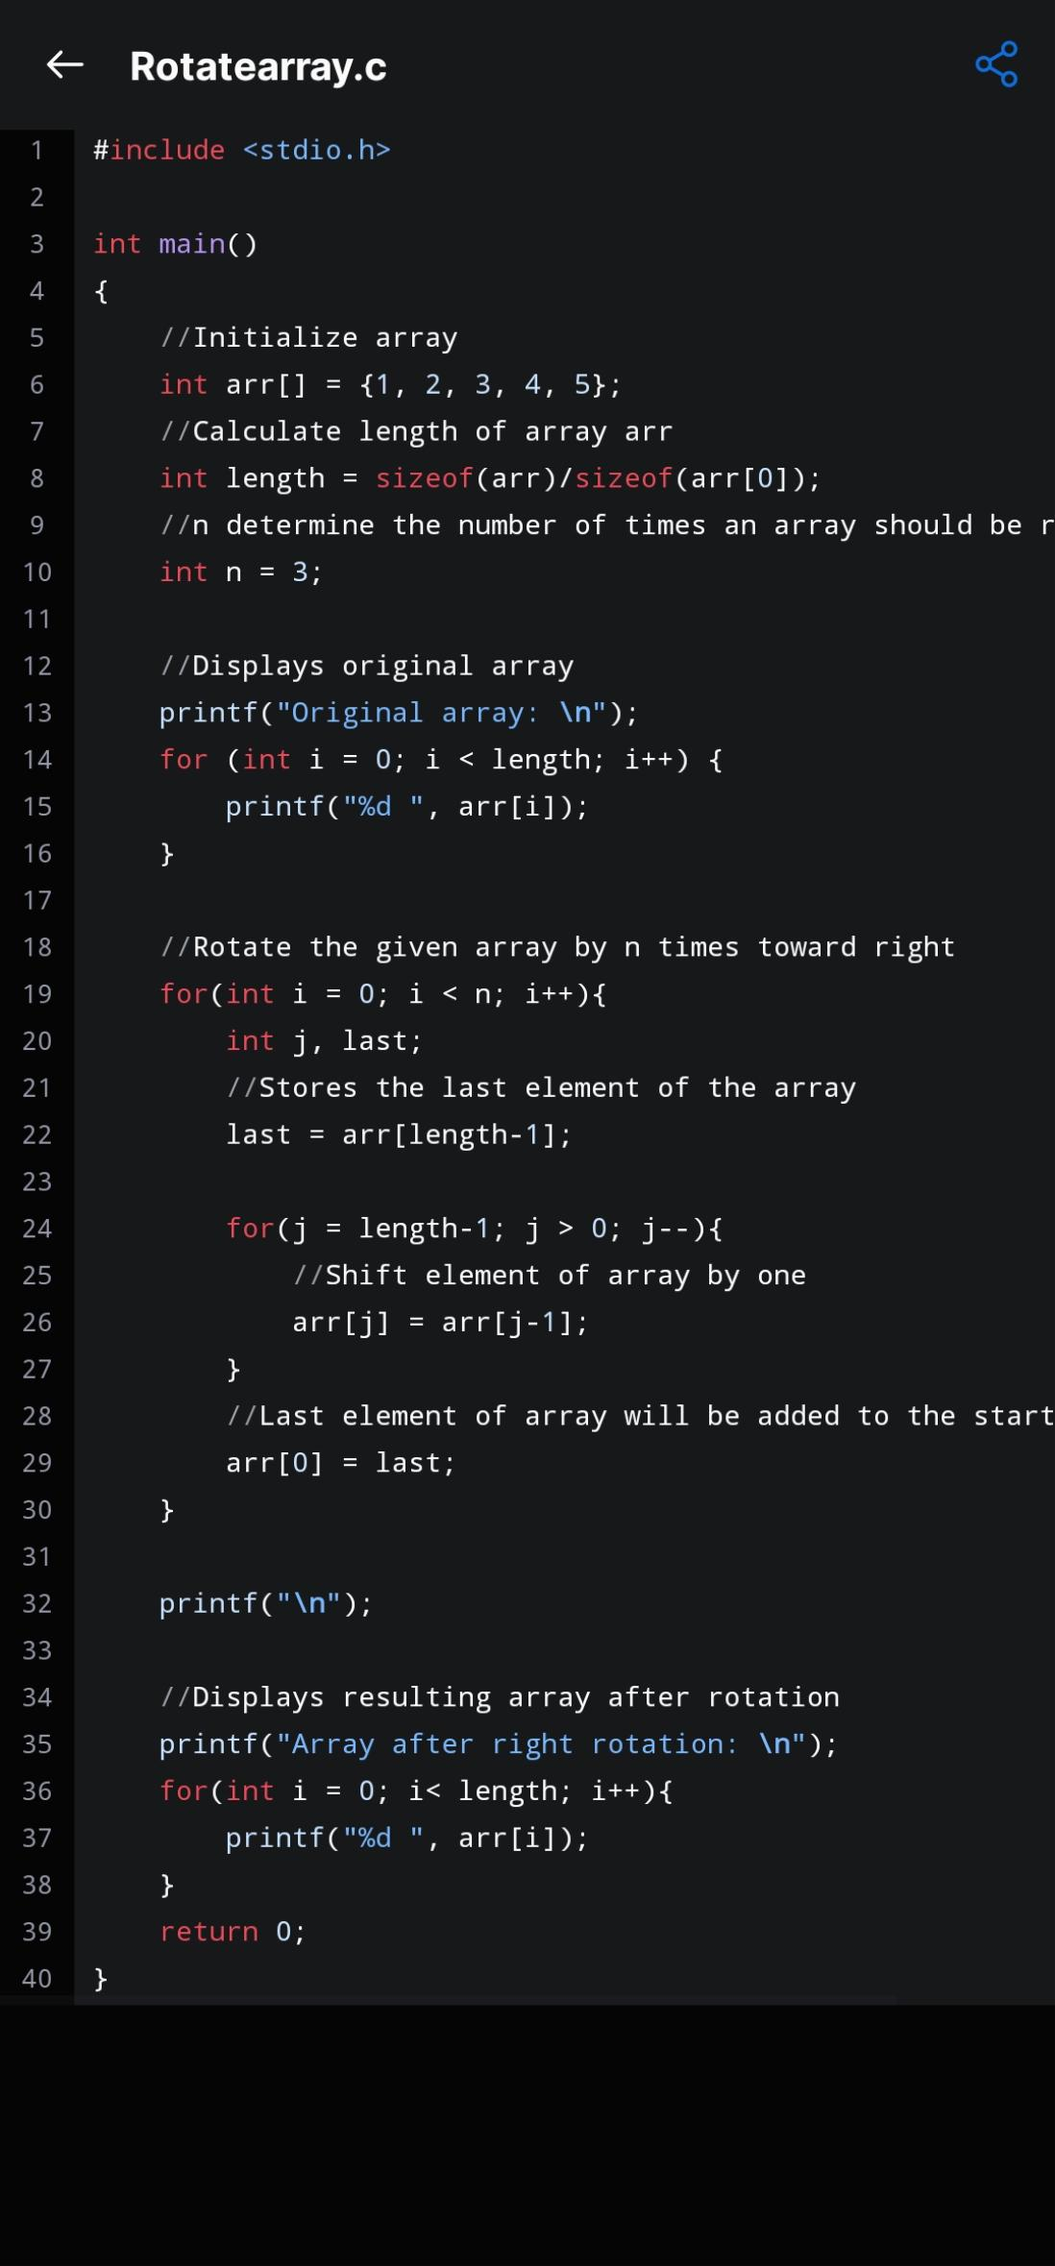

1. Program that compares counting words in a file list using ArrayLists and Maps

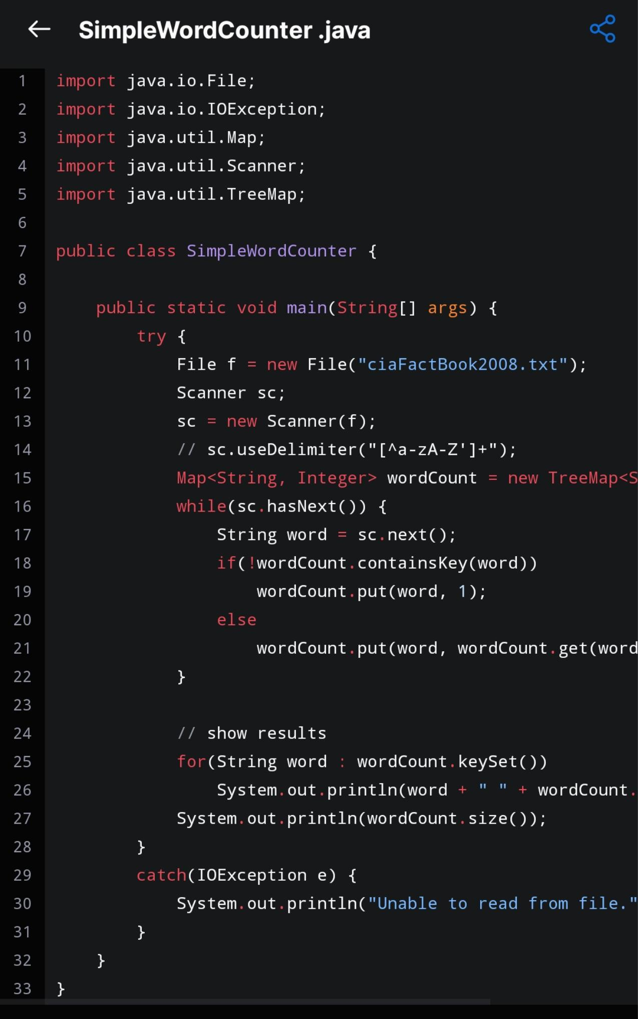Snapshot:

3)Write a java program to count number of bits to be flipped to convert A to B

