**DAILY ONLINE ACTIVITIES SUMMARY**

|  |  |  |  |  |  |  |  |  |  |
| --- | --- | --- | --- | --- | --- | --- | --- | --- | --- |
| **Date:** | **26/06/2020** | | | | | **Name:** | | **Shraddha Acharya** | |
| **Sem & Sec** | **4th sem B sec** | | | | | **USN:** | | **4al18cs079** | |
| **Online Test Summary** | | | | | | | | | |
| **Subject** | | **-** | | | | | | | |
| **Max. Marks** | | **30** | | **Score** | | | | **-** | |
| **Certification Course Summary** | | | | | | | | | |
| **Course** | **1.Predicitive Modeling and Analysis** | | | | | | | | |
| **Certificate Provider** | | | **1.Great Learning Academy** | | | | **Duration** | | **1)5 hours** | |
| **Coding Challenges** | | | | | | | | | |
| **Problem Statement: 1.Write a python program to print negative numbers of given range.** | | | | | | | | | |
| **Status: Done** | | | | | | | | | |
| **Uploaded the report in Github** | | | | | **Yes** | | | | |
| **If yes Repository name** | | | | | **1)** <https://github.com/shraddhaacharya/Lockdown-JavaCodding/blob/master/print_negative.PY.txt> | | | | |
| **Uploaded the report in slack** | | | | | **Yes** | | | | |

Online Test Details: No online test was conducted.

Certification Course Details: Today in the course of Predictive Modeling and Analysis learnt about Multiple Linear Regression.

**Snapshot**

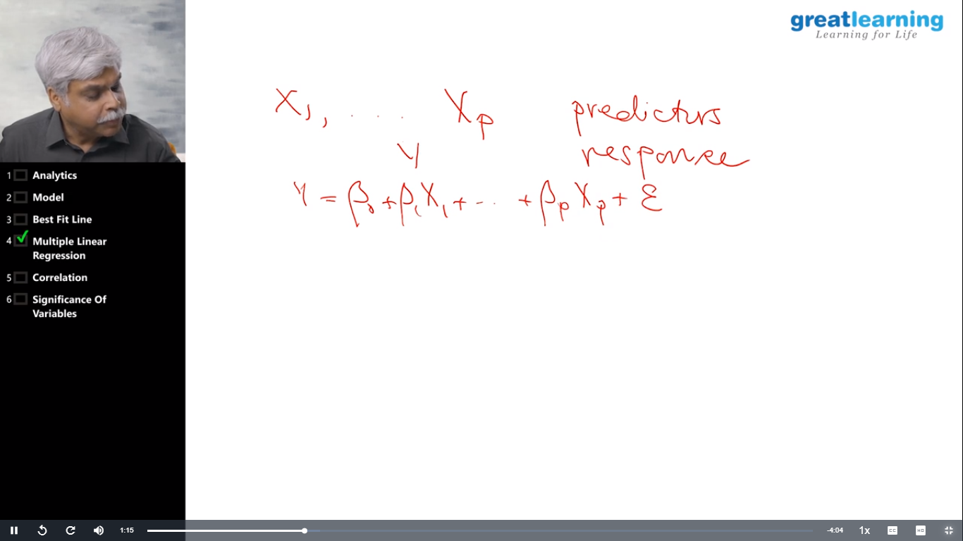

Coding Challenges Details: Problem Statements

**1.Write a python program to print negative numbers of given range.**

**Snapshot:**

