**DAILY ONLINE ACTIVITIES SUMMARY**

|  |  |  |  |  |  |  |  |  |  |
| --- | --- | --- | --- | --- | --- | --- | --- | --- | --- |
| **Date:** | **27/05/2020** | | | | | **Name:** | | **Shraddha Acharya** | |
| **Sem & Sec** | **4th sem B sec** | | | | | **USN:** | | **4al18cs079** | |
| **Online Test Summary** | | | | | | | | | |
| **Subject** | | **Object Oriented concepts** | | | | | | | |
| **Max. Marks** | | **30** | | **Score** | | | | **27** | |
| **Certification Course Summary** | | | | | | | | | |
| **Course** | **1.Java Programming**  **2.Introduction to digital marketing** | | | | | | | | |
| **Certificate Provider** | | | **1.Great Learning Academy**  **2.Introduction to digital Marketing** | | | | **Duration** | | **1)3.5 hrs**  **2)3.5 hrs** |
| **Coding Challenges** | | | | | | | | | |
| **Problem Statement:**  **1.**C program to print all the permutations of a given string using pointers.  **2.Given an array A of size n where the array elements contains values from 1 to n with duplicates the task is to find total number of subarray which start and end with the same element.** | | | | | | | | | |
| **Status: Done** | | | | | | | | | |
| **Uploaded the report in Github** | | | | | **Yes** | | | | |
| **If yes Repository name** | | | | | **1.**<https://github.com/shraddhaacharya/lockdown-C-coding/blob/master/Permutation_String.c>  **2.** <https://github.com/shraddhaacharya/Lockdown-JavaCodding/blob/master/subarray_end_sameElement.java> | | | | |
| **Uploaded the report in slack** | | | | | **Yes** | | | | |

Online Test Details: Online test of Object Oriented concepts was conducted .It was based on fifth module .There where 30 questions of 1mark each.

Snapshot:

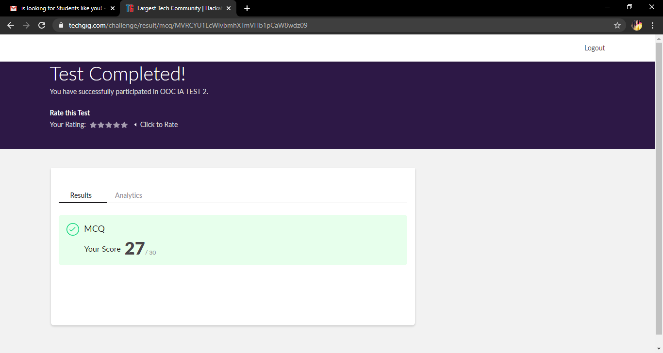

Certification Course Details: Today I have completed the certificate course of Programming in Java which was about 3.5 hrs. And also completed the course of Introduction to digital marketing and the snapshot of both the courses is given below.

**Snapshot**

**1.**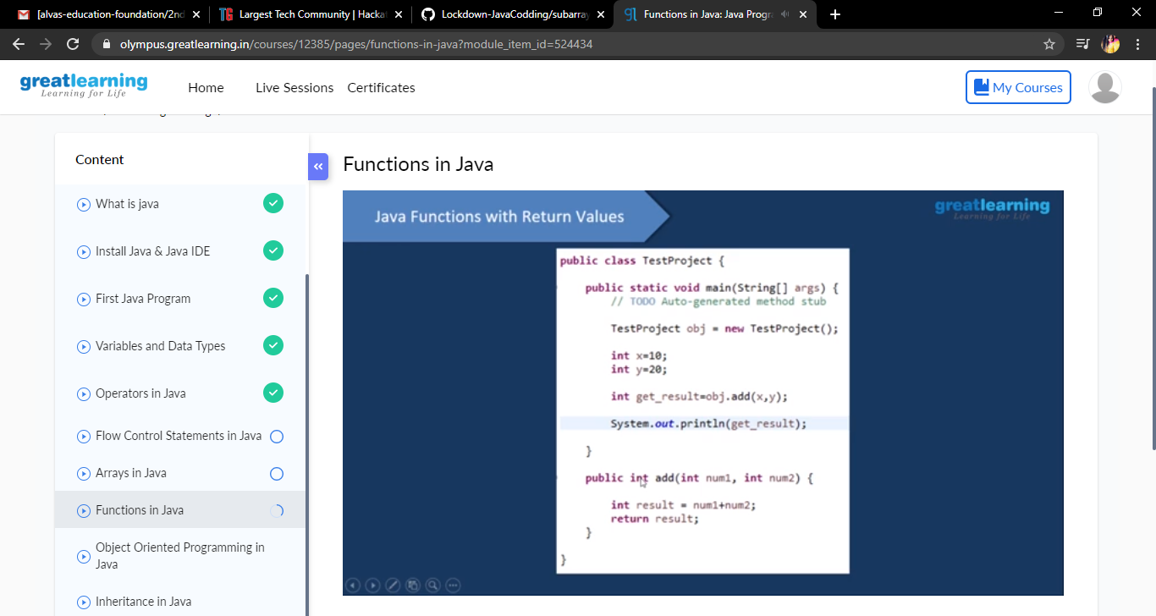

**2.**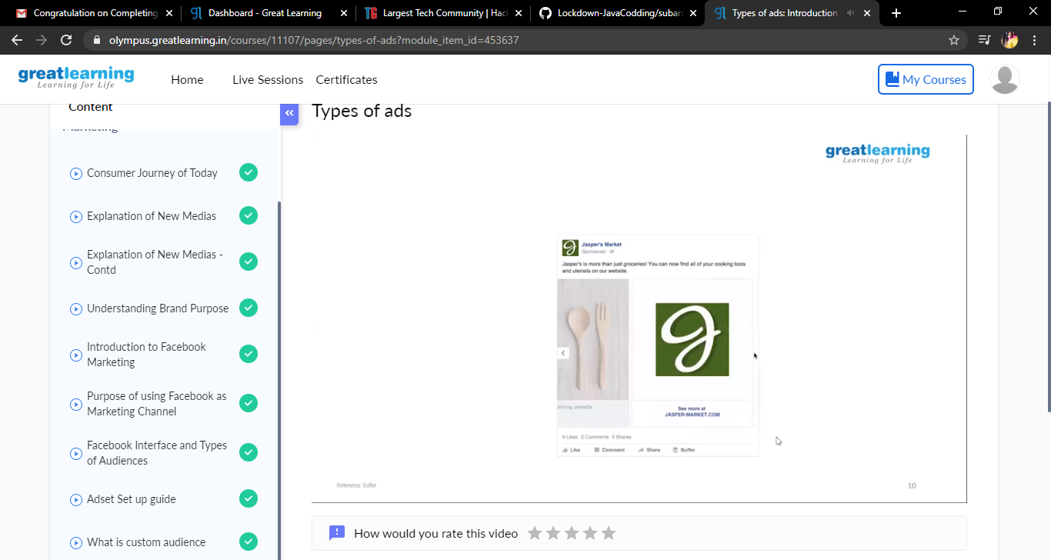

Coding Challenges Details: Problem Statements

1.C program to print all the permutations of a given string using pointers.

**Snapshot**

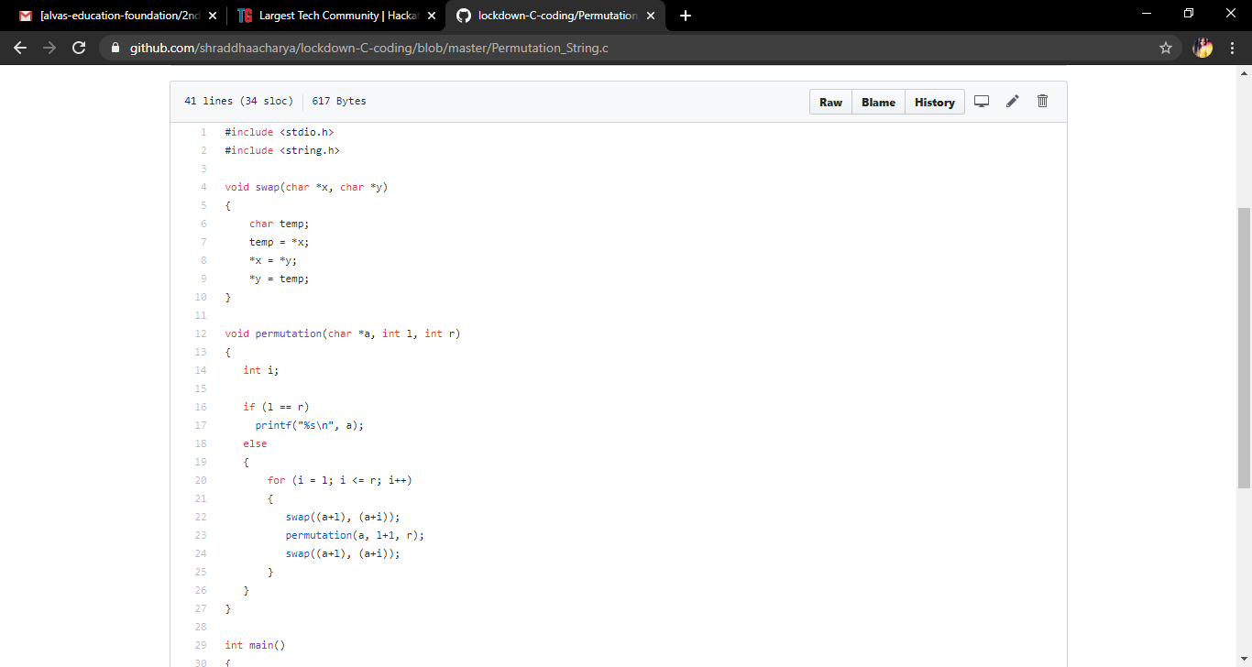

**2. Given an array A of size n where the array elements contains values from 1 to n with duplicates the task is to find total number of subarray which start and end with the same element.**

Examples:

Input: A[ ] = {1, 2, 1, 5, 2}  
Output: 7  
Explanation:  
Total 7 sub-array of the given array are {1}, {2}, {1}, {5}, {2}, {1, 2, 1} and {2, 1, 5, 2} are start and end with same element.

