**DAILY ONLINE ACTIVITIES SUMMARY**

|  |  |  |  |  |  |  |  |  |
| --- | --- | --- | --- | --- | --- | --- | --- | --- |
| **Date:** | **28/05/2020** | | | | | **Name:** | **Shraddha Acharya** | |
| **Sem & Sec** | **4th sem B sec** | | | | | **USN:** | **4al18cs079** | |
| **Online Test Summary** | | | | | | | | |
| **Subject** | | **Microcontroller and Embedded System** | | | | | | |
| **Max. Marks** | | **20** | | **Score** | | | **20** | |
| **Certification Course Summary** | | | | | | | | |
| **Course** | **1.Introduction to Cyber Security** | | | | | | | |
| **Certificate Provider** | | | **1.Great Learning Academy** | | **Duration** | | | **1)7 hours** |
| **Coding Challenges** | | | | | | | | |
| **Problem Statement: 1.Write a C program to find the Digital root of a number**. | | | | | | | | |
| **Status: Done** | | | | | | | | |
| **Uploaded the report in Github** | | | | | **Yes** | | | |
| **If yes Repository name** | | | | | **1.**<https://github.com/shraddhaacharya/lockdown-C-coding/blob/master/digitalroot.c> | | | |
| **Uploaded the report in slack** | | | | | **Yes** | | | |

Online Test Details: Online test of Microcontroller and Embedded System was conducted .It was based on second module .There where 20 questions of 1mark each.

Snapshot:

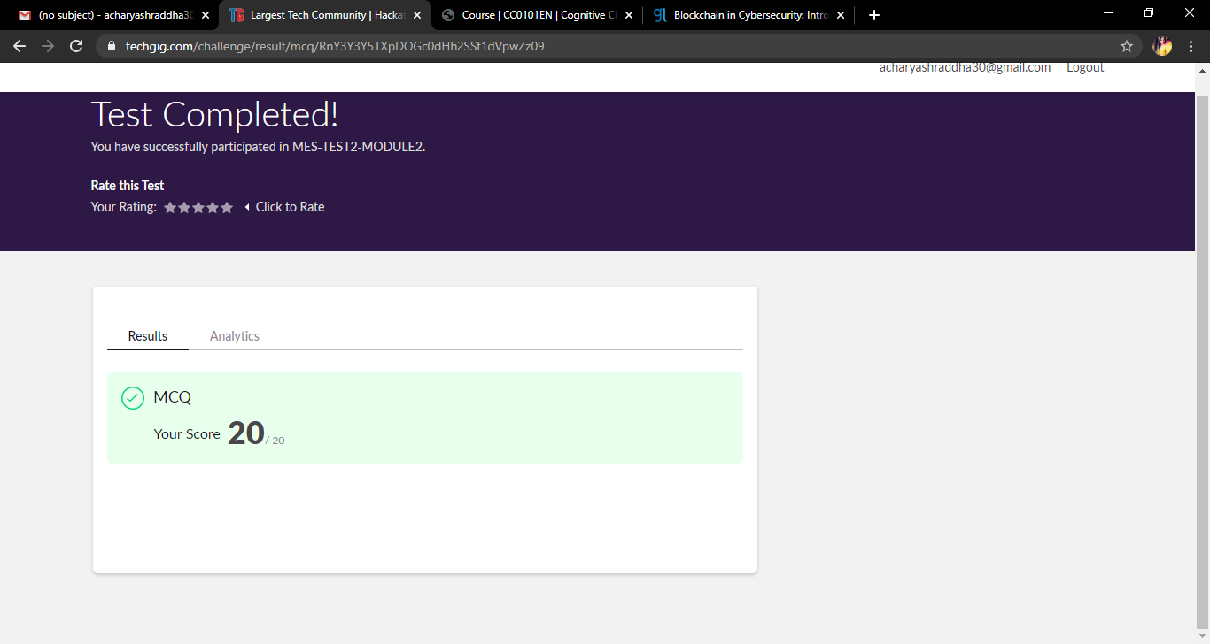

Certification Course Details: Today I have started the certificate course of Introduction to Cyber Security and learnt about how a blockchain technology is used in Cybersecurity.

**Snapshot**

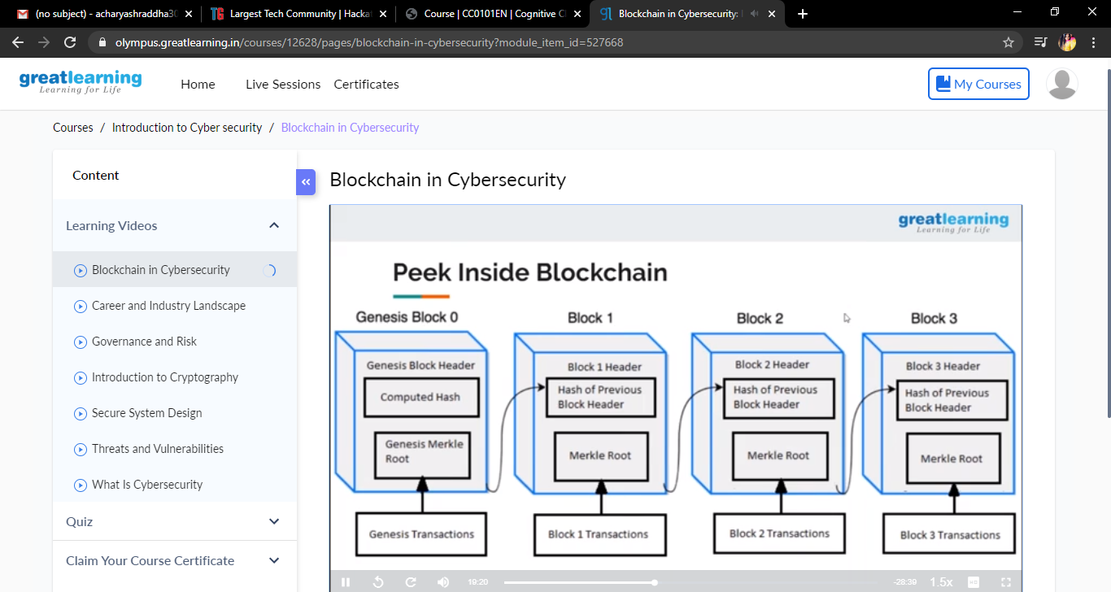

Coding Challenges Details: Problem Statements

1.Write a C program to calculate the digital root of a number.

Description:  
A digital root is the recursive sum of all the digits in a number. Given n, take the sum of the digits of n. If that value has more than one digit, continue reducing in this way until a single-digit number is produced. This is only applicable to the natural numbers.  
digital root(0)= 0

Digital root (16)  
=> 1 + 6  
=> 7

Digital root (132189)  
=> 1 + 3 + 2 + 1 + 8 + 9  
=> 24 ...  
=> 2 + 4  
=> 6

Snapshot:

