**DAILY ONLINE ACTIVITIES SUMMARY**

|  |  |  |  |  |  |  |  |  |
| --- | --- | --- | --- | --- | --- | --- | --- | --- |
| **Date:** | **29/05/2020** | | | | | **Name:** | **Shraddha Acharya** | |
| **Sem & Sec** | **4th sem B sec** | | | | | **USN:** | **4al18cs079** | |
| **Online Test Summary** | | | | | | | | |
| **Subject** | | **Operating System** | | | | | | |
| **Max. Marks** | | **30** | | **Score** | | | **28** | |
| **Certification Course Summary** | | | | | | | | |
| **Course** | **1.Introduction to Cyber Security** | | | | | | | |
| **Certificate Provider** | | | **1.Great Learning Academy** | | **Duration** | | | **1)7 hours** |
| **Coding Challenges** | | | | | | | | |
| **Problem Statement: 1.Write a java program to find the size of the largest ‘+’ formed by all the ones in the binary matrix.** | | | | | | | | |
| **Status: Done** | | | | | | | | |
| **Uploaded the report in Github** | | | | | **Yes** | | | |
| **If yes Repository name** | | | | | **1.**<https://github.com/shraddhaacharya/Lockdown-JavaCodding/blob/master/matrix.java> | | | |
| **Uploaded the report in slack** | | | | | **Yes** | | | |

Online Test Details: Online test of Operating System was conducted .It was based on second module .There where 30 questions of 1mark each.

Snapshot:

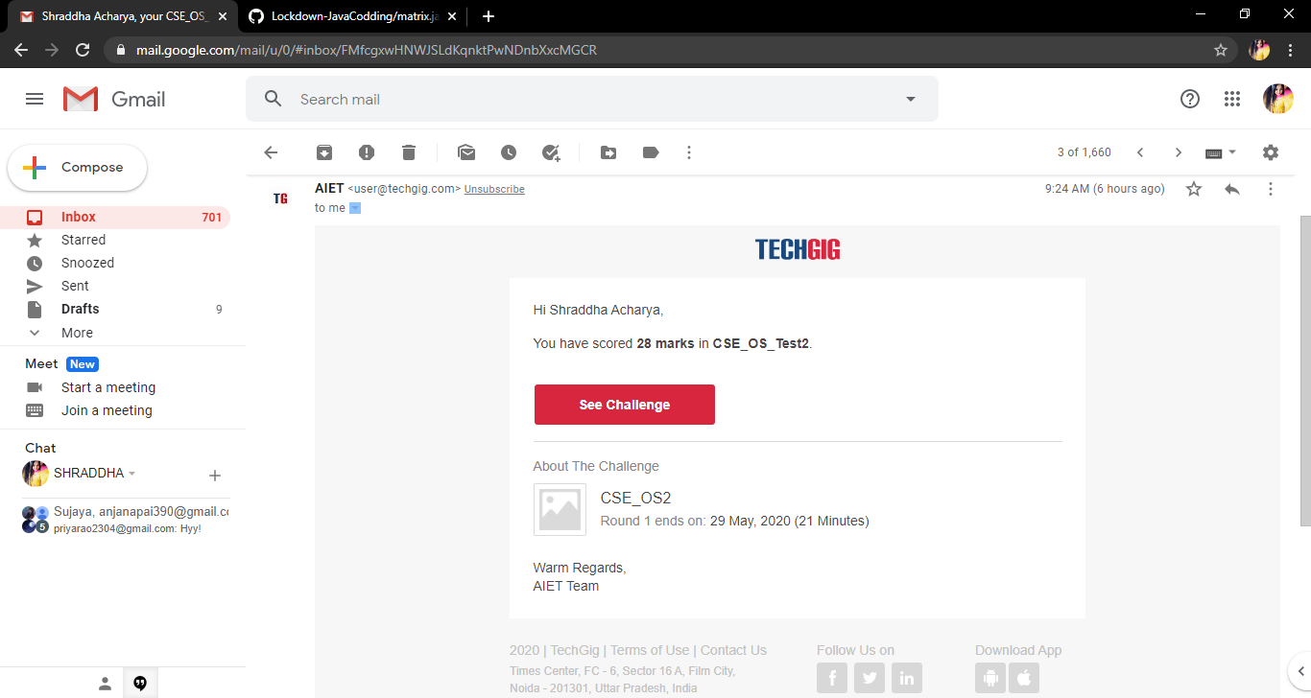

Certification Course Details: Today I have started the certificate course of Introduction to Cyber Security and learnt about different types of Cryptography.

**Snapshot**

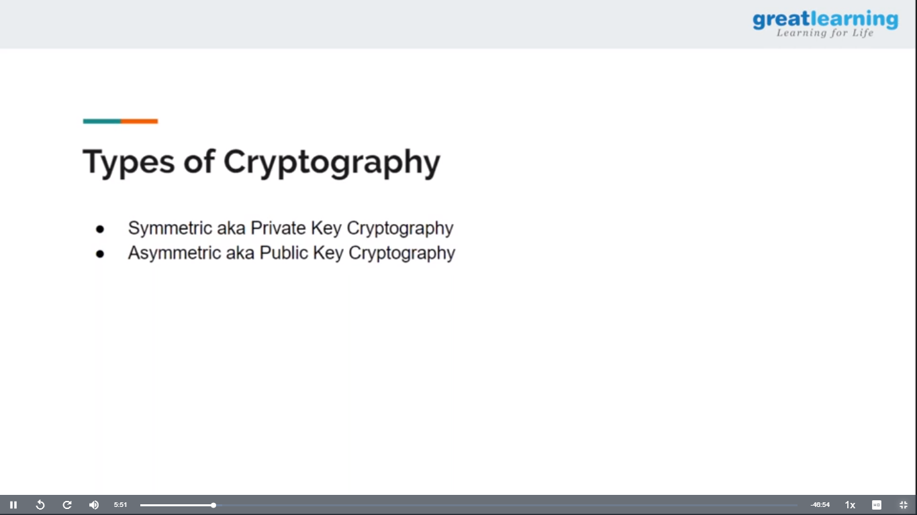

Coding Challenges Details: Problem Statements

1.**Write a java program to find the size of the largest ‘+’ formed by all the ones in the binary matrix.**

**Snapshot**

