**DAILY ONLINE ACTIVITIES SUMMARY**

|  |  |  |  |  |  |  |  |  |  |
| --- | --- | --- | --- | --- | --- | --- | --- | --- | --- |
| **Date:** | **02/06/2020** | | | | | **Name:** | | **Shraddha Acharya** | |
| **Sem & Sec** | **4th sem B sec** | | | | | **USN:** | | **4al18cs079** | |
| **Online Test Summary** | | | | | | | | | |
| **Subject** | | **NA** | | | | | | | |
| **27** | | **30** | | **Score** | | | | **NA** | |
| **Certification Course Summary** | | | | | | | | | |
| **Course** | **1.Introduction to Ethical Hacking** | | | | | | | | |
| **Certificate Provider** | | | **1.Great Learning Academy** | | | | **Duration** | | **1)6 hours** |
| **Coding Challenges** | | | | | | | | | |
| **Problem Statement: 1.Write a C program to find the leaders in the array.**  **2.Write a C program to find the inversion count of array.** | | | | | | | | | |
| **Status: Done** | | | | | | | | | |
| **Uploaded the report in Github** | | | | | **Yes** | | | | |
| **If yes Repository name** | | | | | 1. <https://github.com/shraddhaacharya/lockdown-C-coding/blob/master/leader_in_array.c> 2. <https://github.com/shraddhaacharya/lockdown-C-coding/blob/master/Inversion.c> | | | | |
| **Uploaded the report in slack** | | | | | **Yes** | | | | |

Certification Course Details: Today I have started the new course of Introduction to Ethical hacking and have learnt about Career and Growth Ladder in Ethical Hacking

**Snapshot**

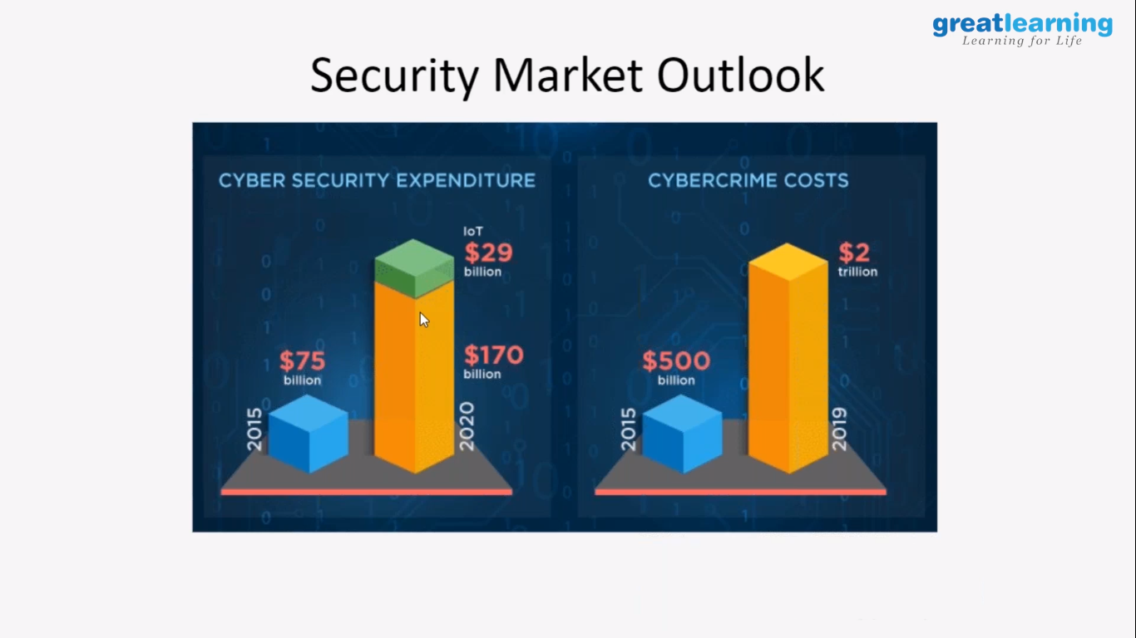

Coding Challenges Details: Problem Statements

**1.Write a C program to find the leaders in the array.**

**Snapshot:**

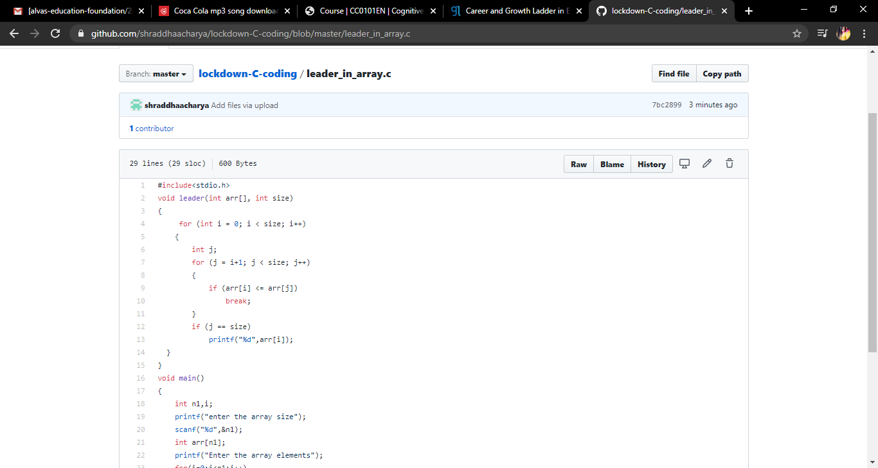

**2.Write a C program to find the inversion count of array.**

Snapshot:

