**DAILY ONLINE ACTIVITIES SUMMARY**

|  |  |  |  |  |  |  |  |  |
| --- | --- | --- | --- | --- | --- | --- | --- | --- |
| **Date:** | **30/05/2020** | | | | | **Name:** | **Shraddha Acharya** | |
| **Sem & Sec** | **4th Sem B sec** | | | | | **USN:** | **4al18cs079** | |
| **Online Test Summary** | | | | | | | | |
| **Subject** | | **1.Data Communication**  **2.Complex analysis ,Probability and Statistical Method** | | | | | | |
| **Max. Marks** | | **1)30**  **2)30** | | **Score** | | | **1)25**  **2)30** | |
| **Certification Course Summary** | | | | | | | | |
| **Course** | **1.Introduction to Cyber Security** | | | | | | | |
| **Certificate Provider** | | | **1.Great Learning Academy** | | **Duration** | | | **1)7 hours** |
| **Coding Challenges** | | | | | | | | |
| **Problem Statement: Write a C program to count the Uppercase Lowercase Numbers and Special Characters in a given String.** | | | | | | | | |
| **Status: Done** | | | | | | | | |
| **Uploaded the report in Github** | | | | | **Yes** | | | |
| **If yes Repository name** | | | | | **1**<https://github.com/shraddhaacharya/lockdown-C-coding/blob/master/Uppercase_Lowercase.c> | | | |
| **Uploaded the report in slack** | | | | | **Yes** | | | |

Online Test Details: Online test of Data Communication was conducted .It was based on 3rd and 2nd module .There where 30 questions of 1mark each.

Online test of Complex Analysis Probability and Statistical method was also conducted at 3:00 PM. There were 10 questions 1 mark each and 10 questions 2 mark each.

Snapshot:

1.Data Communication

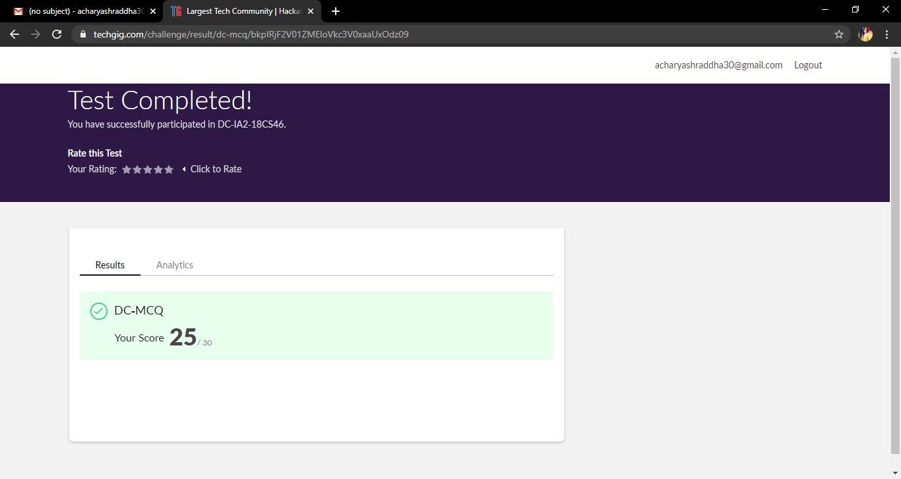

2.Complex Analysis Probability and statistical Method.

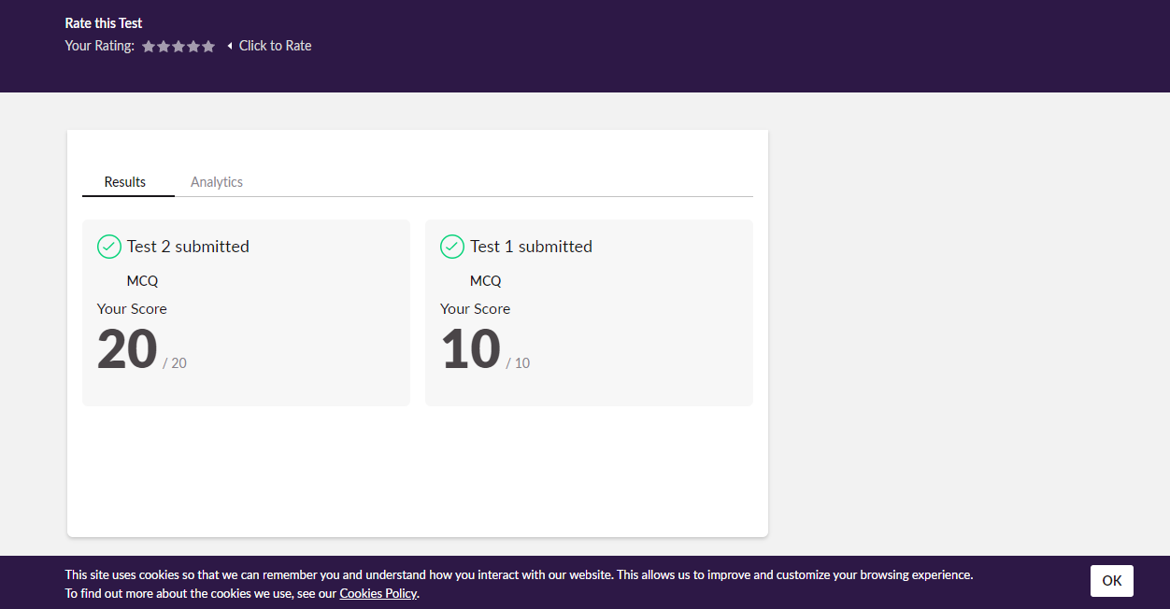

Certification Course Details: Today in Introduction to Cyber Security and learnt about Secure System Designs.

**Snapshot**

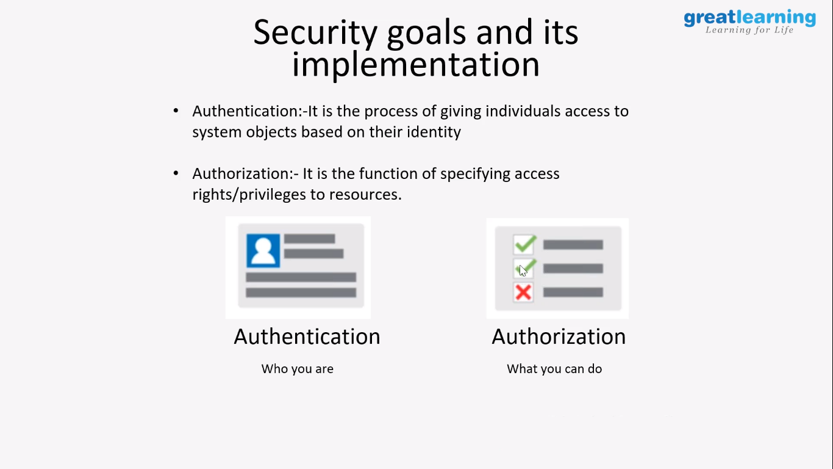

Coding Challenges Details: Problem Statements

1. **Write a C program to count the Uppercase Lowercase Numbers and Special Characters in a given String.**

**Snapshot**

