**DAILY ONLINE ACTIVITIES SUMMARY**

|  |  |  |  |  |  |  |  |  |  |
| --- | --- | --- | --- | --- | --- | --- | --- | --- | --- |
| **Date:** | **04/07/2020** | | | | | **Name:** | | **Shraddha Acharya** | |
| **Sem & Sec** | **4th sem B sec** | | | | | **USN:** | | **4al18cs079** | |
| **Online Test Summary** | | | | | | | | | |
| **Subject** | | **-** | | | | | | | |
| **Max. Marks** | | **30** | | **Score** | | | | **-** | |
| **Certification Course Summary** | | | | | | | | | |
| **Course** | **1.Predicitive Modeling and Analysis** | | | | | | | | |
| **Certificate Provider** | | | **1.Great Learning Academy** | | | | **Duration** | | **1)5 hours** | |
| **Coding Challenges** | | | | | | | | | |
| **Problem Statement: 1.** Given an array of integer arr[] and an integer k, the task is to find the median of each window of size k starting from the left and moving towards the right by one position each time. | | | | | | | | | |
| **Status: Done** | | | | | | | | | |
| **Uploaded the report in Github** | | | | | **Yes** | | | | |
| **If yes Repository name** | | | | | **1** <https://github.com/shraddhaacharya/Lockdown-JavaCodding/blob/master/GFG.java> | | | | |
| **Uploaded the report in slack** | | | | | **Yes** | | | | |

Online Test Details: No online test was conducted.

Certification Course Details: Today in the course of Predictive Modeling and Analysis learnt about Discriminant Analysis.

**Snapshot**

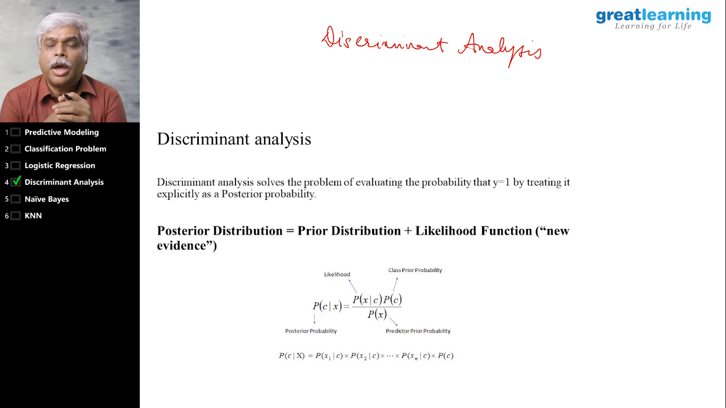

Coding Challenges Details: Problem Statements

1. Given an array of integer arr[] and an integer k, the task is to find the median of each window of size k starting from the left and moving towards the right by one position each time.

**Snapshot:**

