**DAILY ONLINE ACTIVITIES SUMMARY**

|  |  |  |  |  |  |  |  |  |  |
| --- | --- | --- | --- | --- | --- | --- | --- | --- | --- |
| **Date:** | **06/06/2020** | | | | | **Name:** | | **Shraddha Acharya** | |
| **Sem & Sec** | **4th sem B sec** | | | | | **USN:** | | **4al18cs079** | |
| **Online Test Summary** | | | | | | | | | |
| **Subject** | | **Data Communication** | | | | | | | |
| **Max. Marks** | | **30** | | **Score** | | | | **27** | |
| **Certification Course Summary** | | | | | | | | | |
| **Course** | **1.Introduction to Ethical Hacking** | | | | | | | | |
| **Certificate Provider** | | | **1.Great Learning Academy** | | | | **Duration** | | **1)6 hours** | |
| **Coding Challenges** | | | | | | | | | |
| **Problem Statement:**  **1.Write a C program to rotate an array by N position.**  **2.Write a java program to sort an array containing 0s and 1s.** | | | | | | | | | |
| **Status: Done** | | | | | | | | | |
| **Uploaded the report in Github** | | | | | **Yes** | | | | |
| **If yes Repository name** | | | | | 1. <https://github.com/shraddhaacharya/lockdown-C-coding/blob/master/rotatearray.c> 2. <https://github.com/shraddhaacharya/Lockdown-JavaCodding> | | | | |
| **Uploaded the report in slack** | | | | | **Yes** | | | | |

Online Test Details: Online test of Data Communication was conducted .It was based on 5th module .There where 30 questions of 1mark each.

Snapshot:

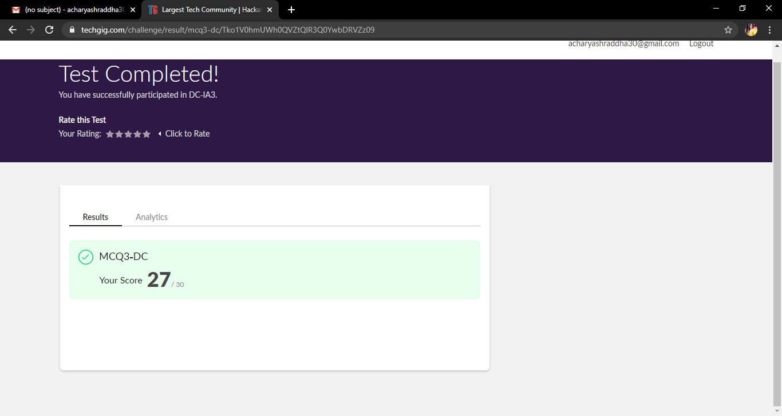

Certification Course Details:

Today in the course of Introduction to Ethical Hacking I have learnt about Ethical Hacking on Mobile Platform and What is Ethical Hacking and have completed this course today.

**Snapshot**

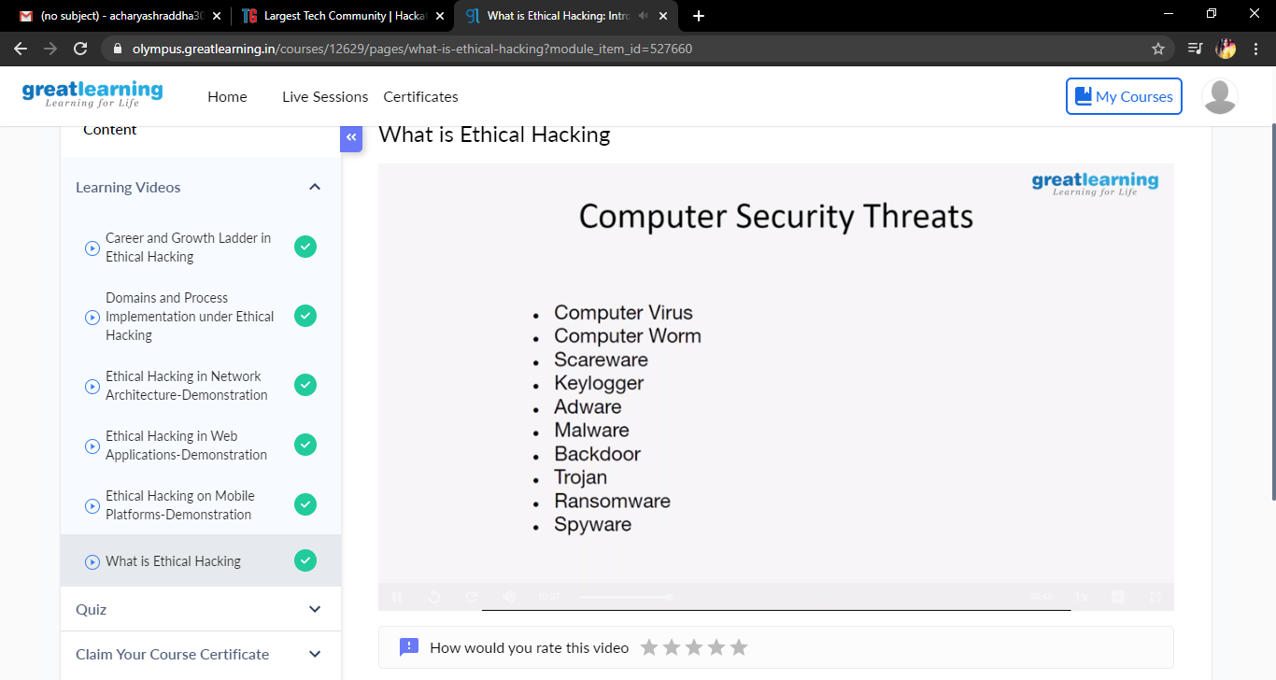

Coding Challenges Details: Problem Statements

1. Write a program in C to rotate an array by N positions.

Snapshot:

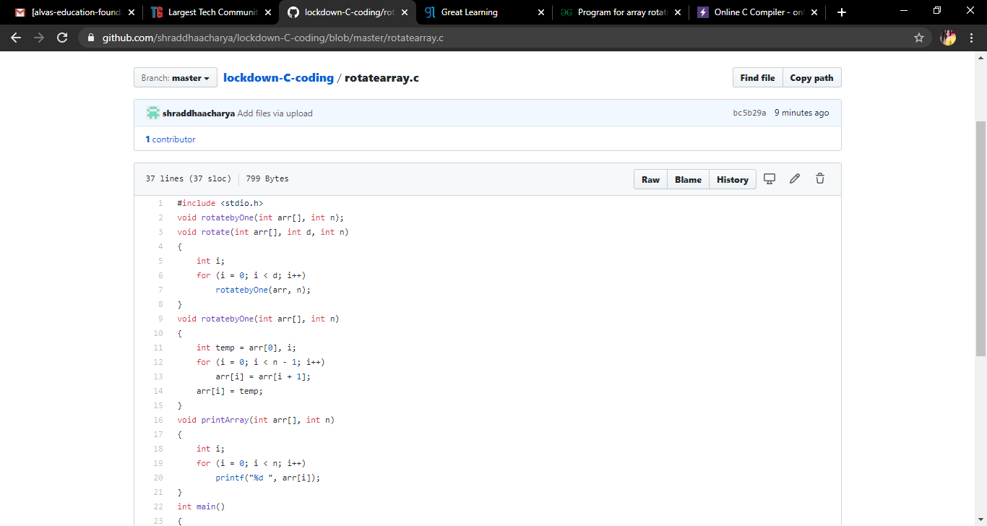

2.Write a Java program to Sort an array containing 0s and 1s.

Snapshot:

