Week 1 Task Report
Data Acquisition, Cleaning, and Exploratory Analysis
Dataset used: Titanic Passenger Dataset (Kaggle / open GitHub mirror)

1. Objective
For this week 1 task I had to practice the full data preparation workflow that is used in almost every data science project: finding a real dataset, cleaning it up, and then exploring it with some basic statistics and charts. I picked the Titanic passenger dataset because it is a well known beginner dataset, it is small enough that I can actually go through every column by hand, and it still has real world problems like missing values that I needed to deal with.
Below I have documented every step I took, the code I used in Python (pandas, matplotlib), the charts I made, and what I noticed from looking at the data.

2. Data Acquisition
I got the dataset from a public GitHub repository that hosts the classic Titanic competition data (originally from Kaggle). It is a CSV file with 891 rows, one row per passenger, and 12 columns describing things like class, sex, age, fare paid, and whether they survived.
Source: https://raw.githubusercontent.com/datasciencedojo/datasets/master/titanic.csv

Loading the data
I loaded the CSV straight into pandas:
import pandas as pd

df = pd.read_csv('titanic_raw.csv')
print(df.shape) # (891, 12)
print(df.head())
Once it loaded I had a quick look at the columns:
Column | What it means
PassengerId | just a row id number
Survived | 0 = died, 1 = survived (this is the target)
Pclass | ticket class, 1 = first class, 2 = second, 3 = third
Name | full name of the passenger
Sex | male / female
Age | age in years (has missing values)
SibSp | number of siblings/spouses aboard
Parch | number of parents/children aboard
Ticket | ticket number
Fare | amount paid for the ticket
Cabin | cabin number (a lot of missing values)
Embarked | port they boarded from: C, Q or S

3. Data Cleaning
Before I could explore the data properly I needed to check for missing values, duplicate rows, and wrong data types. Here is exactly what I found and what I did about it, plus my reasoning for each choice.

3.1 Checking for missing values
print(df.isnull().sum())
Result:
- Age: 177 missing values out of 891 (about 20%)
- Cabin: 687 missing values out of 891 (about 77%)
- Embarked: 2 missing values
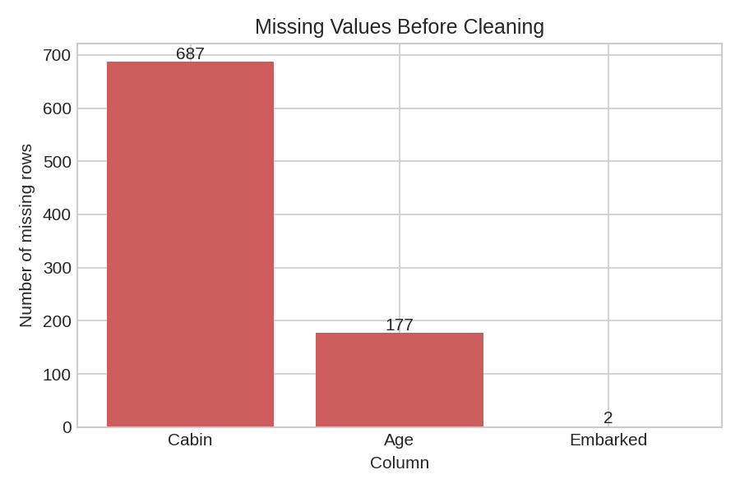
Chart 1 – Number of missing values per column (before cleaning)

3.2 Checking for duplicate rows
print(df.duplicated().sum()) # -> 0
There were no duplicate rows in this dataset, so I did not have to remove anything there. I still ran df.drop_duplicates() at the end just as a safety step in case something slipped through.

3.3 Handling the missing values
Cabin column: I decided to drop this column completely instead of trying to fill it in. With 77% of the values missing, filling it with a placeholder like 'Unknown' would not really give me useful information for later analysis, and it would just add noise. Dropping it felt like the more honest option.
Age column: I filled the missing ages with the median age of the whole dataset instead of the mean, because age has some outliers (very old and very young passengers) and the median is less affected by that. The median age was about 28 years.
Embarked column: only 2 rows were missing here, so I just filled them with the most common value (the mode), which was 'S' (Southampton). Since it's only 2 rows out of 891 this should not change the overall picture at all.
# drop Cabin - too many missing values to be useful
df_clean = df.drop(columns=['Cabin'])

# fill missing Age with the median (robust to outliers)
median_age = df_clean['Age'].median()
df_clean['Age'] = df_clean['Age'].fillna(median_age)

# fill missing Embarked with the mode (only 2 rows affected)
mode_embarked = df_clean['Embarked'].mode()[0]
df_clean['Embarked'] = df_clean['Embarked'].fillna(mode_embarked)

df_clean = df_clean.drop_duplicates()

3.4 Fixing data types
A few columns were being read as plain numbers even though they are really categories, so I converted them to the 'category' type in pandas. This makes it clearer that Pclass, Sex, Embarked and Survived are labels and not something I should be doing math on directly.
df_clean['Survived'] = df_clean['Survived'].astype('category')
df_clean['Pclass'] = df_clean['Pclass'].astype('category')
df_clean['Sex'] = df_clean['Sex'].astype('category')
df_clean['Embarked'] = df_clean['Embarked'].astype('category')

3.5 A small feature I added
I also created one new column called FamilySize, which is just SibSp + Parch + 1 (the +1 is for the passenger themself). I did this because I was curious whether traveling with family made any difference to survival, and it's easier to look at one combined number than two separate ones.
df_clean['FamilySize'] = df_clean['SibSp'] + df_clean['Parch'] + 1
After all this cleaning, the dataset had 891 rows and 12 columns (11 original + FamilySize, minus Cabin), with zero missing values left anywhere. I saved this as titanic_clean.csv so I could use it for the exploration part.

4. Exploratory Data Analysis
With the clean data ready, I looked at summary statistics first and then made some charts to actually see the patterns.

4.1 Summary statistics
print(df_clean.describe())
print(df_clean['Survived'].value_counts(normalize=True))
- Overall survival rate in this dataset: 38.3% survived, 61.7% died.
- Average age (after filling missing values): about 29 years.
- Average fare: around $32, but with a very long tail (max fare was over $512!).
- Most passengers (about 55%) were traveling in 3rd class.

4.2 Age distribution
I made a histogram to see how the ages were spread out.
plt.hist(df_clean['Age'], bins=25)
plt.title('Distribution of Passenger Age')
plt.xlabel('Age'); plt.ylabel('Number of passengers')
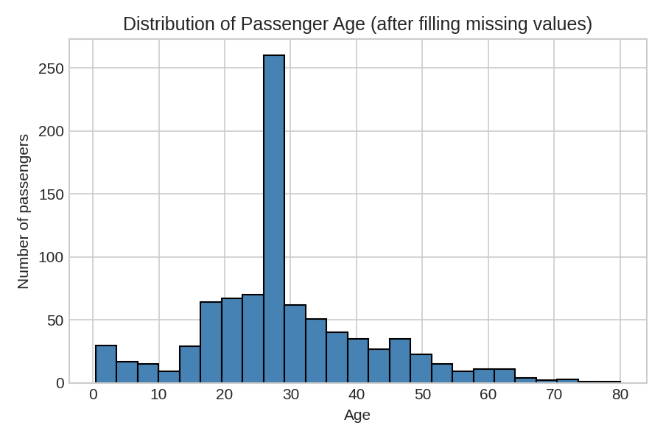
Chart 2 – Distribution of passenger age. There's a big spike around 28 because that's the value I used to fill the missing ages.

4.3 Survival rate by passenger class
This is the chart that surprised me the least but confirmed what I expected: money mattered a lot on the Titanic.
surv_by_class = df_clean.groupby('Pclass')['Survived'].mean() * 100
plt.bar(surv_by_class.index.astype(str), surv_by_class.values)
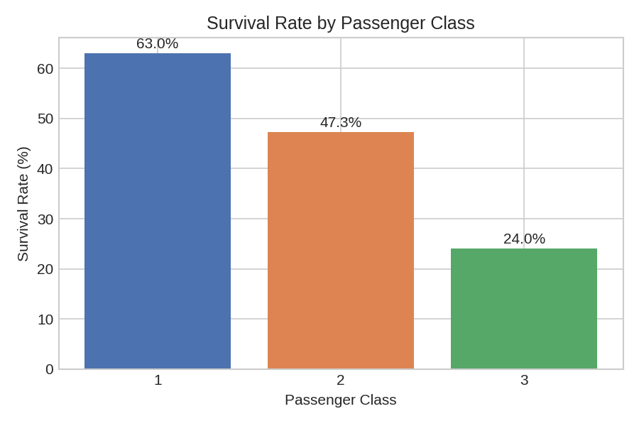
Chart 3 – Survival rate by passenger class. 1st class passengers survived at more than double the rate of 3rd class passengers.

4.4 Fare paid: survivors vs non-survivors
I also wanted to check if there was a fare difference between the people who survived and the people who didn't, so I made a boxplot.
data = [df_clean[df_clean.Survived==0]['Fare'],
df_clean[df_clean.Survived==1]['Fare']]
plt.boxplot(data, labels=['Died','Survived'])
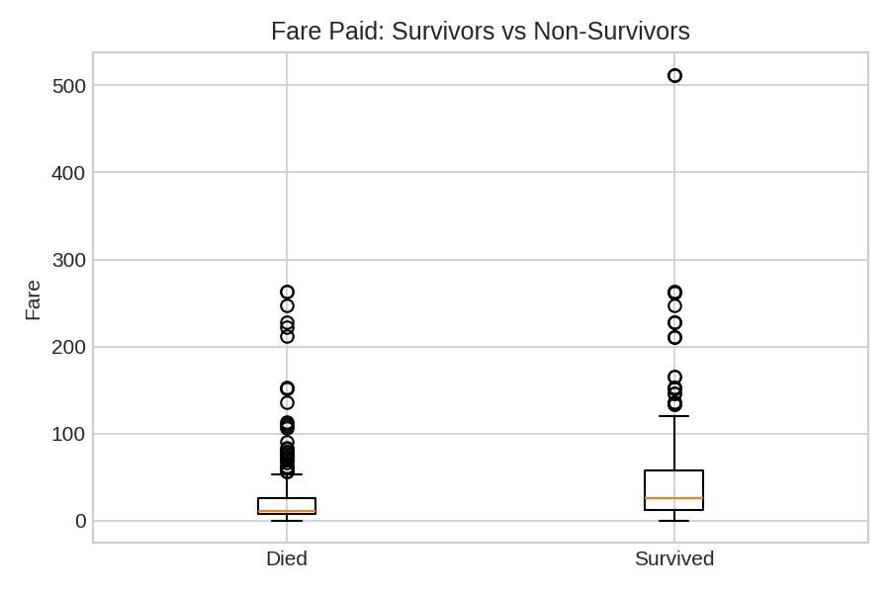
Chart 4 – Boxplot of fare paid, split by survival. Survivors generally paid a higher fare, and there are some big outliers (very expensive tickets).
Average fare for people who died: about $22. Average fare for people who survived: about $49. This lines up with the class chart above, since 1st class tickets cost a lot more.

4.5 Correlation between the numeric columns
Last chart I made was a correlation heatmap, just to see which numeric columns move together.
num_df = df_clean[['Survived','Pclass','Age','SibSp',
'Parch','Fare','FamilySize']]
corr = num_df.corr()
plt.imshow(corr, cmap='coolwarm', vmin=-1, vmax=1)
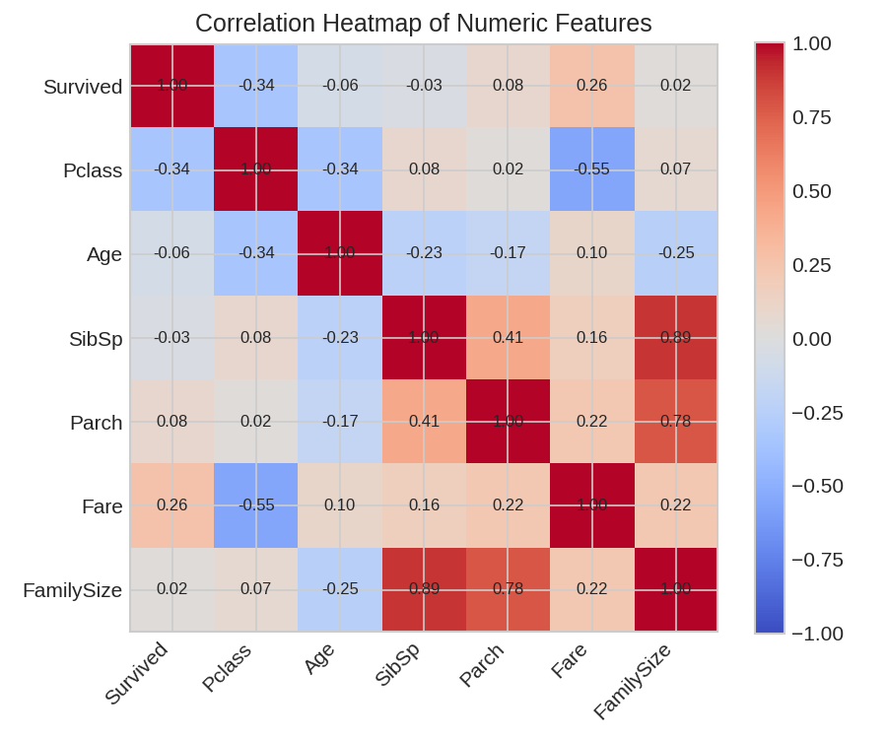
Chart 5 – Correlation heatmap. Fare and Pclass have the strongest (negative) relationship with each other, and Fare has a modest positive correlation with survival.

5. Summary of Insights
- Sex was the single biggest factor in who survived: about 74% of female passengers survived compared to only about 19% of male passengers. This matches the 'women and children first' policy used during the evacuation.
- Passenger class mattered a lot: 63% of 1st class passengers survived, 47% of 2nd class, and only 24% of 3rd class. Wealthier passengers had cabins closer to the deck and probably got to lifeboats faster.
- Fare and Pclass are strongly related to each other (which makes sense, better class = more expensive ticket), and both are related to survival, though Sex is a stronger factor than either of them.
- Family size had an interesting non-straight-line pattern: passengers traveling completely alone had a lower survival rate (about 30%), but people with very large families (7+ members) also had a low survival rate. The 'sweet spot' seemed to be small families of 2-4 people.
- The Cabin column was too incomplete to use (77% missing), which is a good reminder that not every column in a raw dataset is actually usable - sometimes dropping a column is the right call instead of trying to force it to work.

6. Possible Next Steps
If I were to continue with this dataset next week, some things I would want to look into are:
- Building a simple prediction model (like logistic regression) to predict survival, since the data is already clean.
- Looking at passenger titles inside the Name column (Mr, Mrs, Miss, Master) as those might be a better signal than raw age.
- Digging a bit more into why very large families had a lower survival rate.

7. Time Spent
This task took me a bit under a week working on and off - roughly split between finding and understanding the dataset, writing and testing the cleaning code, making the charts, and finally writing up this document, which is in line with the estimated 30-35 hour range for the task.

