Requirement Collision Detection Engine Using Static Analysis and Requirement Knowledge Graphs
Shraddha Ajit¹

¹ Computer Science and Engineering (Data Science),
Vellore Institute of Technology, Chennai
shraddha.ajit2024@vitstudent.ac.in

Abstract: This paper presents the Requirement Collision Detection Engine, a Python-based tool for identifying potential conflicts between software requirements through static analysis of source code. The tool extracts requirements from Markdown files, establishes traceability links using docstrings, and represents the relationships between requirements and code elements in a graph. It applies three rule-based methods to identify shared implementation conditions, overlapping conditions and boundaries, and potential conflicts involving exceptions or overrides. The tool also supports change-impact analysis by tracing relationships between affected requirements and code elements, with results provided in text or JavaScript Object Notation format. The system was evaluated using the Corporate Expense Workflow System and two synthetic projects covering logistics and inventory management. All 125 tests passed, including 24 tests for the Corporate Expense Workflow System. The results indicate that the tool identified potential collisions in the tested projects and provided source-code evidence for further examination. The reported collisions require manual examination, as a detected overlap does not necessarily indicate a confirmed requirements conflict. The current implementation is limited to Python projects that follow the supported Markdown requirement format and docstring-based traceability conventions.
Keywords: Requirement Traceability, Static Analysis, Requirement Collision Detection, Knowledge Graph, Change-Impact Analysis, Python.

Introduction

Problem Background
Requirements may be changed at different stages of development, even when the code implementing them is already in place. Before making such changes, developers need to check which functions use the affected rules. This is not always easy when the connection between a requirement and the code is not documented, particularly when the same rule is used in different parts of the program. This can take considerable time when the connection between a requirement and its implementation is not clearly documented.
A problem also occurs when two requirements affect the same functionality. The rules may use conditions that overlap, or an exception in one may change how the other works. These cases are not necessarily errors, but they can lead to unexpected behaviour if the interaction between the rules is overlooked.
The work presented here examines whether these cases can be identified through static analysis of Python code. The implementation links requirements to code elements and checks for selected patterns that may indicate a collision. It also traces related elements to show what could be affected by a change. The results are intended to help with further investigation, not to replace the review needed to establish whether a real conflict exists. The findings are not necessarily actual defects, so they still need to be reviewed against the requirements of the system.

Scope
This project examines Python source code to find possible conflicts between software requirements. The tool reads requirements from Markdown files and uses docstrings in the source code to connect them to the relevant code elements. These connections show which functions, modules, and conditions are linked to each requirement.
The implementation includes Python Abstract Syntax Tree analysis, a directed graph built using NetworkX, three rule-based collision detection methods, and change-impact analysis. The collision checks look for shared implementation conditions, overlapping conditions and boundaries, and possible conflicts involving exceptions or overrides. Change-impact analysis traces related requirements and code elements to identify what may be affected by a change. The command-line interface generates reports in text or JavaScript Object Notation format.
The tool was tested on the Corporate Expense Workflow System and two synthetic projects covering logistics and inventory management. The tests included examples where potential collisions were detected, as well as cases where no collision was reported. The automated test suite completed 125 tests successfully.
The current implementation supports Python projects that follow the specified Markdown requirement format and docstring-based traceability conventions. A reported collision is not necessarily an actual defect, so the findings must be checked against the intended behaviour of the system. Mutation testing and formal verification are not included in the current implementation. The evaluation is also limited to the tested projects and does not establish the tool's accuracy or scalability across a wider range of software systems.

Objectives
The main objective of this project is to develop the Requirement Collision Detection Engine to identify possible conflicts between software requirements and trace their effects on the implementation. The specific objectives are:
- To read software requirements from Markdown files and extract the information needed for analysis.
- To link requirements to the relevant Python code using traceability information in docstrings.
- To analyse Python source code using the Abstract Syntax Tree module without executing the program.
- To represent the relationships between requirements and code elements in a directed graph using NetworkX.
- To implement rule-based checks for identifying potential collisions involving shared conditions, overlapping conditions and boundaries, and exceptions or overrides.
- To trace the possible impact of a requirement change on related requirements and code elements through graph traversal.
- To generate text and JavaScript Object Notation reports containing collision findings and supporting source-code evidence.
- To test the implementation using the Corporate Expense Workflow System and two synthetic projects covering logistics and inventory management.

Literature Survey
Requirements traceability has been studied extensively in software engineering because requirements are connected to different parts of a software system throughout development. Wang et al. [1] conducted a systematic review of 114 studies published between 2006 and 2016 and identified several challenges in requirements traceability, including the need for trustworthy and automated tracing methods. Their review also found that information-retrieval-based approaches were among the most widely studied techniques. These findings show the importance of maintaining reliable links between requirements and other software artifacts during development and maintenance.
Automation of traceability has also been investigated in relation to software change and maintenance. Aung et al. [2] reviewed 33 studies on automatic traceability-link recovery for change-impact analysis. Their study examined different traceability approaches, artifact types, trace directions, and evaluation methods. The authors noted that relatively few studies focused on designing and evaluating impact-analysis sets, partly because of the limited availability of suitable datasets. They also identified the need for further industrial case studies and more automated traceability tools.
Requirement-to-code traceability is another important area related to the proposed work. Wang et al. [3] investigated state-of-the-art methods for recovering links between requirements and source-code artifacts. Their study evaluated six methods across 13 datasets and compared information-retrieval and machine-learning-based approaches. The authors also pointed out the lack of uniform benchmarks for evaluating requirement-to-code traceability methods. This work demonstrates the importance of establishing reliable connections between requirements and the code that implements them.
Traceability has also been combined with change-impact analysis and graph-based representations. Rubasinghe et al. [4] developed an extension of the SAT-Analyser tool to establish traceability between software artifacts from requirements through testing. Their work used network analysis and centrality measures to examine connections in a traceability visualization graph and proposed a change-impact analysis model for continuously changing software artifacts. This demonstrates how relationships between software artifacts can be represented as a network and used to study the possible effects of changes.
More recent research has explored machine-learning-based methods for automating software traceability. Alturayeif et al. [5] reviewed 59 studies published between 2014 and June 2024 and identified the use of conventional machine learning, deep learning, and emerging large language model approaches. Their review also highlighted challenges such as data scarcity, imbalanced datasets, missing true links, and the limited availability of benchmark datasets. These issues show that although automated traceability is developing rapidly, reliable evaluation and suitable data remain important concerns.

Research Gap
The existing studies provide strong foundations for requirements traceability, automated trace-link recovery, requirement-to-code linking, and change-impact analysis. However, these areas generally focus on establishing or recovering relationships between software artifacts or analysing the effects of changes. The specific problem of identifying collisions between related requirements and then following those collisions through the connected implementation and test artifacts receives less direct attention in the reviewed work.
The proposed Requirement Collision Detection Engine (RCE) addresses this problem by combining explicit requirement traceability, static source-code analysis, and graph-based dependency analysis. It uses requirement identifiers defined in the project rather than relying on automated link-recovery models or large training datasets. The resulting graph connects requirements to the code elements associated with them and supports the detection of potential collisions and the analysis of their possible impact. Unlike approaches focused mainly on establishing traceability links, RCE uses these relationships to examine conditions that may indicate conflicts between requirements.

System Architecture & Methodology
The Requirement Collision Detection Engine checks software requirements against the Python code used to implement them. The developer provides the project path and analysis options through the command-line interface. The tool then reads the requirements and uses the traceability links in the source code to identify the functions and conditions associated with them. It stores these connections in a graph, which is then used to look for possible collisions and trace related parts of the code. The analysis results are provided as text or JavaScript Object Notation reports.

High-Level System Architecture
The system is initiated through the Command Line Interface, where the Developer or Analyst provides the project path and analysis options. The analysis engine coordinates the process and reads the project requirements and Python source files.
The requirement parser identifies the requirement identifiers, while the traceability extractor reads references from source-code docstrings. The source files are examined to identify functions, classes, conditions, calls, and imports. This information is used to build the Requirement Knowledge Graph, which represents the links between requirements and the code. The collision detector examines these links for potential conflicts, and the impact analyzer traces related code and requirements that may be affected. The results are returned through the Command Line Interface in text or JavaScript Object Notation format. The developer can also save the results to a specified file.
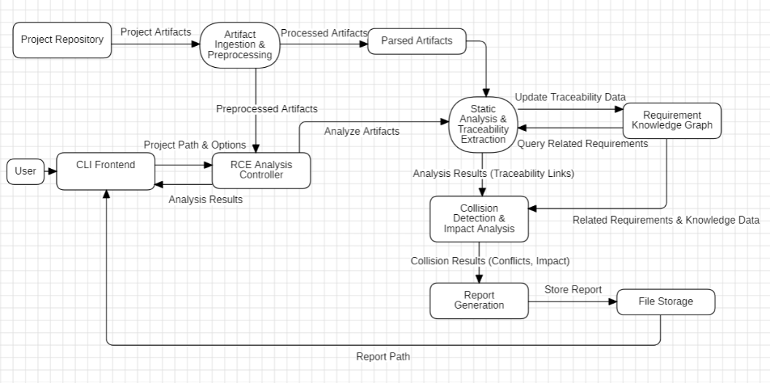
Fig. 1. High-Level System Architecture of the Requirement Collision Detection System.

Data Flow
The Level-1 Data Flow Diagram shows how information moves through the Requirement Collision Detection Engine. The developer provides the project path, and the engine reads the requirement files and Python source code. The requirements and source code are then examined to identify requirement identifiers, traceability references, functions, conditions, and dependencies.
This information is used to build the Requirement Knowledge Graph, which links requirements to the relevant code elements. The collision detector uses these links to check for possible conflicts, and the impact analyzer follows the related connections to identify code and requirements that may be affected. The results are then returned to the developer through the command-line interface, either as text or in JavaScript Object Notation format.
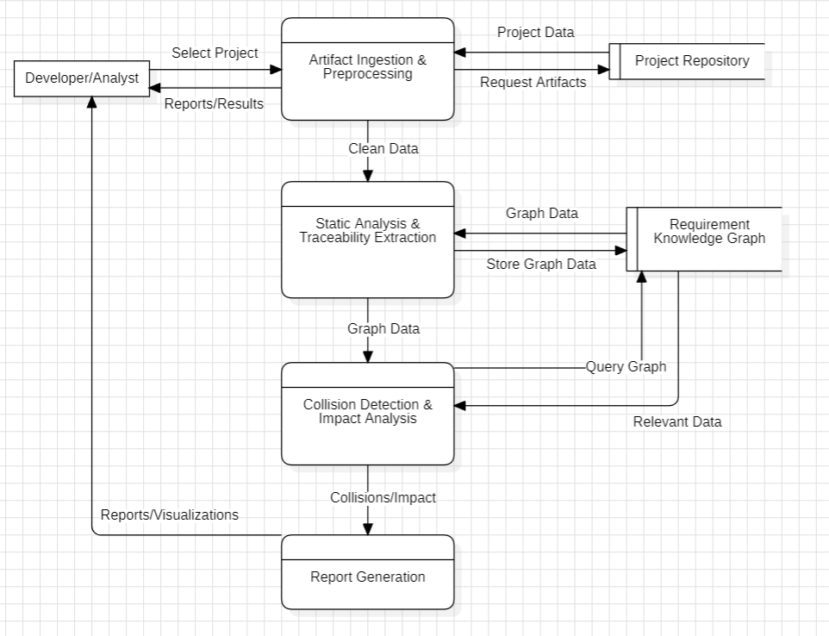
Fig. 2. Level-1 Data Flow Diagram of the Requirement Collision Detection System.

Use Case
The Use Case Diagram shows how a developer or analyst uses the Requirement Collision Detection Engine. The user provides the project path and runs the analysis to check for possible conflicts between requirements. The results can then be examined to understand which requirements are involved and which parts of the code may be affected.
After the analysis, the user can view the results through the command-line interface or save them in JavaScript Object Notation format for later reference.

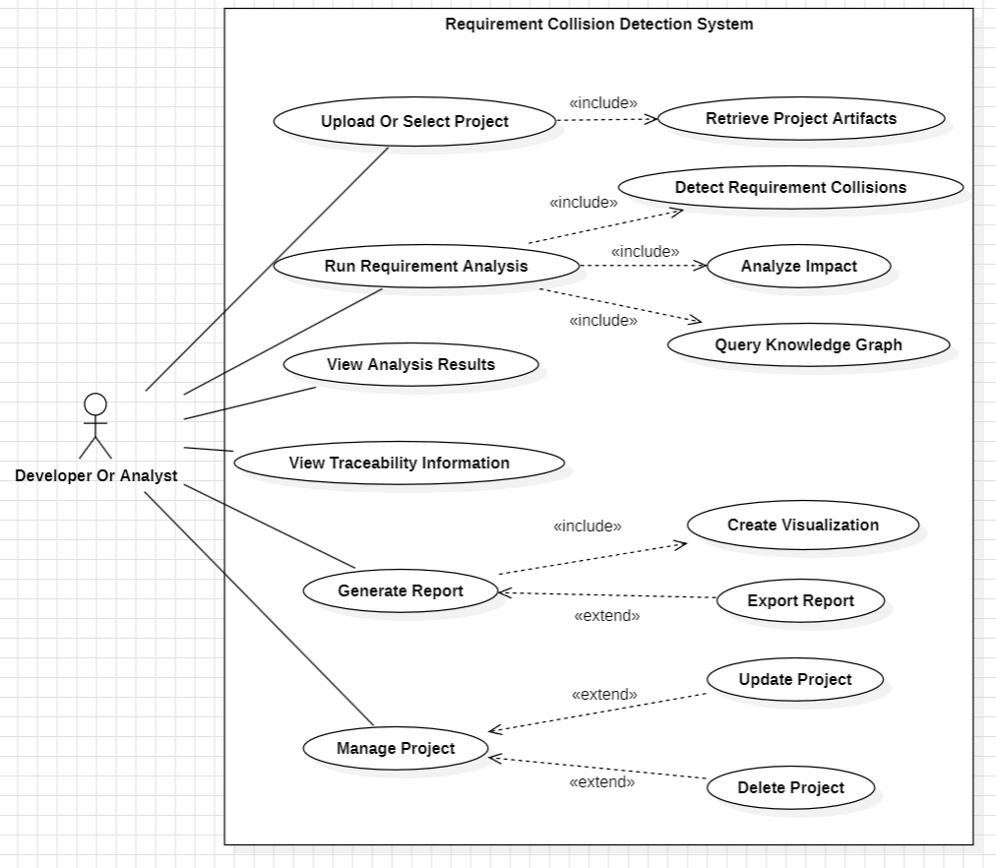
Fig. 3. Use Case Diagram of the Requirement Collision Detection System.

Component
The Component Diagram shows the main parts of the Requirement Collision Detection Engine and how they work together. The developer provides the project path and analysis options through the command-line interface. The analysis engine reads the requirements and source code, and the parser and analysis modules collect the information needed to check for conflicts.
The Requirement Knowledge Graph brings the extracted information together and shows the links between requirements and code. The collision detector checks these links for possible conflicts, and the impact analyser traces related code that may also be affected. Once the analysis is finished, the results are returned through the command-line interface and can be saved to a file.
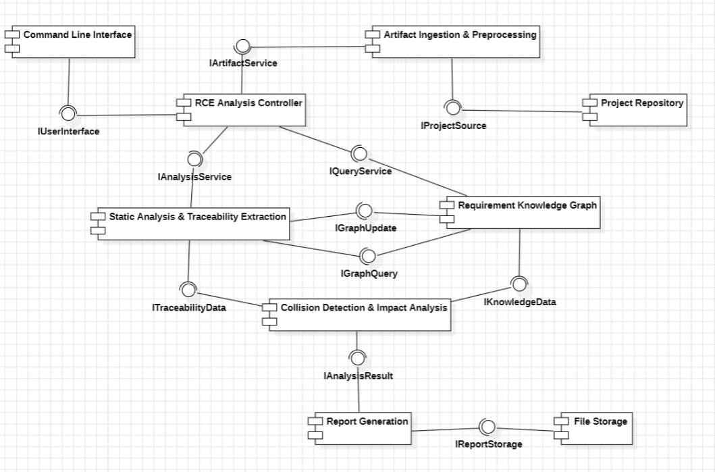
Fig. 4. Component Diagram of the Requirement Collision Detection System.

Sequence of Operations
The Sequence Diagram shows the order in which the Requirement Collision Detection Engine carries out an analysis. The process begins when the developer enters the project path and analysis options through the command-line interface. The analysis engine then reads the requirement files and Python source code.
The engine extracts the requirements, traceability references, and relevant code details before building the Requirement Knowledge Graph. The collision detector uses this information to check for possible conflicts, and the impact analyzer traces the related code and requirements. Once the analysis is complete, the engine prepares the results and returns them to the command-line interface. The developer can view the results directly or save them to a file.
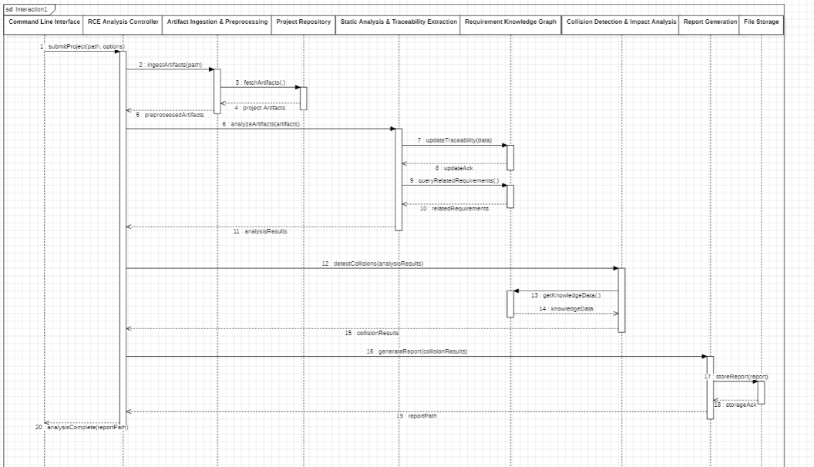
Fig. 5. Sequence Diagram of the Requirement Collision Detection Analysis Process.

Module Breakdown
The complete RCE system consists of the following modules:
Table 1. Module Breakdown of the Requirement Collision Detection System

Module | Function
Command-line interface | Accepts the project path and analysis options and displays the results.
Analysis engine | Coordinates the analysis workflow.
Requirement parser | Reads requirement files and identifies requirement identifiers.
Traceability extractor | Finds requirement references in source-code docstrings.
Abstract Syntax Tree analyzer | Extracts functions, classes, conditions, calls, and imports from Python source code.
Requirement Knowledge Graph | Represents links between requirements and software elements.
Collision detector | Identifies potential conflicts using the implemented detection rules.
Impact analyzer | Traces related requirements and code elements that may be affected.
Output handling | Formats the results as text or JavaScript Object Notation and writes them to a specified file when requested.

Methodology
The methodology used in the Requirement Collision Detection Engine starts with reading the project requirements and Python source files. The developer provides the project path and the required options through the command-line interface. The engine identifies requirement identifiers from the requirement files and uses references in source-code docstrings to link them to the implementation. It also reads the Python code to collect information about functions, classes, conditions, calls, and imports.
These details are used to build the Requirement Knowledge Graph. The graph records the relationships between requirements and the code associated with them, including dependencies between code elements. The collision detector uses this information to look for possible conflicts. The checks cover shared implementation logic, overlapping conditions and boundary values, and cases where an exception or override may bypass a requirement.
The impact analyzer follows the graph from a requirement or reported collision to identify connected code elements and related requirements. The search is limited by the maximum depth specified for the analysis.
The engine returns the findings in text or JavaScript Object Notation format. The developer can review the reported collisions and their related code, then decide whether further investigation or testing is needed. The results can also be written to a file for later use.

Algorithm
Input: Project directory, requirement files, and Python source code
Output: Collision findings and impact analysis results
- Read the requirement files and Python source code from the specified project.
- Identify requirement identifiers from the requirement files.
- Find traceability references in source-code docstrings.
- Analyse Python files to collect functions, classes, conditions, calls, and imports.
- Build the Requirement Knowledge Graph using the extracted information.
- Find related requirements and code elements through the graph.
- Apply the collision detection rules to identify potential conflicts.
- Trace related requirements and code elements to determine the possible impact.
- Prepare the collision findings and impact analysis results.
- Display the results or save them in the requested output format.

Implementation & Experimental Setup
The Requirement Collision Detection Engine (RCE) is developed in Python to identify possible conflicts between software requirements and their implementation. The project includes an enterprise expense workflow, which provides a practical setting for examining how the engine handles requirements that may overlap or contradict one another.
The engine is divided into modules, each responsible for a particular part of the analysis. The analysis engine coordinates these modules, starting with the requirements and source code and bringing their results together. The Python files are examined without executing the application. During this process, the engine collects information about functions, classes, conditions, function calls, and imports to understand how the code is structured.
Requirements are stored in Markdown files and identified by labels such as REQ-01. The engine searches source-code docstrings for these identifiers to establish links between requirements and the parts of the implementation associated with them. These links are then used to build a directed graph with NetworkX. The graph connects requirements to code elements and represents their relationships and dependencies, making it easier to trace how different parts of the system are connected.
The collision detector uses three groups of rules to look for potential conflicts. One group checks whether multiple requirements share implementation logic under overlapping conditions. Another examines condition boundaries and values that may cause requirements to conflict. The third looks for override or exception logic that could allow a requirement to be bypassed. After these checks, the impact analyzer follows the connections in the graph to identify other requirements and code elements that may be affected. The results highlight possible issues for further review rather than automatically confirming that a defect exists.
The enterprise expense workflow is used to examine how these checks behave in different situations. The scenarios include expense limits, approval conditions, travel compliance, emergency expenses, and manager overrides. The engine is not limited to this workflow; it can also analyse other Python projects, provided their requirements and source code follow the formats supported by the tool.
The system is tested using pytest, with 125 tests covering the main parts of the implementation. These include requirement parsing, traceability extraction, source-code analysis, graph construction, collision detection, impact analysis, the command-line interface, and the analysis engine. Tests also cover the enterprise workflow and additional validation scenarios. All 125 tests passed in the reported run, which took approximately 3.2 seconds and produced no failures or warnings.
To run the analysis, the developer uses the command-line interface to specify the project directory and the required options. The engine processes the available requirements and source files and presents the results as readable text or JavaScript Object Notation. The output can also be saved to a specified file. This allows the analysis to be carried out without requiring a separate graphical application.
The current implementation brings together requirement traceability, static source-code analysis, knowledge graph construction, collision detection, and impact analysis. The tests show that these features work across the cases included in the evaluation. However, this is an initial assessment rather than a measure of the engine's overall accuracy. Further testing on larger projects and projects with independently verified collision examples is needed to determine how reliably the approach works in a wider range of software systems.

Preliminary Results & Discussion
The Requirement Collision Detection Engine (RCE) was evaluated using the enterprise expense workflow and two synthetic projects: a logistics system and an inventory and order management system. These projects were used to examine how the engine handles overlapping conditions, possible requirement bypasses, and dependencies between different parts of a codebase.
In the enterprise expense workflow, the engine identified three potential collisions across ten requirements. One involved overlapping expense limits between REQ-03 and REQ-07, where the conditions overlap between ₹10,000 and ₹15,000. The other two findings involved a manager override affecting REQ-03 and REQ-07, and an emergency bypass involving REQ-03 and REQ-08. These findings show how the rules can identify cases where approval conditions or exception handling may need closer examination.
The logistics project contained three requirements across four modules. The engine reported two potential collisions between REQ-01 and REQ-02: one involving overlapping weight limits between 50 and 75 kg, and another involving a waiver interaction. However, the condition zone_code == "ZONE_REMOTE" associated with REQ-03 did not produce a collision. This result is useful because it shows that the engine did not report a conflict for every requirement examined.
The inventory and order management project contained five requirements across four modules. Here, the engine identified one potential collision between REQ-03 and REQ-04, caused by overlapping quantity conditions between 50 and 100. In contrast, the stock conditions stock >= 10 and stock < 5 did not produce a collision because their ranges do not overlap. The condition status == "PENDING" also produced no collision. These cases provided a way to examine how the detector handles both overlapping and separate conditions.
The impact analysis was also tested across module boundaries. Starting from REQ-04 in the inventory and order management project, the engine followed the connections from orders.py to stock.py and identified the related function verify_stock_available and requirement REQ-01. This demonstrated that the analysis could trace dependencies beyond the module in which the initial requirement was identified.
Alongside these project-level evaluations, the automated test suite completed all 125 tests in approximately 3.2 seconds, with no failures or warnings. The tests covered the parser, traceability extraction, source-code analysis, graph construction, collision detection, impact analysis, command-line interface, and analysis engine. Together, the test results and project scenarios provide evidence that the implemented workflow operates as intended for the cases examined.
The results should nevertheless be interpreted with care. The reported collisions are potential conflicts that require human review; they do not necessarily indicate confirmed defects. The evaluation also does not include independently established precision, recall, or accuracy measurements, and the project scenarios do not provide a broad benchmark of real-world software systems. The findings therefore demonstrate the engine's behaviour on the tested examples, but further evaluation on larger and independently assessed projects is needed before drawing conclusions about its general effectiveness.

Conclusion & Future Scope
The Requirement Collision Detection Engine (RCE) was developed to identify potential conflicts between software requirements by examining their relationships with the source code. It combines requirement parsing, traceability extraction, static analysis, a requirement knowledge graph, collision detection, and impact analysis within a single workflow.
The evaluation across the enterprise expense workflow and two synthetic projects showed that the engine could identify overlapping conditions, possible requirement bypasses, and dependencies between code elements. The results also included cases where no collision was reported, such as disjoint stock conditions in the inventory and order management project. In addition, the impact analysis traced dependencies across modules, helping identify requirements and functions that may be affected by a change. All 125 automated tests passed in the reported test run.
These results provide an initial demonstration of the approach, but they do not establish how accurately the engine detects conflicts across software projects in general. The evaluation was limited to the tested workflow and synthetic examples, and the findings still require human review. Broader testing and independently verified examples are needed to assess its reliability and identify cases that the current rules may miss.
Several improvements could be explored in future work. Testing on larger and more varied codebases would help assess how the engine behaves as project complexity increases. Formal constraint-solving techniques could be investigated to examine overlapping conditions more precisely. Natural language processing could also help recover traceability links when requirements are not explicitly referenced in source-code docstrings. Other possible extensions include mutation-based testing to assess the collision rules, a graphical interface for presenting findings, analysis of version-control history, and integration with continuous integration pipelines.
The current implementation provides a foundation for examining requirement conflicts through static analysis and graph-based traceability. Further evaluation and development are required to determine how well this approach can support requirement analysis in larger and more complex software systems.

References
- Wang, B., Peng, R., Li, Y., Lai, H., Wang, Z.: Requirements traceability technologies and technology transfer decision support: A systematic review. Journal of Systems and Software 146, 59–79 (2018). https://doi.org/10.1016/j.jss.2018.09.001
- Aung, T.W.W., Huo, H., Sui, Y.: A literature review of automatic traceability links recovery for software change impact analysis. In: Proceedings of the IEEE/ACM International Conference on Program Comprehension (ICPC 2020), pp. 14–24. ACM (2020). https://doi.org/10.1145/3387904.3389251
- Wang, B., Zou, Z., Wan, H., Li, Y., Deng, Y., Li, X.: An empirical study on the state-of-the-art methods for requirement-to-code traceability link recovery. Journal of King Saud University Computer and Information Sciences 36, 102118 (2024). https://doi.org/10.1016/j.jksuci.2024.102118
- Rubasinghe, I., Meedeniya, D., Perera, I.: Traceability management with impact analysis in DevOps based software development. In: Proceedings of the International Conference on Advances in Computing, Communications and Informatics (ICACCI 2018), pp. 1–6. IEEE (2018). https://doi.org/10.1109/ICACCI.2018.8554399
- Alturayeif, N., Hassine, J., Ahmad, I.: Machine learning approaches for automated software traceability: A systematic literature review. Journal of Systems and Software 230, 112536 (2025). https://doi.org/10.1016/j.jss.2025.112536

