SQL Practice Questions -Employee & Department Databases
Name: Shraddha Santosh Santiur.
Course: SQL Practice
Submitted On: 24/06/2026

Table of Contents
- Top 5 Highest Salary Employees
- Department-wise Employee Count
- Second Highest Salary
- Employees Whose Salary > Department Average Salary
- Inner Join
- Left Join
- Group By with Having
- Employees Hired in Last 6 Months
- Find Duplicate Records
- Remove Duplicate Records
- Add some data in existing data
- Window function handle
- Handle case when
- Views
- Triggers

CREATE DATABASE company;
USE company;

CREATE TABLE department_inf (
dept_id INT PRIMARY KEY,
dept_name VARCHAR (50)
) ;

INSERT INTO department_inf (dept_id, dept_name)
VALUES
(101,"HR"),
(102, "IT"),
(103,"Finance"),
(104,"Marketing"),
(105,"Sales");

SELECT*FROM department_inf;

CREATE TABLE employees (
emp_id INT,
emp_name VARCHAR (50),
salary INT,
dept_id INT,
hire_date date
);

INSERT INTO employees VALUES
(1,'Amit',45000,101,'2025-01-10'),
(2,'Priya',60000,102,'2025-02-15'),
(3,'Rahul',55000,103,'2024-11-05'),
(4,'Sneha',70000,102,'2026-01-12'),
(5,'Neha',48000,104,'2025-03-18'),
(6,'Rohan',80000,105,'2025-06-01'),
(7,'Kiran',75000,101,'2024-12-20'),
(8,'Pooja',65000,103,'2026-02-01'),
(9,'Vikas',50000,104,'2025-07-11'),
(10,'Anjali',90000,102,'2025-09-09'),
(11,'Sagar',47000,105,'2025-08-01'),
(12,'Meena',52000,101,'2026-03-14'),
(13,'Arjun',61000,102,'2025-05-30'),
(14,'Kavya',57000,103,'2025-11-25'),
(15,'Nikhil',68000,104,'2024-10-10'),
(16,'Riya',72000,105,'2026-04-02'),
(17,'Ajay',53000,101,'2025-12-12'),
(18,'Komal',64000,102,'2026-05-06'),
(19,'Tanvi',59000,103,'2025-06-28'),
(20,'Manoj',85000,104,'2026-01-22'),
(21,'Deepa',49000,105,'2025-04-04'),
(22,'Amit',45000,101,'2025-01-10'),
(23,'Priya',60000,102,'2025-02-15'),
(24,'Rakesh',56000,103,'2025-03-21'),
(25,'Shweta',78000,104,'2026-02-18');

SELECT*FROM employees;
#Q1 Top 5 highest salary employees
SELECT *
FROM employees
ORDER BY salary DESC
LIMIT 5;
Output:
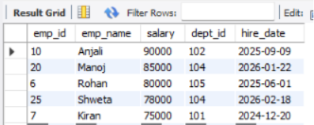

#Q2 Department wise employee count
SELECT dept_id, COUNT (*) AS employee_count
FROM employees
GROUP BY dept_id;
Output:
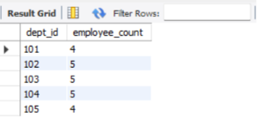

#Q3 Find second highest salary
SELECT MAX (salary) AS second_highest
FROM employees
WHERE salary < (SELECT MAX (salary) FROM employees);
Output:
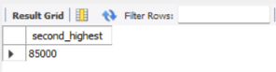
#Q4 Employee whose salary greater than department average salary
SELECT emp_name, salary, dept_id
FROM employees
WHERE salary >
(
SELECT AVG (salary)
FROM employees
WHERE Dept_id = dept_id
);
Output:
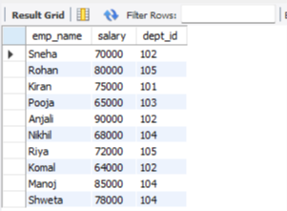

#Q5 Inner join
SELECT e.emp_name, e.dept_id
FROM employees e
INNER JOIN department_inf d
ON e.dept_id = d.dept_id ;
Output:
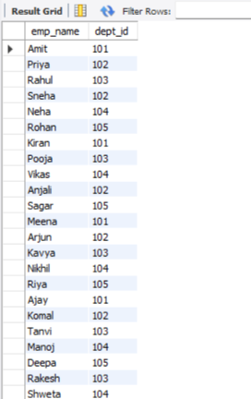
#Q6 Left join
SELECT e.emp_name, e.dept_id
FROM employees e
LEFT JOIN department_inf d
ON e.dept_id = d.dept_id;
Output:

#Q7 Group by with having
SELECT dept_id, COUNT (*) AS total
FROM Employees
GROUP BY dept_id
HAVING COUNT (*) > 5;
Output:

#Q8 Employee hired in last 6 months
SELECT *
FROM Employees
WHERE Hire_date >= CURDATE () - INTERVAL 6 MONTH ;
Output:
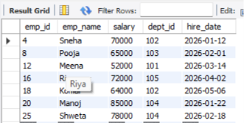

#Q9 Find the duplicate records
SELECT emp_name, COUNT (*)
FROM employees
GROUP BY emp_name
HAVING COUNT (*) > 1;

SET SQL_SAFE_UPDATES =0;

#Q10 How to remove duplicate records
DELETE FROM employees
WHERE emp_id NOT IN
(
SELECT emp_id
FROM
(
SELECT MIN(emp_id) AS emp_id
FROM employees
GROUP BY emp_name
) AS temp
);

#Q11 Add Some Data in Existing Data

#Q12 Window function handle
a) Salary Rank: Rank Employees by Salary
SELECT emp_id, emp_name, salary,
RANK() OVER (ORDER BY salary DESC) AS salary_rank
FROM Employees;
Output:
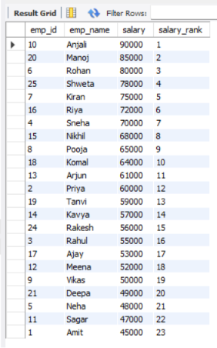
b) Department-wise Average Salary
SELECT emp_name, dept_id, salary,
AVG(salary) OVER(PARTITION BY dept_id) AS dept_avg_salary
FROM Employees;
Output:
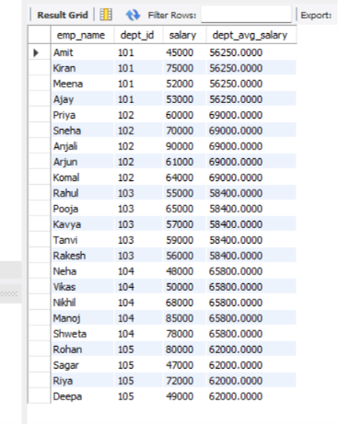
#Q13 Handle case when
a)Salary category
SELECT emp_name, salary,
CASE
WHEN salary >= 80000 THEN 'High'
WHEN salary >= 60000 THEN 'Medium'
ELSE 'Low'
END AS salary_category
FROM Employees;
Output:
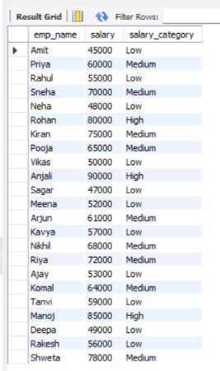

#Q14 Views
a)Create View
CREATE VIEW high_salary_emp AS
SELECT emp_id, emp_name, salary
FROM Employees
WHERE salary > 70000;
b)Display View
SELECT * FROM high_salary_emp;
Output:
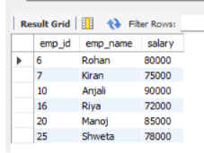

#Q15 Triggers
a)Create Log table
CREATE TABLE emp_log(
log_id INT AUTO_INCREMENT PRIMARY KEY,
emp_id INT,
message VARCHAR(100)
);
b)Trigger

CREATE TRIGGER employee_insert_trigger
AFTER INSERT
ON Employees
FOR EACH ROW
INSERT INTO emp_log(emp_id,message)
VALUES(NEW.emp_id,'New Employee Added');
c)Test Trigger
INSERT INTO Employees VALUES
(26,'Shraddha',65000,101,'2026-06-24');
Log पाहा:
SQL
SELECT * FROM emp_log;

