**Charithra M**

Mugerumaru House

Gerukatte Post,Kaliya Village

Belthangady TQ,DK

-

574217

Contact.No:9901183684

E

-

m

ail:

charithra3101@gmail.com

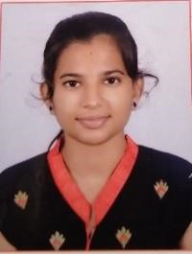

# OBJECTIVE

I am looking forward for an opportunity where I can use some of my skills to develop the organization.

Also I can improve my skills and financial sector. If I get a job it will be helpful for your organization and also for me.

|  |  |  |
| --- | --- | --- |
| **Qualification** |  |  |
| Course | University/Board | Marks(%)/Grade |
| MCA | VCET College,Puttur | Pursuing |
| BSc(computer Application) | SDM Degree College,Ujire | 69.19 |
| PUC | Vani PU College,karnataka | 74% |
| SSLC | Karnataka Secondary Board | 90% |

# ACADEMIC PROJECT DETAILS

**Project Name**: **Electronic shop Management**

**Front End:** VB.Net

**Back End**: MS Access **Team size:**3  **Duration:** 2 Month

# ADDITIONAL SKILLS

* **Microsoft Office package**: Microsoft Word, Power Point, Excel
* **Programming**: C, C++, HTML, DBMS, VB.NET

# EXTRA CURRICULAR ACTIVITY

* Had participated in WORKSHOP ON MICROSOFT EXCEL 2013-ADVANCED organized by S.D.M Rotary Career Guidance & Placement (HRD) Centre.
* I have also attended the workshop based on Mobile Application Development.

# HOBBIES

* Dancing
* Origami
* Simple drawings

# PERSONAL DETAILS

Father Name : Shekar Shetty

Date Of Birth : 31/01/2021

Gender : Female

Nationality : Indian

Religion : Hindu

Languages known : English, Kannada, Tulu

Marital Status : Unmarried

**Place**:Belthangady Charithra M