REASONING |  |  |  |  | 6. Sushil walked 15 metres towards
 |  |  |  |  | South, took a left turn and walked
1. In a certain code language, 'no |  |  |  |  | 20 metres again he took a left turn
 |  |  |  |  | and walked 15 metres. How far
more food' is written as 'ta ka da'
 |  |  |  |  | and in which direction is he from
and 'more than that' is written as
 |  |  |  |  | the starting point ?
'sa pa ka'. How is 'that' written in
 |  |  |  |  | (1) 20 metres. West
that code language ?
 |  |  |  |  | (2) 20 metres, East
1) sa
(2) ka |  |  |  |  | (3) 50 metres, West
(2) ka |  |  |  |  | (4) 50 metres, East
(3) sa or pa
(3) sa or pa |  |  |  |  | (5) Data inadequate
(4) Date inadequate
 |  |  |  |  | 7. How many such pairs of digits are
(5} None of these
2. In a certain code SHOULDER is |  |  |  |  | there in the number 254983 each
 |  |  |  |  | of which has as many digits/ be-
written as VPITQDCK. How is
 |  |  |  |  | tween them in the number as
MORNINGS written in that code ?
 |  |  |  |  | when the digits are rearranged in
(1) OSPNRFMH
 |  |  |  |  | descending order within the num-
(2) NPSORFMH
 |  |  |  |  | ber ?
(3) OSPNHMFR |  |  |  |  | (l)None |  |  | (2) One
(4) OSPNSFEM |  |  |  |  |  |  |  | (2) One
 |  |  |  |  | (3) Two |  |  | (4) Three
(5) None of these
 |  |  |  |  | (5) More than three
3. In a certain code GUEST isrwrit-
 |  |  |  |  | 8. How many such pairs f letters
ten as 53@$2 and MEAN is writ-
 |  |  |  |  | are there in the word CHRONI-
ten as 6@4#. How is SAME writ-
 |  |  |  |  | CLE each of which has as many
ter in that code ?
 |  |  |  |  | letters between the in the w rd
(1)4$6@ |  | (2) | $46®
(1)4$6@ |  | (2) | $46® |  | as in the English alphabet ?
(3) $36@ | . | (4) 5$6@ |  |  | (1) None |  |  | (2) One | o
(5) i\one of these |  |  |  |  |  |  |  | (2) One
 |  |  |  |  | (3) Two |  |  | (4) Three
4. D is brother of K, M is sister of |  |  |  |  | (5) M |  | re than three
K. R is father of D and S is moth- |  |  |  |  | 9. If V mean |  |  | V;m'+' eans '-=-'; '-'
er of M How is K related to R ? |  |  |  |  | mean |  | '+' and 'x' means' -'; then
(l)Son
(l)Son |  |  |  |  | 20 - 16 + 4 x 3 -s- 2 = ?
(2) Daughter |  |  |  |  |  |  | s
 |  |  |  |  | (1)16 |  |  | (2)3 0
(3) Son or daughter |  |  |  |  |  |  |  | (2)3 0
 |  |  |  |  | (3) | 18 |  | (4) 24
(4) Data inadequai e |  |  |  |  | (3) |  |  | (4) 24
 |  |  |  |  | o
(5) None of these |  |  |  |  | (5) None of these
 |  |  |  |  | 10. Pointing to a boy in a photograph
5. If it is possible to make only one
 |  |  |  |  | k
meaningful English word with the |  |  |  |  | Sudhir said "He is the son of my
 |  |  |  |  |  |  |  | grandfather's only
 |  |  |  | Imaternal
first, the fifth, the ninth and the |  |  |  |  | child". How is the boy related to
tenth letters |  | of the word SE-
 |  |  |  |  | Sudhir ?
QUENTIAL, which of the follow-
 |  |  |  |  | (l)Self
ing will be | the second letter of
that word ? If no such word can |  |  |  |  | (2) Brother
be formed | give 'X' as the answer |  |  |  | (3) Cousin brother
and if more than one such word |  |  |  |  | (41 Data inadequate
can be formed, give T a s the an- |  |  |  |  | (5) None of these
swer. |  |  |  |  | Directions (11 - 15) : In each of
( U S |  | (2) A |  |  | the questions below are given four state-
(3) E |  | (4) X |  |  | ments followed by four conclusions
(51Y |  |  |  |  | numbered I, II, III and IV. You have to
take the given statements to be true even if they seem to be at variance from commonly known facts. Read all the conclusions and then decide which of the given conclusions logically fol-lows from the given statements disre-garding commonly known facts.

- Statements:

Some tools are radios. Some radios are ponds. Some ponds are mirrors.
All mirrors are chalks.

Conclusions:

I. Some mirrors are tools. II. Some chalks are ponds. III. Some ponds are tools.

IV. Some chalks are radios.

        - None follows

        - Only I follows

        - Only II follows

        - Only III follows

        - Only IV follows

  - Statements:

All chairs are sofas. All sofas are books. All books are nets.
All nets are gardens.

Conclusions:

  - Some nets are sofas.

II. Some gardens are books. III. Some nets are chairs. IV. All books are gardens.

      - Only I, II and III follow

      - Only I, III and IV follow

      - Only II, III and IV follow

      - All I, II, III and IV follow

      - None of these

- Statements:

All monkeys are parrots. No parrot is crow. Some crows are horses.
All horses are tigers.

Conch»*ioT>s:

    - Some tigers are parrots. II. Some crows are monkeys. III. No tiger is parrot.

IV. Some horses are parrots.

- None follows

- Only II follows

- Only III follows

- Only I follows

- Only either I or III follows

14.Statements :
All houses are rooms All rooms are baskets All baskets are tyres Some [tyres are lanterns

Conclusions :

I. Some lanterns Sfelrooms.

  - Some tyres are houses . III. Some tires are rooms . IV. All houses are baskets .

(1) Only I, II and III follow

(2) Only II, III and IV follow

(3) Only I, III and IV follow

(4) All I, II, III and IV follow

(5) None of these

- Statements:

Some tractors are buses .

All buses are trains.

Some trains are boats.

All boats are ships.

Conclusions :

I. Some boats are.buses .

- Some ships are buses . III. Some trains are tractors . IV. Some ships are trains .

(1) Only I and II follow

(2) Only I and III follow

(3) Only I and IV follow

(4) Only II and IV follow

(5) None of these

Directions ( 1 6 - 20) : Study the

following arrangement carefully and answer the questions given below :

Q R 4 $ 3 K H 1 M D 5 © N E J 8 I # T V U % W 6 5 B A 7 2 F P

- How m a n y such numbers are there in the above arrangement

each of which is immediately fol-lowed by a letter but not immedi-ately preceded by a letter ?

( l ) N o n e (2) One

(3) T w o (4) Three

  - More than three

- How many such consonants are there in the above arrangement each of which is immediatetely preceded by a number and im-mediately followed by a symbol ?

( l ) N o n e (2) One

(3) T w o (4) Three

(5) More than three

- Which of the following is the sixth to the left of the fourteenth from the left end of the above arrange-ment ?

(1) | V | (2) | 1
(3) | 6 | (4) | ©

  - None of these

- What should come in place of the question mark (?) in the following series based on the above ar-rangement ?

4 3 H D©E | ITU | ?
( 1 ) 6 A 2 | ( 2 ) 6 B 2
(3) W5A | (4) W87
(5) None of these
20. Four of the foll | wing five are alike
in a certain way based on their
positions in the ab |  | ve arrange-

ment and so form a gr up. Which is the one that d es not belong to that group ?

( 1 ) H D 3 | (2)J©I
(3) V I % | (4) | N 8 D
(5) B26
Directions | ( 2 1 - | 25) : In each

que tion below is given a group of dig-its/symbols followed by four combina-ti ns f letters numbered (1), (2), (3) and (4). You have to find out which of the combinations correctly represents the group of digits/symbols based on the following coding system and the conditions that follow and mark the number of that combination as your answer. If none of the combinations correctly represents the group of dig-its/symbols mark (5) i.e. 'None of these' as your answer.
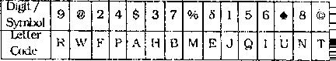

Conditions:

- If the first unit is an even digit and the last unit is a symbol, both are to be coded as the code for the even digit.

- If the first unit is a symbol and the last unit is an odd digit, their codes are to be interchanged.

- If the first unit is an odd digit and the last unit is an even digit, both are to be coded as the code for the odd digit.

21 . 853©2S

- N Q H T F E

- N Q H T F N

- E Q H T F N

- E Q H T F E

- None of these

- 4 $ % 3 * 6

  - PAMHUI

  - P A M H U P

  - IAMHUP

  - IAMHUI

  - None of these

- . 9© $ 3%6

(1) IWAHMI (2) RWAHM1

  - IWAHMR (4) R W H A M R

  - None of these

- 7 2 8 % 9 $

  - AFNMRB (2) BFNMRB

  - AFNMRA (4) BFNMRA.

  - None of these

- ©75541

  - T B E Q P T (2) TBEQPJ

(3) J B E Q P T (4) JBEQPJ

(5) None of these

Directions (26 - 3 0 ) : Study the following information carefully and an-swer the given questions :

A word and number arrangement machine when given an input line of words and numbers rearranges them following a particular rulein each step. The following is an illustration of input

and rearrangement.
Input | : nine poll |  | 19 34 12 69 hour
 | call
Step I | : call | nine | poll | 19 | 34 | 12 | 69
 | hour
Step II | : call | 12 nine |  | poll | 19 | 34 | 69
 | hour |  |  |  |  | ,
Step III: call |  | 12 hour nine poll |  |  |  | 19 34
 | 69
Step I V : call |  | 12 hour 19 nine poll 34
 | 6 9
Step V | : call | 12 hour 19 nine 34 poll
 | 69

and Step V is the last step of the rearrangement of the above input.

As per the rules followed in the above steps, find out in each of the following questions the appropriate step for the given input.

- Step II of an input is : bend 15 will care 46 53 29 then

H o w m a n y more steps will be required to complete the rear-

rangement?
( l ) F i v e | (2) | Three
(3) Four | (4) | Six

  - None of these

- I n p u t : land 62 clear over 41 37 again 56

Which of the following steps will be the last but one ?

(1) VIII | (2) | IX
(3) VII | (4) | VI

  - None of these

- Step II of an input is : desk 12 year Victor 86 71 störe 65 Which of the following will be step VII ?

  - desk 12 störe 65 year 71 vic-tory 86
  - desk 12 stoie 65 71 yearvic-tory 86
  - desk 12 störe 65 year victory 86 71
  - There will be no such step

  - None of these

- Inpuu earn 39 23 48 Station 19 begin day
How many teps will be required to complete the rearrangement ? (l)Five (2)Seven

(3)Eight (4)Six

(5) None of these

30. Step III of an input is : and 25 jungle 93 84 kite more 36 Which of the following is definite-ly the input ?

(1) 93 84 kite more and 36 25 jungle
(2) 9S 81 and 25 kite jungle more

36

(3) jungle 93 and 84 25 kite more

36

(4) Cannot be determined
(5) None of these
lowing questions, the Symbols 8, ⋆, %,
Directions (31- 35) : In the fol-

# and @ are used with the following meaning as illustrated below :

'P % Q' means 'P is neither great-er than nor equal to Q'.

'P 8 Q' means 'P is neither small-er than nor equal to Q'.
'P @ Q' means 'P is not greater than Q'.
'P * Q' means 'P is not smaller than Q'.
'P # Q' means 'P is neither great-er than nor smaller than Q'.
Now in each of the foEowing ques-tions assuming the given Statements to be true, find which of the four con-clusions I, II, III and IV given below them is/are definitely true and give your answer accördingly.

31. Statements:

H 8 J , J # N , N @ R , R 8 W
Conclusions:

I. W % N

II. W % H

III. R # J

IV. R 8 J

(1) Only I is true

(2) Only II is true

(3) Only III is true

(4) Only IV is true

(5) Only either III or IV is true
32. Statements: | ⋆ N
B @ D, D 8 F, F % M. M | ⋆ N
Conclusions :

  - B % F II. MÖD III. N % F IV. DON

      - None is true

      - Only 1 is true

      - Only II is true

      - OnK III is true

      - Only IV is true

- Statements:⋆

R T, 1 8 M, M % K, K @ V

Conclusions:

I. V 8 M

II. V ö T

III. M % R

IV. K 5 R

(1) Only I and II are true

(2) Only I and III are true

(3) Only II and IV are true

(4) Only I, III and IV are true

(5) None of these

34. Statements:

M % K, K W, W δ V, V @ N
Conclusions:
I. | N K | ⋆
II. | % W
II. | M ⋆
III. K δ V

IV. V % M

  - None is true

  - Only I is true

  - Only II is true

  - Only III is true

  - Only IV is true

- Statements:

F # Z, Z @ H, H °/o N, N δ B

Conclusions:

- F @ H

II. N δ Z

III. B % H

IV. B % Z

- In which of the following combi­ nations is the third person sit­ ting in between the first and the second persons ?
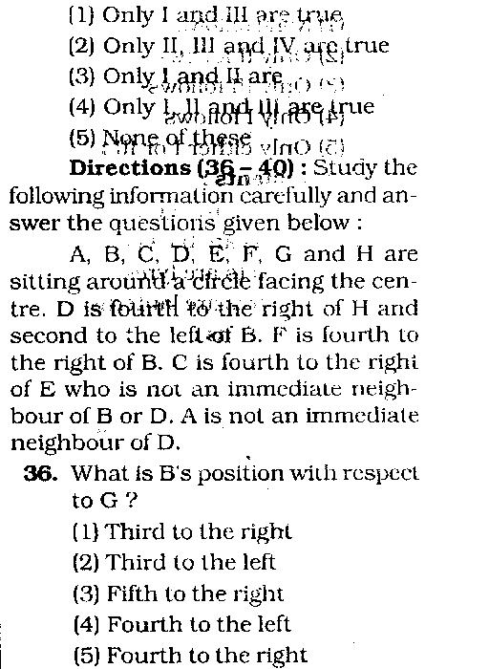
(l)ABC (2)GCD

(3) AHE (4) CBA

  - EFG

- Who is third to the right of A ?

  - H

(2)E

    - F

    - Data inadequate

    - None of these

- Who is to the immediate left of D ?
    - G

    - C

      - F

      - Data inadequate

      - None of these

  - Who is fourth to the left of G ?

(1) | E | (2)F
(3) | A | (4) H
(5) | Data inadequate

Directions (41 - 45): Study the following information carefully and an­ swer the questions given below:

Following are the conditions for selecting Manager­Marketing in an Or­ ganisation. The candidate must —
- be at least 25 years and not more than 30 years as on 01.05.2010.
- be a graduate in any discipline with at least 55 percent marks.

Mark answer (2) if the candidate is to be selected.
Mark answer (3) if the candidate is not to be selected.
Mark answer (4) if the case is to be referred to G M-Marketing.
Mark answer (5) if the case is to be referred to CGM-Marketing.
41. Archit Pradhan has been work-ing in. the Marketing division of an organisation for the past five years. He has secured 60 per-cent marks in both B.Sc. and post graduate degree in Marketing Management. He was born on 8th May 1984. He has secured 46 percent marks in the selection process.
42. Ankida Bhave has been working in the Marketing division of an organisation for the past four years after completing her post

(iii) have completed post graduate |  |  |  | graduate diploma in Marketing
degree/diploma is Marketing |  |  |  | Management with |  |  | 62 percent
Management with at least 60 per- |  |  |  | marks. She was born on 11th
• i• , , ^Bn^.fflfffiShmavoOsriT |  |  |  | August 1982. She has secured
 |  |  |  | 52 percent marks in B.Sc. She
(iv) have post qualificatipn work ex-
 |  |  |  | has secured 48 percent marks
perience of at least three years
 |  |  |  | in the selection process.
in the marketing division in an
 |  |  | 43. Subodh Saxena was born on 15th
organisation.
(v) have secured at least 45 percent |  |  |  | November 1982, He has been
marks in the selection process. |  |  |  | working |  | as Deputy | Marketing
 |  |  |  | Manager in an organisation for the
In the case, of a candidate who
 |  |  |  | past two years after completing
satisfies all the conditions EXCEPT —
 |  |  |  | his post graduate degree in Mar-
(A) at (ii) above but has secured
 |  |  |  | keting Management with 68 per-
at least 65 percent marks in
 |  |  |  | cent marks. He has secured 56
post graduation degree/diplo-
 |  |  |  | percent marks in B.Com. and 50
ma in | marketing manage-
ma in |  |  |  | percent marks in the selection
ment, | the case is to be re-
ment, |  |  |  | process.
ferred to GM-Marketing.
 |  |  | 44. Nisha Awashti was b rn on 29th
(B) At (iv) | above but has post
(B) At (iv) |  |  |  | April 1981. She has been work-
qualification work experience
 |  |  |  | ing in the Marketing division of
of at least one year as Deputy
 |  |  |  | an organisation for the past five
Marketing Manager in an or- |  |  |  |  |  | o
 |  |  |  | year | after completing her post
ganisation, the case is to be. |  |  |  | year
 |  |  |  | graduate |  | degree in | Marketing
referred, to CGM-Marketing. |  |  |  |  |  | degree in | Marketing
 |  |  |  | Manage |  | ent with | 67 percent
In each question below details |  | f |  | arks. She has secured 50 per-
one candidate are given. You have t |  |  |  | m
 |  |  |  | cent marks in the selection pro-
take one of the following courses |  | f |  | ces | and | 53 percent marks in
action based on the information pro- |  |  | sB.Com.
vided and the conditions and sub - c n- |  |  | 45. Shreyas Ingle was born on 12th
ditions given above and mark the num- |  |  |  | July 1983. He has secured 57
ber of that course of action as your |  |  |  | percent marks in B.Com. He has
answer. You are not to assume any- |  |  |  | been working in the Marketing
thing other than the information pro- |  |  |  | division of an organisation for the
 | k
vided in each question. All these cases |  |  |  | past four years after completing
 | I |  |  | his post graduate diploma in Mar-
are given to you as on 01.05.2010.
Mark answer (1) if the data pro- |  |  |  | keting Management with 67 per-
vided are not adequate to take a deci- |  |  |  | cent marks, He has secured 48
sion. |  |  |  | percent marks in the selection
 |  |  |  | process.

Directions (46 - 50) : Below is given a passage followed by several possible inferences which can be drawn from the facts stated in the pas-sage. You have to examine each infer-ence separately in the context of the passage and decide upon its degree of truth or falsity.

Mark answer (1) if the inference is 'definitely true', i.e., it properly fol-lows from the statement of facts giv-en.

Mark answer (2) if the inference is 'probably true' though not 'definitely true' in the light of the facts given. .

Mark answer (3) if the 'data are inadequate", i.e, from the facts given you cannot say whether the inference is likely to be true or false .

Mark answer (4) if the inference is 'probably false', though not 'definite-ly false' in the light of the facts given.

Mark answer (5) if the inference is 'definitely false', i.e., it cannot pos-sibly be drawn from the facts given or it contradicts the given facts.
Even as the economy is back on track and consumer confidence up, the number of credit cards in the system continues to dip. In the last one year, the total number of credit cards in use has dipped by almost 50 lakhs. Accord-ing to the latest data released, the num-ber of credit cards dipped to about 2 crores as of end February 2010 from around 2.5 crores a year ago. The data also indicate that average monthly card Spends both in terms of value as well as volume has still not touched the pre-crisis levels. Average monthly spend in Financial Year 2010 has fallen to Rs.5,100 crores against Rs.5,400 crores in Financial Year 2009, while average monthly volumes in the cur-rent year has been just 1.94 crores a month compared to 2.16 crores a month in Financial Year 2009. Even peak festival spending through cards in the current fiscal is less than the previous year's levels.

- Credit card usage in the current year has substantially decreased from Financial Year 2009.

- There has been a drop of about 40 percent in use of credit card in the current year from the pre-vious year.

- There has been a drop of about

10 percent in the number of credit card transactions in the current year from the previous year.

- The drop in usage of credit cards in India is lesser than that in many other countries.

- People are not using credit cards in the current year due to ram-pant credit card related fraud.

- Statement: Many persons in the locality are diagnosed to be suf-fering from gastro-intestinal diseas-es after consuming poor quality drinking water supplied by the municipal authority.

Which of the following substanti-ates the facts stated in the above statement ?

- Gastro-intestinal diseases are not very severe in nature
"(2) People suffering from gastro-intestinal diseases need not take medicines. .

  - Many people suffer from gas-trointestinal diseases after consuming stale food.

  - Gastro-intestinal diseases are waterborne diseases.

  - None of these

- Statement : Many students were caught while using unfair means during the final examinations by the special team of the universi-ty-

Which of the following can be a possible consequence of the facts stated in the above statement ?

    - The teachers responsible for invigilation in all such exami-nation halls where the stu-dents were caught are to be suspended from their servic-es.

    - All those students who were caught while using unfair means are to be debarred from appearing in these ex-aminations for a year.

    - The college should be black-listed by the university for holding final examinations at least for a year.

      - Only (A) (2) Only (B) ^{r}

(3) Only (C) (4) Only (B) and (C)

  - None of these

- Statement : Based on the find-ings of a recent study, it has been reported that regular consump-tion of ripe mango helps in con-trolling blood pressure as it in-creases the level of potassium in the blood stream.

Which of the following contradicts the findings reported in the above statement ?

    - Increased level of potassium

in blood stream e n h a n c e s quality of health

- Many people who consume ripe mangoes regularly were found to be suffering from hypertension.

- Consumption of ripe mango helps in storing anti-oxidant in the body.

- Ripe mango is a good source of many vitamins

- None of these

54. S t a t e m e n t : Most part of the boundary walls of the local school collapsed completely last night.

Which of the following can be a

possible consequence of the facts stated in the above statement ?
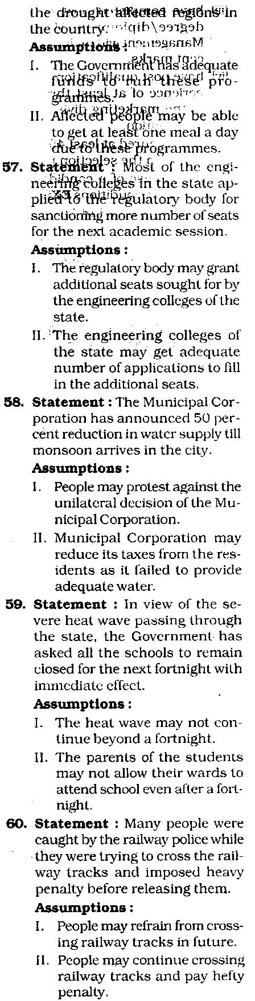
- The local school authority will close down the school till the boundary walls are erected.

- The Government will levy pen-alty to the school management
  - for their negligence.

- The management of the school will erect temporary fences till the boundary walls are erect-ed.

(1) Only (A) (2) Only (B)

- Only (C)

- Only (A) and (C)

- None of these

55 . S t a t e e n t : T h e p r i c e s of foodgrains and ther essential co odities have decreased for the second c nsecutive week.

Which of the following can be a po ible consequence of the facts tated in the above statement ?

- The consumer price index will come down considerably.

- People will increase their pur-chase of quantity of essential commodities and food grains.

- Government will increase its taxes on essential commodi-ties and food grains.

  - Only (A) and (B)

  - Only (B) and (C)

  - Only (A) and (C)

    - All (A), (B) and (C)

    - None of these

Directions (56 - 60) : In each question below is given a statement followed by two assumptions numbered I and II. An assumption is something supposed or taken for granted. You have to consider the statement and the following assumptions and decide which of the assumptions is implicit in the statement.

Give answer (1) if only Assump-tion I is implicit.

Give answer (2) if only Assump-tion II is implicit.

Give answer (3) if either Assump-tion I or Assumption II is implicit.

Give answer (4) if neither As-sumption I nor Assumption II is im-plicit.

Give answer (5) if both Assump-tions I and II are implicit.

56 . Statement : The Government has recently announced additional food for work programmes for all

Directions (61-75) : In each of the questions given below which_{QUANTITATIVE}oneofthefollowing_{APTITUDE}answerfigures on the righ figures on th^efjj ^ ^ S J ^ u e n c e were continued ?
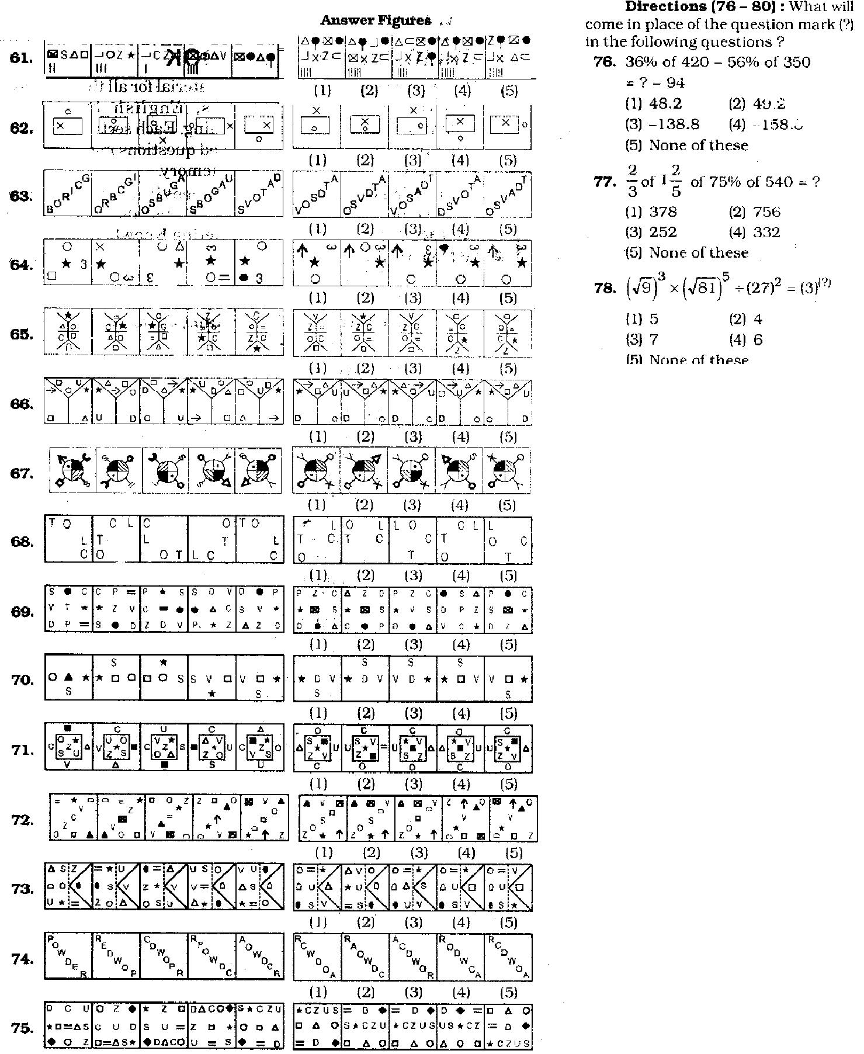

79. | 36 x 15 |  | 56 x 784 + 112 = ?
 | (1) | 138 | (2' | "So
 | (3) | 158 | (4) | 258
80. | (5) | None of these
80. | 28.314 31.427 * I ' o.!j28 = ?
 | + 29.114
 | (1) | 81.711 | (2) | 80 7u:
 | (3) | 71.711 | (4) | 81.701
 | (5) | None of these

Directions (81-85) • What ap-proximate value will come in place oi the question mark (?) in the following questions ? (You are not expected to calculate the exact va'ue).
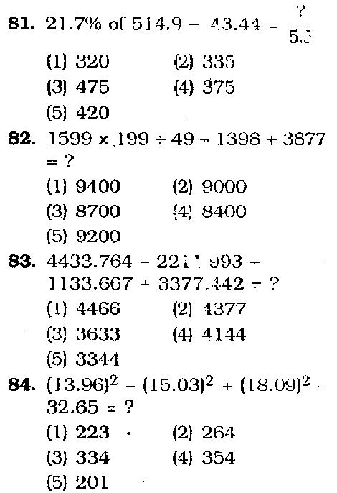

(1) (2) (3) (4) (5)

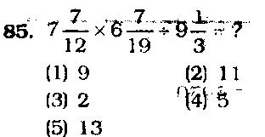
 |  |  |  |  |  |  |  |  |  |  |  | 96. | Twenty per cent of An uj'sannu
 |  |  |  |  |  |  |  |  |  |  |  |  | al salary is equal to seventy five
 |  |  |  |  |  |  |  |  |  |  |  |  | per cent of Raj's annual salary-
 |  |  |  |  |  |  |  |  |  |  |  |  | Raj's monthly |  |  | salary is |  |  | 6 0 % | of
 |  |  |  |  |  |  |  |  |  |  |  |  | Ravi's monthly salary. If Ravi's
 |  |  |  |  |  |  |  |  |  |  |  |  | annual salary is Rs . 1.44 lacs,
 | Directions |  |  |  | (86 - 90) |  | : W h a t will |  |  |  |  |  | what is Anuj's monthly salary ?
come in place of the'question mark (?) |  |  |  |  |  |  |  |  |  |  |  |  | (1) Rs . |  | 2,70,000
in the following number series ? |  |  |  |  |  |  |  |  |  |  |  |  | (2) Rs . |  | 27,000
86. | 13 | 16 | 22 |  | 33 , | 51 |  | (?) |  |  |  |  | (3) Rs . |  | 3,24,000
 | (1) | 39 |  |  | (2) | 78 |  |  |  |  |  |  | (4) | Rs . | 5,400
 | (3) | 102 |  |  | (4) | 69 |  |  |  |  |  |  | (5) None of these
 | (5) | None of these |  |  |  |  |  |  |  |  |  | 97. | Ram's present age is three times
87. | 39 | 52 | 78 |  | 117 | 169 |  |  | (?) |  |  |  | his son's present age and two-
 | (1) | 246 |  |  | (2) | 182 |  |  |  |  |  |  | fifth of his father's present age.
 | (3) | 234 |  |  | (4) | 256 |  |  |  |  |  |  | T h e average |  |  | f the present ages
 | (3) | 234 |  |  | (4) |  |  |  |  |  |  |  | of all of them is 46 years . What
 | (5) | None of these
 | (5) |  |  |  |  |  |  |  |  |  |  |  | is | the | difference |  |  | b e t w e e n the
88. | 62 | 87 | 187 |  | 4 1 2 | 8 1 2 |  |  | (?) |  |  |  | is | the
 |  |  |  |  |  |  |  |  |  |  |  |  | R a | ' s | son's | present age a n d
 | (1) | 1012 |  |  | (2) | 1437
 | (1) |  |  |  | (2) |  |  |  |  |  |  |  | Ra | 's father's present age ?
 | (3) | 1337 |  |  | (4) | 1457 |  |  |  |  |  |  | (1) | 68 years |  | (2) | 88 years
 | (5) | None of these |  |  |  |  |  |  |  |  |  |  | (3) | 58 yearso
89. | 7 | 8 | 24 | 105 |  | 361 |  |  | (?) |  |  |  | (4) | Cannot be determined
 | (1) | 986 |  |  | (2) | 617 |  |  |  |  |  |  | (5) | None of these
 | (3) | 486 |  |  | (4) | 1657 |  |  |  |  |  | 98. T h e ratio between |  |  |  |  |  | the | speed | of
 | (5) | None of these |  |  |  |  |  |  |  |  |  |  |  | m |  |  |  |  | : 15 | re-
 | (5) |  |  |  |  |  |  |  |  |  |  |  | a train and a car is 16 |  |  |  |  |  | : 15 | re-
90. | 656 432 |  |  |  | 320 | 264 |  |  | 2 3 6 |  | (?) |  | pectively. Also, |  |  |  | a b u s covered
 | (1) | 222 |  |  | (2) | 229 |  |  |  |  |  | sa d i t a n c e of 4 8 0 k m s . in 8
 | (1) | 222 |  |  | (2) |  |  |  |  |  |  |  | hours . T h e speed |  |  |  |  | of the bus |  | is
 | (3) | 232 |  |  | (4) | 223 |  |  |  |  |  |  |  |  |  |  |  |  |  | is
 | (3) | 232 |  |  | (4) |  |  |  |  |  |  |  | three - fourth the speed of the
 | (5) | None of these |  |  |  |  |  |  |  |  | or
 |  |  |  |  |  |  |  |  |  |  |  |  | train. How much distance will the
 | Directions (91 - 95) : |  |  |  |  |  |  |  | n the |  | fol - |  | car cover in 6 hours ?
lowing questions two equationskn u m - |  |  |  |  |  |  |  |  |  |  |  |  | (1) | 450 km |  | (2) | 480 km
bered 1 and II are given. Y o u have to |  |  |  |  |  |  |  |  |  |  |  |  | (3) | 360 | k m
 |  |  |  |  |  |  |  | I |  |  |  |  | (3) | 360 | k m
solve both the equations and |  |  |  |  |  |  |  |  |  |  |  |  | (4) | Cannot be determined
 | Give answer (1) if x > |  |  |  |  |  |  |  |  |  |  |  | (4)
 |  |  |  |  |  |  |  |  | y |  |  |  | (4)
 |  |  |  |  |  |  |  |  |  |  |  |  | (5) | No: AC of these
 | Give answer (2) if x > |  |  |  |  |  |  |  | y |  |  | 99. | T h e total area of a |  |  |  |  | circle and a
 | Give answer (3) if x < y |  |  |  |  |  |  |  |  |  |  | 99.
 |  |  |  |  |  |  |  |  |  |  |  |  | squai e is equal to |  |  |  |  | 5450 sq . cm .
 | Give answer (4) |  |  |  |  | if x < |  |  | y |  |  |  | T h e diameter of the circle is |  |  |  |  |  |  | 70
 | Give answer (5) if x = y or the |  |  |  |  |  |  |  |  |  |  |  | cms . W h a t is the s u m of the cir-
relationship cannot be established |  |  |  |  |  |  |  |  |  |  |  |  | cumference of the circle and the
 |  |  |  |  |  |  |  |  |  |  |  |  | perimeter of the square ?
 |  |  |  |  |  |  |  |  |  |  |  |  | (1) | 360 c m
 |  |  |  |  |  |  |  |  |  |  |  |  | (2) | 380 cm
 |  |  |  |  |  |  |  |  |  |  |  |  | (3) | 270 cm
 |  |  |  |  |  |  |  |  |  |  |  |  | (4) | Cannot be determined
 |  |  |  |  |  |  |  |  |  |  |  |  | (5) | None of these
 |  |  |  |  |  |  |  |  |  |  |  | 100. | T h e largest and the second larg
 |  |  |  |  |  |  |  |  |  |  |  |  | est angles of a triangle are in the
 |  |  |  |  |  |  |  |  |  |  |  |  | ratio of 3 : 2 |  |  | respectively. T h e
 |  |  |  |  |  |  |  |  |  |  |  |  | smallest angle is 2 0 % of the sum
 |  |  |  |  |  |  |  |  |  |  |  |  | of the largest and the second
 |  |  |  |  |  |  |  |  |  |  |  |  | largest angles . W h a t is the s u m
 |  |  |  |  |  |  |  |  |  |  |  |  | of the smallest and the second
 |  |  |  |  |  |  |  |  |  |  |  |  | largest |  | angles ?
 |  |  |  |  |  |  |  |  |  |  |  |  | (1) | 80° |  | (2) | 60°
 |  |  |  |  |  |  |  |  |  |  |  |  | (3) | 100° |  | (4) | 90°
 |  |  |  |  |  |  |  |  |  |  |  |  | (5) | None of these
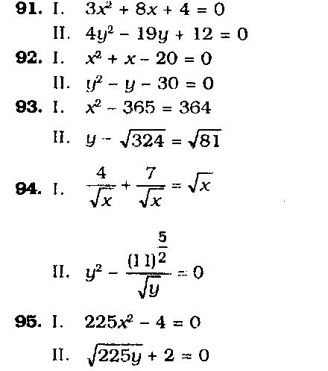
Directions (101 - 1 0 5 ) : Study the information carefully to answer the questions that follow.

In a school there are 1200 stu-dents w h o have visited five different cities viz. Delhi, Kolkata, Varanasi, Mumbai and Jodhpur . Forty five per cent of the total students are boys. Thirty per cent of the total girls visit-ed Mumbai . Two-fifth of the total girls visited Delhi. Number of girls who vis-ited J o d h p u r is half of the girls visit-ed Delhi. Two - third of the remaining girls visited Kolkata. Total number of students w h o visited Mumbai is 300. T w e n t y per cent of the total boys vis-ited Delhi. Forty per cent of the total boys visited Jodhpur . Equal number of boys visited Kolkata and Varanasi.

- What is the total number of girls w h o visited Delhi, Mumbai and Varanasi together ?
(1) | 4 6 4 | (2) | 484
(3) | 536 | (4) | 556

  - None of tr-ese

- Total n u m o e r of students who visited Jodhpur is approximate-ly what per cent of number of girls w h o visited Delhi ?

(1) | 111 | (2) | 91
(3) | 132 | (4) | 32

  - 72

- W h a t is the. average number of boys wiio visited Kolkata, Vara-nasi and J o d h p u r together ?

(1) | 110 | (2) | 122
(3) | 101 | (4) | 104

  - None of these

- W h a t is the total number of stu-dents w h o visited Varanasi ?

(1) | 78 | (2) | 69
(3) | 102 | (4) | 103

  - None of these

- W h a t is the respective ratio be-tween the number of girls who visited Kolkata and number of boys w h o visited Mumbai ?

  - 22 r 51

  - 23 : 51

  - 21 : 55

  - 51 : 2 2

  - None of these

Directions (106-110) : Study the following graph carefully to answer the questions that follow.
Number of Students (in thousands) in three Schools over the years
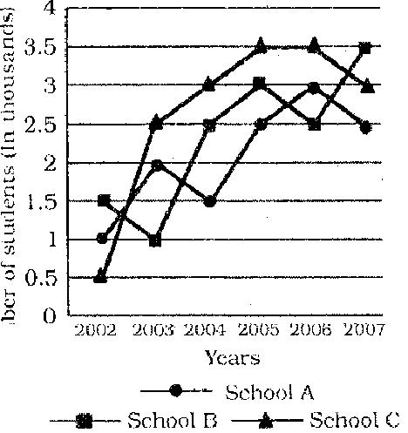

106. What was the average number i of students in all the Schools to-

gether in the year 2006 ?

- 30,000

- 9,000

(3) 3,000 (4) 6,000

  - None of these

- Total number of students in School B and School C together in the year 2004 was approxi-mately what percentage of the total number of students in School B and School C together in the year 2007 ?

(1) | 85 | (2) | 80
(3) | 75 | (4) | 184

  - 131

- How many times the total num-ber of students in all the three Schools A, B and C together was exactly equal among the given years ?

(1) | 2 | (2) | 5
(3) | 4 | (4) | 3

  - None of these

- What was the approximately average number of students in School A over all the years to-gether ?

(1) | 1990 | (2) | 2090
(3) | 2300 | (4) | 1800

  - 2700

- What was the difference between the total number of students in all the schools together in the year 2003 and number of stu-

dents in School B in the year 2005 ?
(1) | 2000 | (2) | 3000
(3) | 3500 | (4) | 2500
(5) | None of these
Directions (111-115): Study the following table carefully to answer the questions that follow.
Number of Officers (in thousands) passed out from five

different academies during six different years

Acade | Air | Army | Navy | Coast | BSF
mies | Force |  |  | Guard
Years'
2004 | 1.4 | 4.2 | 0.6 | 1.7 | 2.6
2005 | 1.7 | 5.1 | 0.9 | 2,8 | 3.1
2006 | 0.9 | 7.7 | 1.2 | 1.6 | 4.7
2007 | 2.4 | 3.6 | 1.8 | 4.7 | 5.8
2008 | 1.3 | 4.5 | 2.9 | 5.1 | 6.4
2009 | 2.7 | 3.9 | 3.5 | 3.9 | 4.3

- In which academy the total num-ber of officers passed out over all the years together was the maximum ?

(1) | Air force | (2) | Army
(3) | Navy | (4) | Coast Guard

  - BSF

- Number of officers passed out from BSF academy in the year 2008 was approximately what per cent of the total number of officers passed out from Army academy over all the years to-gether ?

(1) | 12 | (2) | 19
(3) | 33 | (4) | 28

  - 22

- What was the average number of officers passed out from all the academies together in the year 2007 ?

(1) 1830 (2) 3660

    - 3.66 lacs (4) 1.83 lacs

    - None of these

- In which academy the number of the officers passed out con-tinuously increased during the year 2004 to 2009 ?

    - Air Force

    - Army and BSF only

    - Navy only

      - Coast Guard

      - BSF and Navy only

  - What was the respective ratio between the number of officers

passed out from Air force acad-emy in the year 2006 and num-ber of officers passed out from Coast Guard academy in the year 2009 ?

(1) | 30 | : | 17 | (2) | 3 : 23
(3) | 17 | : | 30 | (4) | 45 : 13
(5) | None of these
Directions (116-120) : Study the following graph carefully and an-swer the questions that follow.
Three different products (in Thousands) produced by a company in five different years
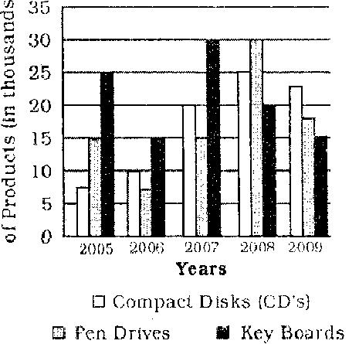

- What was the total number of all the products produced by the company in the year 2006 and 2008 together ?

  - 10750 (2) 107.5 lacs

(3) 105700 (4) 10570

  - None of these

- What was the average number of Pen-drives produced by the company over all the years to-gether ?

  - 1700 (2) 1.7 lacs

(3) 17000 (4) 85000

  - None of these

- What is the difference between the total number of Pen-drives and CDs produced by the com-pany together in the year 2008 and the number of Key boards produced by the company in the year 2006 ?

(1) | 40000 | (2) | 4000
(3) | 35000 | (4) | 3500

(4) None of these

- What was the respective $$jo between the number of ,K.sy boards produced by the compa-ny in the year 2006, 2007 and 2009 ?

(1) | 1 : 2 : 3 |  |  |  | GENERAL SOCIO - ECONOMIC
(2) 1 : 2 : 2
 |  |  |  |  | AND BANKING AWARENESS
(3) 2 : 1 : 3
(4) 1 : 2 : 1 |  |  |  |  | 126. As per the news published in
(5) None of these
 |  |  |  |  |  | various newspapers, some pub-
120. What was the respective ratio |  |  |  |  |  | lic sector banks are getting fresh
between the number of CDs pro- |  |  |  |  |  | capital infusion as a part of the
duced by the company in the |  |  |  |  |  | recapitalisation plan announced
year 2009 and the number of |  |  |  |  |  | by the Finance Minister in Unipn
Keyboards produced by the com- |  |  |  |  |  | Budget 2010-11. How much mon-
pany in the year 2005 ? |  |  |  |  |  | ey was earmarked for the same ?
(1) 9 : 10 |  | (2) 11 : 10 |  |  |  | (1) Rs. 10,000 crore
(3) | 10 : 9 | (4) 10 : 11 |  |  |  | (2) Rs.12,000 crore
(5) None of these |  |  |  |  |  | (3) Rs. 15,500 crore
121. The ratio between the angles of a |  |  |  |  |  | (4) Rs. 16,500 cr re
quadrilateral is 7 : 2 : 5 : 6 re- |  |  |  |  |  | (5) None of these
spectively. What is the sum of
 |  |  |  |  | 127. As per the rep rts published in
double the smallest angle and half
the largest angle of the quadrilat- |  |  |  |  |  | various newspapers, N n-Per-
 |  |  |  |  |  | forming Assets f the banks have
eral?
 |  |  |  |  |  | increased a little during 2009-10.
(1) | 162° | (2) 198° |  |  |  | What does it indicateoab ut the
(3) 99° |  | (4) 135° |  |  |  | perfor ance of the banks dur-
(5) None of these |  |  |  |  |  | ing that period ?
122. The sum of five consecutive num- |  |  |  |  |  | (A) Bank have not earned good
bers is 270. What is the sum-of |  |  |  |  |  |  | profitmduring the period.
the second and the fifth number ? |  |  |  |  |  | (B) Bank had given some loans
(1) 108 |  |  |  |  | swhich became bad loans.
(2) 107 |  |  |  |  |  | (C) Banks did not make provis-
(3) 110 |  |  |  | o |  |  | fon for such bad loans earli-
(4) Cannot be determined |  |  |  |  |  |  | er. ...
 |  |  |  |  | . |  | er. ...
(5) None of these |  |  |  |  |  | (1) Only (A)
123. 3 men can complete a piecekof |  |  |  |  |  | (2) Only (B)
work in 6 days. 5 women can |  |  |  |  |  | (3) Only (C)
 |  |  | I
complete the same work in 18 |  |  |  |  |  | (4) Only (A) and (C)
days. In how many, days will 4
 |  |  |  |  |  | (5) Only (B) and (C)
men and 10 women together com-
 |  |  |  |  | 128. The RBI has decided to introduce
plete the same work ? |  |  |  |  |  | which of the following systems in
(1) 3 days |  | (2) 5 days
 |  |  |  |  |  | place of the existing "Benchmark
A3) 2 days |  | (4) 4 days
 |  |  |  |  |  | Prime Lending Rate System" for
(5) None of these
 |  |  |  |  |  | charging interest on loans/ad-
124. A man crosses a stationary train |  |  |  |  |  | vances from July 2010 ?
in 12 minutes. The same train |  |  |  |  |  | (11 Prime Asset Lending System
crosses a man in 54 seconds.
 |  |  |  |  |  | \2) Base Lending Rate System
What is the respective ratio be-
 |  |  |  |  |  | (3) Net Lending Rate System
tween lhe speed of the train and
 |  |  |  |  |  | (4) Gross Lending Rate System
the man ?
(1) 40 : 7 |  |  |  |  |  | (5) None of these
 |  |  |  |  | 129. One of the sources of income of
(2) 400 : 3
 |  |  |  |  |  | banks is to charge fee for certain
(3) 40 : 3
 |  |  |  |  |  | services. What are some of the
(4) Cannot be determined
 |  |  |  |  |  | services provided by the banks
(5) None of these
 |  |  |  |  |  | for which they charge fee ?
125. If a number is subtracted by two- |  |  |  |  |  | (A) Issuing Demand Drafts/Pay
third of 75 per cent of 600, the |  |  |  |  |  |  | Orders
value so obtained is 320. What |  |  |  |  |  | (B) Issue of ATM/Creditl/Debit
is the number ?
 |  |  |  |  |  |  | Cards
(1) | 300 | (2) 620 |  |  |  |  | Cards
(1) | 300 | (2) 620 |  |  |  | (C) Electronic Transfer of Money
(3) 720 |  | (4) 500
 |  | (4) 500 |  |  |  | (1) Only (A)
-tpiq jgj | jyj_{o n e 0}f these |  |  |  |  | (2) Only (B)

    - Only (C)

    - All (A),(B) and (C)

    - None of these

- Which of the following is the full form of the term SLR as used in the banking sector ?

    - Social Lending Ratio

    - Statutory Liquidity Ratio

    - Scheduled Liquidity Rate

    - Separate landing Rate

    - None of these

  - As per the news published in a major newspaper, profits of a major private bank in the 4th quarter of the year increased by 35% as the bank decided to keep a tight control on the cost. What are some of the ways by which the banks can control the cost ?

      - By lowering down the inter-est rates on deposits

      - By bringing down the operat-ing expenses
      - By reducing the interest rates on the credit
        - Only (A)

        - Only(B)

        - Only (C)

        - All (A), (B)and(C)

        - None of these

  - As we all know, the major source of income of the banks is lending money (providing credit) and earn-ing interest on it. In normal cir-cumstances, the demand of the credit comes mainly from which of the following sectors ?

      - Personal Loans

      - Priority Sector Lending and Bailout Packages
          - Project Finance

        - Only (A)

        - Only (B)

        - Only (C)

        - All (A), (B) and (C)

        - None of these

  - The set of directive principles is-sued by the Central Bank of a country or the process adopted by it to control the supply of mon-ey, availability of money, cost of money and rate of interest, etc. in order to bring stability and growth of the economy" are com-monly known as —

(1) Monetary policy of the Cen-tral Bank of the countiy

  - Budget of the Government

  - Profit and loss Account

  - Business Policy df the Bank

  - None of these

- As per the news in some major newspapers, 'Kawasaki' has es-tablished an Indian unit to man-ufacture its products locally. What is the product of the Ka-wasaki ?

  - Luxury cars

  - Motorcycles

  - Tractors

  - Power tillers and agricultural equipments
  - None of these

- The Prime Minister of India was recently on a visit to Bhutan. He went there for which of the fol-lowing purposes ?

    - To attend SAARC Summit

    - To attend the CHOGAM

    - To inaugurate the first nucle-ar power plant of Bhutan made with the help of India

    - He was to attend the 50th Independence Day of Bhutan as Chief Guest

(5) None of these ^{r}

- As per the news published in some newspapers, some ndian business houses are willing to import Uranium from Australia. But due to certain regulatory is-sues, this is not possible for them. What is/are these regula-tory problems particularly those which govern the import/export of Uranium like materials ?

  - India has a special agreement with USA which does not al-low India to import such ra-dioactive materials from any-where else

  - India is not a signatory of Non-Proliferation Treaty. Hence, it cannot import Uranium from Australia or other such coun-tries

  - As per WTO rules, the export-import of radioactive material in its raw, form is not allowed as it creates health hazards.

    - Only (A)

    - Only (B)

    - Only (C)

    - All (A), (B) and (C)

    - None of these

- Many banks have launched / floated their subsidiaries which are fully owned by them. Banks launch subsidiaries normally for which of the following business-es ?

        - Home loan Business

        - To sell Insurance Policies

        - To control Online Operations or Internet Banking business
          - Only (A)

          - Only(B)

          - Only(C)

          - All (A), (B) and (C)

          - None of these

  - In one of his speeches, Dr Pranab Sen said that there is no firm in-dication of sustainable recovery of India's ec n my. Who is Dr Pranab Sen ?

            - He is Chief Statistician of In-dia
            - He is Chief Economist of RBI

            - He is the Deputy Chairman of the Planning Commission of India

            - He is the Foreign Secretary of India
            - None of these

    - When the common people of a nation start getting very high sal-ary or wages, the consumption of the goods like eatables and white goods, also start increas-ing. This situation brings which of the following types of inflation in the economy ?

              - Cost inflation

              - Demand pull inflation

              - Low inflation

Only (A) and (C)

Only(B)

Only(C)

All (A), (B) and (C)

Only (A)

      - When the Reserve Bank says that the Rupee is over-valued, it means

RBI has shortage of hard cur-rency and it has to order for printing of new notes to the press concerned

Rupee is appreciating against other currencies whereas oth-er currencies are weakening against US Dollar.

Money is locked in banks and people do not have enough to

make their day to day pur-chases, it is a strategy which brings the inflation down.

      - More and more people are selling their stocks. As a re-sult stock market may crash, as there is no hard cash for such voluminous transac-tions.

      - None of these

- Which of the following public sec-tor banks has the largest num-ber of branches in foreign coun-tries ?

      - Bank of India

      - Bank of Baroda

      - Punjab National Bank

      - Corporation Bank

      - None of these

- As per the news in some major newspapers, Tata Group of In-dustries has launched a joint ven-ture in some countries which is planning to generate power by

"the energy of the heat of the earth" . Energy generated through this method is technical-ly known as

        - Hydro-thermal energy

        - Natural power energy

        - Geo-thermal energy

        - Solar energy

        - None of these

  - Which of the following is now a fundamental right of every child in India ?

        - To get a unique identity card as a proof of citizenship
          - To get a free medical aid in any hospital in India, private or government
          - To get enough food to survive even without any parental support
          - To get elementary education

          - All of these

    - "Higher provisioning dragged the profits of the 4th quarter of some banks" was in the news in some major newspapers. This mea^ife that the bank

            - had many NPAs

            - had no NPA

            - was in great loss

            - was not able to earn any prof-it last year
            - None of these

- Which of the following agencies/ organizations has proposed to impose Global Taxes on all the banks ? (The issue was. dis-cussed in the meeting of the G-20 nations held recently.)

  - IMF

  - WTO

  - World Bank

  - Federal Reserves of U.S.A.

  - None of these

- As we see every day, many Indi-an banks are in close competi-tion to open their branches/of-fices in various countries. What benefit will the Indian economy have if banks open branches in a foreign country ?

  - It will bring substantial eco-nomic benefits to India and also to the countries where branches will be opened.

    - It will help in smooth inflow of FDI, long term capital in-flow and also technical know-how to India.

    - It will give better opportuni-ties to Indians to visit foreign nations and get better facili-ties like education, medical treatment, etc.

(1) Only (A) (2) Only (B)

  - Only (C) (4) Only (A) and (B)

  - All (A), (B) and (C)

- As we all know, RBI recently hiked the CRR by 0.25 basis points. What immediate impact will it have on the functioning of banks ?

(A) Banks will have to lock some additional fund with the RBI without any income generation to the banks on these funds,
(B) Banks will have to raise their capital base by bringing IPOs or by taking money from the Government of India.

(C) Banks will have to give more funds to priority sectors and less to corporate sector.

  - Only (A)

  - Only (B)

  - Only(C)

  - All (A), (B) and (C)

  - None of these

- Which of the following is NOT the name of a Chemical Fertilizer ?
  - Urea

  - Murate of Potash

  - Di ammonium Phosphate

  - Sodium Sulphate

  - All are fertilizers

- The Securities & Exchange Board of India (SEBI) has asked all FIIs to divulge the structure of their offshore entities. What purpose will it serve ?

    - To identify if there is any flow of funds from some question-able sources
    - To know how much money FIIs are planning to invest in India in 2010-11
    - To forecast the possibility of any financial crisis in near future.
  - Only (A)

  - Only (B)

  - Only (C)

  - All (A), (B)and (C)

  - None of these

- Which of the following schemes i to be launched by the Govern-ment of India with an initial fund f Rs. 100 crores ?

  - Mahila Kisan Sashaktikaran Pariyojana
  - Backward Region Grant Fund

  - Scheme for Women and Child Development
  - Sabke Liye Swasthya Yojana

  - None of these

- Government of India is making special efforts to bring second 'Green Revolution' in a particular region of the country. Which is that region ?

  - Central India

  - Vidharbha Region

  - Eastern and North Eastern States
  - Rajasthan

  - Orissa

- Which of the following pro-grammes has been launched by the "Ministry of Food and Civil Supplies', of the Government of India ?

  - Mid-Day Meal Scheme

  - Wheat-based Nutrition Pro-gramme
  - Public Distribution System

  - Annapurna Scheme

  - None of these

- Which of the following is a sort of Poverty Eradication Pro-

gramme of the Government of India, specially designed for ru-ral areas ?
  - Self Help Group

  - Antodaya Anna Yojana

  - Social Security for Agricultural and unorganized Labour

  - Enforcement of Minimum Wages
  - None of these

- What is the contribution of the agriculture and allied activities in the total GDP of the country ?
(1)4% | (2)8%
(3) 12% | (4) 23%

  - 17%

- 'Project Tiger' is a scheme launched by the —
  - Government of Gujarat and Madhya Pradesh
  - Government of India

  - United Nations Wild Life Fund

  - Society for Prevention of Cru-elty on Animals (SPCA)

  - None of these

- In each rupee earned by the Gov-ernment of India, how many paise come from the tax collec-tions or receipts ?

(1)29 paise | (2) 33 paise
(3) 50 paise | (4) 71 paise

  - None of these

- Which of the following is NOT the abbreviated name of a scheme launched for watershed develop-ments in India ?

(1) DPAP (2) DDP

(3) VHNDs (4) IWDP

  - Hariyali

- Government of India has allocat-ed a special package of central assistance of Rs. 12,000 crores for the drought mitigation in which of the following areas of the country ?

  - Bikaner in Rajasthan

  - Kalahandi in Orissa

  - Bundelkhand

  - Vidharbha

  - None of these

- Which of the following schemes of the Government of India is associated with the health sec-tor?

(l)NRDP (2)IRDP

- ASHA

- Bharat Nirman

- All of these

160. The per capita income bri current prices in India is R s : ' .

(1)20,000 | (2)25,000
("•) 30,000 | (4) .'57,000

  - 50,000

- Which of the following terms is NOT used in the game of Foot-ball?

  - Back Heel (2) Far Post

(3) Toe Poke (4) Out Swinger,

  - Love

- Which of the following teams won the 58th National Volleyball Cham-pionship Tournament held in Jan-uary 2010?

  - Karnataka (2) West Bengal

(3) Delhi (4) Kerala

  - Tamil Nadu

- The Population Stabilization Scheme launched by the Govern-ment of India is named

(1) Prerna (2) Sthapana

  - Unmesh (4) Aaradhana

  - None of these

- World Day for Water is observed on which of the following days ?
  - 22nd May

  - 22nd April

  - 22nd March

  - 20th March

  - 20th April

- Which of the following awards is given by the Government of In-dia?

  - Kalinga Prize

    - Oscar Awards

    - Man Booker Prize

    - Pulitzer Prize

    - Jawaharlal Nehru Award for International Understanding

- Who amongst the following is the Nobel Prize Winner for Literature for 2009 ?
    - Barrack Obama

    - Venkatraman Ramakrishnan

    - HertaMuller

    - V. S. Naipaul

    - None of these

- A.R. Rahman is NOT associated with which of the following films ?

(1) Ghajini (2) Rock Star

  - Slumdog Millionaire

  - Fashion (5) Raavan

- The third permanent research centre being built in Antarctica is named

(1) Partkrama (2)Rohini

(3)Bharati (4) Himalaya

    - None of these

- Lin Dan whose name was in the news recently is a famous
    - Lawn Tennis prayer

    - Badminton player

    - Golf player

    - Footballer

    - None of these

  - Who amongst the following is the author of the book "Many Lives Many Masters" ?

    - Robin Cook

    - BriyanViz

    - L. K. Advani

    - Ad iral Vishnu Bhagwat

    - None f these

  - Who a ongst the f llowing is NOT a Padma Shri Award winner ?
      - Virender Sehwag

      - Saif Ali Khan

      - PL Ulhas Kashalkar

      - Abhishek Bachchan

      - SainaNehwal

  - Which of the following countries won the under-19 World Cup Cricket Finals held in 2010 ?
      - Bangladesh

(2) India (3) New Zealand

(4) Pakistan (5) Australia

- Lt. General V. K. Singh is the —

  - new Lt. Governor of Delhi

  - new Lt. Governor of Chandi-garh

  - new Chief of Armed Forces

  - Governor of Rajasthan

  - None of these

- Who amongst the following is the recipient of the prestigious Dada Saheb Phalke Award announced recently ?

  - JavedAkhtar

  - Gulzar

  - Rajesh Khanna

    - DevAnand

    - None of these

- Who amongst the following is adjudged as "European Footballer of the year 2009"?
    - Christiano Ronaldo

    - Lionel Messi

    - Thierry Henry

    - Michael Owen

    - None of these

ENGLISH LANGUAGE

Directions (176 -190): Read the following passage carefully and answer the questions given below it. Certain words have been printed in bold to help you locate them while answering some of the questions.

Thinking of what education might look like in the next decade, one quickly realizes that the trends in technology are leaving a large number of our stu-dents behind. Today is an age of expo-nential change. New and ever-improv-ing technologies are popping up every day and in every corner of society.
Educating the best and the bright-est in this brave new world will take a new and improved educational para-digm. Allowing our educational tools to age in the corner of the classroom will be the mistake that may cost us our future. Throwing away masses of chil-dren to inequitable access will ensure that we languish at the bottom of the global pool of employable workers for decades to come.

Technology will shape 1 be way we educate students in the next decade. A user is not simply a person who uses. For the student, being a user should involve using the latest technology in a free and autonomous manner. This new-found freedom will allow the stu-dent to become an active participant in his/her education instead of a pas-sive passenger. In our current techno-logical society, being a user also means being tracked. Tracking a student means having the ability to target edu-cation towards weaknesses and strengths. The ability to accurately customize curricula to the individual has been the holy grail of educational philosophy for many years. This gold-en age of technological development may soon enable this dream to become a reality.

Current educational curricula and individual assessment is arbitrary at best. Accurately assessing a student can only be achieved by using modern tracking and database technologies. Imagine a world where every child has a tablet computer with ready access to the internet. Further, imagine that ev ery student can access all the knowl-edge of humankind freely at any mo-ment in time. Continue to imagine a world where a misspelled word brings

(2) All (A). (B) and (C)
(3) Only (B) and (C)
(4) Only (A) and (B)
(5) Only (A)
177. Which of the following is/are true in the context of the passage ?
(C) In the presence of technolo-gy each student would re-quire constant monitoring by other individuals to maximize learning.
(B) Educational philosophy is based on the belief of tailor-

up a spelling challenge application in- |  |  | er from the burden of record-keeping
stead of an auto correction. Try to con- |  |  | and tedious tasks that currently dis .
template what it would mean for a |  |  | tract from the real job of teaching and
teacher to have a database of every |  |  | learning.
misspelled word, every misunderstood |  |  | Under a standardized system,
concept or every missed, equation for |  |  | grade level will be far less important.
each of their students. Try to envision |  |  | Achievement and progression will be
a teacher with the ability to customize |  |  | measured by accomplishment and in-
the experience of the individual "user" |  |  | telligence as a benchmark for success.
with minimal effort. Imagine the cur- |  |  | The question of failure or success will
riculum being automatically targeted to |  |  | be irrelevant and replaced with a stan-
the user through an intuitive educa- |  |  | dard and consistent measurement of
tional platform that knows all strengths |  |  | potential and overall intelligence. Infor-
and each unique weakness. In the last |  |  | mation will no longer be missed but
few hundred years, most individuals |  |  | continually rehearsed and m nitored
would consider an education as some- |  |  | for retention by the machine. Tasks
thing you receive. You often hear the |  |  | such as data tracking, rep rting and
question asked, "Where did you receive |  |  | record keeping are currently accom-
your education?" As |  | we proceed | plished manually. These tasks could
 |  | we proceed | easily be delegated t |  |  |  |  |  | an intuitive da-
through the next decade, education will |  |  |  |  |  |  |  |  | an intuitive da-
 |  |  | tabase. Developing a standard to fol-
slowly move away from reception and
 |  |  | low would eli |  |  |  |  | o
toward being custom designed for the |  |  |  |  |  | inate these tasks and
 |  |  | free the teacher to do their main job of
individual user. New technology will not
 |  |  | teaching |  | tudents.
only allow us to receive an education,
 |  |  | The nextmdecade may mark the
but also develop an education. The
question we might ask in ten years, |  |  | m ment in hi tory when all are grant-
"How did you develop |  | your educa- | ed equal acces |  |  | to technology. Access
tion?" The question of where will still |  |  | s
 |  |  | t quality education will only be gained
be important, but the how of the mat - |  |  | thr ugh investment and universal stan-
 |  |  | dardization of this technology. If we
ter will be the focus that defines theo
individual. |  |  | continue to divert wealth towards fruit-
 |  |  | less goals and corporate greed, this
To make this a reality we willkneed
a standardized platform from which to |  |  | opportunity will be lost or hopelessly
 |  | Idelayed.
develop a student's unique education. |  |  | 176. According to the author, which of
This standardized platform will allow
 |  |  | the following will be the benefit(s)
us to tailor a custom curriculum that
 |  |  | of introducing |  |  |  |  |  | a standardized
will be matched to talents, interests |  |  |  |  |  |  |  |  | a standardized
 |  |  | technological platform?
and life goals. For the educator, a stan-
 |  |  | (A) |  | Potential of a child will take
dardized platform will create a way to
assist the student in discovering a true |  |  |  |  | precedence |  |  |  | over the grades
purpose in life through a unique edu- |  |  |  |  | he/she scores.
cational experience. The basics of read- |  |  | (B) |  | Improving |  |  |  | the educational
ing, writing and arithmetic will not be |  |  |  |  | syllabus would become easi-
taught as much as they will be discov- |  |  |  |  | er.
ered and used. Learning will become a |  |  | (C) Teachers would be able to
reciprocal experience |  | between the
 |  | between the |  |  | devote more time to teaching.
 | teacher, the student and the machine. |  |  | (l)Only(C)
Under a standardized platform, each of these three participants will have a role to play. The teacher will be the facilitator, assisting the develop-ment of the curriculum and inspiring the direction the student takes. The student will be the user, gathering re-sources, skills and knowledge in an efficient and measured sequence. The machine will do the work of data gath-ering and analysis, which will assist the teacher and student in refining the curriculum. This data gathering work of the machine will also free the teach-

ing educational syllabus to irid'ividual student capability.

- The author visualizes that each student 'will have ac-cess to technology in the fu-ture.

      - Only (A) and(B)

      - Only(B)

      - Only(C)

      - Only (B) and (C)

      - All (A), (B) and (C)

- Which of the following is possi-bly the most appropriate title for the passage ?

      - Technology - A Welcome Re-lief to Teachers
      - Revamping the Educational Sector - An Impossible Fu-ture
        - Education - Arbitrary But a Reality
        - Technology and the Economy

        - Technology - Reshaping the Future of Education

  - How, according to the author, will the perception towards education change over the next decade ?

        - Where an individual gets his education will gain increasing importance
        - Education will be viewed as a prerogative of the elite only
        - Creativity in an individual will be regarded as needless
          - The importance of education will decline
          - None of these

    - What does the author mean by the term "tracking a student" ?
          - Analyzing the strengths and weaknesses of a student and designing an educational syl-labus accordingly

          - Assessing whether a student is paying due attention to the existing curriculum offered by an institute of learning

            - Analyzing the positives and negatives of an educational institute and modifying it suit-ably to cater to industrial re-quirements

            - Following a student to the educational institute that he visits frequently in order 'to estimate the time he spends there

            - None of these

181. According to the author, why is |  |  |  |  | 184. RECIPROCAL
the current education provided |  |  |  |  | (1) interactive (2) unresponsive
not satisfactory ? |  |  |  |  | (3) reverse |  |  |  | (4) regular
(1) The teachers providing edu- |  |  |  |  |  |  |  |  | (4) regular
 |  |  |  |  | (5) inverse
 | cation are not qualified enough
 |  |  |  |  | 185. PARADIGM
 | to emphasize on quality
 |  |  |  |  | (1) change |  |  |  | (2) shift
(2) Quality of education provided |  |  |  |  |  |  |  |  | (2) shift
 |  |  |  |  | (3) future |  |  |  | (4) mode!
 | is not uniform across the |  |  |  |  |  |  |  | (4) mode!
 |  |  |  |  | (5) diagnosis
 | globe and individual assess-
 | ment is subjective |  |  |  | 186. AUTONOMOUS
(3) The educational |  |  | sector | is | (1) single |  |  |  | (2) independent
 | fraught with corrupt practic- |  |  |  | (3) governed |  |  |  | (4) forceful
 | es and thus does not produce |  |  |  | (5) insufficient
 | the desired result
 |  |  |  |  | 187. DELEGATED
(4) The education system is not
 |  |  |  |  | (1) taxed
 | guided by | technology and
 | guided by |  |  |  | (2) demoted
 | hence the pace of learning is
 |  |  |  |  | (3) input
 | slow
(5) There are too many schools |  |  |  |  | (4) authorized
 |  |  |  |  | (5) assigned
 | in the country which cannot
 | be monitored effectively |  |  |  | Directions (188-190): Choose
182. What is the author's vision re- |  |  |  |  |  |  |  | o
 |  |  |  |  | the word which is most opposite in
garding the integration of tech- meaning to the word printed in boM
nology with education ? |  |  |  |  | a u ed in the passage.
(A) | A substantial database con- |  |  |  | 188. INEQUITABLE
 | sisting of | each | student's |  |  | m |  |  | (2) complete
 | sisting of | each |  |  | (1) abundant |  |  |  | (2) complete
 | learning curve would be readi- |  |  |  | (3) unequal |  |  |  | (4) fair
 | ly available. |  |  |  | s
 | ly available. |  |  |  | (5) sufficient
(B) | An error would activate a soft-
(B) |  |  |  |  | 189. LANGUISH
 | ware which would encourage
 |  |  |  | o |  |  | ripen |  | (2) hasten
 | learning rather than auto - cor- |  |  |  | (1) |  | ripen |  | (2) hasten
 | recting. |  | k |  | (3) |  | flourish |  | (4) weaken
 | recting. |  |  |  | (5) climb
(C)
(C) | Experimentation in academ- |  |  |  | 190. ARBITRARY
 |  | I
 | ics would be encouraged. |  |  |  | (1) |  | objective |  | (2) deliberate
(1) Only(C) |  |  |  |  |  |  |  |  | (2) deliberate
(2) Only (A) and (B) |  |  |  |  | (3) random |  |  |  | (4) transparent
(3) A11(A),(B) and(C) |  |  |  |  | (5) lawful
(4) Only (A) and (C) |  |  |  |  | Directions (191-195): Which of
(5) None of these |  |  |  |  | the phrases (1), (2), (3) and (4) given
183. How has the author defined the |  |  |  |  | below each sentence should replace the
 |  |  |  |  | phrase given in bold in the following
term 'user' ?
 |  |  |  |  | sentence to make the sentence gram-
(1) One who invests in the latest
 |  |  |  |  | matically meaningful and correct. If the
 | technology | even when it |  | is
 | technology |  |  | is | sentence is correct as it is and 'No cor-
 | beyond his/her means
 |  |  |  |  | rection is required', mark (5) as the
(2) One who uses available tech-
 |  |  |  |  | answer.
 | nology to the maximum and |  |  |  | 191. After enjoying one of the biggest
 | for the longest period
 |  |  |  |  | successes of Indian cinema, the
(3) | One who freely and actively
(3) |  |  |  |  | actor is pulled the brakes on his
 | participates in |  | acquiring
 |  |  |  |  | career.
 | skills and knowledge in a sys-
 |  |  |  |  | (1) |  | has putting brake
 | tematic manner
 |  |  |  |  | (2) has pulled the brakes
(4) Anyone who invests in tech-
 |  |  |  |  | (3) is braking
 | nology as per his/her require-
 | ment and wherewithal |  |  |  | (4) is put brakes
(5) | None of these |  |  |  | (5) |  | No correction required
Directions (184-187) : Choose |  |  |  |  | 192. Many of our tinsel town beauties
the word which is most similar in |  |  |  |  | will bit the panic button if they
meaning to the word printed in bold |  |  |  |  | didn't have at least one movie in
as used in the passage. |  |  |  |  | hand.

    - would hit panicky buttons

    - would hit the panic button

    - will be hitting panic buttons

    - have hit panicky button

    - No correction required

- Alarm to declining marriage fig-ures and increasing divorce rates, the government has come up with a novel way to tackle the issue.

    - Aiamiingly on

    - Alarming as

    - Alarms with

    - Alarmed by

    - No correction required

- The two sisters dropped in to watch the film with none other than their father.

    - dropping in for

    - dropped by as

      - drop on to

      - dropped in for

      - No correction required

- The researchers found that chil-dren with lung disease are at in-crease risk for developing a sec-ond type of pneumonia.

  - (1) were at increased risk

      - is increasingly risking

      - is increased risky '

      - are increasingly risky

      - No correction required

Directions (196-200) : Each question below has two blanks, each blank indicating that something has been omitted. Choose the set. of words for each blank which best fits the mean-ing of the sentence as a whole.

196. What goes into making a marriage can only be by trial and error

and couples are best left to out what works.
  - discovered, translate

  - regulated, find

  - learnt, figure

  - seen, thrash

  - experienced, judge

- The producer is known to with new stars and fresh talent, and though there have been a few hits and misses, this filmmaker

totally for the new breed.

- try, demands

- experiment, vouches

- sign, goes

- produce, promises

- work, supports

198. The Government stated that it had the right to use as much

force as was necessary to regain
control of areas |  | by terror-
ists.

  - free, marked

  - practical, left

  - fundamental, infest

  - basic, undertaken

  - legitimate, dominated

- Obesity and alcohol __ togeth-er to ; the risk of liver dis-ease in both men and women.

  - act, increase

  - result, aggravate

  - taken, arrest

  - put, heighten

  - mix, lower

- There were screams, chills and

thrills at the discotheque the

other night as the director along with the producers hosted a party to the success of their lat-

est horror flick.

- combined, downplay

- alike, mourn

- experiences, mark

- galore, celebrate

(5) risen, generate |  | t
Directions (201- | 205) | : Rear-
range the following six sentences (A), (B), (C), (D). (E) and (F) in the proper sequence to form a meaningful para-graph; then answer the questions giv-en below them.

- However, many people may not be aware of the numerous oth-er areas where it has been ap-plied.
- Today, even, those who have little knowledge about the pro-duction of virtual reality are now most likely aware of its use in video games.

- Similarly, medical students have substituted a cadaver for a fiberglass mould of a body and a headset when training to perform surgery.

- Virtual reality was an unfamil-iar concept to many people till the early 90's.

- Introducirigvirtual reality to the real world, thus, has already proven to be beneficial for ev-

In | V ery industry it encounters.
In | 9 | 1 | For example, astronaut' train-
In |  | 1 | ees have recently used virtual
lit |  |  | reality to simulate a trip to
lit |  |  | space.

- Which of the following should be the FOURTH sentence after re-arrangement ?

(1) | E | (2) | F
(3) | A | (4) | D

(5) B

- Which of the following should be the FIRST sentence after rear-rangement ?

(1) | A | (2) B
(3) | C | (4) D

  - E

- Which of the following should be the LAST (SIXTH) sentence af-ter rearrangement ?

(1) | A | (2) B
(3) | C | (4) D

(5) E

- Which of the f ll wing should be the SECOND sentence after re-arrange ent ?
(1) | B | (2) C
(3) | D | (4) E

  - F

- Which of the following should be the FIFTH sentence after rear-rangement ?

(1) | A | (2) B
(3) | C | (4) D
(5) | E

Directions (206- 215) : Read each sentence to find out whether there is any grammatical error in it. The er-ror if any will be in one part of the sentence, the number of that part will be the answer. If there is no error, the answer is (5). i.e. 'No error'. (Ignore the errors of punctuation, if any.)

- Human babies whose mothers (1)/ have had the flu while preg-nant may (2)/ have a greater risk of developing (3)/ schizophrenia lately in life. (4)/ No e.iror {u)

- Six women achievei s, who con-tinue (1)/ to inspire the younger lot, were honoured (2)/ with their contributions in their chouen fields (3) / on the occasion of wom-en's day. (4)/ No error (5)

- All Indians know that they are (1)/ superior in all respects not only to (2)/ those unfortunately beings called foreigners, but (3)/ also that they are superior to all other Indians. (4)/ No error (5)

- While the handsome actor was busy (1)/ belting out one-liners, his (2)/ graceful co-star was a (3)/ i_. mplele imagery of woman pow-er. (4)/ No e.rcr (5)

- He is one of the first film pro-ducers (1)/ to actually take the much needed step (2)/ against stars putting up information about (3)/ under-production films on social networking websites. (4)/ No error (5)

- It was an evening of (1)/ fun and frolic as the city's glitterati (2)1 and high-profile businessmen made sure (3)/ that they didn't miss the show. (4)/ No error (5)

- Results founding that boys not only (1) / play more than girls, but (2)/ they start earlier, an outcome that (3)/ could be clearly related to a cultural influence. (4)/ No error (5)

- Videogames may not (1)/ neces-sarily adversely affect (2)/ the academic results in children (3)/ contrary to most parents's per-ception. (4)/ No error (5)

  - Celebrities showed their childlike side (1)/ yesterday, as most of them turn up wearing (2)/ car-toon T-shirts for the screening of (3)/ the latest animated film in town. (4)/ No error (5)

  - The study focusing exclusively to (1)/ critically ill children found that children with chronic illness-es, (2)/especially respiratoiy ill-nesses, are most likely, (3)/ to develop influenza that requires critical care. (4)/ No error (5)

Directions (216-225) : In the

following passage there are blanks, each of which has been numbered. These numbers are printed below the passage and against each, five words are suggested, one of which fits the blanks appropriately. Find out the ap-propriate word in each case.

Prior to independence the health-care sector in India was in a (216) with a large number of deaths and rampant spread of infectious diseases. After independence the Government of In-dia laid (217) on primary healthcare and India has put in sustained efforts to better the healthcare system (2181 the country, The government initiative was not enough to meet the demands of a growing population be it in prima-ry, secondary or tertiary healthcare. Alternate sources of finance were crit-ical for the sustainability of the health sector.

Till about 20 years ago, private sector ventures in the healthcare see-

tor (219) of only solo practitioners, small hospitals and nursing homes. The qual-ity of service provided was excellent especially in the hospitals run by char-itable trusts and religious foundations. In 1980's realizing that the government on its own would not be able to {220) for health care, the government allowed the entry of private sector to reduce the (221) between supply and demand for healthcare. The establishment of the private sector has resulted in the (222} of opportunities in terms of medical equipment, information technology in health services. BPO, telemedicine and medical tourism.

Large companies and (223) indi-viduals have now started five star hos-pitals which dominate the space for the high end market. The private sector has made (2241 progress, but on the flip side it is also responsible for in-creasing (225) in the healthcare sec-tor. The private sector should be m re socially relevant and effort must be made to make private sector accessi-ble to the weaker sections of society.

216. | (1) shambles |  | (2) failure
 | (3) demand |  | (4) | prosperity
 | (5) ruined
217. | (1) | bricks | (2) emphasize
 | (3) request |  | (4) | stress
 | (5) | important
218. | (1) through |  | (2) | across
 | (3) sharing |  | (4) with "
 | (5) | on
219. | (l)made |  | (2) | comprise
 | (3) | consisted | (4) | is
 | (5) | contained
220. | (1) | cater | (2) | provide
 | (3) | manage | (4) survive
 | (5) | give
221. | (l)gap |  | (2) position
 | (3) distance |  | (4) length

(5) thought

- (1) reduction (2) sea

 | (3) | cropping | (4) disabling
 | (5) emergence
223. | (1) | needy | (2) destitute
 | (3) bigger |  | (4) affluent
 | (5) | much
224. | (1) slowly |  | (2) improve
 | (3) many |  | (4) improvised
 | (5) | tremendous
225. | (1) | speed | (2) pace
 | (3) inequality |  | (4) uniformity
 | (5) | seriousness

