1. GET list of all users

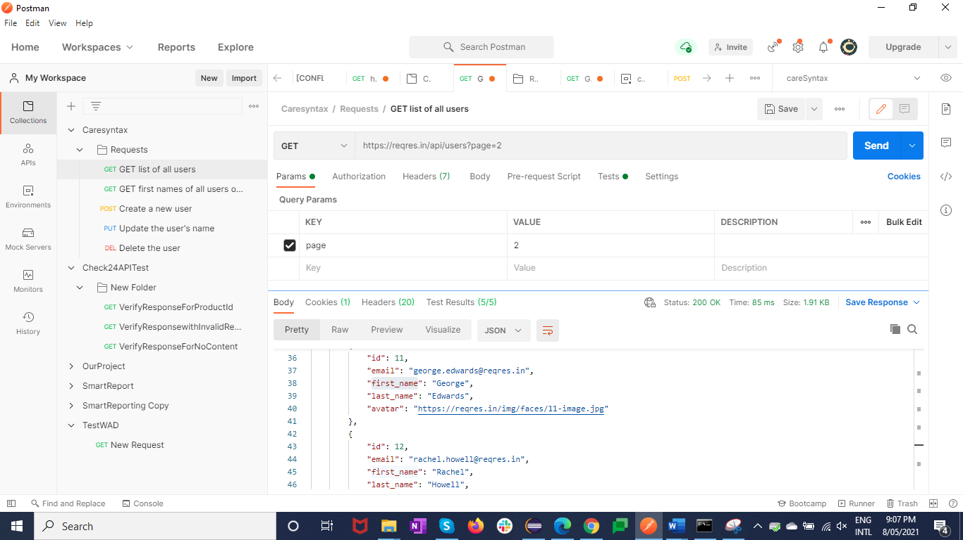

Verified below points for request

1. Verified response body
2. Verified response code
3. Verified header has “content type”
4. Verified response time
5. Verified status code string

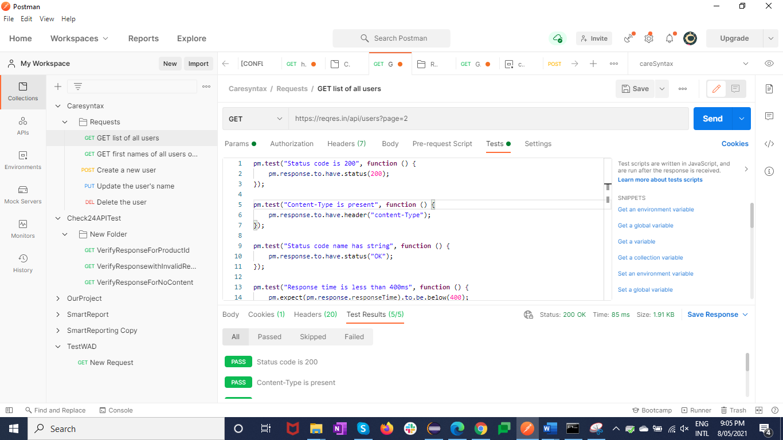

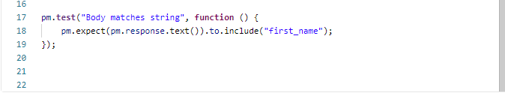

1. GET first names of all users on page 2

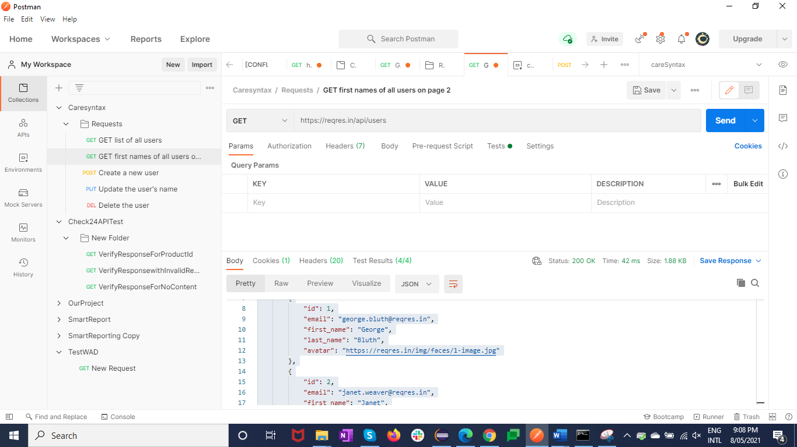

Verified below points for request

a.Verified response body

b.Verified response code

c.Verified header has “content type”

d.Verified response time

e.Verified status code string

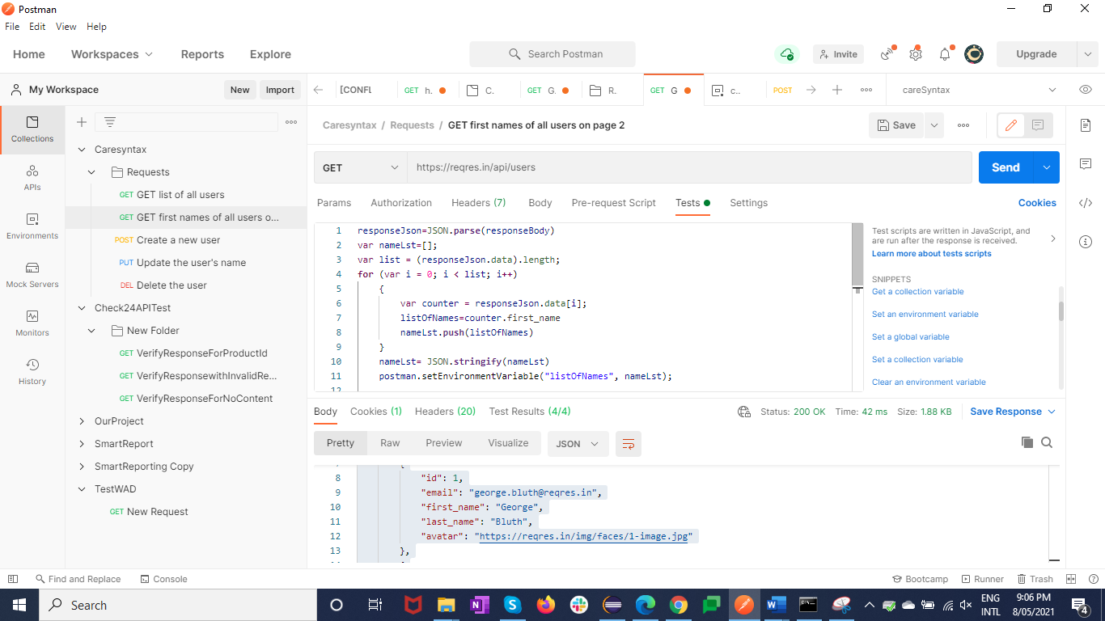



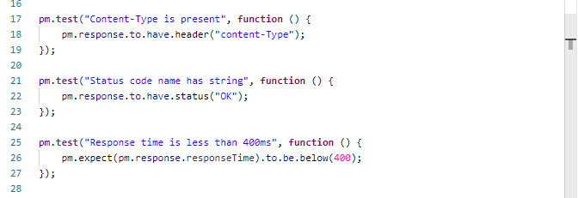

o/p variable

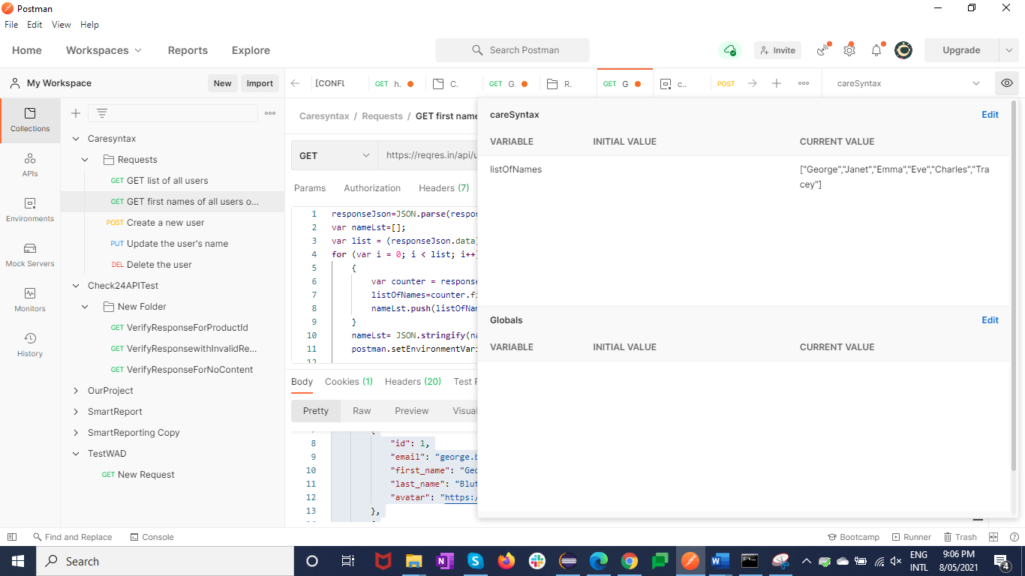

3. Create a new user with the name "Arnold" and Job as "Dev" and print new users details name and ID

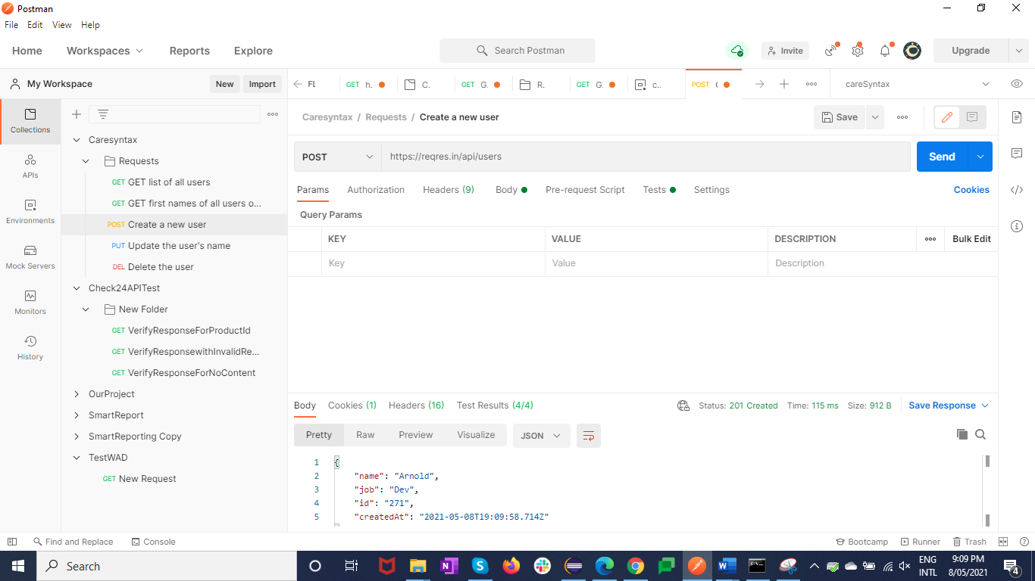

Verified below points for request

a.Verified response body

b.Verified response code

c.Verified header has “content type”

d.Verified response time

e.Verified status code string

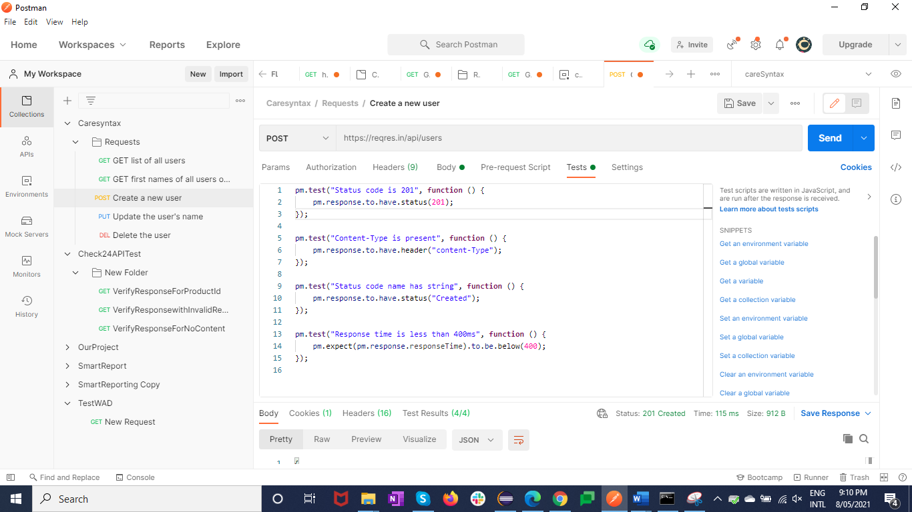

4. Update the user's name to "Sam"

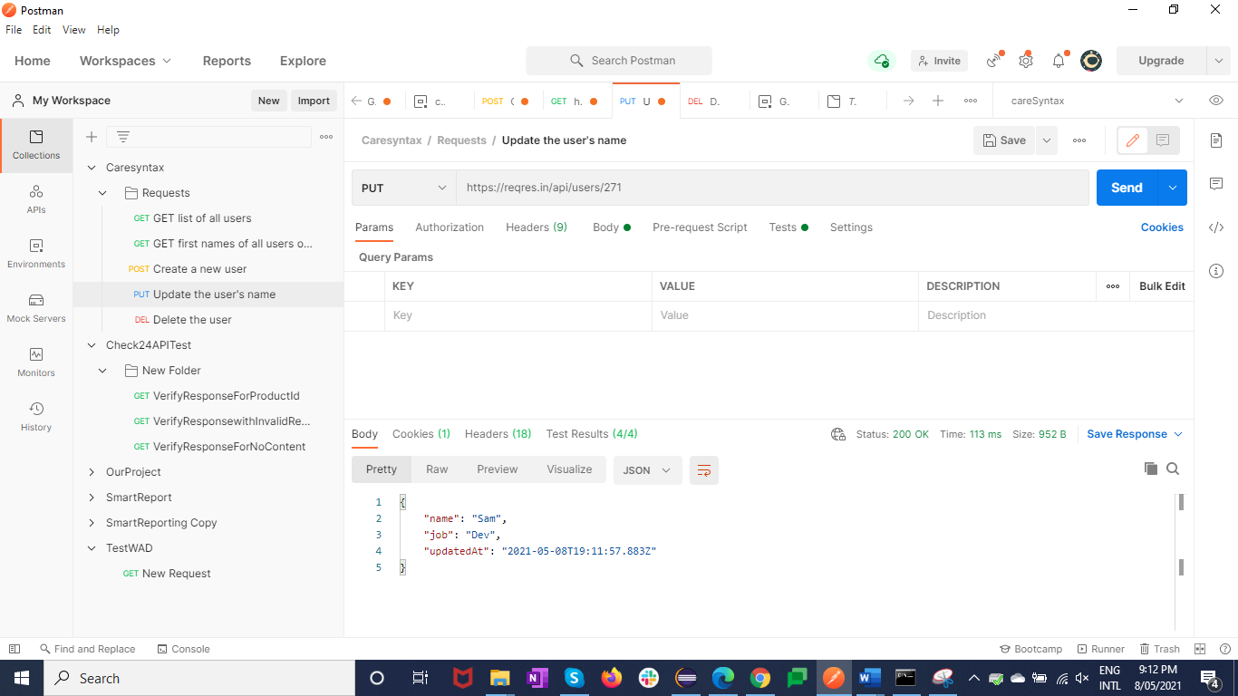

Verified below points for request

a.Verified response body

b.Verified response code

c.Verified header has “content type”

d.Verified response time

e.Verified status code string

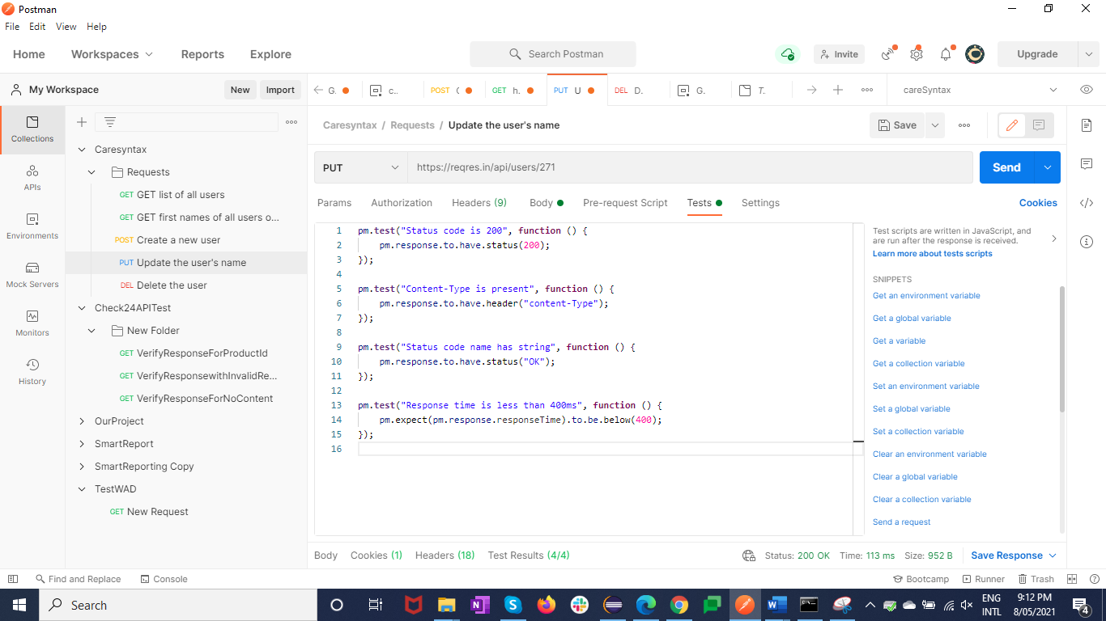

5. Delete the user

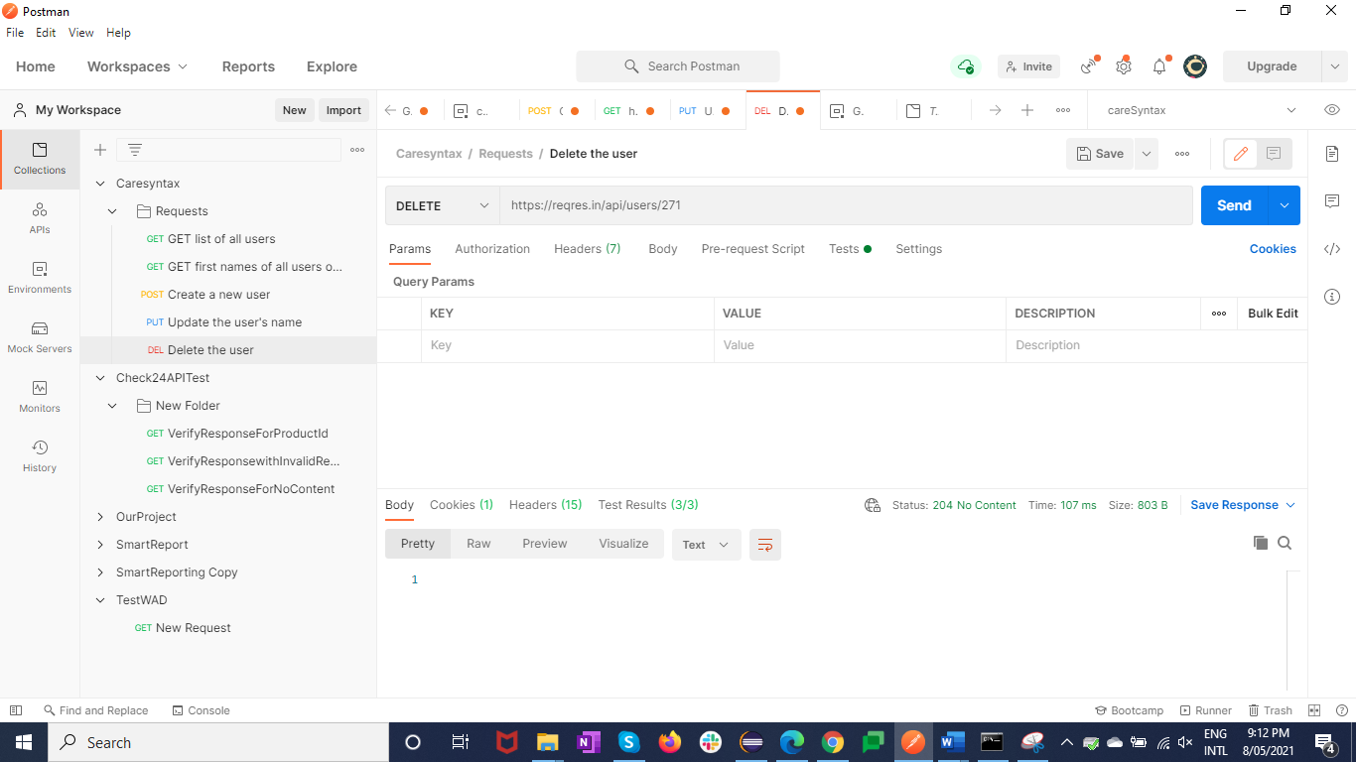

Verified below points for request

a.Verified response body

b.Verified response code

c.Verified response time

d.Verified status code string

