Prerequisite:

Step 1: Install node.js

Step 2: Verify version of node using command 'node -v'

Step 3: Verify version of node using command 'npm -v'

Step 4: Install newman using command 'npm install -g newman'

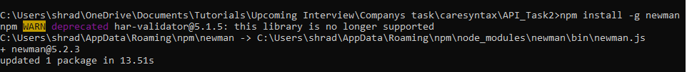

Step 5:Run command newman run Caresyntax.postman_collection.json



Step 6:Verify results on console

