

**e-Yantra Robotics Competition - 2016**

**Theme and Implementation Analysis – Cross a Crater**

**#1146**

|  |  |
| --- | --- |
| **Team leader name** | BOLLAPRAGADA LALITHA SAI SHRADDHA |
| **College** | PES University |
| **Email** | shraddhaszz@gmail.com |
| **Date** | 5/2/2017 |

**Scope and Preparing the Arena**

**Q1 a. State the scope of the theme assigned to you. (3)**

Answer:

The theme, cross a crater includes the entire process crossing the cavities on its way back to the base station after collecting samples. It includes various hindrances (cavities and obstacles) and how to overcome them. By using image processing, we detect the cavities and obstacles on the way. Also, we need to mathematically determine the best bridge to be traversed among the two bridges by appropriate algorithms.

The firebird should avoid the green obstacles and fill the cavities with boulders.

1. **Attach the Final Arena Images. (20)**

**## Sent with the Document in the Zip file.**

**Building Modules**

**Q2. Identify the major components required for designing the robotic system for the solution of the theme assigned to you. (5)**

Answer:

**Mechanical components:**

1. Limb: It will be connected using actuators (servo motors) in order to pick up the boulders and fill the craters, cloning an arm.

**Electrical components:**

1. Motor: We use a servo motor to control the angle of the limb to pick up the right boulder which might be at a random angle.
2. Electromagnet: The electromagnet is present on the end of the limb which is used to pick up the boulder which has to be put in the crater. The boulder will contain a small piece of magnetisable material that enables it to get attracted to the electromagnet.
3. Battery Supply: To power the Electromagnet.

**Electronic components:**

1. Motor Bridge: To reverse the polarity of the electromagnet while picking up ad dropping the boulder.

**Actuators**

**Q3. List all the actuators present on Firebird V robot. Besides the existing actuators, please mention any additional actuators that may be required for designing the theme. (5)**

**Existing motors on the Firebird V:**

1. Two 60 rpm DC geared motors (its motor drivers are already attached on the firebird)

**Additional motors that are required:**

1. Servo motors: We use a servo motor to control the angle of the limb to pick up the right boulder which might be at a random angle.

**Power Management (2)**

**Q4. Explain the power management system required for a robot in general and for Firebird V robot in particular.**

The robot can work in two modes. Either of the modes can be used for powering the robot.

There are two modes:

 Battery power: Its voltage rating is 9.6V and is a 2100mAH dc source.

It will be used during run time of the robot so that there is no obstruction due to the wires of the adapter. This battery is placed on the Firebird itself, so it will not cause any hindrance to the movement of the robot.

Auxiliary power: Its voltage rating is 9V and current rating is 1A which is a DC adapter. It can be used during the testing phase.

**Design Analysis**

**Q5.** **Teams have to design a mechanism for picking and dropping the Boulders into the Cavities.**

1. **Choose an** **option to position the mechanism on the robot and why? (4)**
2. **Front 2. Back 3. Right/Left**

Answer: Front. Front side of the firebird is preferred so that the angle between the robot and boulder remains same for boulders on both sides of the robot. If the limb is placed behind, the angle calibration would be 180- (the certain angle) whereas when we put it in the front, it would be 0+ (desired angle). Also, it has to be placed in the front so that filling of cavities takes place before the robot has to cross the cavities**.**

1. **Explain the design of the mechanism and how it is mounted on the robot. (4)**

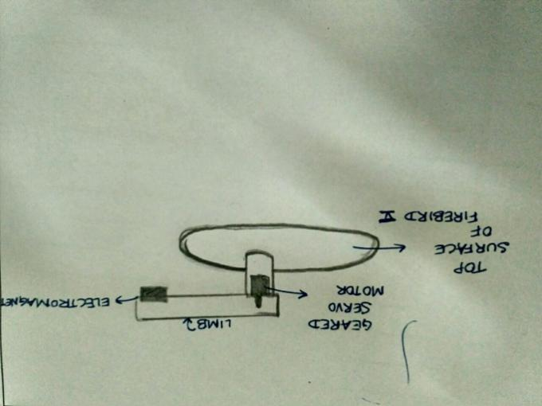

1. **To design the mechanism for picking and dropping the Boulders, what challenge/s do you expect to face and how you will overcome them? (2)**

Answer:

1. Challenge: To pick the boulder in the crater region arena.

Solution: We are using electromagnets which will pick up the boulder by electromagnetism.

1. Challenge: Powering the electromagnet which will lift the boulder.

Solution: By using batteries to power the electromagnet.

1. Challenge: Dropping the boulder over the cavity

Solution: By using the motor bridge in order to reverse the polarity of the electromagnet by programming it.

**Q6. Choose the actuator/s you will use to design the mechanism. (2)**

* **DC-Motor 2. Servo Motor 3. Stepper Motor 4. Others**

**Answer: _______2. Servo motor__________**

Answer:

Advantages:

* For better accuracy of positioning and angle control.
* Servo’s have better error sensing feedback control which is utilized to correct the performance of a system.
* Programming it is easier.
* Inexpensive.
* Geared motor provides better torque.

Why not DC motor?

Because it is difficult to control the angle at which it must position itself.

Why not Stepper motor?

Because if the motor is not controlled well, it can easily cause resonance.

**Environment Sensing**

**Q7. Explain how you will use the USB camera to decide the course of action. (5)**

Answer:

The overhead camera which is placed at 7 feet is crucial in obtaining the exact position of all the components in the arena (obstacles, cavities, and the 2 bridges) and also the numbers on the boulders, depending on which the appropriate boulder can be selected to be picked up by the arm to finally give the required Sum value.

The USB 2.0 extension cable will be used to connect the USB of the camera to the laptop (or another arduino). So, the images from the camera will be analyzed to detect the navigation of the robot and will be send via Xbee communications.

The (x, y) position of obstacles (green) and cavities (blue) will be found and the best possible path and bridge will be chosen, using the algorithm.

During the Run, we will keep tracking the position of the firebird on the arena and will be giving necessary fudge factor rectification to get the firebird back on track.

**Q8. Name the sensors (if any) on Firebird V used to complete the task. If used, describe the placement of these sensors on the robot and briefly explain the reason for their placement. If not, justify not using these sensors.**

Answer:

1. Sharp IR Range Sensors: There is one Sharp IR Range Sensor in the front part of the Firebird module. This will be used to detect any object (boulder or obstacles) present in the front of the bot. It will tell us the distance of the object so that it does not collide and also stays within the arena limits.

2. IR proximity sensor: There are 8 IR proximity sensors placed on all sides of the bot because it needs to detect objects on all sides. It detects objects within the range of about 10cms. In case, it detects on any one side, the bot must move away from it without colliding.

3.Whiteline sensor: There is an array of 3 white line sensors placed beneath the bot so that, each node present on the flex sheet of the Base Arena and Crater region arena can be detected indicating that it must stop at that point.

4. Position Encoder: There are 2 Position Encoders which are basically slotted discs placed on the shaft of the DC motors and the wheels. It is required to tell us the distance by which the robot has moved. By this, we can also calculate the velocity.

5. Infrared TSOP Receiver: Not used by us.

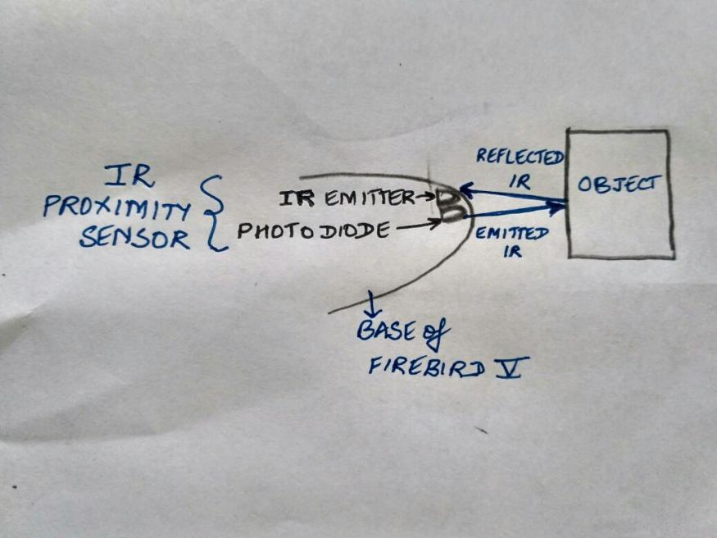

**(2)**

**Communication**

**Q9. Describe the method of communication between the computer and the Firebird V robot. Please draw a block diagram illustrating the same. (3)**

Answer: From the overhead USB camera which is connected to the laptop via the USB extension cable, the image is sent to the laptop and processed. The laptop communicates wirelessly with the Firebird using the Xbee communication modules.

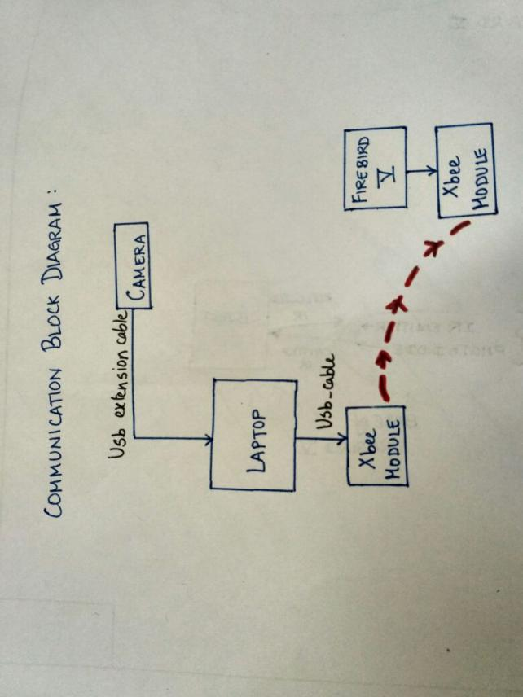

**Testing your knowledge (theme analysis and rulebook-related)**

**Q10. How will you analyze the Sum given during execution of the code? (4)**

Answer:

1. The sum will be provided initially to the laptop/PC.
2. The numbers on the boulders is detected by the camera and feeded to the laptop.
3. Various combinations of the sum of the detected boulder numbers are computed with either three boulders (assuming bridge 1) or two boulders (assuming bridge 2).
4. If only one of the sum satisfies the condition, the respective bridge is chosen
5. If sum satisfies Bridge 1 and Bridge 2,then the bridge which has to be chosen for traversing must be based on the duration the firebird takes and probably the bridge with higher number of cavities.

Algo example:

Sum: 10

Boulder: 0 2 8 2

Solutions found: (0+2+8) , (0+8+2) , (2+8) , (8+2)

Solution chosen: (0+2+8)

**Q11. Illustrate the risks and the rewards associated with each bridge. If a Sum satisfies both bridges, how your code will decide which bridge to use? Explain the factors influencing the bridge choosing decision in this scenario. (4)**

Answer:

1. The reward maybe be higher on bridge 2, but the risk of the firebird falling of the bridge due to the extra navigation of avoiding the obstacles is higher, hence we shall avoid using it. On the other hand we believe it is easier to pick a boulder and place it in the cavity, thus we would prefer bridge 1.
2. First various combinations of sum with either 3 or 2 boulders is calculated. If only one of these sums match the given sum, the particular bridge is chosen.
3. If there is a conflict Bridge 2 is chosen if the number of obstacles are minimum or else Bridge 1 will be chosen. (More preferably bridge 1 as we would score higher by picking more boulders).

Algorithm example:

Sum: 10

Boulder: 0 2 8 2

Solutions found: (0+2+8) , (0+8+2) , (2+8) , (8+2)

Solution chosen: (0+2+8)

**Q12. How will you detect the Cavities and Obstacles on the arena? (10)**

Answer:

Step 1: The image of the arena is sent from the camera via Xbee communications.

Step 2: It is now processed on the firebird using Libraries available in OpenCV.

Step 3: The RGB values of the pixels are checked to match the values of green and blue colour. This is done using Feature matching and Template Matching. Previously generated test images shall be taken and tested with.

Step 4: If Green Colour is detected, the area of the colour is stored as the position of an Obstacle.

Step 5: If Blue Colour is detected, the area of the colour is stored as the position of a cavity.

(The area will be mapped as coordinate on the arena.

**Q13. Explain in brief the navigation algorithm you will use for various regions of the arena. (10)**

The algorithm is predominately based on the speed of the firebird. Our navigation needs to be automated and a standalone system, for that we will use the concept of coordinate geometry to map entire arena and the various bridges and regions within. We will experimentally and mathematically test out with the firebird to create a ground: image distance and the velocity of the firebird.

Our main goal is not only to complete the track but also pick as many boulders as possible. Thus for the given sum we will navigate to the respective boulders and choose the bridge with higher number of boulders. Preferably the first bridge as navigating on the second bridge would be hard and unpredictable. The coordinates calculated would be mapped to linear mono directional units on the base station and on the crater region as we would use the black line follower method to navigate through these terrains.

**Algorithm Analysis**

**Q14. Draw a flowchart illustrating the algorithm you propose to use for theme implementation. (10)**

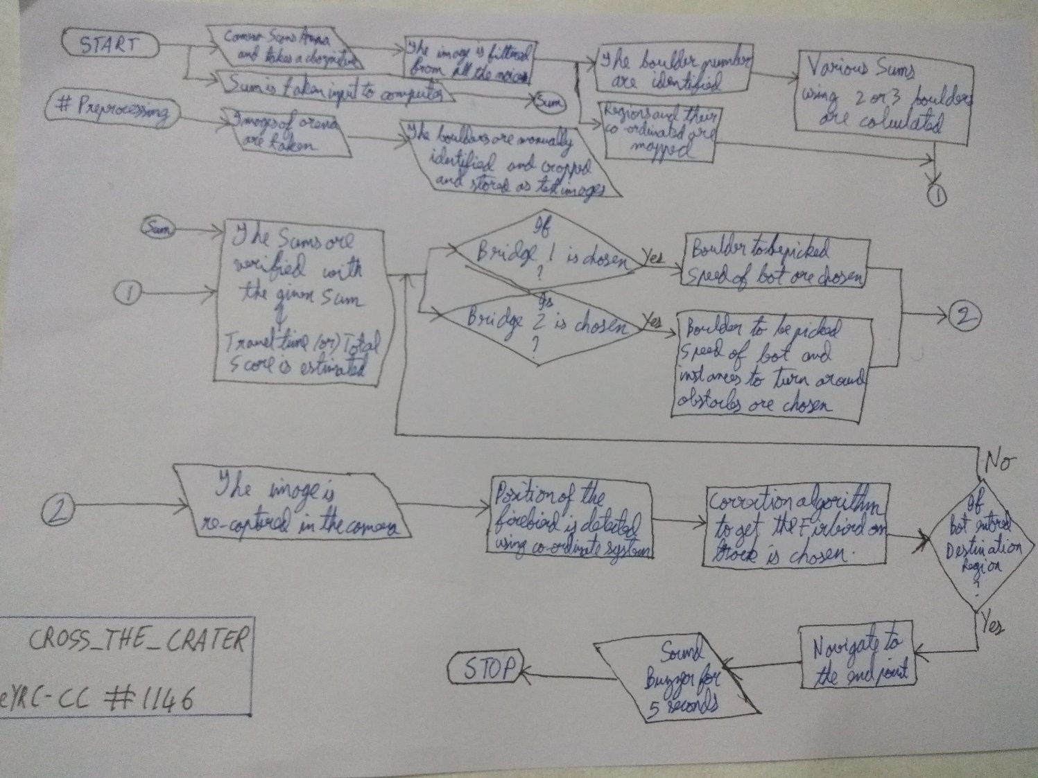

**Challenges**

**Q15. What are the major challenges that you can anticipate in addressing this theme and how do you propose to tackle them? (5)**

Answer:

1. Challenge 1: Complexity in the mechanism of lifting and dropping boulders.

Solution: By using a simple arm, with a single limb, having only one degree of freedom as we use only one servo motor for it. Complexity of the gripper is greatly reduced by the use of the electromagnet.

2. Challenge 2: Finishing the task in the specified time.

Solution: Developing a simple algorithm to choose the fastest route and also match the Sum to the required value.

3. Challenge 3: Maintaining the Balance of the Firebird

Solution: Using very light material to make the limb of the arm and trying to center the firebird on the bridge.

1. Challenge 4: Friction on the surface

Solution: Make the firebird travel at optimum speeds at the optimum places.