Draw the Path: Portfolio Sitemap + Toolkit
Track: General AI Fluency Phase: Setup Workload: 3h
Name: Shraddha Chavan

1. Proof Statement
I clean and prepare messy real-world datasets using Python and pandas, turning raw, error-filled data into something usable. I am proving this to a hiring manager at a small data/analytics team looking for an intern, so they will email me to set up an interview.
Why it needs a portfolio: A CV can list "Python, pandas" as a bullet point, but it can't show a hiring manager my actual before-and-after work — my portfolio does.

2. Sitemap Sketch
Home (states the claim) → Work (proves the claim) → About (rewritten to reinforce the claim) → Contact (drives the one action: email).
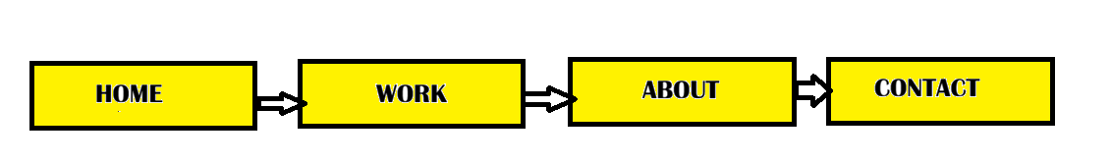

3. Toolkit Setup — Evidence
Claude Project — "Portfolio" (custom instructions with proof statement)
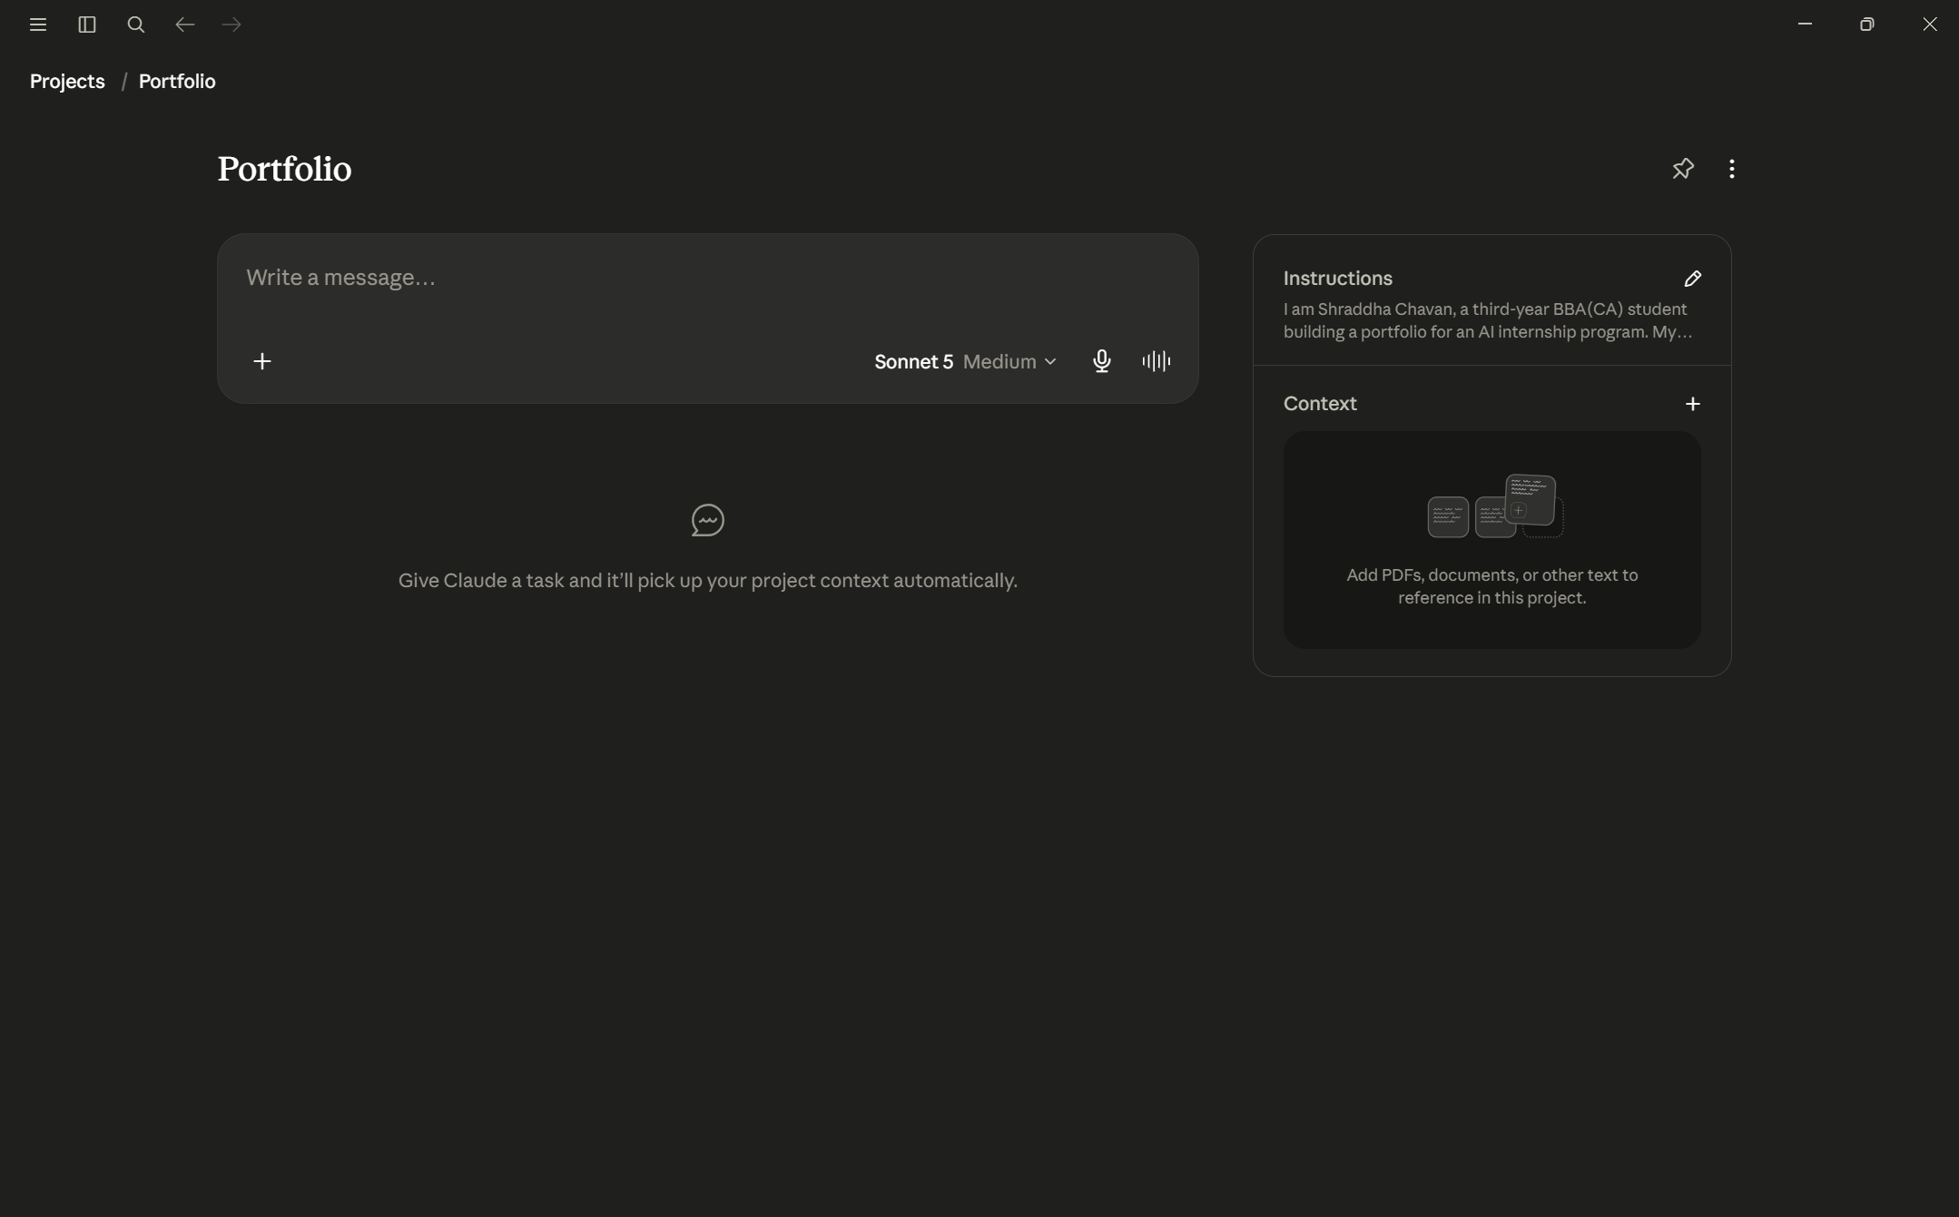

Gemini account
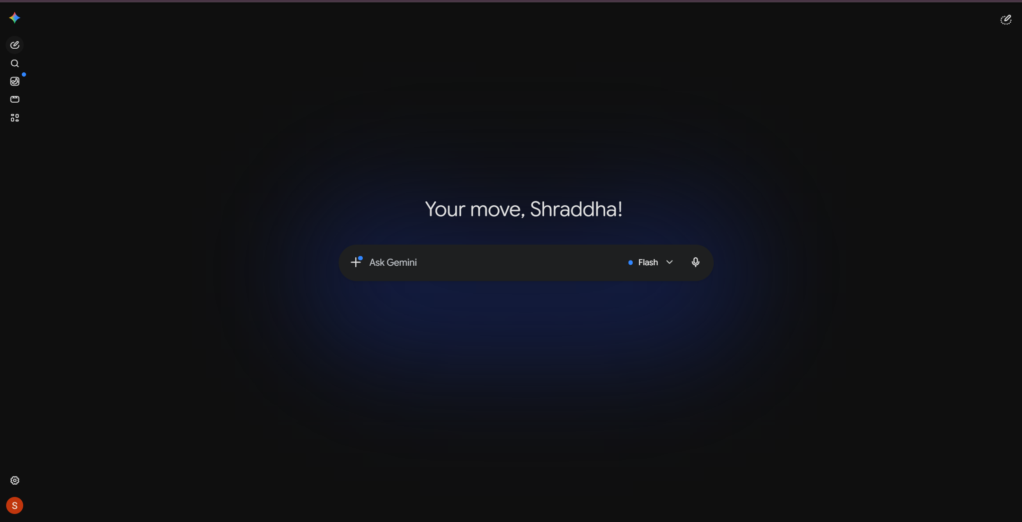
Perplexity account
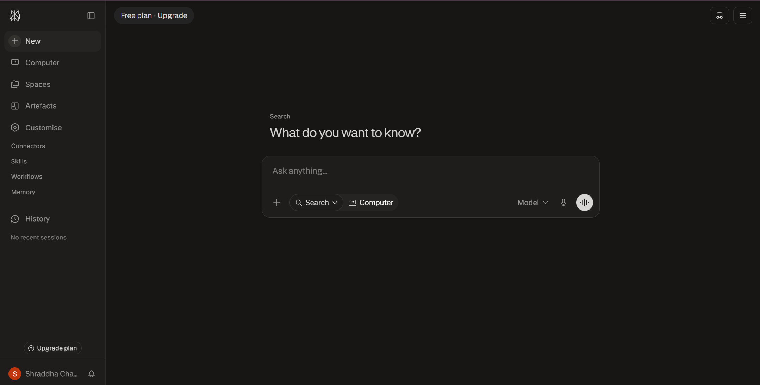
Claude and ChatGPT accounts were also set up (previously evidenced in the FL-01 submission).

4. Pressure-Test Prompt + Output
Prompt sent inside the Portfolio Claude Project
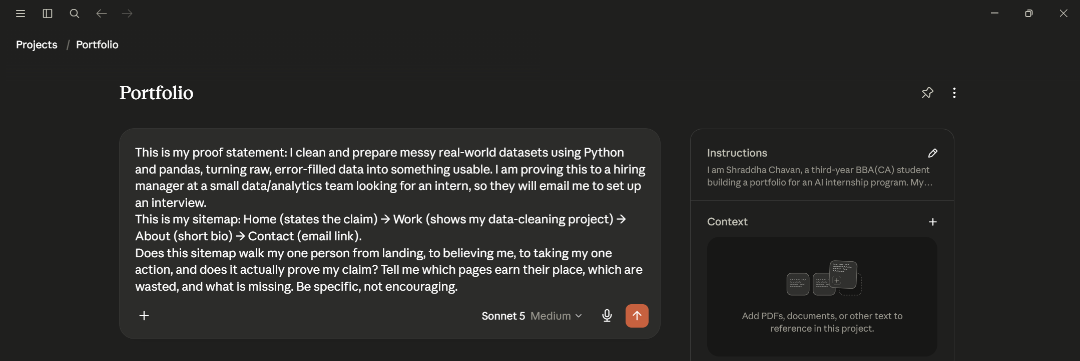
Claude's response (full critique, in order)
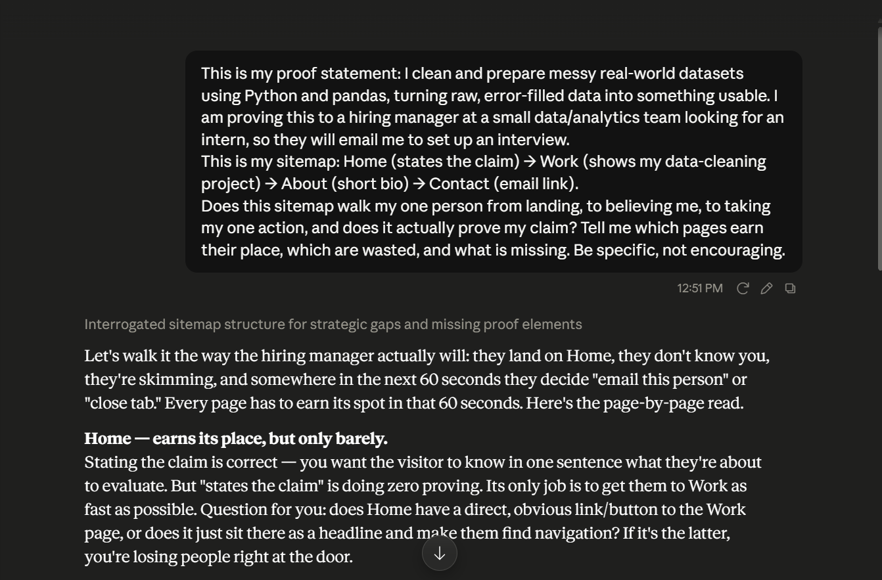
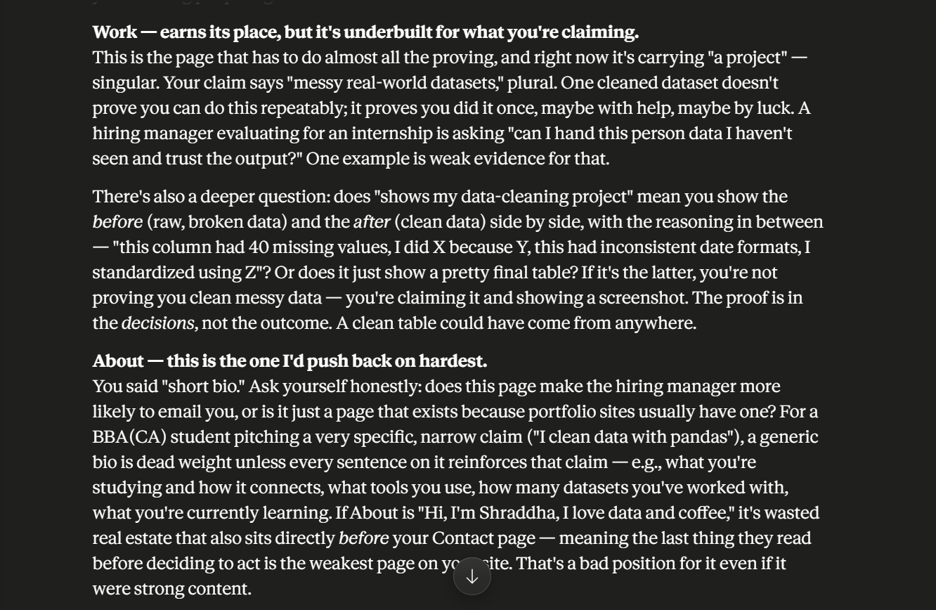
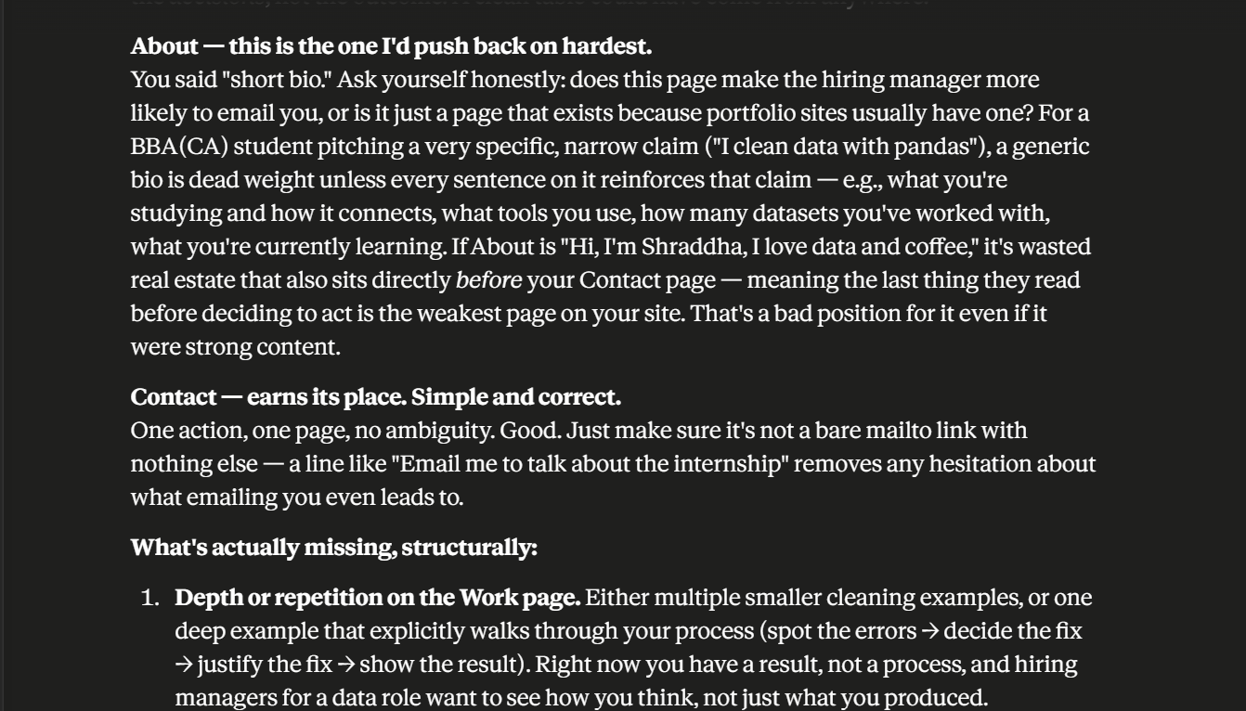
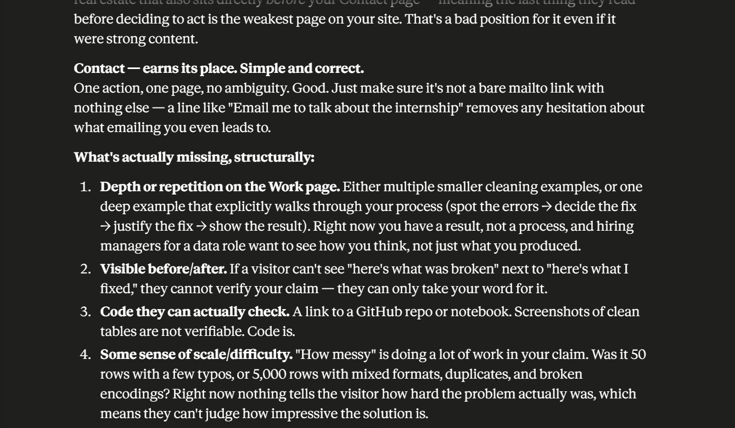

5. What I'll Change
Claude's critique pointed out that my About page was "dead weight" unless every sentence reinforces my specific claim. I'm keeping the About page, but rewriting it so every line supports my claim — what I'm studying and how it connects to data work, which tools I use (Python, pandas), how many datasets I've cleaned, and what I'm currently learning — instead of a generic bio.

