AI Workflow Audit and Tool Setup
Assignment Code: FL-01 Track: General AI Fluency
Name: Shraddha Chavan Role: Third-Year BBA(CA) Student, AI Intern

1. Weekly Recurring Task Audit
The table below lists 13 recurring tasks drawn from my real weekly routine (study, college, internship, and personal development), each classified using the four-category framework: Just Me, Delegate to AI with Review, Collaborate with AI, or Fully Automate.
# | Task | Classification | Rationale
1 | Attending lectures | Just Me | Requires my own presence and attention in real time — no substitute is possible.
2 | Revising notes | Collaborate with AI | AI can quiz me or summarize, but the memory work itself has to be mine.
3 | Practicing coding (HTML/CSS/JS) | Collaborate with AI | Writing the code myself builds the skill; AI can review my work and explain errors.
4 | Internship tasks (general work) | Collaborate with AI | Core deliverables need my judgment; AI can assist with drafts or research along the way.
5 | Completing college assignments | Collaborate with AI | AI should help me learn, not do the work for me, so the grade reflects my own ability.
6 | Watching programming tutorials | Just Me | Learning from a video is a personal comprehension process AI cannot do for me.
7 | Debugging coding problems | Collaborate with AI | AI can suggest likely causes quickly, but I need to understand and apply the fix myself.
8 | Updating internship documentation | Delegate to AI with Review | Drafting docs from my notes is largely mechanical — AI can draft, I verify accuracy.
9 | Studying DBMS/Python concepts | Collaborate with AI | AI can explain tricky concepts, but real understanding has to be built by me.
10 | Researching project topics | Collaborate with AI | AI speeds up gathering information, but I must evaluate and choose what is relevant.
11 | Preparing LinkedIn profile/content | Delegate to AI with Review | AI can draft strong wording quickly; I just need to review that it reflects me accurately.
12 | Organizing study materials | Fully Automate | A repetitive, low-judgment sorting task AI can complete on its own with clear instructions.
13 | Reviewing progress & planning next week | Just Me | Honest self-reflection on my own effort and goals cannot be outsourced.

2. Toolkit Setup — Evidence
- Claude account created and in active use.
- ChatGPT account created (chatgpt.com).
- Anthropic Academy account created; enrolled in "AI Fluency: Framework & Foundations"; Module 1 completed.
- Claude Project created with custom instructions covering who I am, tone preferences, and current goals. (See screenshots below.)

Evidence Screenshots
Claude Project — Custom Instructions
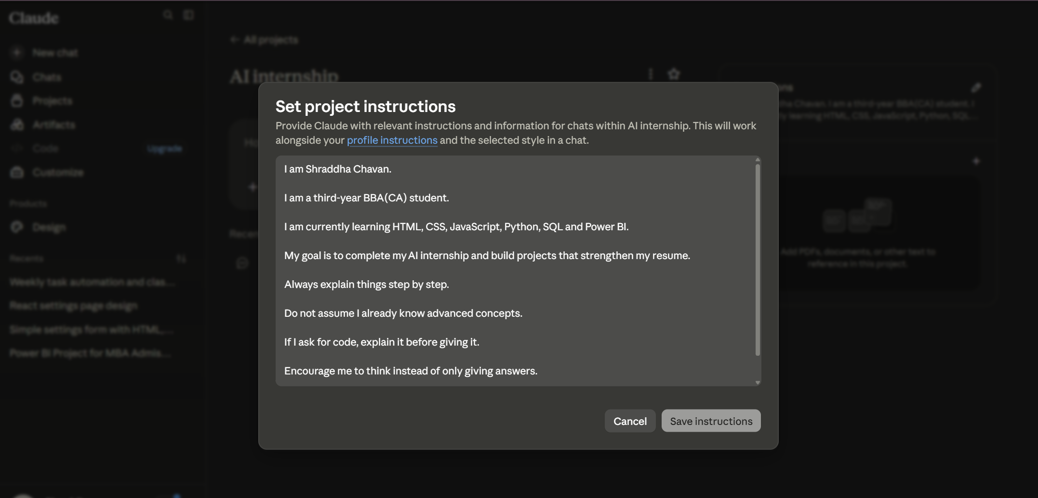
Anthropic Academy — AI Fluency: Framework & Foundations
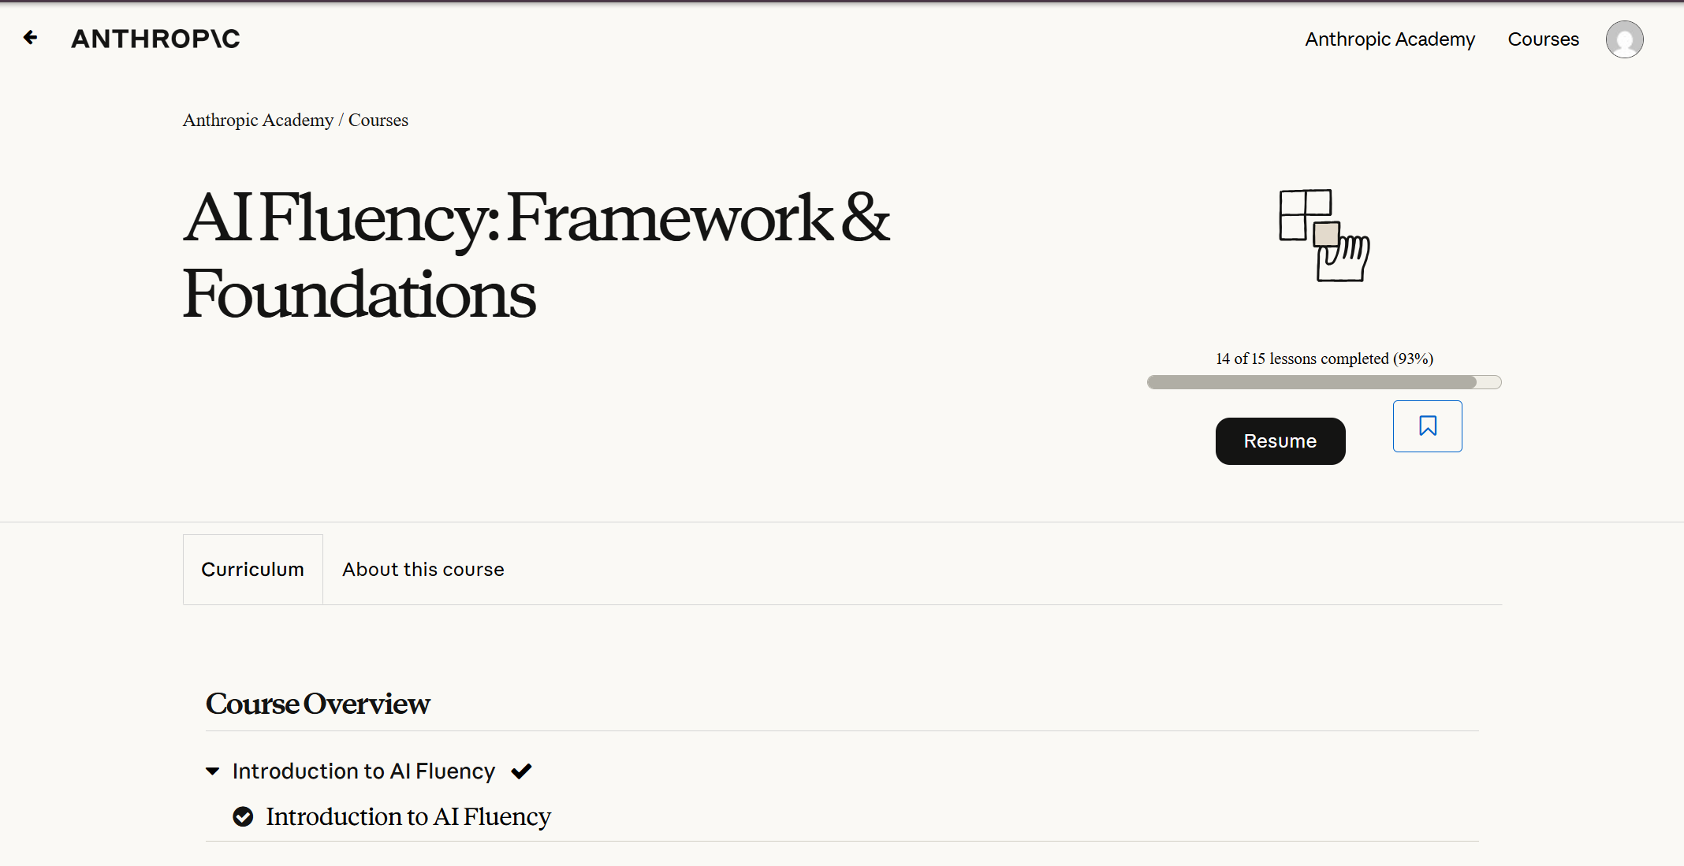
ChatGPT Account
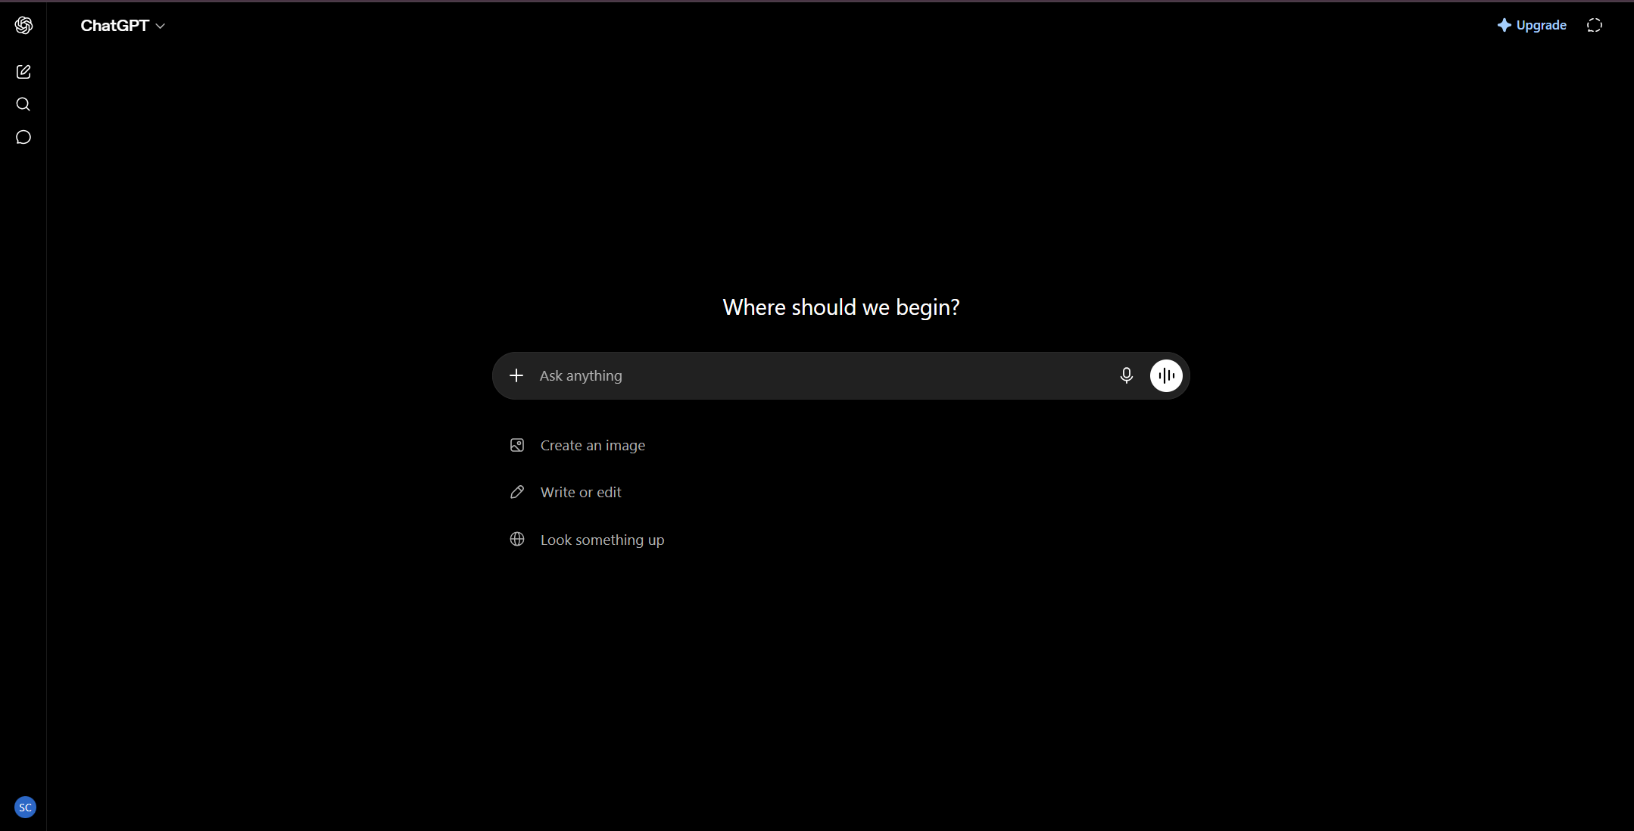

3. Three Target Tasks for FL-02 through FL-04
These three tasks were chosen because they occur frequently, involve genuine AI collaboration (rather than pure independent work), and have clear, checkable success criteria.
Target Task 1: Debugging Coding Problems
Classification: Collaborate with AI
"Done well" means:
- The bug is fixed and the code runs without errors.
- I can explain why the fix worked, not just that it worked.
- I did not simply copy-paste AI's fix — I understood it and could reproduce the logic independently.
Target Task 2: Updating Internship Documentation
Classification: Delegate to AI with Review
"Done well" means:
- Documentation accurately matches what was actually done, with no AI-invented details.
- Formatting is clean, consistent, and easy to scan.
- A teammate unfamiliar with the task could understand it just from reading the document.
Target Task 3: Preparing LinkedIn Profile/Content
Classification: Delegate to AI with Review
"Done well" means:
- The content sounds like me, not generic AI phrasing.
- It highlights specific, real skills and projects rather than vague buzzwords.
- Grammar and spelling are error-free, with a tone that is professional but approachable.

