.

SpringBoot and ReactJS Integration

4-2-2022 @Ramkumar

Axios is a Javascript library **used to make HTTP requests from node.** **js or XMLHttpRequests from the browser** and it supports the Promise API

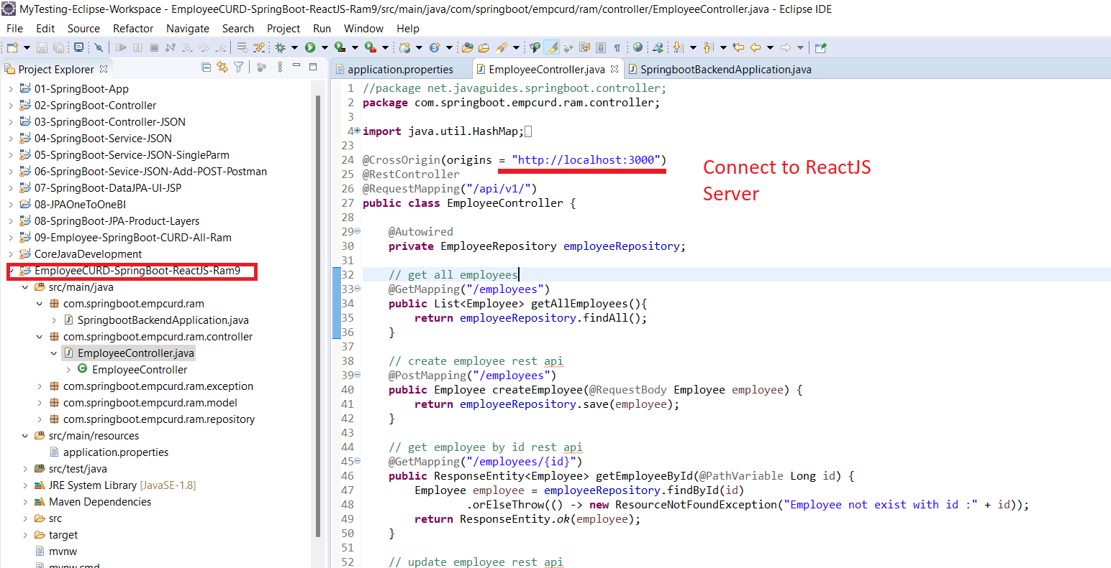

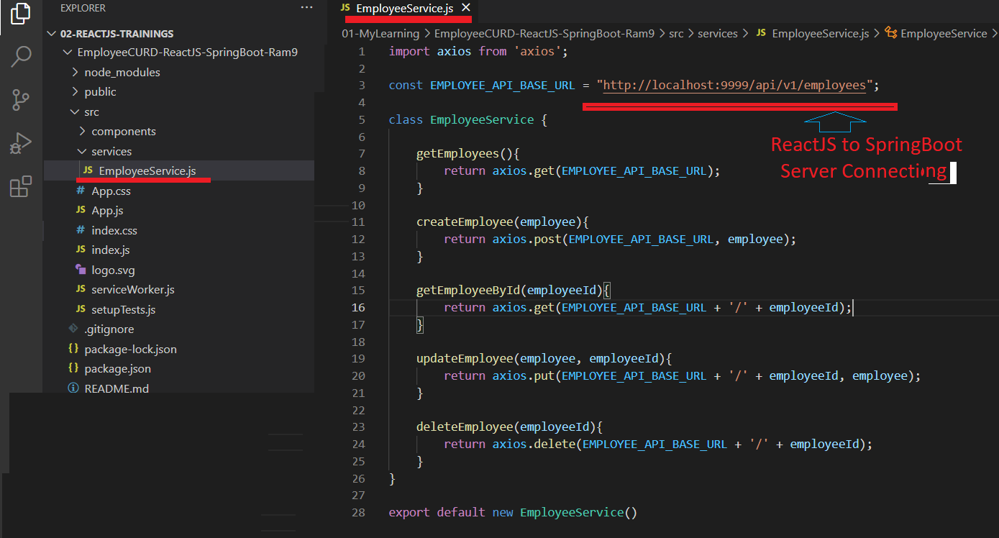

axios

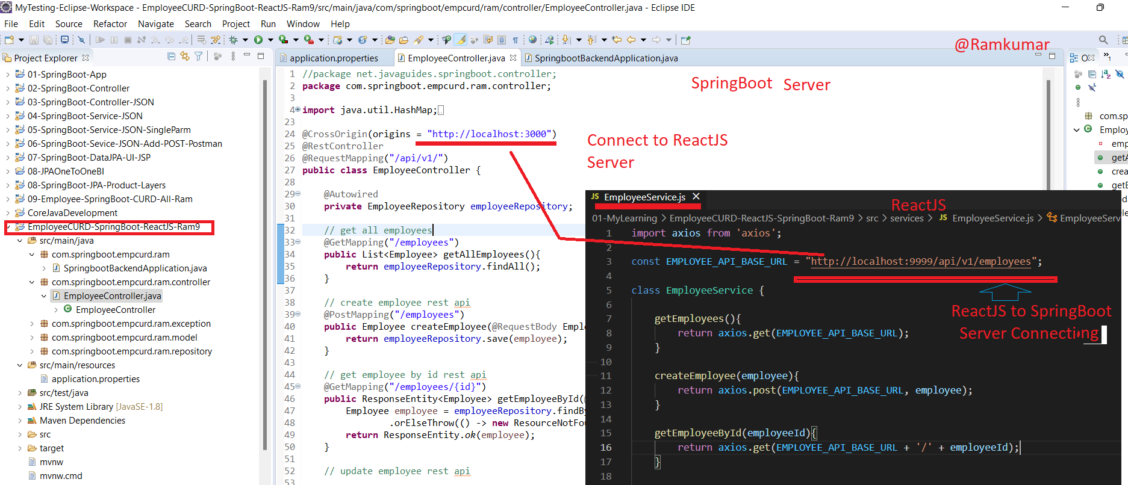

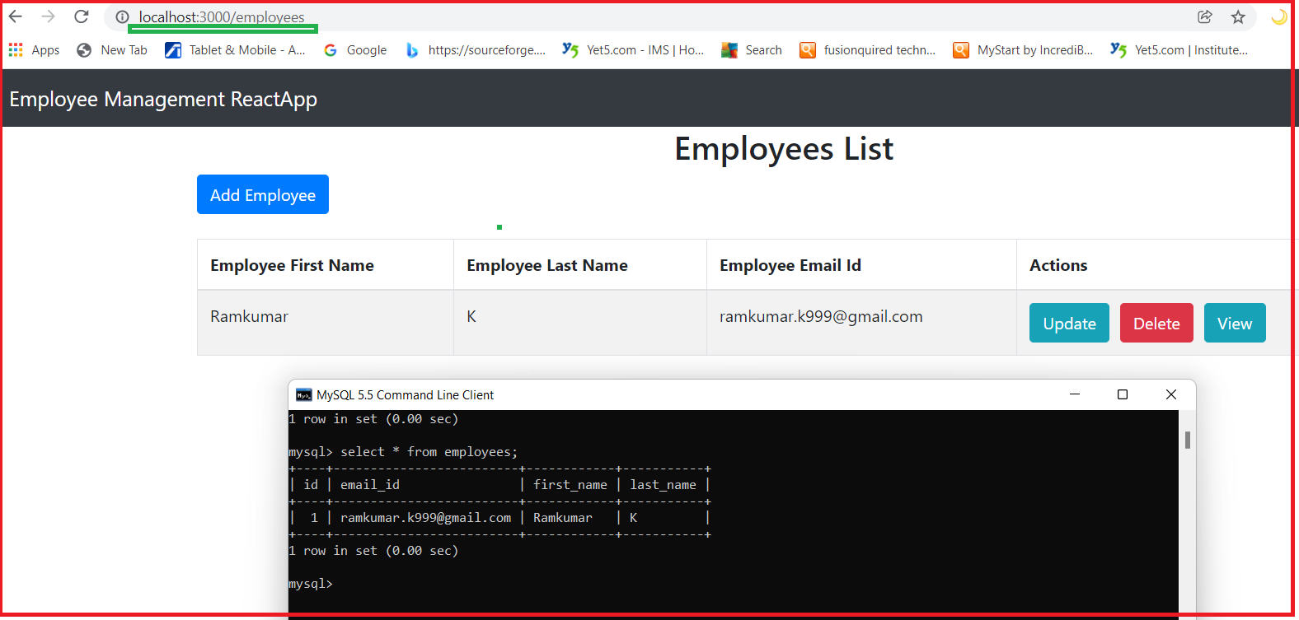

What is Axios?

1. Axios is used to communicate with the backend and it also supports the Promise API that is native to JS ES6.
2. It is a library which is used to make requests to an API, return data from the API, and then do things with that data in our React application.
3. Axios is a Javascript library used to make HTTP requests from node. js or XMLHttpRequests from the browser and it supports the Promise API
4. Axios allows you to communicate with the APIs in your React project.
5. Axios has function names that match any HTTP methods. To perform a GET request, you use the .get() method.

C:\EmployeeCURD-ReactJS-SpringBoot-Ram9> npm install axios/>npm install axios

Example :

