|  |
| --- |
| **A**  **PROJECT REPORT ON** |
|  |
|  |
| EASY CLEANING |
|  |
|  |
| SUBMITTED IN  PARTIAL FULFILLMENT OF  **DIPLOMA IN MOBILE COMPUTING (PG - DMC)** |
|  |
|  |
|  |
|  |
|  |
|  |
|  |
| **BY**  **SHRADDHA KHILLARI** |
|  |
|  |
| **UNDER THE GUIDENCE OF**  **Rohan Paramane** |
|  |
|  |
|  |
| **AT**  **SUNBEAM INSTITUTE OF INFORMATION TECHNOLOGY,**  **PUNE** |

|  |  |  |  |
| --- | --- | --- | --- |
|  | | | |
|  | | | |
|  | | | |
| **CERTIFICATE** | | | |
|  | | | |
| This is to certify that the project | | | |
|  | | | |
| EASY CLEANING | | | |
|  | | | |
| Has been submitted by | | | |
|  | | | |
| **SHRADDHA KHILLARI** | | | |
|  | | | |
|  | | | |
| In partial fulfillment of the requirement for the Course of **PG Diploma in Mobile Computing (PG – DMC FEB 2024)** as prescribed by The **CDAC** ACTS, PUNE. | | | |
|  | | | |
|  | | | |
| Place: Pune | | | Date: 29-JUL-2019 |
|  | | | |
|  | | | |
|  | | | |
|  | | | |
|  | | | |
|  | | | **Rohan Paramane** |
|  | | | **Project Guide** |
|  |  |  |  |

**ACKNOWLEDGEMENT**

I would like to express my special thanks of gratitude to my teacher Rohan Paramane as well as our Director Nitin Khudale who gave me the golden opportunity to do this wonderful project on the topic Easy Cleaning, which also helped me in doing a lot of Research and I came to know about so many new things I am really thankful to them.

Shraddha Khillari

**ABSTRACT**

Easy Cleaning app is designed to streamline home maintenance services by offering a user-friendly platform where individuals can easily access professional cleaning and repair services. Drawing inspiration from successful models like Urban Company, the app caters to the needs of busy modern lifestyles, providing a seamless experience for booking services, scheduling appointments, and making payments. With a focus on quality assurance, a wide range of service offerings, and an emphasis on convenience and transparency, Easy Cleaning aims to revolutionize the way people manage their household needs.

|  |  |  |
| --- | --- | --- |
|  | **INTRODUCTION** | 1 |
|  | 1.1 Introduction | 2 |
|  | **Product Overview and Summary** |  |
|  | 2.1 Purpose |  |
|  | 2.2 Scope |  |
|  | 2.3 User Classes and Characteristics |  |
|  | 2.4 Design and Implementation Constraints |  |
|  | **REQUIREMENTS** |  |
|  | 3.1 Functional Requirements |  |
|  | 3.1.1 Use case for Administrator. |  |
|  | 3.1.2 Use case for User. |  |
|  | 3.2 Non - Functional Requirements |  |
|  | 3.2.1 Usability Requirement |  |
|  | 3.2.2 Performance Requirement |  |
|  | 3.2.3 Reliability Requirement |  |
|  | 3.2.4 Portability Requirement |  |
|  | 3.2.5 Security Techniques |  |
|  | **PROJECT DESIGN** |  |
|  | 4.1 Data Model |  |
|  | 4.1.1 Database Design |  |
|  | 4.2 Process Model |  |
|  | 4.2.1 Functional Decomposition Diagram |  |
|  | 4.2.2 Data Flow Diagram (DFD) |  |
|  | **PROJECT RELATED STATISTICS** |  |
|  | **CONCLUSION** |  |

**INDEX**

**LIST OF TABLES**

|  |  |  |
| --- | --- | --- |
| **Section** | **Table Title** | **Page** |
| **Fig 3** | **Complete Database** |  |
|  |  |  |
|  |  |  |
|  |  |  |
|  |  |  |
|  |  |  |

**LIST OF FIGURES**

|  |  |  |
| --- | --- | --- |
| **Section** | **Figure Title** | **Page** |
| **Fig 1-2** | **User & Admin Use Case Diagram** |  |
| **Fig 3** | **Data Flow Diagram** |  |
| **Fig 4 -9** | **Dashboard Screen Shots** |  |
| **Fig 10-13** | **Mobile Application Screen Shots** |  |
|  |  |  |
|  |  |  |
|  |  |  |
|  |  |  |
|  |  |  |
|  |  |  |
|  |  |  |
|  |  |  |

**INTRODUCTION**

Easy Cleaning, the ultimate solution for modern homeowners seeking convenience and efficiency in home maintenance. Inspired by the success of pioneering platforms like Urban Company, Easy Cleaning aims to streamline the process of accessing professional cleaning and repair services. Designed to cater to the fast-paced lifestyles of today's individuals, our user-friendly app provides seamless booking, scheduling, and payment options, ensuring a hassle-free experience every time. With a focus on quality, reliability, and customer satisfaction, Easy Cleaning sets a new standard in home services. Say goodbye to the stress of household chores and embrace a cleaner, more organized home with Easy Cleaning.

**The goal of this project:** The goal of Easy Cleaning is to revolutionize home maintenance services by offering a convenient and efficient platform for users to access professional cleaning and repair services. The app aims to cater to the busy lifestyles of modern individuals, providing them with reliable and hassle-free solutions for their household needs. By seamlessly connecting users with skilled professionals through a user-friendly interface, Easy Cleaning seeks to simplify the process of booking, scheduling, and managing home services. Ultimately, the goal is to enhance the overall experience of maintaining a clean and well-maintained home, allowingusers to focus on other aspects of their lives with peace of mind.

**Product Overview and Summary**

**| Purpose:** Through research of similar apps we found a number of features that seemed useful in our design. Simplistic Design: Overall, we found that the Moves app presented an extremely clean and simplistic layout that presented important information as soon as it was opened. We decided to model our app with this same mentality of keeping screens simplistic and present important data upfront.

**Scope**: The scope of the Easy Cleaning app encompasses a comprehensive suite of features aimed at revolutionizing the home maintenance service experience for users. Primarily, the app facilitates seamless access to professional cleaning and repair services, offering a user-friendly interface .Users can browse a diverse range of cleaning and repair services, including general house cleaning, deep cleaning, plumbing, electrical repairs, and more.The app enables users to effortlessly book services at their preferred date and time, with options for one-time or recurring appointments to accommodate diverse scheduling needs.Easy Cleaning provides transparent pricing information for all services, including upfront cost estimates and any additional fees, empowering users to make informed decisions.Following service completion, users can provide feedback and ratings based on their experience, fostering accountability and continuous improvement within the Easy Cleaning community.

**| Design and Implementation Constraints**

**- User Interface**

In order to effectively incorporate each of the three focus areas of our application (sleep, food consumption) into the user interface without creating too much clutter, we opted to use a tabbed design. When the app is initially opened, the user is taken to the “main” or “home” tab.

**- Tab Design**: Relatively early in the development process, we came to the decision to separate each data tracked aspect (steps, sleep, and mood) into individual tabs within the app. After researching several different methods for implementing this type of multi-page app design, we came to the decision to use the ViewPager layout manager, an Android class that is “most often used in conjunction with Fragment, which is a convenient way to supply and manage the lifecycle of each page” (ViewPager). Each of the four tabs is implemented in its own class, and is a subclass of the Fragment class. In addition, the tabs share a single Android activity, which is the Android class that handles all user interaction with the app. The main activity of the application manages the tab layout and tells the application which tab view to display when a user selects a certain tab. The purpose of using fragments is to eliminate the need to create a new activity every time the user switches between tabs, thus increasing both the temporal and spatial efficiency of the application. Structurally, each fragment is comprised of two components. The first is an XML file that defines the visual layout of the fragment. The second is the logic of the fragment, which contains various functions defining certain actions to take at different times. Each time a certain fragment is switched to or away from, these functions are called in a particular order, all of which make up what is called the fragment’s “lifecycle”. For example, when a particular fragment is displayed on the screen, the function onCreateView() is called, which is generally where most of the initialization process occurs

**Functional Requirements**

**| Use Case diagram**:

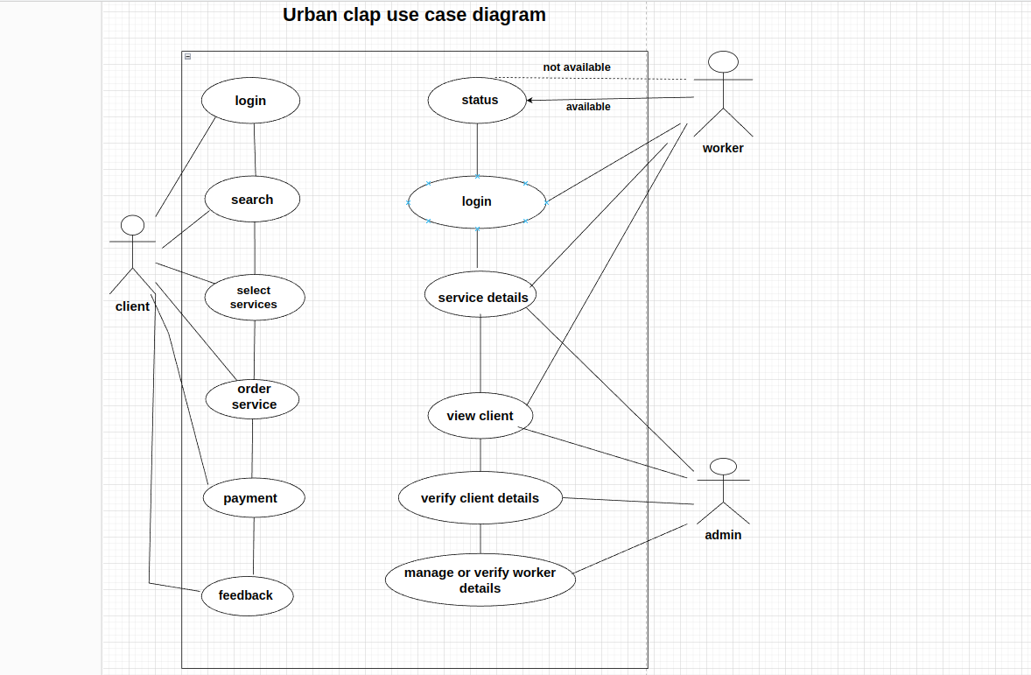

**Non - Functional Requirements**

**Usability Requirement:** The Easy Cleaning app must offer an intuitive and straightforward user interface that can be navigated without the need for tutorials. It should utilize multiple views for modularity and ease of use. The mobile application should adhere to usability standards, ensuring effectiveness, sophistication, and satisfaction. Design elements such as color, contrast, and layout should be carefully considered to cater to users of all abilities, including those with disabilities such as hearing impairment, low vision, or blindness. Sound implementation should provide an alternative to visual cues, with unnecessary sounds avoided and those that convey screen elements designed for clarity and efficiency. Overall, the app should be accessible and user-friendly for all individuals, regardless of their capabilities or disabilities.

**Data Model**

n order to efficiently manage user data for Easy Cleaning, we opted to utilize a SQL database, which is inherently integrated into the Android operating system. Given the app's focus on home maintenance services, our database primarily consists of tables for user profiles, service requests, and service history. The User Profile table stores essential user information such as name, contact details, and address. The Service Requests table records details of service requests made by users, including the type of service requested, preferred date and time, and any additional notes. Additionally, the Service History table maintains a record of completed service transactions, including details such as service type, service provider, date and time of service, and payment information. These tables are structured to facilitate efficient data retrieval and management within the app.

Upon receiving a service request from a user, the app creates an entry in the Service Requests table, capturing all relevant details. As service providers accept and complete these requests, entries are updated accordingly in the Service History table. The app utilizes SQL queries to insert, retrieve, and update data within the database, ensuring seamless communication between the user interface and the underlying data storage.

While the Google Fit API is not directly relevant to the core functionality of Easy Cleaning, the app may incorporate third-party integrations for additional features in future updates. Nonetheless, the SQL database serves as a robust and reliable solution for managing user and service-related data, contributing to the overall efficiency and effectiveness of the Easy Cleaning app.

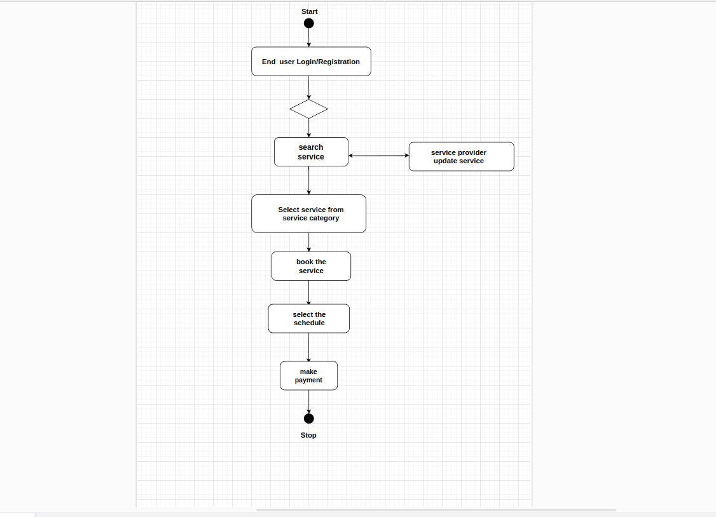

**Screen Shots**

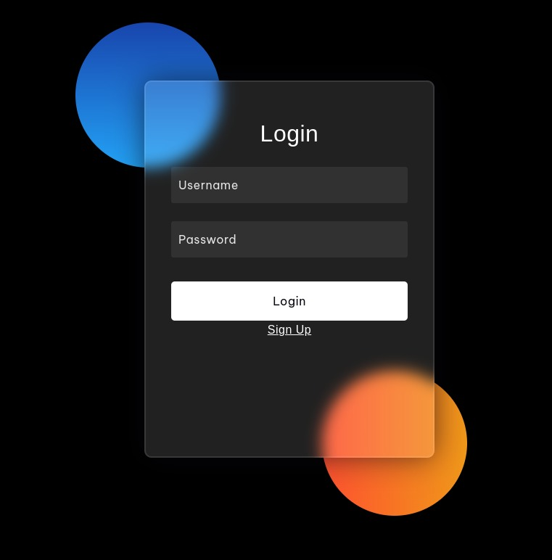

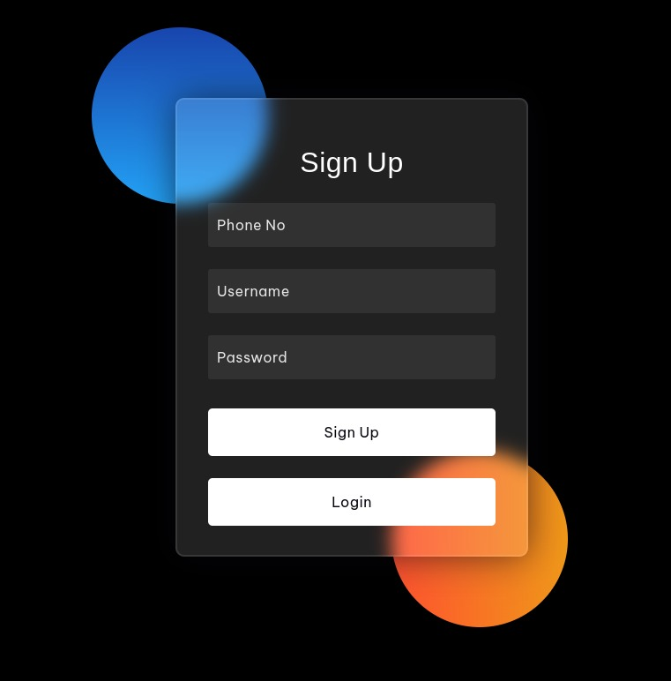

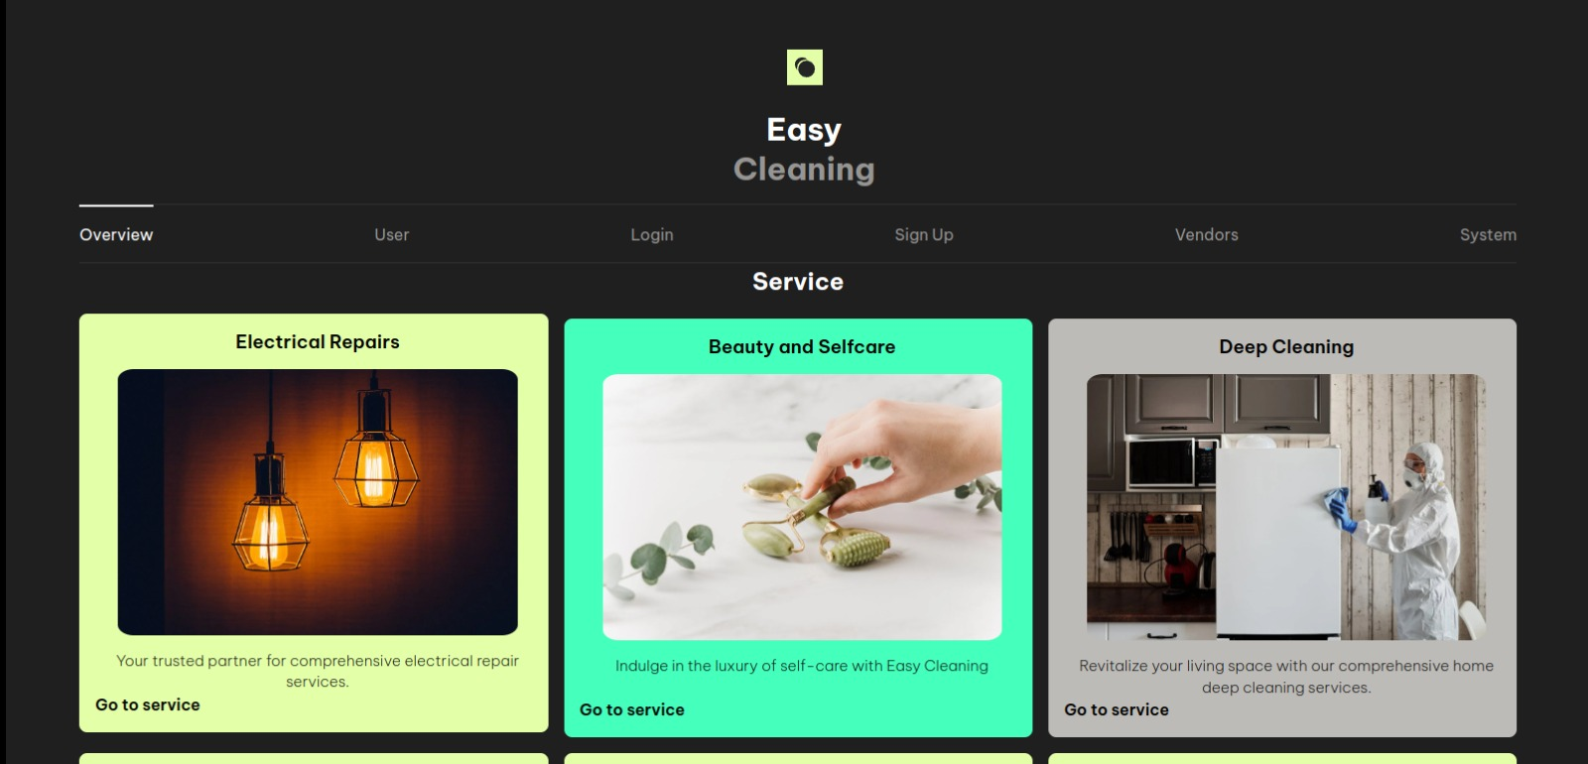

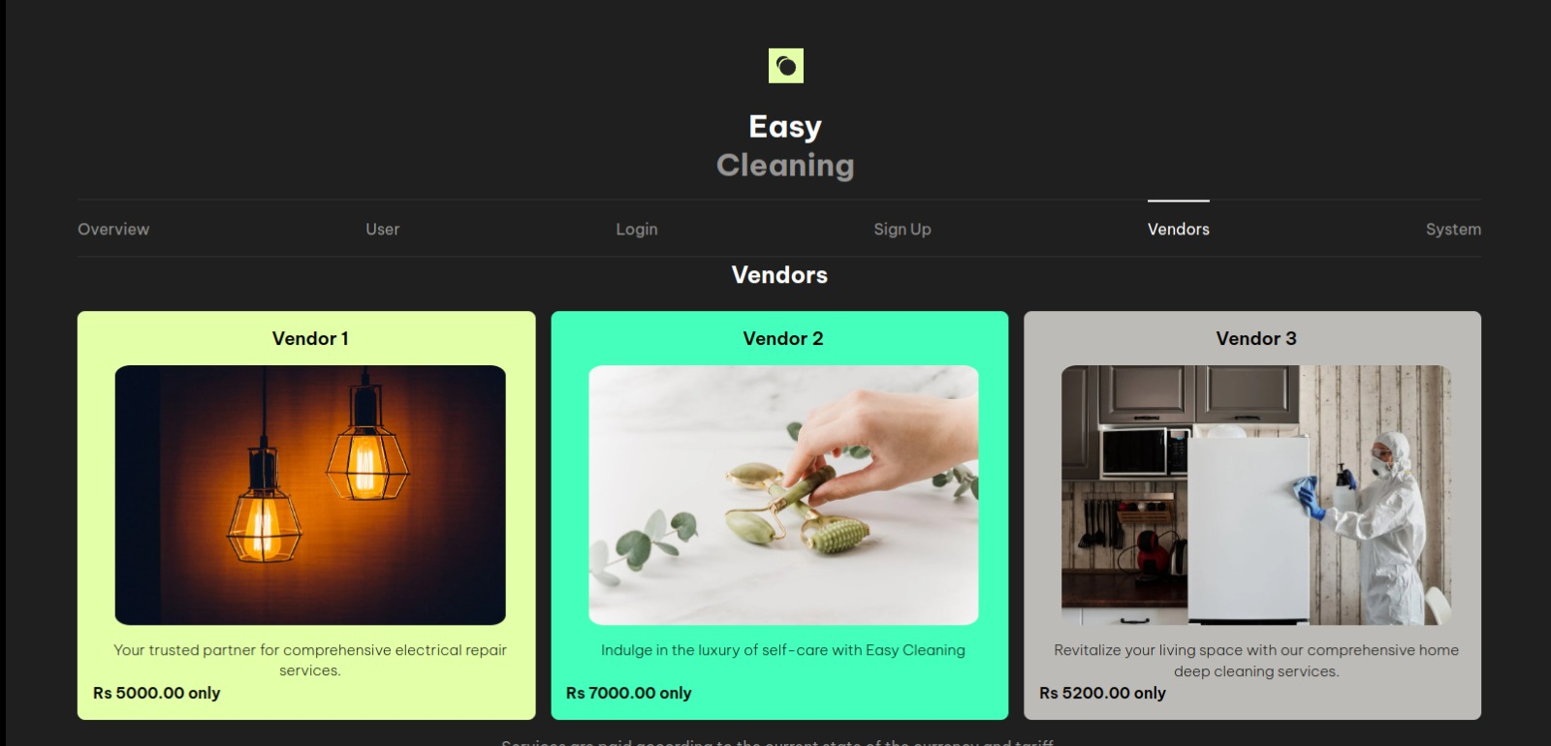



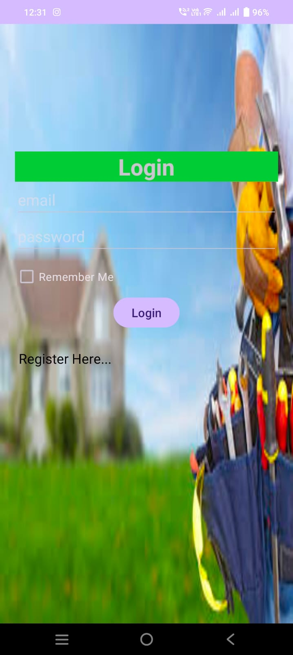

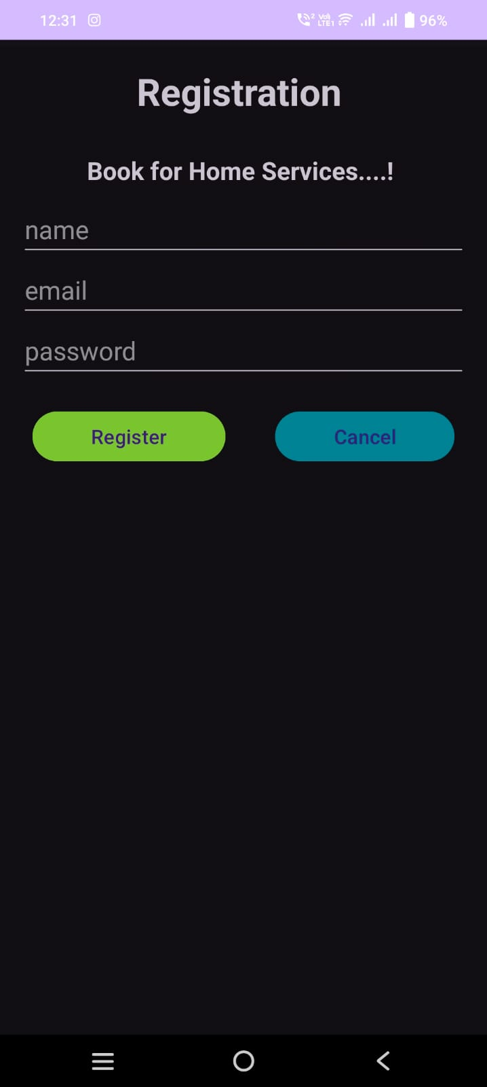

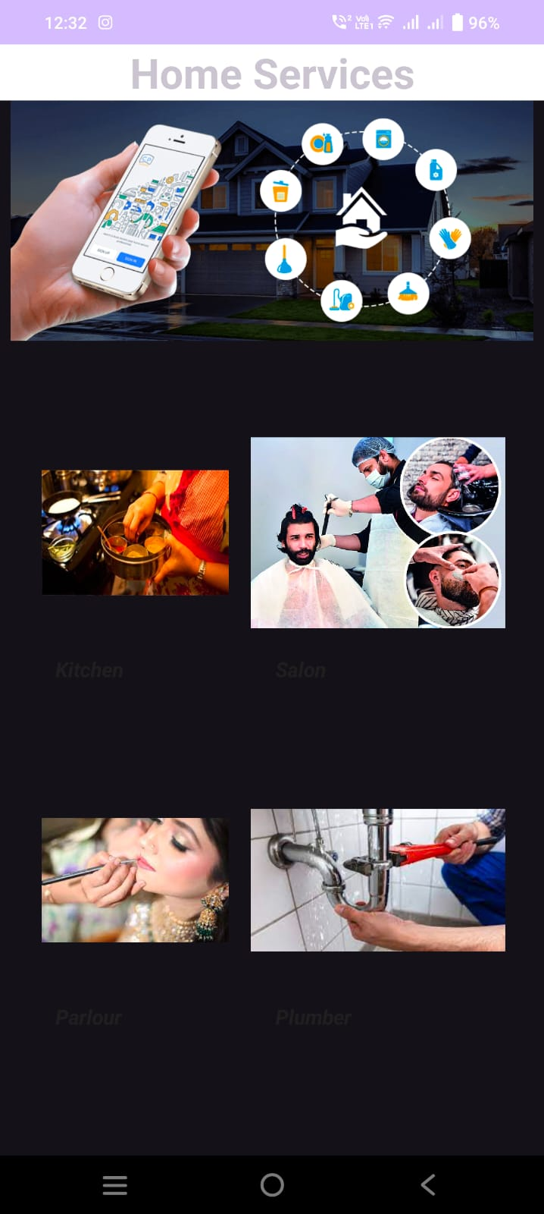

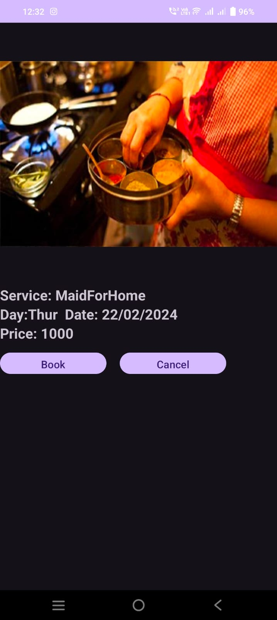

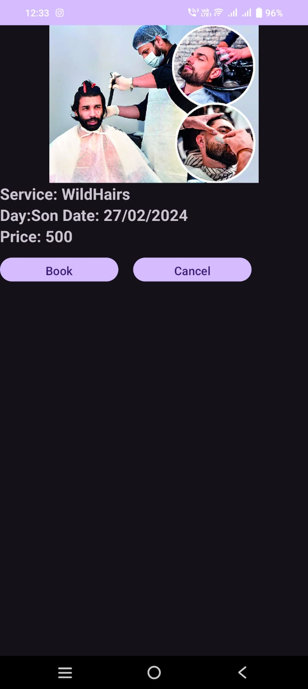

**|**

**Conclusion:**  The development of Easy Cleaning, our project designed to offer multiple services at home, marks a significant milestone in the realm of on-demand service platforms. Through meticulous planning, robust technology infrastructure, and a commitment to user satisfaction, we have endeavored to redefine convenience and efficiency in the domain of household services.

The journey of creating Easy Cleaning has been a testament to our dedication to innovation and customer-centricity. By leveraging modern technologies and incorporating user feedback at every step, we have strived to create a platform that seamlessly connects service providers with customers, offering a diverse range of services tailored to meet their needs.

**Future Work** : Expansion of Services: Beyond just cleaning, Easy Cleaning can expand its services to include a wide array of home-related tasks such as plumbing, electrician services, carpentry, gardening, appliance repair, and more. This expansion will cater to the diverse needs of homeowners, making Easy Cleaning a one-stop solution for household maintenance.

Mobile Application Enhancements: Continuously improving the mobile application interface and functionality can enhance user experience and engagement. This can include features such as real-time tracking of service providers, secure payment gateways, and seamless communication channels between customers and service providers.

By embracing these future-oriented strategies, Easy Cleaning can position itself as a leading provider of home services, catering to the evolving needs and preferences of its customers while staying ahead in a competitive market landscape.

**|**

**References:**

Time - Alarm Clock. Retrieved from https://play.google.com/store/apps/details?id=com.azumio.android.sleeptime&feature=search_r esult#?t=W251bGwsMSwxLDEsImNvbS5henVtaW8uYW5kcm9pZC5zbGVlcHRpbWUiXQ Fitbit Inc. (n.d.). Fitbit. Retrieved from http://dev.fitbit.com/ Fragments. (n.d.). Retrieved March 23, 2015, from

http://developer.android.com/guide/components/fragments.html Gehring, J. (n.d.). Documentation. Retrieved March 27, 2015, from http://www.androidgraphview.org/documentation Google. (n.d.). E.

Automation and developer API - Sleep as Android. Retrieved from https://sites.google.com/site/sleepasandroid/doc/developer-api Lopresti, A. L., Hood, S. D., & Drummond, P. D. (2013). A review of lifestyle factors that contribute to important pathways associated with major depression: Diet, sleep, and exercise. Journal of Affective Disorders, 148, 12-27 Michaud, C. (n.d.). Pedometer Using Accelerometer Sensor. Retrieved March 26, 2015, from

http://nebomusic.net/androidlessons/Pedometer_Project.pdf PELUSO MAM et al. Physical activity and mental health: the association between exercise and mood. CLINICS 60(1): 61-70, 2005. ProtoGeo. (n.d.). Moves. Retrieved from

https://play.google.com/store/apps/details?id=com.protogeo.moves&hl=en Recording Fitness Data. (n.d.). Retrieved March 23, 2015, from https://developers.google.com/fit/android/record Sleepiness:

Cognitive and Emotional Effects. (n.d.). Retrieved March 23, 2015, from http://www.webmd.com/sleep-disorders/excessive-sleepiness-10/emotions-cognitive?page=3 Sonstroem RJ, Morgan WP. Exercise and self-esteem rationale and model. Med Sci Sports Exerc 1989;21:329-37. ViewPager. (n.d.). Retrieved March 23, 2015, from

http://developer.android.com/reference/android/support/v4/view/ViewPager.html 40 Working with

the Fitness History. (n.d.). Retrieved March 23, 2015, from https://developers.google.com/fit/android/history Build software better, together. (n.d.). Retrieved

December 15, 2014, from https://github.com/ Tudor-Locke, C., & Bassett Jr, D. (n.d.). How Many Steps/Day Are Enough? Retrieved November 15, 2014, from

http://www.health.utah.edu/peak/docs/Tudor Locke Paper.pdf National Sleep Foundation

Recommends New Sleep Times. (n.d.). Retrieved February 27, 2015, from http://sleepfoundation.org/media-center/press-release/national-sleep-foundationrecommends-new-sleep-times