Railway Station Connections Using Graph and Adjacency Matrix

1.Problem Statement
To implement a graph using an adjacency matrix to represent railway stations and their direct train connections, and display all stations directly connected to a selected station.

2. Aim
To implement a graph data structure using an adjacency matrix in C++ to represent railway stations and identify directly connected stations.

3. Objectives
- To understand the graph data structure.
- To represent railway stations as vertices and direct train connections as edges.
- To implement a graph using an adjacency matrix.
- To accept railway station connections from the user.
- To display all stations directly connected to a selected station.

4. Introduction
A graph is a non-linear data structure consisting of vertices and edges. It is used to represent relationships between different objects.
In this project, railway stations are represented as vertices, and direct train connections between stations are represented as edges. An adjacency matrix is used to store these connections in a two-dimensional array.
If two stations are directly connected, the corresponding matrix element is 1. If they are not directly connected, the element is 0.
This project helps identify the stations directly connected to a selected railway station.

5. Theory
Graph: A graph is a collection of vertices and edges that represent objects and their connections.
Vertex: Each railway station is represented as a vertex.
Edge: A direct train connection between two stations is represented as an edge.
Adjacency Matrix: An adjacency matrix is a two-dimensional array used to represent graph connections.
For example, consider four railway stations: Pune, Mumbai, Nashik, and Nagpur.

Example adjacency matrix

Station Pune Mumbai Nashik Nagpur
Pune 0 1 1 0
Mumbai 1 0 0 1
Nashik 1 0 0 0
Nagpur 0 1 0 0

Here, 1 indicates a direct connection and 0 indicates no direct connection. The diagonal elements are 0 because a station is not considered directly connected to itself.
For this example, Pune is directly connected to Mumbai and Nashik.

6. Algorithm
Start the program.
Read the number of railway stations.
Enter the names of all stations.
Initialize the adjacency matrix with zeros.
Enter the number of direct train connections.
Enter the station names for each connection and mark the corresponding matrix entries as 1.
Display the list of stations.
Ask the user to select a station.
Search for the selected station.
Display all stations directly connected to it by checking its row in the adjacency matrix.
Stop the program.

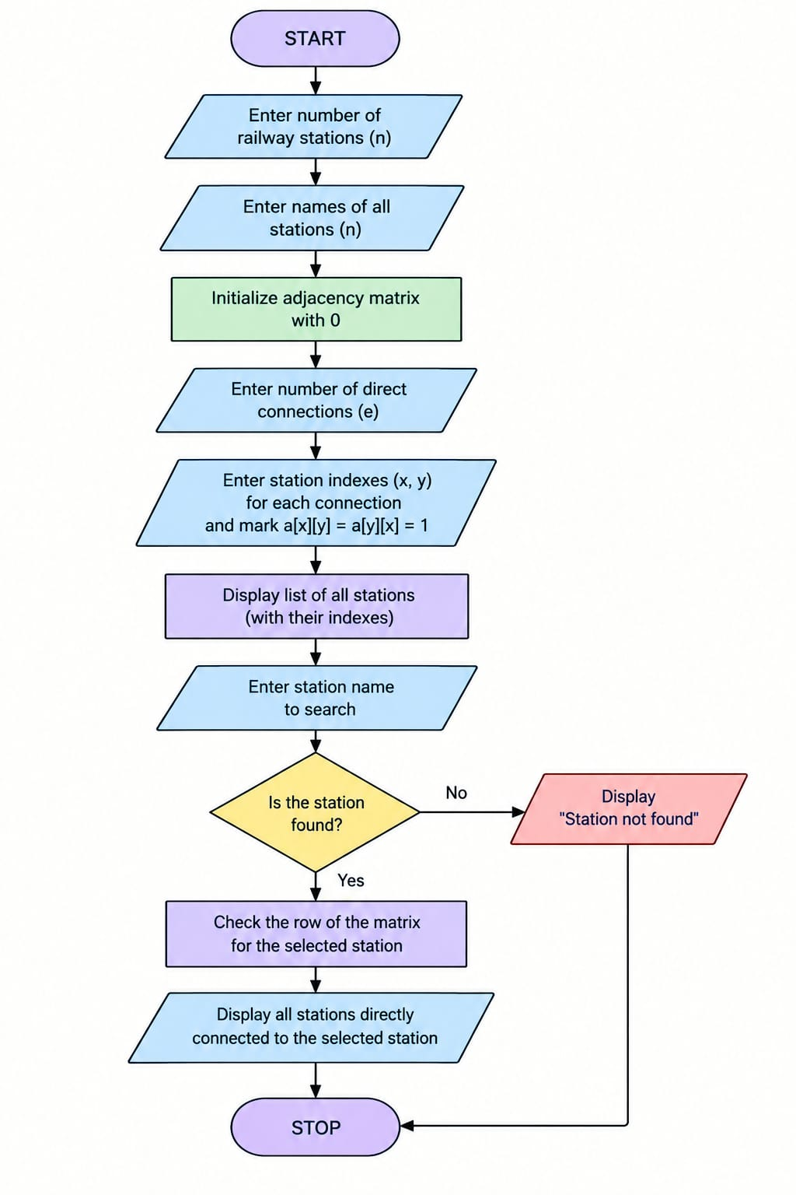
7.Flowchart

8.Advantages
- Simple and easy-to-understand representation.
- Fast checking of direct connections.
- Suitable for graphs with a small number of stations.
- Easy to implement using a two-dimensional array.
- Helps organize railway station connectivity.

9. Limitations
- Requires more memory as the number of stations increases.
- The program supports a maximum of 20 stations.
- Station names with spaces are not supported.
- The program represents direct connections only, not complete routes or travel distances.
- It assumes connections are bidirectional.

10. Conclusion
This project demonstrates how a graph can represent railway stations and their direct train connections using an adjacency matrix. Each station is stored as a vertex, and each direct connection is represented by 1 in the matrix. The program accepts input from the user and displays all stations directly connected to a selected station. Thus, it provides a simple practical application of graph data structures in railway connectivity systems.

