Week 1: Data Science Project Planning and Strategy Design
Hypothetical Project: Customer Churn Prediction for a Subscription-Based Digital Service
Project Planning Document | Python-Based Data Science Workflow

Executive Summary
This project plan proposes a data science solution for predicting customer churn in a hypothetical subscription-based digital service. The organization wants to identify customers who are likely to cancel their subscriptions so that it can take timely retention actions. The project will use Python to structure the complete analytical workflow, from data acquisition and quality assessment to exploratory analysis, feature engineering, predictive modeling, evaluation, and communication of results. Week 1 focuses on strategy and planning rather than execution on a real dataset.

1. Introduction and Project Background
Customer churn is a major business problem for subscription-based organizations. Acquiring a new customer is often more expensive than retaining an existing one, yet customer cancellations may be difficult to anticipate without systematic analysis. A data science approach can combine historical customer behavior, account information, service usage, billing history, and support interactions to estimate the probability that a customer will leave.
The hypothetical organization currently relies on descriptive reports and manual judgment. These approaches explain what has already happened but provide limited ability to identify future churn risk. A Python-based predictive analytics project is justified because it can automate repeatable analysis, test multiple machine-learning models, and translate patterns in customer data into actionable risk scores.

2. Project Problem Statement
How can historical customer and service data be used to predict which active customers are most likely to churn within the next 30 days?

3. Project Objectives and Scope

3.1 Primary Objective
Develop a reproducible Python-based analytical strategy for estimating customer churn probability and identifying the most important factors associated with churn.

3.2 Specific Objectives
- Define a clear target variable representing customer churn within a chosen prediction window.
- Identify the data sources and variables required for the analysis.
- Create a structured plan for data cleaning, exploratory data analysis (EDA), and feature engineering.
- Compare baseline and advanced classification models.
- Evaluate models using business-relevant and statistically appropriate metrics.
- Produce interpretable findings that can support customer-retention decisions.
- Document risks, assumptions, limitations, and ethical considerations.

3.3 In Scope
- Historical structured customer data and approved operational records.
- Data quality checks and preprocessing.
- Exploratory and statistical analysis.
- Feature engineering from existing variables.
- Binary classification models and probability scoring.
- Model evaluation, interpretation, and a deployment recommendation.

3.4 Out of Scope
- Real-time production deployment and infrastructure engineering.
- Collection of unnecessary sensitive personal information.
- Automated customer decisions without human/business review.
- Causal claims that cannot be supported by observational data.
- Guaranteeing that retention interventions themselves will prevent churn.

4. Methodology and Strategy
The project will follow an iterative data science lifecycle rather than a strictly linear process.
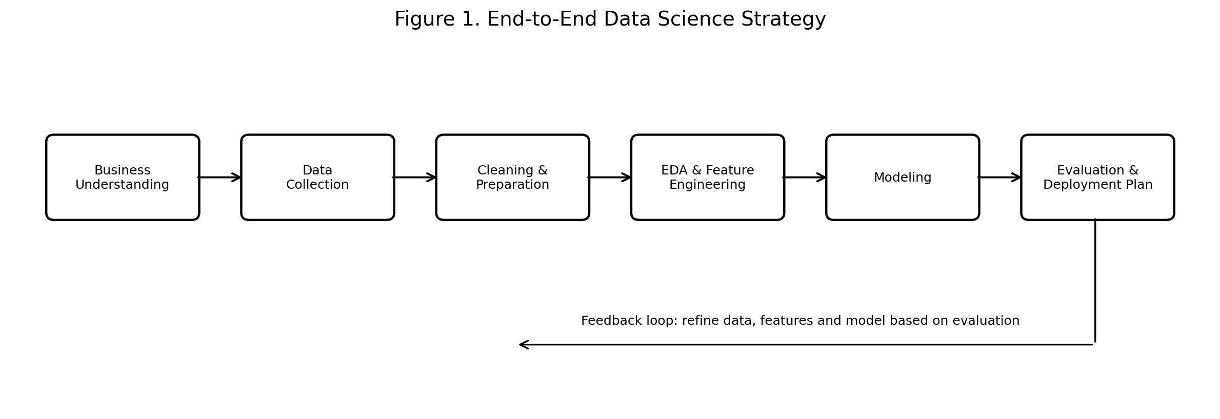

4.1 Business Understanding and Requirements
Confirm the definition of churn, prediction horizon, intended users, acceptable false-positive/false-negative trade-offs, and success criteria. Establish a data dictionary and assumptions register before analysis begins.

4.2 Data Collection Strategy
Potential inputs include customer demographics where appropriate and permitted, subscription tenure, plan type, login frequency, feature usage, payment history, customer-support interactions, and cancellation records. Data access will follow privacy and organizational governance rules. Source lineage and extraction dates will be documented.

4.3 Data Cleaning and Preparation
Profile missing values, duplicates, inconsistent categories, impossible values, date formats, and outliers. Apply appropriate imputation or exclusion rules. Encode categorical variables, scale variables only when required by the chosen model, and create reproducible preprocessing pipelines.

4.4 Exploratory Data Analysis
Use summary statistics and visualizations to understand distributions, churn rates, relationships among variables, class imbalance, temporal patterns, and potential data leakage. Findings will guide feature engineering and model selection.

4.5 Feature Engineering
Candidate features may include tenure bands, recent usage trends, changes in engagement, payment delays, support-ticket frequency, and ratios or aggregates. All engineered features must use information available before the prediction point to avoid leakage.

4.6 Modeling
Start with an interpretable baseline such as Logistic Regression. Compare it with tree-based methods such as Random Forest and Gradient Boosting. Use cross-validation and a clearly separated validation/test strategy. Hyperparameter tuning will be limited to a controlled search budget.

4.7 Evaluation and Interpretation
Evaluate ROC-AUC, precision, recall, F1-score, precision-recall performance, confusion matrices, and calibration where probability scores are used. Because churn actions may have costs, the final threshold will be selected using business priorities rather than accuracy alone. Feature importance and model-explanation techniques will be used to improve interpretability.

4.8 Reproducibility and Documentation
Organize code into notebooks or scripts with version control, environment documentation, consistent random seeds, and clear output folders. Record assumptions and decisions throughout the project.

5. Data Strategy and Quality Controls
Data Area | Examples | Quality Control
Customer account | Tenure, plan, account status | Unique customer ID, valid dates
Usage behavior | Logins, sessions, feature activity | Consistent time windows, anomaly checks
Billing | Payment delays, renewal history | Currency/date validation, duplicate checks
Support | Ticket count, issue categories | Standardized categories, missing-text policy
Outcome | Cancellation/churn label | Prediction-window alignment and leakage review

6. Timeline and Work Allocation
The Week 1 plan allocates approximately 35 hours to planning and strategy development.
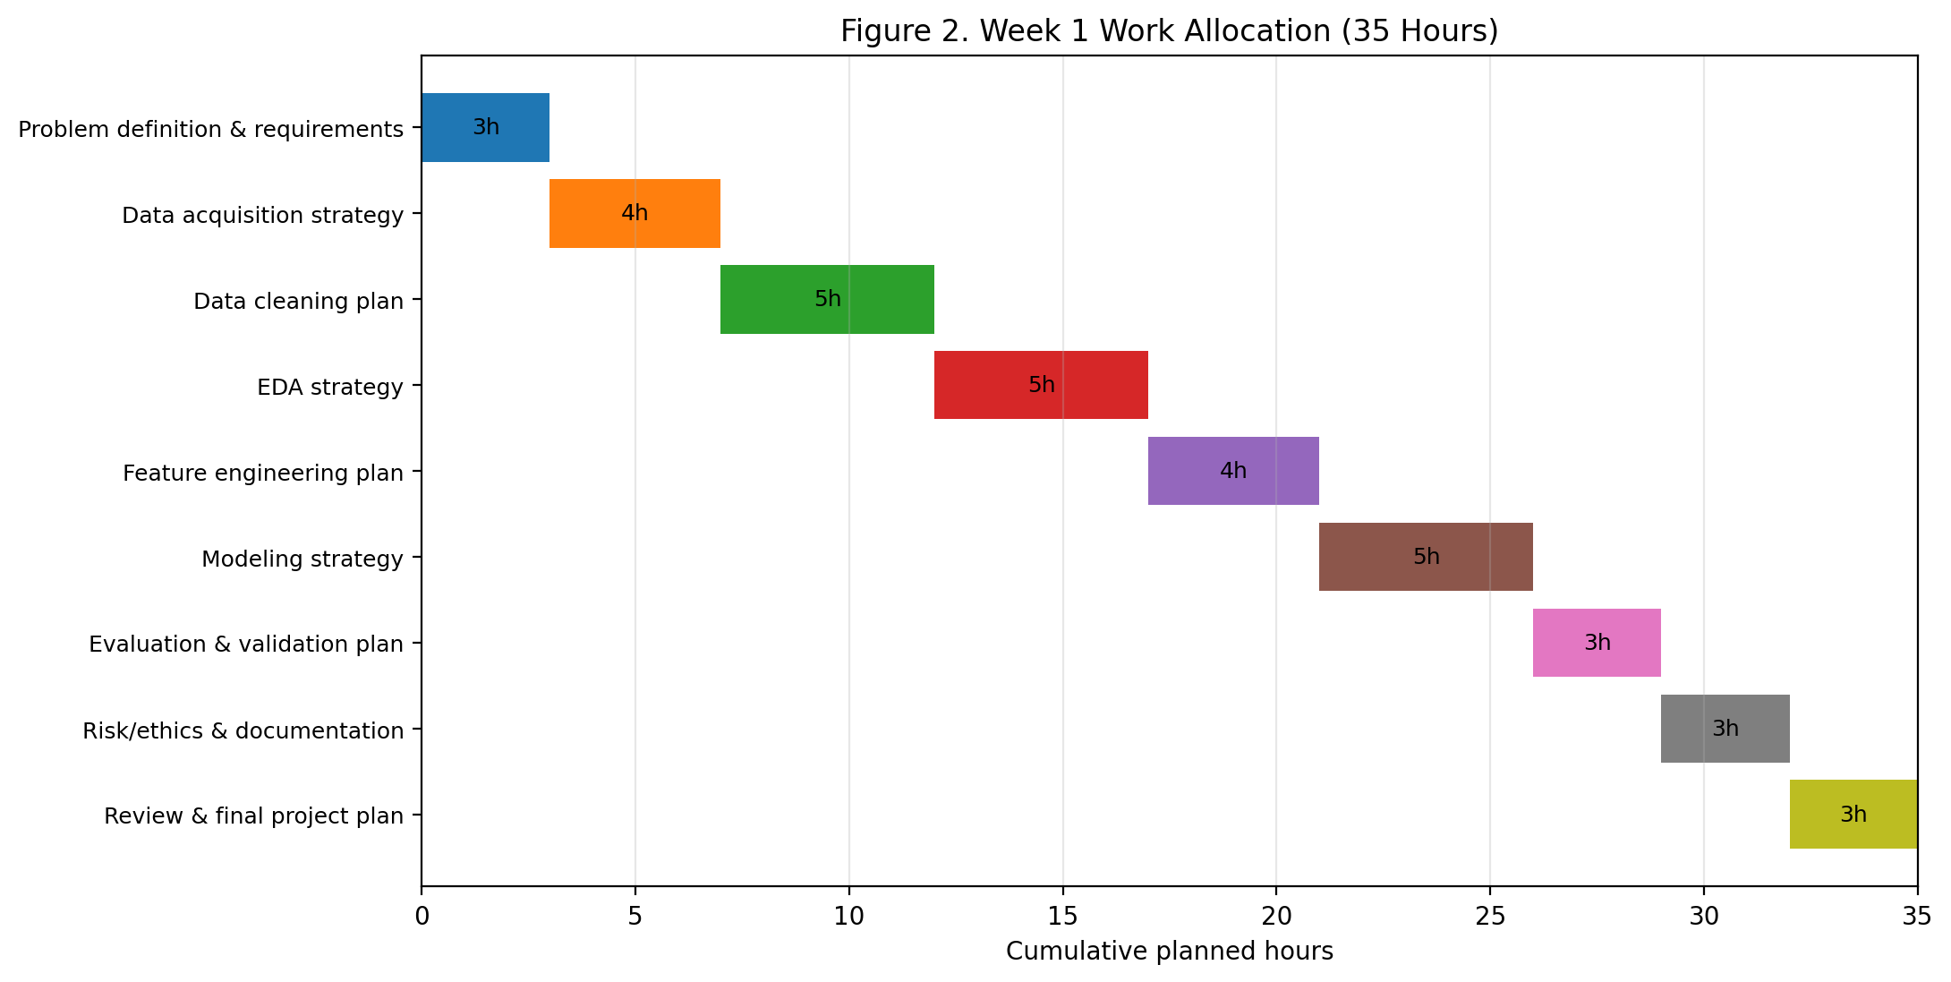

6.1 Detailed Schedule
- Problem definition & requirements: 3 hours
- Data acquisition strategy: 4 hours
- Data cleaning plan: 5 hours
- EDA strategy: 5 hours
- Feature engineering plan: 4 hours
- Modeling strategy: 5 hours
- Evaluation & validation plan: 3 hours
- Risk/ethics & documentation: 3 hours
- Review & final project plan: 3 hours

7. Python Libraries and Tools
- Python: Primary programming language for the analytical workflow.
- Jupyter Notebook / JupyterLab: Interactive exploration, documentation, and presentation of analysis.
- pandas: Data loading, cleaning, transformation, and tabular analysis.
- NumPy: Numerical operations and array processing.
- Matplotlib and Seaborn: Exploratory visualizations and reporting charts.
- scikit-learn: Preprocessing, modeling, cross-validation, and evaluation.
- SciPy / statsmodels: Optional statistical testing and diagnostics.
- SHAP (optional): Model interpretation for complex models.
- Git and GitHub/GitLab: Version control and collaboration.
- VS Code: Code development and project organization.
- SQL: Potential extraction of structured source data.

8. Evaluation Framework
Model success will be assessed at three levels: technical performance, business usefulness, and operational reliability.
- Technical: compare models using cross-validation and holdout performance.
- Business: assess whether the selected threshold identifies enough high-risk customers to support a feasible retention campaign.
- Reliability: verify reproducibility, absence of obvious leakage, stable performance across relevant customer segments, and understandable outputs.

9. Expected Outcomes and Benefits
- A complete blueprint for implementing the churn prediction project in Python.
- A prioritized list of data requirements and quality checks.
- A reproducible methodology for preprocessing, EDA, modeling, and evaluation.
- An interpretable churn-risk scoring concept to support proactive retention efforts.
- Improved understanding of behavioral and service factors associated with churn.
- A foundation for future dashboards, monitoring, and model deployment.

10. Anticipated Challenges and Mitigation Strategies
Challenge | Potential Impact | Mitigation
Missing or inconsistent data | Could reduce reliability and bias analysis. | Profile early; define imputation rules; document exclusions.
Class imbalance | A model may favor the majority non-churn class. | Use stratified splits, appropriate metrics, class weighting, and resampling where justified.
Data leakage | Can produce unrealistically high performance. | Enforce a prediction cutoff and audit every feature for timing.
Overfitting | Model may perform well in training but poorly on new data. | Use cross-validation, regularization, simpler baselines, and a final holdout set.
Privacy and ethics | Customer data may contain sensitive information. | Apply data minimization, access controls, anonymization/pseudonymization where appropriate, and governance review.
Changing behavior over time | Model performance can degrade after deployment. | Recommend monitoring, drift checks, and periodic retraining.
Limited time/resources | May restrict experimentation. | Prioritize a strong baseline and a small number of well-justified models.
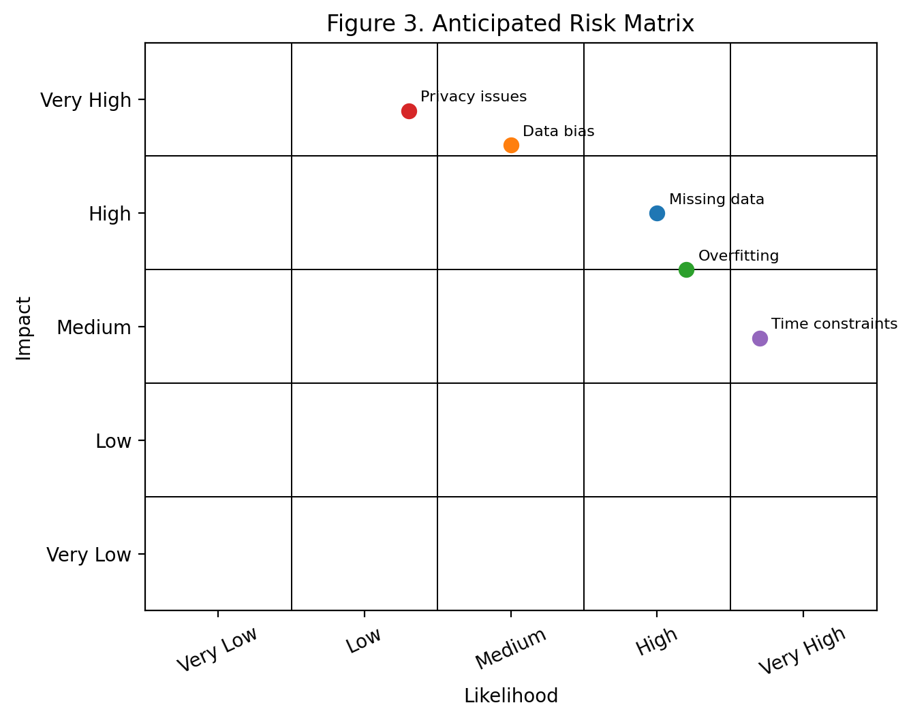

11. Success Criteria
The planning phase will be considered successful if it produces a clear problem definition, measurable objectives, a justified scope, an end-to-end methodology, a realistic 30–35 hour work allocation, an identified Python toolset, and documented risks and mitigation strategies. In the later implementation phase, success would additionally depend on model performance, interpretability, and practical usefulness for retention decisions.

12. Conclusion
This Week 1 project plan establishes a structured foundation for a hypothetical customer churn prediction project. The proposed approach emphasizes business understanding, data quality, leakage prevention, reproducible Python workflows, careful model evaluation, and ethical handling of customer information. By completing this planning stage before technical implementation, the project can proceed with clearer requirements, lower risk, and stronger alignment between analytical results and business needs.

Appendix: Proposed Project Structure
project/
├── data/ # Raw and processed data (access controlled)
├── notebooks/ # EDA and experimentation
├── src/ # Reusable Python modules
├── models/ # Saved model artifacts
├── reports/ # Figures and final outputs
├── tests/ # Validation tests
├── requirements.txt # Python dependencies
└── README.md # Project documentation

