Week 2: Exploratory Data Analysis (EDA) and Visualization Framework Design
A General Python Framework Adaptable to Multiple Dataset Types

Executive Summary
This report presents a comprehensive framework for conducting Exploratory Data Analysis (EDA) and designing effective visualizations using Python. Because no specific dataset is provided, the framework is adaptable to structured datasets from business, healthcare, finance, education, marketing, operations, and other domains. It explains how an analyst should understand data structure, assess quality, handle missing values and outliers, perform univariate, bivariate, and multivariate analysis, select appropriate charts, and document findings reproducibly.

1. Introduction to Exploratory Data Analysis
Exploratory Data Analysis is the process of examining data before formal modeling or advanced statistical analysis. Its purpose is to understand what the data contains, how variables behave, how variables relate to one another, and whether quality problems could affect later conclusions. EDA combines numerical summaries with visual inspection and is iterative: each discovery may generate new questions or require additional checks.
EDA is important because models and statistical methods can produce misleading results when data contains missing values, duplicates, inconsistent categories, extreme observations, leakage, or unrecognized bias. A well-designed EDA framework improves data quality, supports informed feature selection, and helps analysts communicate meaningful patterns to stakeholders.

2. Report Purpose and Objectives
The purpose of this report is to define a clear, repeatable EDA and visualization strategy that can be applied to a wide range of datasets using Python. The framework guides the initial analytical stage before predictive modeling or advanced statistical analysis begins.
- Profile dataset structure and identify potential data types.
- Assess completeness, consistency, validity, and uniqueness.
- Plan systematic treatment of missing values and outliers.
- Apply univariate, bivariate, and multivariate exploration.
- Select visualizations based on variable type and analytical question.
- Document findings, assumptions, transformations, and limitations.
- Create a reproducible workflow suitable for technical and non-technical audiences.

3. Potential Data Types and Initial Data Profiling
Data Type | Examples | EDA Focus | Typical Visualizations
Numeric | Age, revenue, temperature | Distribution and spread | Histogram, box plot
Categorical | Region, product type | Counts and proportions | Bar chart
Ordinal | Ratings, satisfaction | Ordered distribution | Ordered bar chart
Datetime | Transaction date | Trends and seasonality | Line chart
Text | Comments | Keywords and themes | Frequency summaries
Boolean | Yes/No | Class balance | Bar chart
Identifier | Customer ID | Uniqueness and duplicates | Usually not plotted
Initial profiling should record dataset dimensions, column names, inferred data types, descriptive statistics, unique counts, duplicate rows, missing-value percentages, date ranges, and suspicious or impossible values. A data dictionary should be created or updated as understanding improves.

4. Data Exploration Techniques

4.1 Data Quality Assessment
Check duplicate records, inconsistent spelling or category labels, invalid numerical ranges, incorrect data types, unexpected zeros, unit inconsistencies, and missing values. Log data quality issues rather than silently correcting them.

4.2 Missing Data Analysis
Measure missingness by variable and record. Examine whether missing values occur randomly or are associated with other variables. Possible treatments include retaining missingness as information, median or mode imputation, model-based imputation, or removing records and variables when justified.

4.3 Outlier Analysis
Investigate outliers before removing them. Methods may include box plots and IQR, z-scores where appropriate, percentile thresholds, robust statistics, and domain-specific limits. Distinguish true unusual observations from likely data-entry errors.

4.4 Univariate Analysis
Study one variable at a time. For numerical variables, examine count, mean, median, standard deviation, range, quartiles, skewness, and distribution shape. For categorical variables, calculate frequencies and proportions.

4.5 Bivariate Analysis
Investigate relationships between two variables. Use scatter plots and correlations for numerical pairs, grouped box or violin plots for categorical-numerical comparisons, and contingency tables or grouped bars for categorical pairs. Association does not automatically imply causation.

4.6 Multivariate Analysis
Consider three or more variables simultaneously using correlation heat maps, pair plots, faceting, grouped visualizations, interaction analysis, and dimensionality reduction when high-dimensional data requires it.
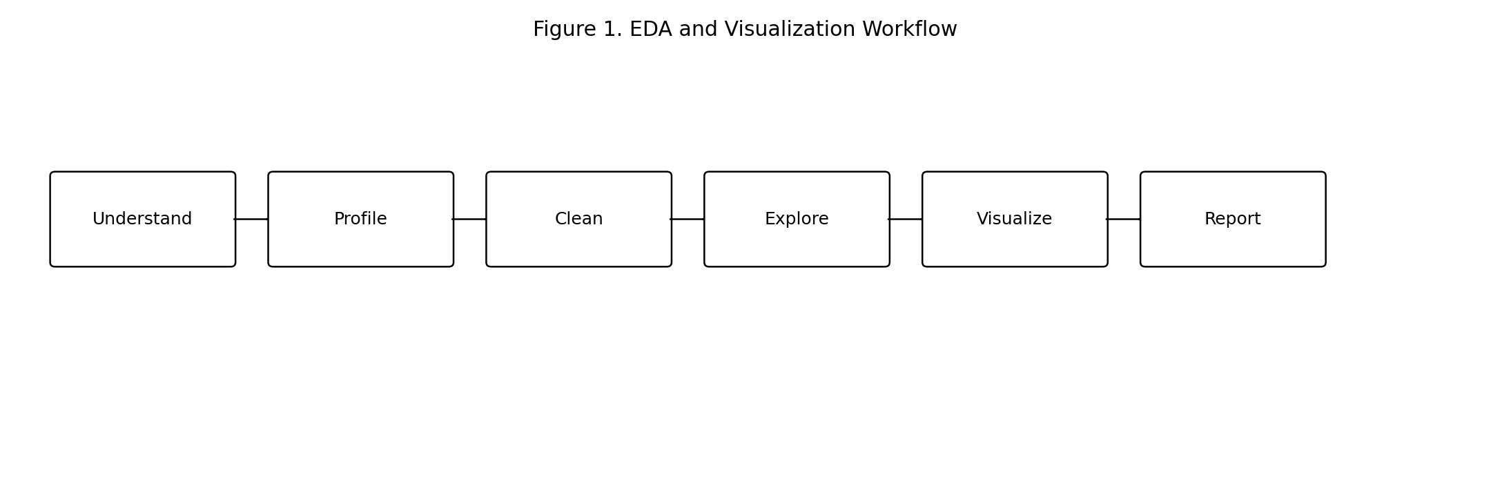

5. Visualization Strategies
Visualization should be selected according to the analytical question, variable type, and intended audience. A chart should reveal a pattern more clearly than a table alone and should avoid unnecessary complexity.
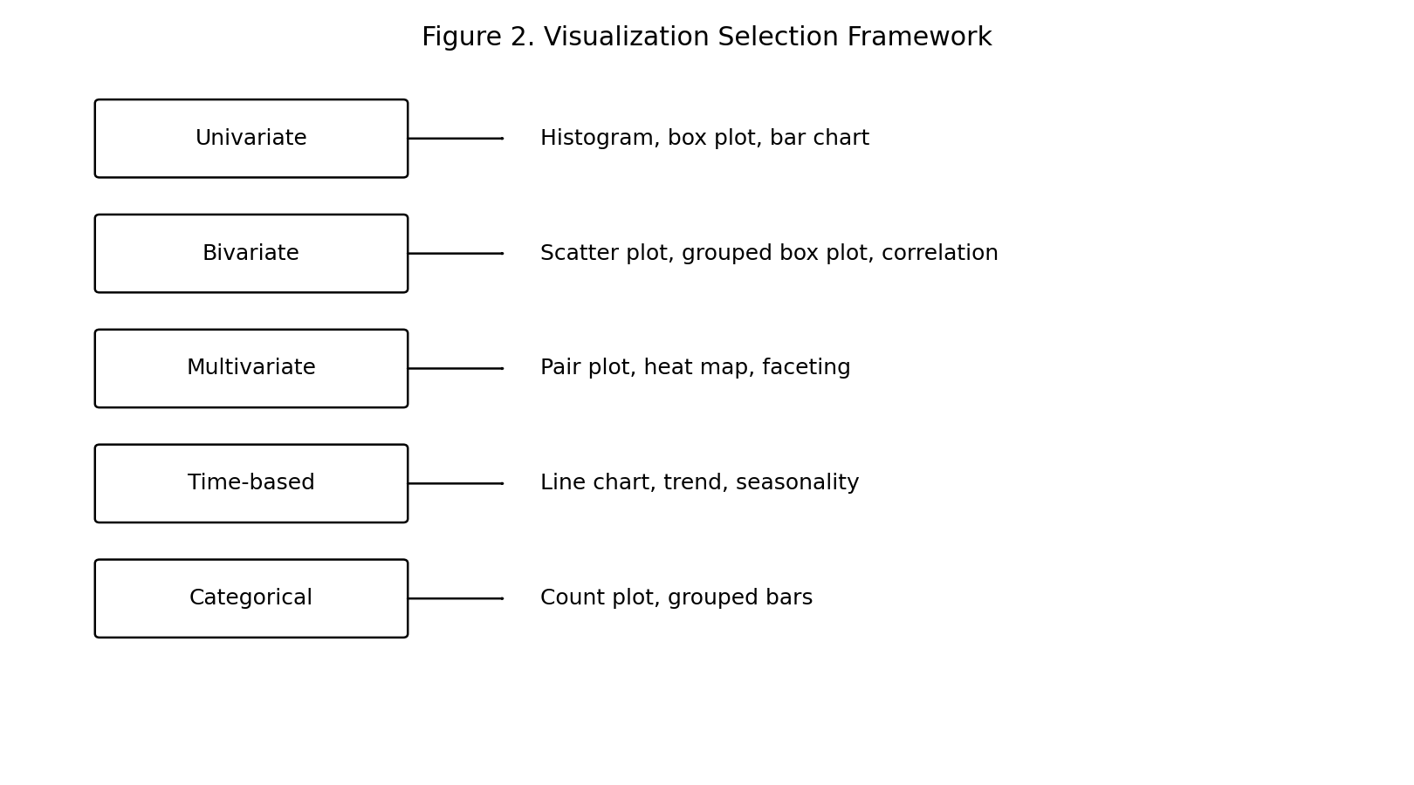
Chart Type | Best Used For | Key Insight
Histogram | One numeric variable | Shape and skewness
Box plot | Distribution and outliers | Median and spread
Bar chart | Category frequencies | Class balance
Line chart | Time data | Trends and seasonality
Scatter plot | Two numeric variables | Association and clusters
Heat map | Correlations | Relationship strength
Pair plot | Multiple numeric variables | Cross-variable patterns
Grouped bars | Category comparison | Differences between groups

6. Tools and Python Libraries
- pandas: Data loading, cleaning, filtering, grouping, merging, and descriptive summaries.
- NumPy: Numerical calculations and array operations.
- Matplotlib: Highly customizable foundational plotting.
- Seaborn: High-level statistical visualization.
- Plotly: Interactive charts and dashboard-ready visuals.
- SciPy: Statistical functions and scientific computing.
- statsmodels: Statistical modeling and diagnostics.
- scikit-learn: Preprocessing and dimensionality reduction support.
- Jupyter Notebook/JupyterLab: Interactive analysis, narrative, and visual output.
- VS Code: Development and debugging.
- Git: Version control and reproducible collaboration.

7. Proposed EDA Workflow in Python
- Load data and preserve an unchanged raw copy.
- Inspect shape, columns, data types, and sample records.
- Generate descriptive statistics and unique-value summaries.
- Calculate and visualize missing-value patterns.
- Check duplicates, invalid values, inconsistent categories, and possible unit problems.
- Analyze distributions and potential outliers.
- Explore relationships using bivariate and multivariate techniques.
- Create focused visualizations for important findings.
- Record transformations, assumptions, and limitations.
- Prepare an EDA summary and recommendations for the next phase.

8. Reporting and Documentation Plan
EDA findings should allow another analyst to understand what was discovered and reproduce the work. The report should separate observations from assumptions and clearly state limitations.
- Executive Summary: key findings and implications.
- Dataset Overview: source, size, variables, and time coverage.
- Data Quality Findings: missingness, duplicates, inconsistencies, and actions.
- Univariate Findings: important distributions and category patterns.
- Bivariate and Multivariate Findings: major relationships and interactions.
- Visualization Gallery: selected charts with short interpretations.
- Limitations and Risks: bias, coverage gaps, and uncertainty.
- Recommendations: next steps for feature engineering, testing, or modeling.
- Appendix: code references, data dictionary, and technical notes.

9. Visualization Design Principles
- Start with a clear analytical question.
- Use informative titles, axis labels, units, and legends.
- Keep scales honest and avoid misleading axes.
- Use consistent formatting across related charts.
- Limit unnecessary decoration and clutter.
- Annotate important findings when useful.
- Ensure charts suit the intended audience.
- Check accessibility and readability.

10. Timeline and Work Allocation
Approximately 34 hours are allocated to this Week 2 planning and framework-design task.
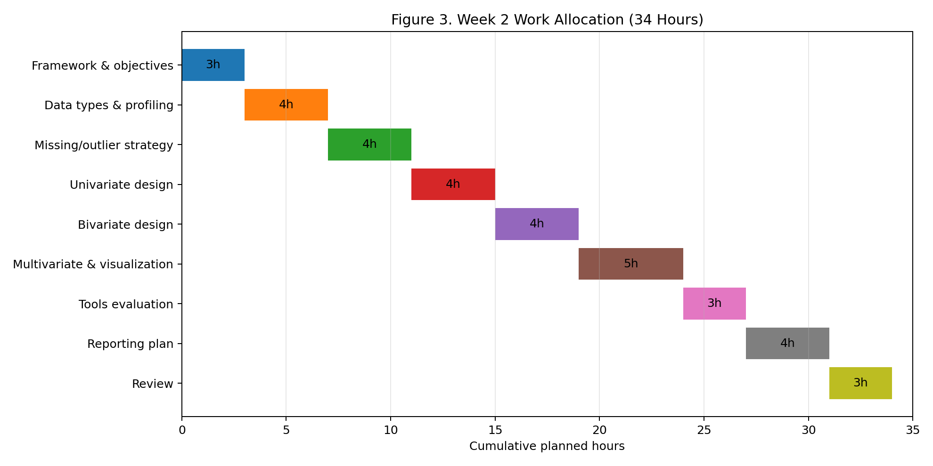
- Framework & objectives: 3 hours
- Data types & profiling: 4 hours
- Missing/outlier strategy: 4 hours
- Univariate design: 4 hours
- Bivariate design: 4 hours
- Multivariate & visualization: 5 hours
- Tools evaluation: 3 hours
- Reporting plan: 4 hours
- Review: 3 hours

11. Expected Outcomes and Challenges

Expected Outcomes
- A reusable EDA checklist applicable to multiple datasets.
- A structured approach to data profiling and quality assessment.
- A visualization selection framework linked to analytical questions.
- A documented Python toolset for analysis and visualization.
- A reporting structure supporting reproducibility and stakeholder communication.

Potential Challenges and Mitigation
Challenge | Risk | Mitigation
Large datasets | Slow processing and plotting | Use sampling, efficient types, aggregation, and scalable tools.
High-dimensional data | Too many relationships | Prioritize variables and use screening or reduction.
Poor data quality | Misleading patterns | Profile early and document decisions.
Misleading visualizations | Incorrect interpretation | Validate charts with numerical summaries.
Audience differences | Technical findings misunderstood | Use layered reporting with summary and appendix.

12. Conclusion
This EDA and visualization framework provides a logical, adaptable process for understanding a dataset before advanced modeling begins. It combines systematic profiling, quality assessment, univariate, bivariate, and multivariate analysis with purposeful visualization and thorough documentation. Following this framework can reduce avoidable errors, reveal meaningful patterns, and establish a strong evidence base for later modeling and decision-making.

