Week 3: Python-Based Machine Learning Model Development and Evaluation Plan
Hypothetical Project: Customer Churn Prediction for a Subscription-Based Digital Service
Machine Learning Model Development Plan | Python-Based Predictive Workflow

Executive Summary
This report presents the Week 3 plan for developing and evaluating a machine learning model to predict customer churn for a hypothetical subscription-based digital service. It builds directly on the Week 1 project plan, which defined the business problem and analytical strategy, and the Week 2 exploratory data analysis (EDA) and visualization framework, which established how the underlying data would be profiled and understood. Week 3 shifts the focus to the conceptual design of the modeling pipeline: how raw, EDA-informed data would be transformed into model-ready features, how candidate algorithms would be trained and compared, how model quality would be measured, and how a selected model could eventually be maintained in production. No code is executed at this stage; the deliverable is a structured plan detailed enough to guide a full implementation.

1. Introduction and Recap of Prior Phases
The Week 1 plan established the business context: a subscription-based digital service wants to identify customers who are likely to cancel so that retention actions can be taken proactively. It defined the problem statement, project scope, data strategy, and a proposed Python toolset. The Week 2 plan then designed a general, reusable framework for exploring and visualizing the underlying data — profiling structure, assessing data quality, examining missing values and outliers, and performing univariate, bivariate, and multivariate analysis.
Week 3 assumes that the EDA phase has been completed and that the analyst now has a validated, well-understood dataset. This plan describes how that dataset would be carried through preprocessing, model training, evaluation, and conceptual deployment using Python's machine learning ecosystem, primarily scikit-learn.

2. Problem Definition
The modeling problem is defined as a binary classification task:
Given a customer's account information, subscription tenure, product usage patterns, billing history, and support interactions as of a given date, predict the probability that the customer will cancel their subscription within the following 30 days.
This framing is chosen because it converts an ambiguous business concern ("which customers are at risk?") into a measurable, supervised-learning target with a clear label (churned = 1, retained = 0) and a fixed prediction horizon. A 30-day horizon is used because it is short enough to reflect near-term risk and long enough to allow a retention team to act before cancellation occurs. The target variable, its exact cutoff logic, and the population eligible for scoring (e.g., only currently active customers) must be defined precisely before training begins, since inconsistent labeling is one of the most common sources of downstream model error.

3. Machine Learning Workflow Overview
The plan follows a five-stage workflow, shown in Figure 1, that mirrors standard applied machine learning practice while remaining iterative: results from evaluation routinely send the process back to model tuning or feature engineering, and results from monitoring in production send the process back to preprocessing when retraining is required.
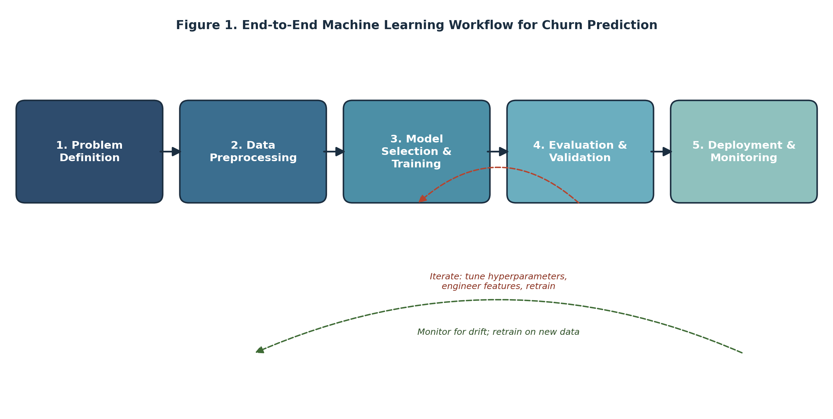
Figure 1. End-to-end machine learning workflow for churn prediction, including feedback loops for tuning and retraining.

4. Data Preprocessing
Preprocessing converts the cleaned, EDA-validated dataset from Week 2 into a numerical, model-ready feature matrix. This plan separates preprocessing into four sub-tasks.

4.1 Data Cleaning
Building on the data-quality findings from Week 2, cleaning steps would include resolving remaining missing values using the treatment decided during EDA (retention as a signal, imputation, or exclusion), removing exact duplicate customer records, correcting inconsistent categorical labels (e.g., "Monthly" vs. "monthly"), validating date fields, and confirming that no impossible values (such as negative tenure) remain.

4.2 Normalization and Scaling
Distance- and gradient-based models (e.g., logistic regression, SVM) are sensitive to feature scale, while tree-based models are not. The plan is to apply standardization (zero mean, unit variance) or min-max scaling within a scikit-learn Pipeline so that scaling parameters are learned only on training folds and applied consistently to validation and test data, preventing information leakage from the test set into training.

4.3 Feature Engineering
Candidate engineered features, consistent with the Week 1 data strategy, include:
- Tenure bands (e.g., 0–3 months, 4–12 months, 12+ months) to capture non-linear lifecycle effects.
- Rolling and trend features summarizing recent usage change (e.g., 30-day vs. 90-day login frequency).
- Engagement-decline indicators derived from feature-usage trajectories.
- Payment-delay counts and billing-issue flags from payment history.
- Support-ticket frequency and recency, including sentiment or issue-type category counts.
- Ratio and interaction features (e.g., usage per dollar of plan cost) where they show explanatory value during EDA.
All engineered features must be computed using only information available strictly before the prediction cutoff date, following the leakage-prevention rule established in Week 1.

4.4 Feature Selection
With a potentially large candidate feature set, the plan calls for a staged selection process: first removing near-zero-variance and highly correlated redundant features, then applying model-based importance ranking (e.g., permutation importance or tree-based feature importance) during cross-validation, and finally confirming that retained features have a plausible business interpretation. Automated selection is treated as a hypothesis-generation step, not a substitute for domain review.

4.5 Anticipated Preprocessing Challenges and Solutions
- Challenge: Class imbalance in the churn label. Solution: Address at the modeling stage with class weighting and stratified sampling rather than naive oversampling that could distort the feature distribution.
- Challenge: High cardinality categorical variables (e.g., ZIP code, plan SKU). Solution: Use target encoding computed only within training folds, or group rare categories, to avoid an unmanageable number of dummy variables.
- Challenge: Temporal inconsistency between when features and labels are captured. Solution: Build a single, versioned feature-generation function that is applied identically at training and scoring time.
- Challenge: Multicollinearity among usage-based features. Solution: Use variance inflation checks and rely on regularized or tree-based models that are more robust to correlated inputs.

5. Model Selection and Training

5.1 Candidate Models Considered
The plan proposes evaluating a small set of models spanning a range of complexity and interpretability, summarized in Table 1.
Table 1. Candidate models for churn classification.
Model | Strengths | Limitations | Role in This Plan
Logistic Regression | Highly interpretable; fast to train; coefficients map to churn drivers; strong baseline. | Assumes linear decision boundary; may underfit complex interactions. | Baseline model and interpretability benchmark.
Decision Tree | Captures non-linear splits; easy to visualize; no scaling required. | Prone to overfitting; unstable with small data changes. | Exploratory model; feeds intuition for ensemble methods.
Random Forest | Robust to noise and outliers; handles non-linearity; provides feature importance. | Less interpretable than a single tree; larger memory footprint. | Strong candidate for production-quality accuracy with moderate interpretability.
Gradient Boosting (XGBoost / LightGBM) | Typically highest predictive performance; handles imbalanced data well with class weighting. | More hyperparameters to tune; higher risk of overfitting without care; slower to explain. | Primary candidate for the final selected model, pending validation results.
Support Vector Machine | Effective in high-dimensional feature spaces; flexible kernels. | Computationally expensive at scale; less intuitive probability outputs. | Secondary comparison point; not primary due to dataset size expectations.

5.2 Selected Modeling Strategy and Justification
The plan recommends training Logistic Regression as an interpretable baseline, Random Forest as a robust mid-complexity model, and a gradient boosting model (XGBoost or LightGBM) as the primary candidate for final selection. This approach is justified because it gives stakeholders an interpretable point of comparison while still allowing the project to capture the non-linear relationships that are typical in churn behavior. The final model would be chosen based on validation performance rather than assumed in advance, consistent with the evaluation-driven approach described in Week 1.

5.3 Training Process
Training would proceed through a consistent scikit-learn Pipeline for every candidate model, so that preprocessing steps are always fit on training data only. The high-level training procedure is:
- Split the full dataset chronologically into training/cross-validation (70%), validation (15%), and a final held-out test set (15%), so that the model is always evaluated on customer behavior that occurred after the data it was trained on.
- Within the training portion, apply stratified k-fold cross-validation to preserve the churn/non-churn ratio in every fold.
- Fit each candidate model's pipeline (preprocessing plus estimator) on the training folds of each split.
- Score each fold's held-out portion using the metrics defined in Section 6.
- Aggregate fold-level scores to compare candidate models and hyperparameter settings.
- Refit the selected model and configuration on the full training + cross-validation portion.
- Evaluate once on the held-out test set to obtain an unbiased estimate of production-like performance.
Figure 2 illustrates this train/validation/test split together with the 5-fold cross-validation scheme used within the training portion.
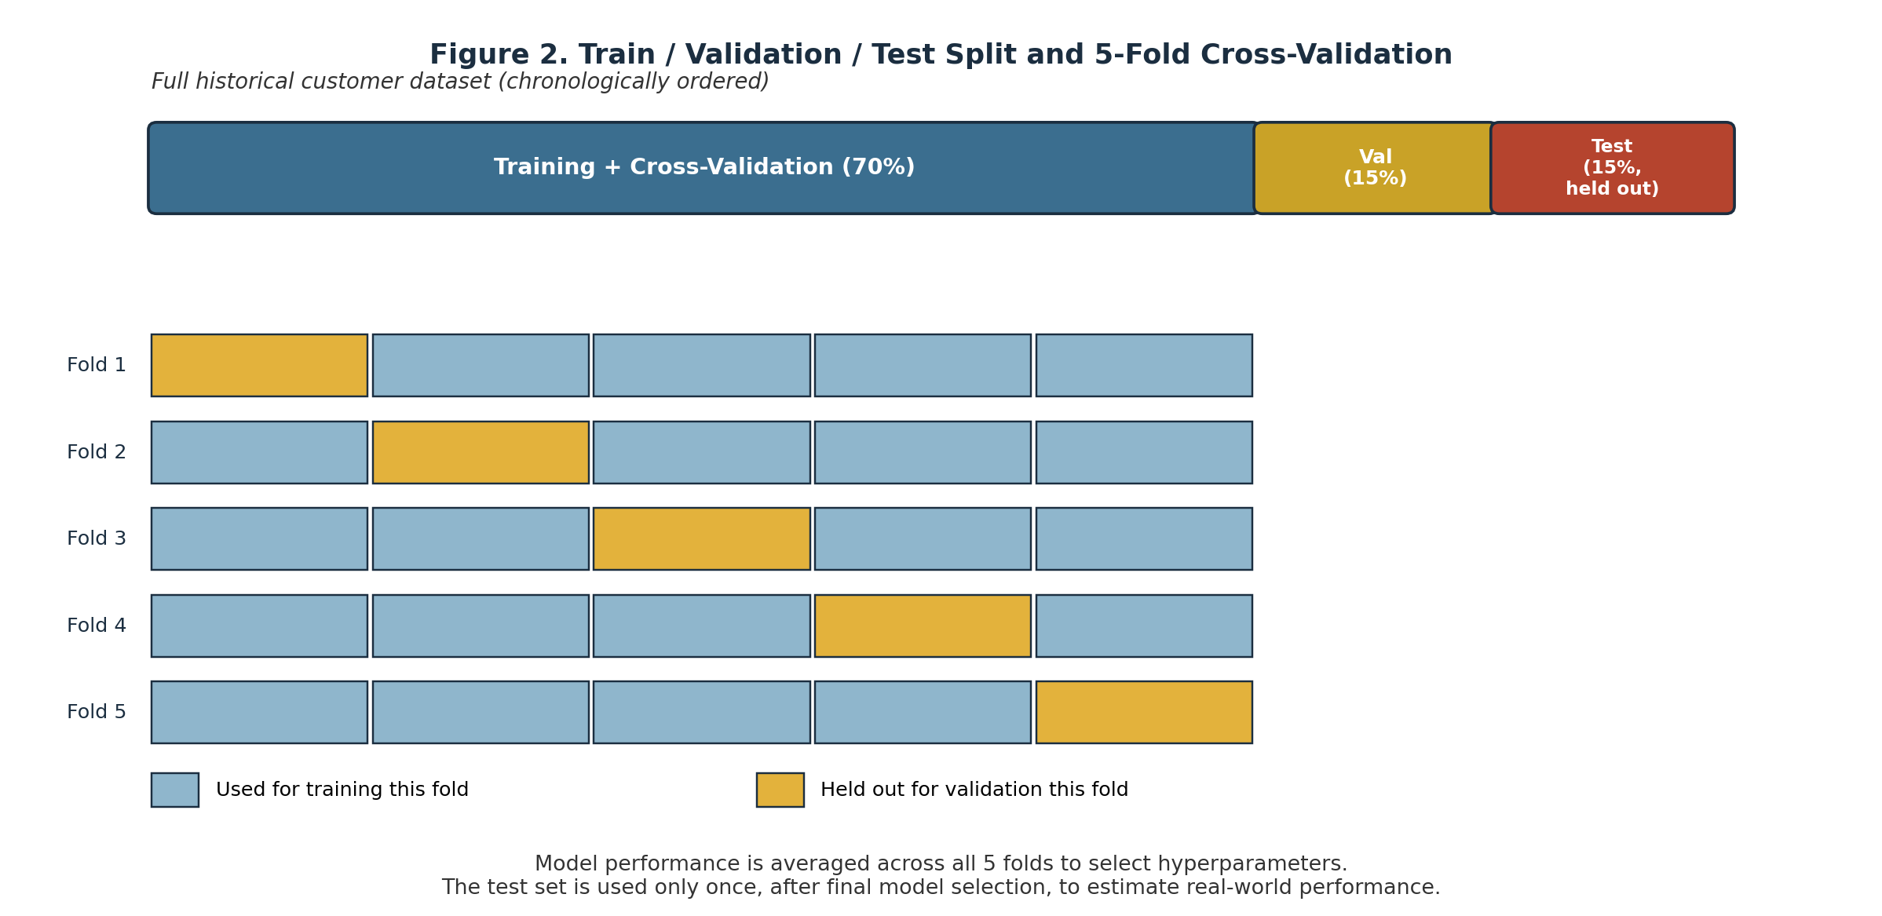
Figure 2. Train / validation / test split and 5-fold cross-validation used to tune and compare models.

5.4 Hyperparameter Tuning Strategy
Hyperparameter tuning would use a controlled search budget, consistent with the time allocation in Week 1, rather than exhaustive search. The plan is to use randomized search or Bayesian optimization (e.g., via scikit-learn's RandomizedSearchCV or Optuna) over a bounded grid for each model family — for example, regularization strength for logistic regression; tree depth, number of estimators, and minimum samples per leaf for Random Forest; and learning rate, tree depth, and subsampling ratio for gradient boosting. All tuning decisions would be made using cross-validation performance only, with the test set reserved exclusively for the final, single evaluation to avoid overfitting to validation results.

6. Evaluation Metrics and Validation Strategy

6.1 Metrics
Because churn is a business decision problem with asymmetric costs (missing an at-risk customer is typically more costly than a wasted retention offer), the plan uses a portfolio of metrics rather than a single number. Table 2 summarizes the primary metrics and their business relevance.
Table 2. Evaluation metrics and their business relevance.
Metric | Definition | Why It Matters for Churn Prediction
Accuracy | Proportion of all predictions that are correct. | Reported for context only; misleading under class imbalance since churners are the minority class.
Precision | Of customers predicted to churn, the proportion who actually churn. | High precision limits wasted retention offers sent to customers who were not going to leave.
Recall | Of customers who actually churn, the proportion correctly identified. | High recall reduces missed at-risk customers, which is often the costlier business error.
F1-Score | Harmonic mean of precision and recall. | Balances false positives and false negatives into a single comparable score across models.
ROC-AUC | Area under the true-positive vs. false-positive rate curve across thresholds. | Summarizes overall ranking ability independent of a single threshold choice.
PR-AUC | Area under the precision-recall curve. | More informative than ROC-AUC when the positive (churn) class is rare.

6.2 Confusion Matrix and Threshold Selection
A confusion matrix would be produced for the final model at several candidate probability thresholds, not only the default 0.5. Because the cost of a false negative (a churner who is missed) likely differs from the cost of a false positive (a retention offer sent unnecessarily), the plan calls for selecting the operating threshold using an approximate cost-benefit analysis in collaboration with business stakeholders, rather than by accuracy alone — consistent with the Week 1 evaluation framework.

6.3 Cross-Validation Strategy
Stratified k-fold cross-validation (k = 5, as shown in Figure 2) is used during model development to obtain a stable estimate of each candidate configuration's performance while preserving the proportion of churners in every fold. Because customer behavior can shift over time, a time-aware split is used for the outer train/validation/test division so that the model is never evaluated on data that occurred before the data it was trained on, reducing the risk of an overly optimistic performance estimate.

6.4 Handling Class Imbalance
Churn datasets are typically imbalanced, with far more retained customers than churners. The plan addresses this through class-weighted loss functions (available in scikit-learn, XGBoost, and LightGBM), stratified sampling in cross-validation, and by prioritizing PR-AUC, recall, and F1-score over raw accuracy when comparing models, since accuracy alone can be misleadingly high for a model that simply predicts the majority class.

7. Model Deployment (Conceptual)
Although full production deployment is out of scope for this planning exercise, the plan outlines how the selected model could eventually be maintained:
- Batch scoring: The model would run on a scheduled basis (e.g., weekly) to score the active customer base and output churn-risk probabilities for the retention team.
- Model packaging: The trained pipeline (preprocessing plus estimator) would be serialized with a tool such as joblib and version-controlled alongside the code and training configuration that produced it.
- Monitoring: Input feature distributions and prediction distributions would be tracked over time to detect data drift; realized outcomes would be compared against predictions to track performance decay.
- Retraining cadence: A scheduled retraining process (e.g., quarterly, or triggered by a monitoring alert) would refresh the model using the most recent labeled data.
- Human-in-the-loop review: Consistent with the Week 1 scope boundaries, model outputs would inform, not replace, business decisions about which customers receive retention outreach.

8. Timeline and Work Allocation
Consistent with the 30–35 hour planning scope for this assignment, the following allocation of approximately 34 hours is proposed across the modeling-plan workstreams.
Task | Hours | Workflow Stage
Review Week 1–2 outputs; finalize modeling problem framing | 2 | Problem Definition
Design preprocessing pipeline (cleaning, encoding, scaling) | 5 | Preprocessing
Design feature engineering and feature selection plan | 4 | Preprocessing
Research and compare candidate algorithms | 3 | Model Selection
Design training procedure and cross-validation scheme | 4 | Training
Design hyperparameter tuning strategy | 3 | Training
Define evaluation metrics and validation strategy | 4 | Evaluation
Design threshold-selection and business-cost analysis | 3 | Evaluation
Draft deployment and monitoring concept | 3 | Deployment
Diagrams, documentation, and final review | 3 | Documentation

9. Python Libraries and Tools
- pandas and NumPy: Feature engineering, data manipulation, and array operations, continuing from Weeks 1–2.
- scikit-learn: Preprocessing pipelines, model implementations, cross-validation, hyperparameter search, and evaluation metrics.
- XGBoost / LightGBM: Gradient boosting implementations for the primary candidate model.
- imbalanced-learn: Optional utilities for class-imbalance handling if class weighting alone proves insufficient.
- SHAP: Model interpretation and feature-contribution explanations for the selected model.
- Matplotlib / Seaborn: Diagnostic plots such as ROC curves, precision-recall curves, and calibration plots.
- joblib: Serialization of trained pipelines for reuse and conceptual deployment.
- MLflow (optional): Experiment tracking for comparing model runs, parameters, and metrics.
- Jupyter Notebook / VS Code and Git: Development environment and version control, continuing from Weeks 1–2.

10. Risks and Mitigation
Risk | Potential Impact | Mitigation Strategy
Data leakage from features computed using post-outcome information | Inflated validation performance that fails to replicate in production. | Enforce a strict feature cutoff date; audit each feature's information timing before training.
Class imbalance between churners and non-churners | Model biased toward the majority class; poor recall on churners. | Use class weighting, stratified cross-validation, and threshold tuning rather than relying on accuracy.
Overfitting to historical patterns | Model performs well on past data but degrades as customer behavior shifts. | Use regularization, cross-validation, a held-out test set, and monitor performance after deployment.
Limited interpretability of complex models | Difficulty justifying retention decisions to business stakeholders. | Apply feature-importance and SHAP-based explanation techniques alongside model selection.
Concept drift after deployment | Model accuracy declines as customer behavior or product offerings change over time. | Establish monitoring dashboards, performance alerts, and a scheduled retraining cadence.

11. Success Criteria
This planning phase will be considered successful if it produces: a precisely defined modeling target and prediction horizon; a preprocessing plan that prevents data leakage; a justified, compared set of candidate models; a training procedure with an appropriate train/validation/test and cross-validation design; a metrics framework aligned with business costs rather than accuracy alone; clear diagrams representing the workflow; and a conceptual deployment and monitoring plan. In a later implementation phase, success would additionally depend on the trained model's actual validation and test performance, its interpretability, and its practical usefulness for guiding retention decisions.

12. Conclusion
This Week 3 plan extends the Week 1 project strategy and the Week 2 EDA framework into a concrete design for machine learning model development and evaluation. It defines the churn-prediction target, a leakage-aware preprocessing plan, a justified set of candidate models culminating in a gradient boosting approach, a rigorous cross-validation and testing strategy, a business-aligned evaluation framework, and a conceptual path to deployment and monitoring. Taken together with the prior two weeks, this plan provides an end-to-end blueprint that could guide a full-scale implementation of the customer churn prediction project in Python.

