**Prof. Ram Meghe Institute of Technology & Research**

**Badnera,Amravati. (M.S.)444701**



**Practical Record**

**Semester III**

**Subject:-(K3S08)COMPUTER LAB-I (Web technology)**

**Department of Computer Science & Engineering**

Vidarbha Youth Welfare Society’s

**Prof.Ram Meghe Institute of Technology & Research**

**Badnera, Amravati(M.S.)444701**



**CERTIFICATE**

This is to certify Miss.**Snehal K. Deshmukh .**Roll no.76**,** Enrollment No._______________________________Section :B of B.E second year Semester III department of Computer Science and Engineering has satisfactorily completed term work of the subject **COMPUTER LAB-I (WEB TECHNOLOGY)** prescribed by SantGadge Baba Amravati Univesity, Amravati during the academic term 2018-19.

**Signature of the Faculty Head of Department**

Date:

**TAGS USED:**

|  |  |
| --- | --- |
| Tag | Description |
| <html> | This tag encloses the complete HTML document. |
| <head> | This tag represent the document header |
| <title> | This is used to mention title |
| <body> | This represents document body |
| <p> | This is the paragraph tag |
| <br/> | This is the break tag |
| <form> | This is used to create form |
| <dropdown> | Provides lists of options |

**General Description:**

An movie ticket (commonly abbreviated as e-ticket) is the digital ticket equivalent of a paper ticket.

There are many types of online ticket booking such as airlines ticket booking, rail ticket booking, It is also used in ticketing in the entertainment industry.

The E-ticket is indeed a ticket that you can directly download to your smartphone.

A mobile ticket offers multiple opportunities. It allows consumers to order, pay for, obtain and validate tickets wherever they are and whenever they want by using their smartphones.

Besides, mobile tickets offer more advantages than traditional ones : better commodity for users, less queuing at the entrance of a theater, concert or event. And costs will also drop because of the reduced printing and diffusion costs. Furthermore, it will be impossible to lose your ticket.

Consumers now gain time because they have the possibility to buy and use their tickets whenever they want and wherever they are thanks to their smartphones.

Movie tickets are only the beginning of a more digitalized way of living. Indeed, smartphones are becoming real digital wallet and retailers cannot wait anymore before exploiting this major opportunity.

Movie Ticket Booking System is a site to provide the customers facility to book tickets for a movie and to gather information about the movies and theaters.

**Technical Description:**

Our Ticket System (ETS) is a desktop-based system based on HTML. Designed with the help of HTML tags such as <form> tag, select box control,file upload box etc.

General Requirements :

**Software Requirements:**

* Operating System :Windows 8.1
* Notepad/text Editor
* Browser/Google Chrome

**HTML:**

HTML stands for Hypertext markup language and it is most widely used language to write web pages.

Hypertext refers to the way in which Web pages are linked together. Thus the link available on webpage is called Hypertext.

As its name suggests,HTML is a markup language which means you use HTML to simply “mark up ”a text document with tags that tell a web browser how to structure it to display.

Originally, HTML was design eith the intent of defining the structure of documents like heading, paragraph, lists, and so forth to facilitate the sharing of scientific information between researches.

Now HTML being widely used to format web pages with the help of different tags of HTML.

**Flowchart:**

Select options

Ticket Booking

Submitmit

Reset

Next

Flowchart for Ticket Booking

**Coding**

**TB.html:**

<html>

<head>

<title>TicketBooking</title>

</head>

<h1>WELCOME

<br> You can book your tickets here...

</h1>

<body>

<form>

<p>Theater Name :</p><br>

<select name="dropdown">

<option value="E-Orbit">E-Orbit</option>

<option value="Rajlakshmi">Rajlakshmi</option>

<option value="Big Cinema">Big Cinema</option>

</select>

</br>

<p>Movie Name:</p></br>

<select name="dropdown">

<option value="Bahubali">Bahubali</option>

<option value="Padmavati">Padmavati</option>

</select>

</br>

<p>Seating Type:</p></br>

<select name="dropdown">

<option value="Platinum">Platinum</option>

<option value="Gold">Gold</option>

<option value="Silver">Silver</option>

</select>

<br/>

<p>Date:</p></br>

<select name="dropdown">

<option value="13/10/18">13/10/18</option>

<option value="14/10/18">14/10/18</option>

</select>

</br>

No. of Tickets:<input type="text" name="first_name"/>

<br/>

<p>Show Time:</p><br/>

<select name="dropdown">

<option value="9 to 12 AM">9 to 12 AM</option>

<option value="12 to 3 PM">12 to 3 PM</option>

<option value="6 to 9 PM">6 to 9 PM</option>

</select>

<br/>

<input type="submit" name="submit" value="Submit" />

<input type="reset" name="reset" value="Reset" />

<br/>

<a href="C:\Documents and Settings\fff\Desktop\success.html">NEXT</a>

<br/>

<br>

</form>

</body>

</html>

**Success.html:**

<html>

<head>

<title>Success</title>

</head>

<body>

<h1>Success!! <br>

Your ticket is Booked</h1><br>

<br>

</body>

</html>

**Output:**

**TB.html**

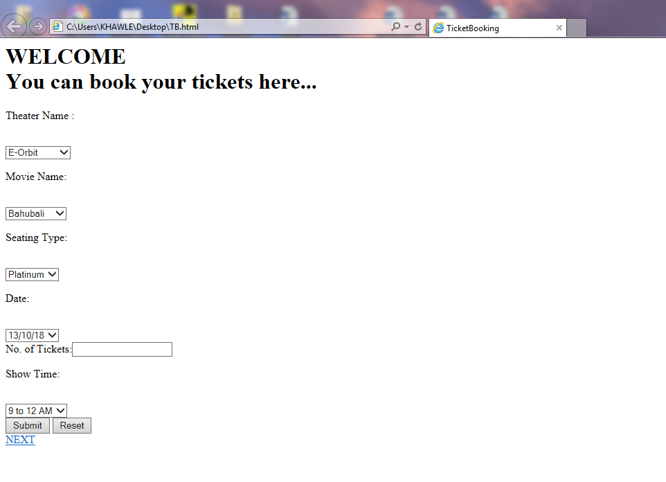

**Success.html**

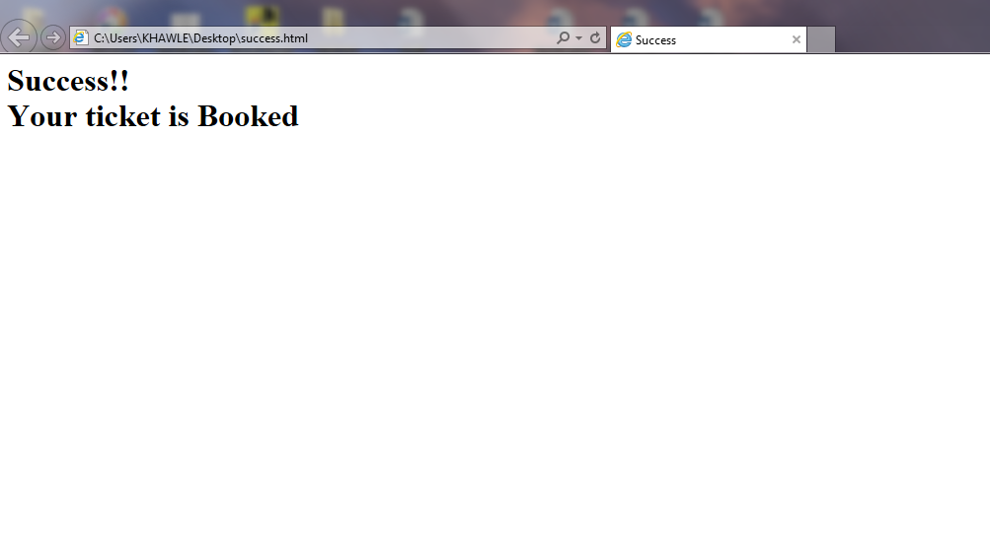

**Applications:**

* Ticket booking system provides easy way to buy tickets in single tap.
* Ticket booking system saves time as well as efforts as compared to traditional way of ticket booking.
* It stores all the necessary information about the movies, Premier dates, show times, Sitting types, etc.
* Ticket booking system provides a better understanding of latest and upcoming movies in the theatre.
* User can easily choose the type of movies among the various movies types.
* User can easily choose the convenient theater as per their convenience ,nearest to them.
* Provides more ease to users.
* Book any type of ticket.

**Conclusion And Summary:**

* This project has been developed successfully and the performance of the system has been found satisfactory
* Use of this interface helps customer in having immediate information about running movies and reserve their seats without wasting their precious time.
* User friendly interface also for the customer to add and delete the information.