
KARNATAK LAW SOCIETY’S

GOGTE INSTITUTE OF TECHNOLOGY

UDYAMBAG, BELGAVI – 590008

Academic Year 2019-20

Department of Computer Science and Engineering

A Project Synopsis

On

“Online PG Accommodation”

Submitted By

Shraddha Narale 2GI17CS121

Shradha Mungurkar 2GI17CS122

Shreya Vaidya 2GI17CS126

Under the guidance of

Prof. Gouri Khadabadi



TABLE OF CONTENTS:-

Serial Title
No.

1. |  | Abstract
2. |  | Introduction
3. |  | Objective
4. |  | Hardware and software requirement
5. |  | Scope
6. |  | Project Planning and sheduling
7. |  | Functional Nonfunctional Requirement
8. |  | List of the figures
9. |  | Different testing
10. |  | Code
11. |  | Screenshort
12. |  | Conclusion
13. |  | References

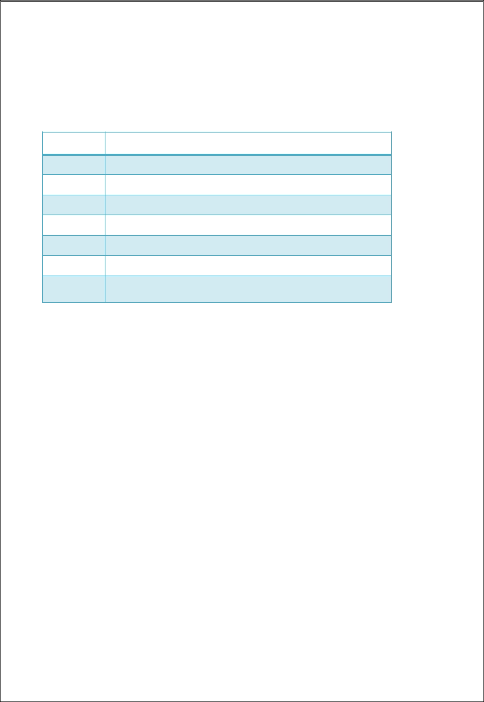

8. LIST OF FIGURES:-

Fig. No. | Figure Name
A. | Use-case diagram
B. | ER diagram
C. | Class diagram
D. | Activity diagram
E. | State diagram
F. | Sequence diagram
G. | Data Flow diagram

- ABSTRACT:

In this online paying guest system, users can find a number of paying accommodation nearby work place or desired place. Even user can add his/her own desired places and get the tenant easily by just uploading picture and details of the respective place.

- Introduction:

It has become easy to search pg accommodation nearby the work place. It was difficult earlier to go a place to work which was situated at long-distances and hence had to lose good opportunities, as we don’t know where to stay and where unaware about a particular city. But now it has become easier to find an accommodation nearby the work place in cheap rates. In this online paying guest system, users can find a number of paying accommodation nearby work place or desired place. Even user can add his/her own desired places and get the tenant easily by just uploading picture and details of the respective place. In this system user can register to get login id and password. With login id and password user can get logged in. After logging in, user can post the paying guest post by adding details and pictures of the place. He/she can also view the interested users in his/her uploaded post. The uploaded post can be removed or deleted. User can also see for the paying accommodation and after getting the desirable place he/she can select the place he/she is interested in. After selecting the desired place, user will get the personal details of the owner, he/she can get in contact with the owner and go for further processing.

This further processing may include payment done either by cash or by the card. Admin manages the customers as well as PG owner, he validates all the details and after the accommodation the admin will generate the report.

3.Objective:

The objectives of the project are:

- Online accommodation search.
•
- Details of rooms provided on private basis.

- Details of food facilities in the PG.

- Admin control over the website . •

- A full fledged database of all the PG. •

- A Google map experience that makes your problem more easy.

4.Hardware and Software requirement:

Hardware Requirements
- Intel core i5 2nd generation is used as a processor because it is fast than other processors an provide reliable and stable and we can run our pc for longtime.

- By using this processor we can keep on developing our project without any worries.

- Ram 1 GB is used as it will provide fast reading and writing capabilities and will inturn support in processing

Software Requirements

- Operating system - Windows 7 is used as the operating system as it is stable and supportsmore features and is more user friendly.

- Database MYSQL - MYSQL is used as database as it easy to maintain and retrieve records by simple queries which are in English language which are easy to understand and easy to write.

- Development tools and Programming language - HTML is used to write the whole code and develop webpages with CSS, java script for styling work and php for sever side scripting.

5.Scope:

- Students, in fact will be benefited with this system as some of their work load will be reduced and will relieve them from stress.
- Reduces manual work and scope for errors.

- To build a specialized project for people who travel a lot, where it will act as solution for them in finding rooms.
- Paper work is reduced.

- Time is saved.

6. Project Planning and Sheduling:

Planning:

Software project plan indicates scope of the project, milestones and deliverables, project

estimates, resource allocation, risk management, scheduling techniques and quality control

and standard.

Scheduling:

Scheduling of a project can be correlated to prioritizing various jobs with respect to their cost,

time and duration. It can be done with resource constraint or time constraint in mind.

7.Functional and NonFunctional Requirements:

Functional Requirement:

- SEARCH ACCOMODATION : This feature used by the user to search for accommodation in the system. They are required to enter fields regarding their gender,location,range region etc. .The corresponding details will be retrieved from the database and displayed to the user.The system performs the search from the database and based on the entered field required information is displayed to the user. New accommodation can be added by the admin. This feature can be performing by all users to register new admin .Admin is the moderator of the page and can modify info about the accommodation.

- VERIFY ACCOMODATION : System must be able to verify information,Only single entry must be assigned for each attribute of a table and it should not allow two same address having same location id.

- DESCRIPTION OF FOOD FACILITY : In this feature we can get the info about the food facility available in the PG.

Non-Functional Requirement:

- EFFICIENCY REQUIREMENT : When this online accommodationportal system will be implemented users and house owners can easily access online accommodation system and searching for accommodation will be very faster .

- RELIABILITY REQUIREMENT : The system should accurately performs accommodation registration, user validation , report generation and search.

- USABILITY REQUIREMENT : The system is designed for a user friendly environment so that student and house owners can perform the various tasks easily and in an effective way.

- IMPLEMENTATION REQUIREMNTS : In implementing whole system it uses html in front end with php as server side scripting language which will be used for database connectivity and the backend ie the database part is developed using mysql

8.List of the Figures to the Digital Notice Board:

A. Use Case diagram

A use case diagram at its simplest is a representation of a user's interaction with the system that shows the relationship between the user and the different use casesin which the user is involved. A use case diagram can identify the different types of users of a system and the different use cases and will often be accompanied by other types of diagrams as well. The use cases are represented by either circles or ellipses.

Staff

User

Add notice/ Photos /News clippings

Approve notice/Photos News clippings

Modify notice/Photos/
News clippings

Delete notice/Photos/
News clippings

View notice/Photos/
News clippings

Allocation of notice boards

View notice board allocation/Board layout

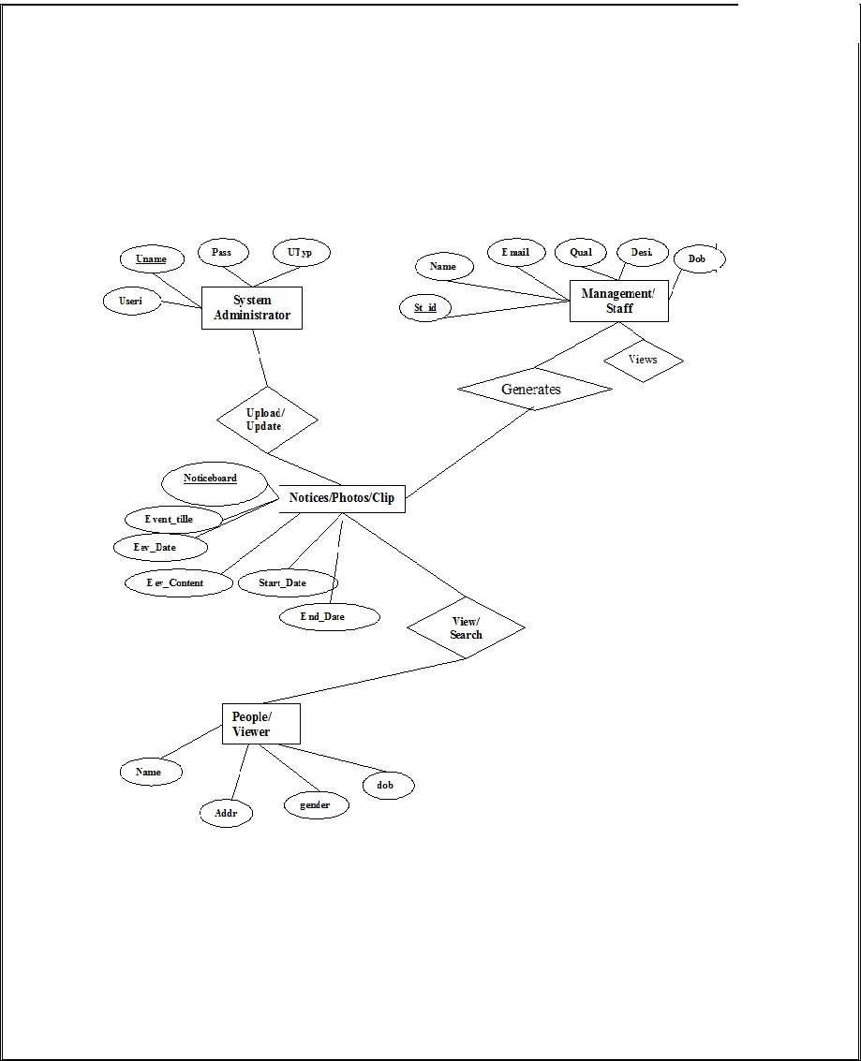
B. ER diagram:

ENTITY RELATIONAL (ER) MODEL is a high-level conceptual data model diagram. ER modeling helps you to analyze data requirements systematically to produce a well-designed database. The Entity-Relation model represents real-world entities and the relationship between them. It is considered a best practice to complete ER modeling before implementing
your database.
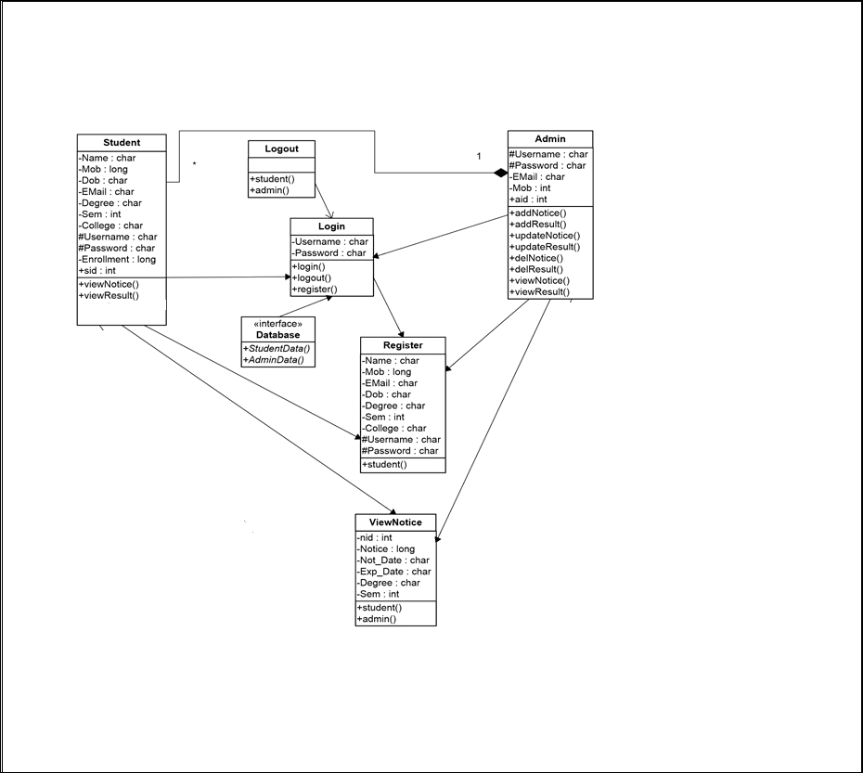
C. Class diagram:

Class Diagram defines the types of objects in the system and the different types of relationships that exist among them. It gives a high-level view of an application. This modeling method can run with almost all Object -Oriented Methods. A class can refer to another class. A class can have its objects or may inherit from other classes.
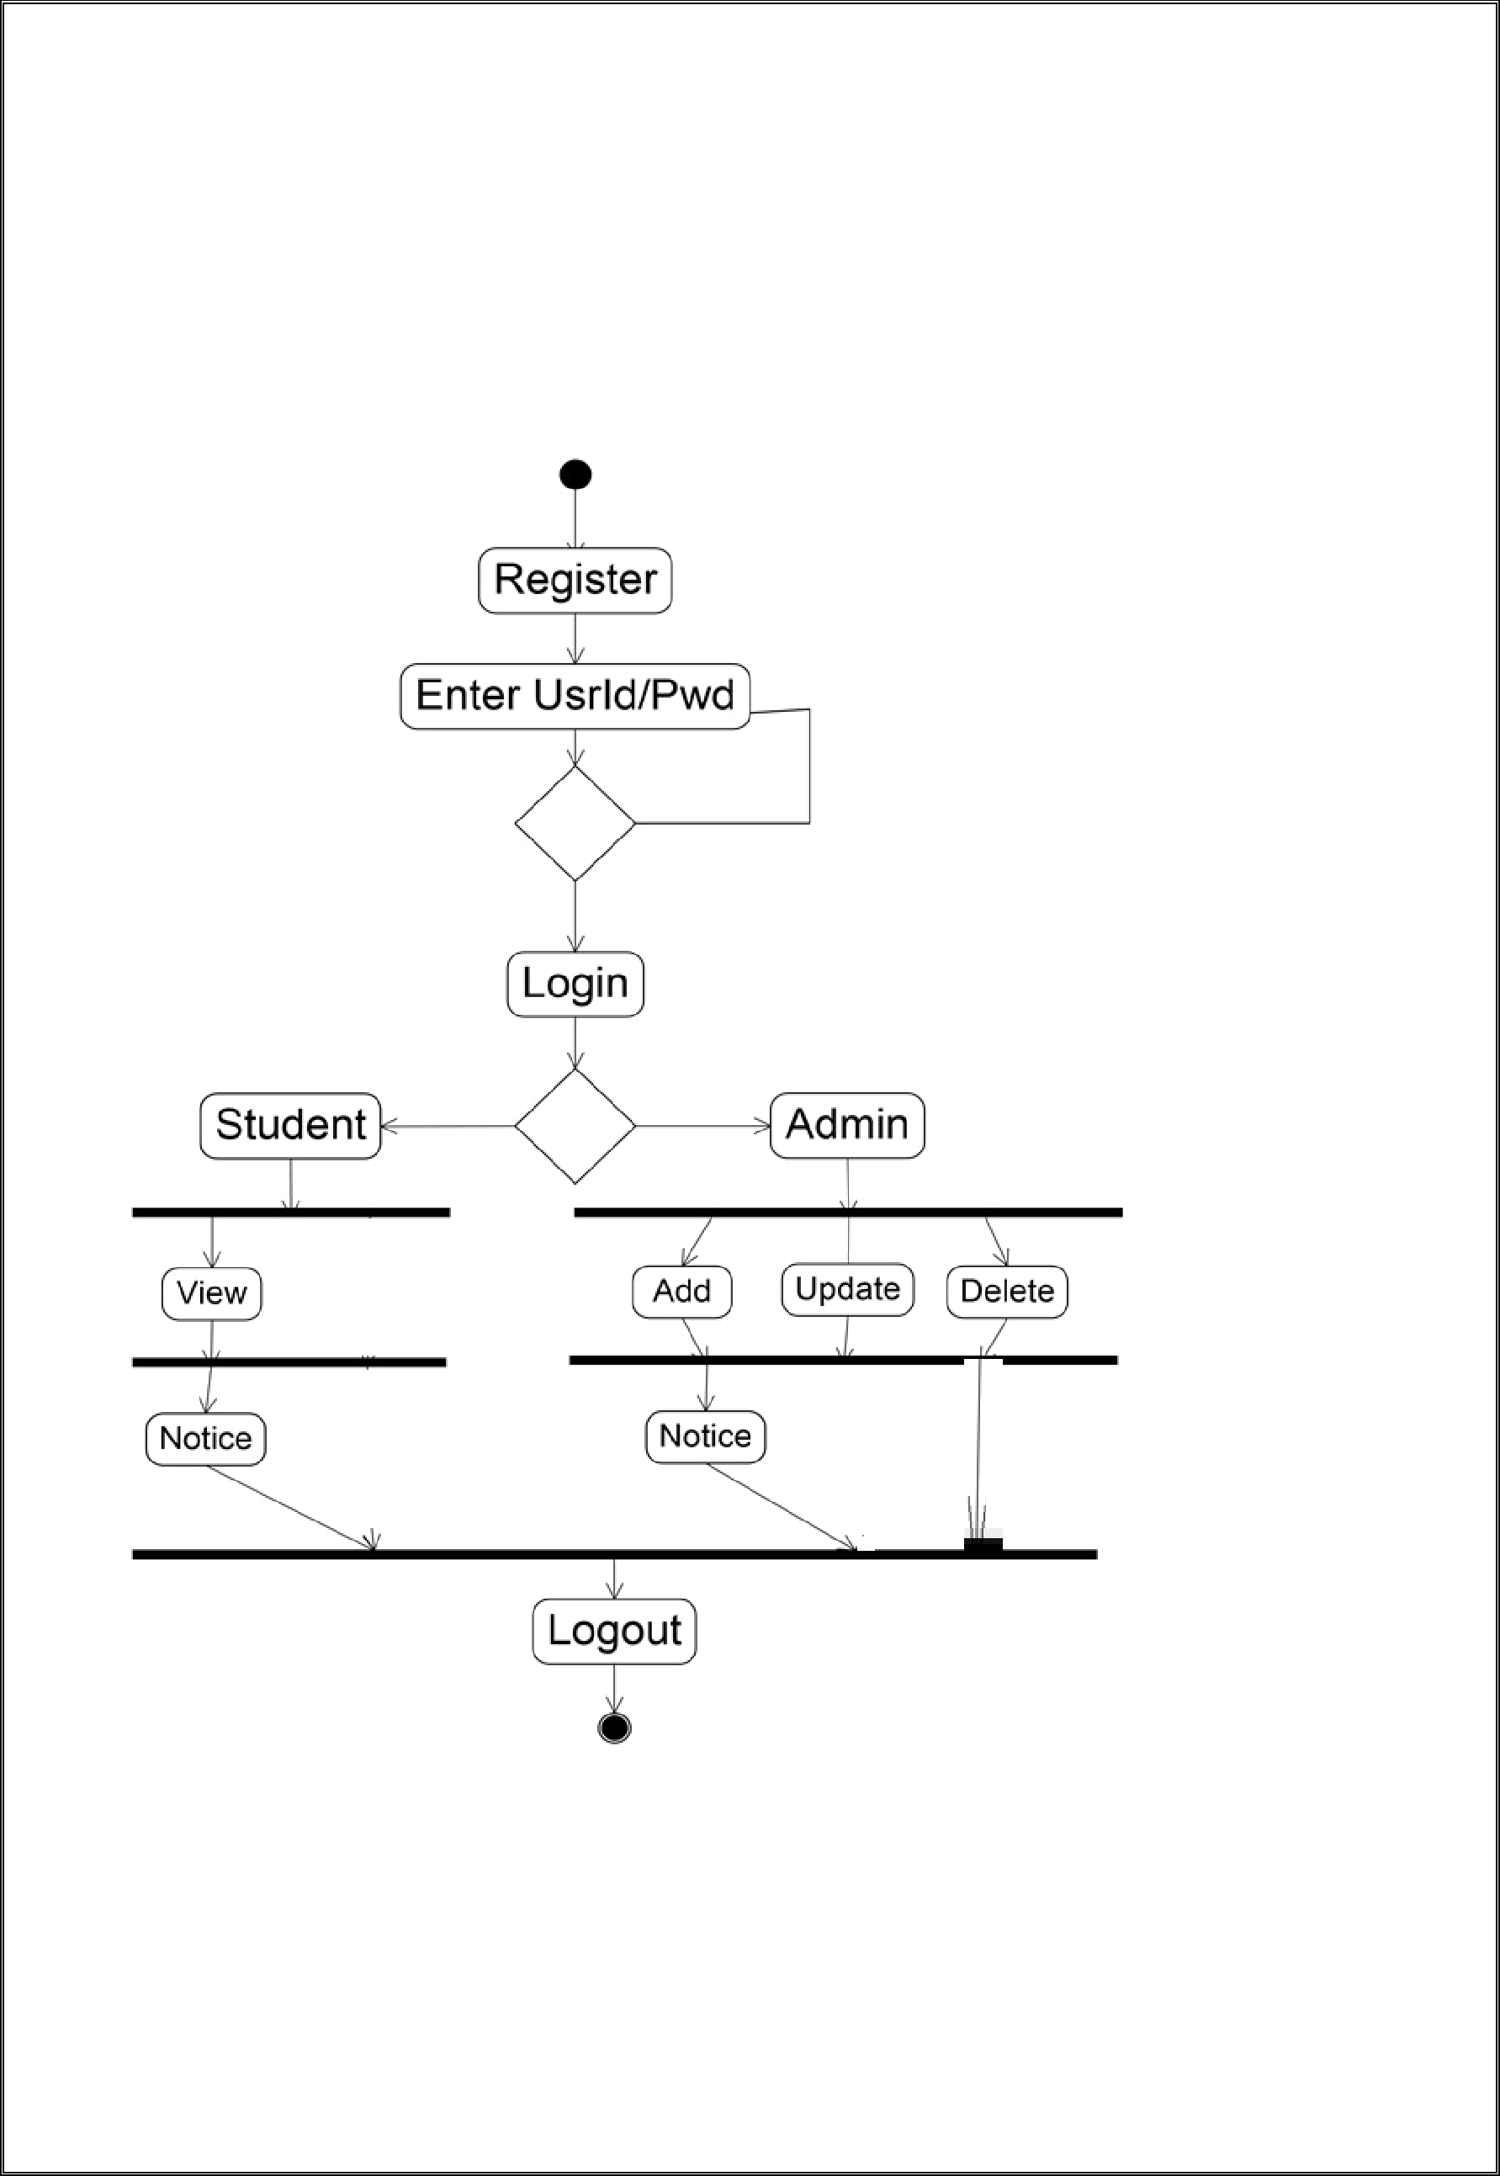
D. Activity Diagram:

An activity diagram visually presents a series of actions or flow of control in a system similar to a flowchart or a data flow diagram. Activity diagrams are often used in business process modeling. They can also describe the steps in a use case diagram. Activities modeled can be sequential and concurrent. In both cases an activity diagram will have a beginning (an initial state) and an end (a final state).
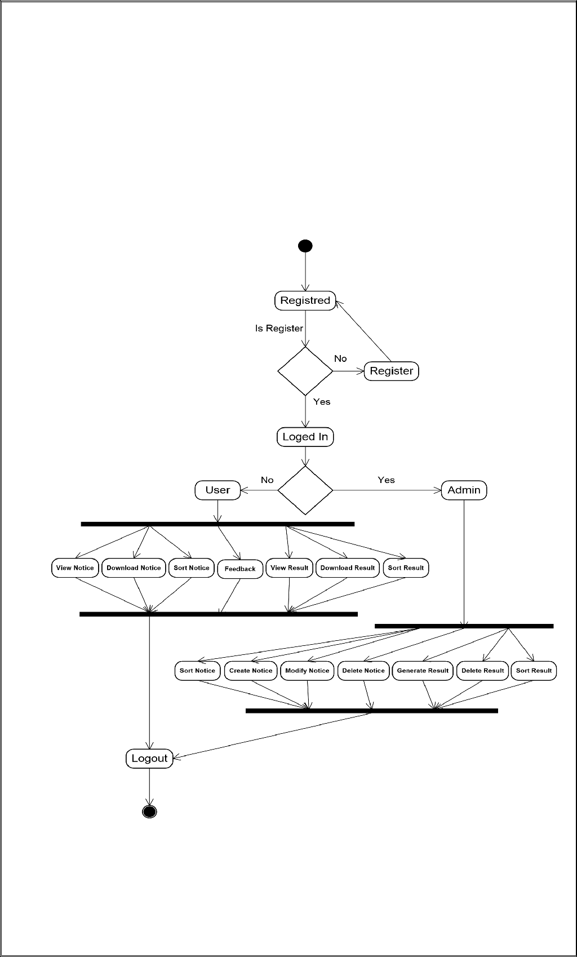
E. State Diagram:

A state diagram is a diagram used in computer science to describe the behavior of a system considering all the possible states of an object when an event occurs. This behavior is represented and analyzed in a series of events that occur in one or more possible states. Each diagram represents objects and tracks the various states of these objects throughout the system.
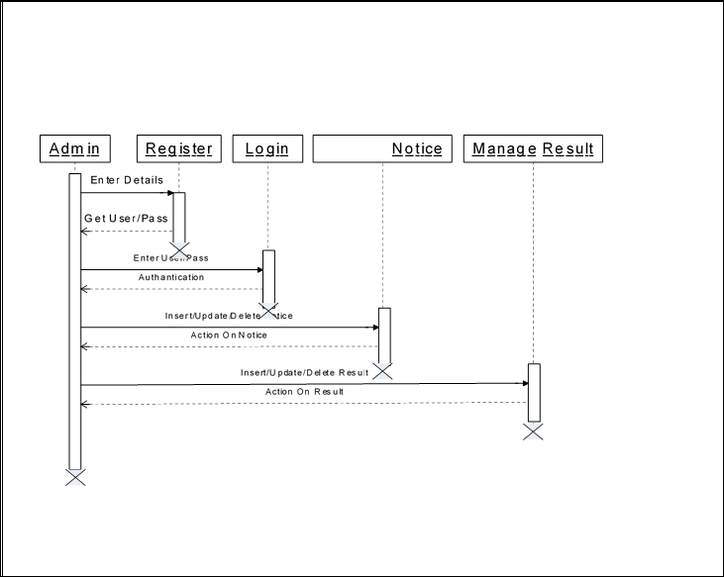

F. Sequence Diagram

Sequence diagram is a visual representation of various messages sent between the objects of a system and the order in which these messages occur.
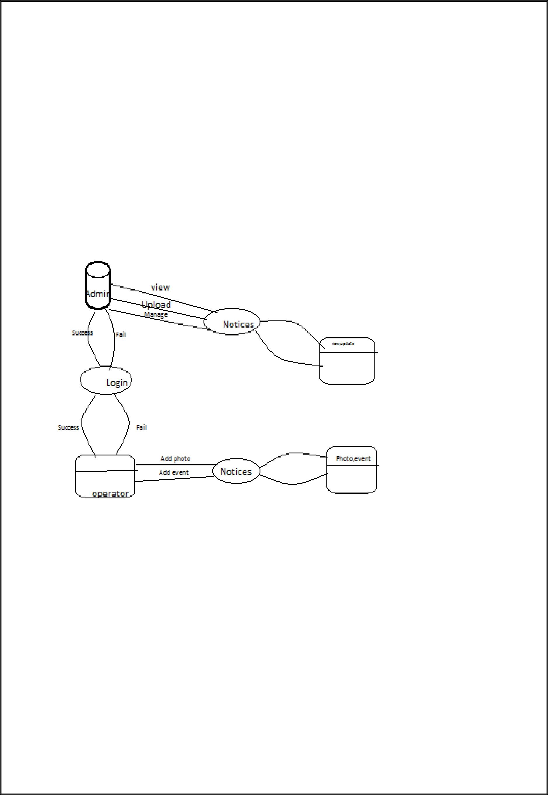

H. Data flow Diagram:

A data flow diagram (or DFD) is a graphical representation an information system. It shows how information is input to information sources and destinations, and where it's stored.

of the flow of data through and output from the system,

.

9. Different Testing Techniques used in the project:

The Testing Techniques used in this project are as follows:

- Unit Testing:

Individual components are tested to ensure that they operate correctly. Each component is tested independently without other system components.
For example while displaying the details of students by roll no, it should prompt error message if roll no is kept blank.
- Module Testing:

Module is collection of independent components such as an object class, an abstract data type or some loser collection of procedures and functions. A module encapsulates related components so can be tested without other modules.
For example after attendance entry module, we used view attendance to check whether attendance is been added or not. Thus both the modules are tested.
- Sub System Testing:

This phase involves testing collection of modules, which have been integrated into subsystems. Subsystems may be independently designed and implemented. The most common problems, which arise in the large software systems, are subsystems interface mismatches. The subsystem test process should therefore concentrate on the detection of interface errors by rigorously exercising these interfaces.

This test was carried out to assure that the information properly flows out of the program units. This test was carried out by executing all the modules present under every sub system.

- System Testing:

The subsystems are integrated to makeup the entire system. The testing process is concerned with finding errors, which result from unanticipated interactions between subsystems and system components. It is also concerned with validating that the system is functional or non-functional requirements.

10. Code :

Login Module
*{
margin: 0;
padding: 0;
}
.hero
{
height: 100%;
width: 100%;
background-image: linear-gradient(rgba(0,0,0,0.4),rgba(0,0,0,0.4)),url(bed.jpg);
background-position: center;
background-size: cover;
position: fixed;
}

.form-box
{
width: 380px;
height: 480px;
position: relative;
margin: 6% auto;
background: white;
padding: 6px;
}
.button-box
{
width: 220px;
margin: 35px auto;
position: relative;
box-shadow: 0 0 20px 9px;
border-radius: 30px;
}
.toggle-btn
{
padding: 10px 30px;
cursor: pointer;
background: transparent;
border: 0;
outline: none;
position: relative;
}
#btn
{
top: 0;
left: 0;
position: absolute;
width: 110%;
height: 100%;
background:linear-gradient(to right,#ff105f,#ffad06 );
border-radius: 30px;
transition: 0.5s;
}
.social-icon
{
margin: 30px auto;
text-align: center;

}
.social-icon img
{
width: 30px;
margin: 0 12px;
box-shadow: 0 0 20px 0 #7f7f7f3d;
cursor: pointer;
border-radius: 50%

}
.input-group
{
top: 180px;
position: absolute;
width: 280px;
transition: 0.5s;

}
.input-field
{
width: 100%;
padding: 5px 0;
margin: 5px 0;
border-left: 0;
border-right: 0;
border-top: 0;
border-bottom: 1px solid #999;
outline: none;
background: transparent;
}
.sub-btn
{
width: 85%;
padding: 10px 30px;
cursor: pointer;
display: block;
margin: auto;
background: linear-gradient(to right,#ff105f,#ffad06);
border:0;
outline: none;
border-radius: 30px;

}
.check-box
{
margin: 30px 10px 30px 0;

}
.span
{
color: #777;
font-size: 12px;
border:68px;
position: absolute;
}
#Login
{
left: 50px;

}
#Signup
{
left: 450px;
}

Code for admin module

<html>
<head>
<meta http-equiv="Content-Type" content="text/html; charset=iso-8859-1" />
<title>Login Box HTML Code - www.PSDGraphics.com</title>

<link href="login-box.css" rel="stylesheet" type="text/css" />

<title>HTML Backgorund Color</title>

</head>

<body>
<body style="background-color:cyan;">
<h1>Products</h1>
<p>We have developed more than 10 products till now.</p>
</body>

<div style="padding: 100px 0 0 250px;">

<div id="login-box">

<H2 align="margin-left">Admin Login</H2>

<br />
<br />
<div id="login-box-name" style="margin-top:20px;">Email:</div><div id="login-box-field" style="margin-top:20px;"><input name="q" class="form-login" title="Username" value="" size="30" maxlength="2048" /></div>
<div id="login-box-name">Password:</div><div id="login-box-field"><input name="q" type="password" class="form-login" title="Password" value="" size="30" maxlength="2048" /></div>
<br />
<span class="login-box-options"><input type="checkbox" name="1" value="1"> Remember Me <a href="#" style="margin-left:30px;">Forgot password?</a></span>
<br />
<br />
<a href="#"><img src="images/login-btn.png" width="103" height="42" style="margin-left:90px;" /></a>

</div>

</div>

</body>
</html>

Code for style

.padding {
padding: 5rem !important
}

.form-control:focus {
box-shadow: 10px 0px 0px 0px #ffffff !important;
border-color: #4ca746
}

header{
background-size: cover;
background-position: center;
}

Code for Index

<!DOCTYPE html>
<html>
<head>
<title>WEBSITE</title>
<link rel="stylesheet" type="text/css" href="CSS/style.css">
</head>
<body>
<header>
<script src="https://cdnjs.cloudflare.com/ajax/libs/jquery.payment/3.0.0/jquery.payment.min.js"></script>
<div class="padding">
<div class="row">
<div class="container-fluid d-flex justify-content-center">
<div class="col-sm-8 col-md-6">
<div class="card">
<div class="card-header">
<div class="row">
<div class="col-md-6"> <span><center>CREDIT/DEBIT CARD PAYMENT</center></span> </div>
<div class="col-md-6 text-right" style="margin-top: -5px;"> <center><img src="https://img.icons8.com/color/36/000000/visa.png"> <img src="https://img.icons8.com/color/36/000000/mastercard.png"> <img src="https://img.icons8.com/color/36/000000/amex.png"></center> </div>
</div>
</div>
<div class="card-body" style="height: 350px">
<div class="form-group"> <label for="cc-number" class="control-label"><center>CARD NUMBER</label> <input id="cc-number" type="tel" class="input-lg form-control cc-number" autocomplete="cc-number" placeholder="•••• •••• •••• ••••" required> </center></div>
<div class="row">
<div class="col-md-6">
<div class="form-group"> <label for="cc-exp" class="control-label"><center>CARD EXPIRY</label>
<input id="cc-exp" type="tel" class="input-lg form-control cc-exp" autocomplete="cc-exp" placeholder="•• / ••" required></center> </div>
</div>
<div class="col-md-6">
<div class="form-group"> <label for="cc-cvc" class="control-label"><center>CARD CVC</label> <input id="cc-cvc" type="tel" class="input-lg form-control cc-cvc" autocomplete="off" placeholder="••••" required></center> </div>
</div>
</div>
<div class="form-group"> <label for="numeric" class="control-label"><center>CARD HOLDER NAME</label> <input type="text" class="input-lg form-control"></center> </div>
<div class="form-group"><center> <input value="MAKE PAYMENT" type="button" class="btn btn-success btn-lg form-control" style="font-size: .8rem;"></center> </div>
</div>
</div>
</div>
</div>
</div>
</div>
</header>

</body>
</html>

11.Screenshort:

Operator:

Notice:

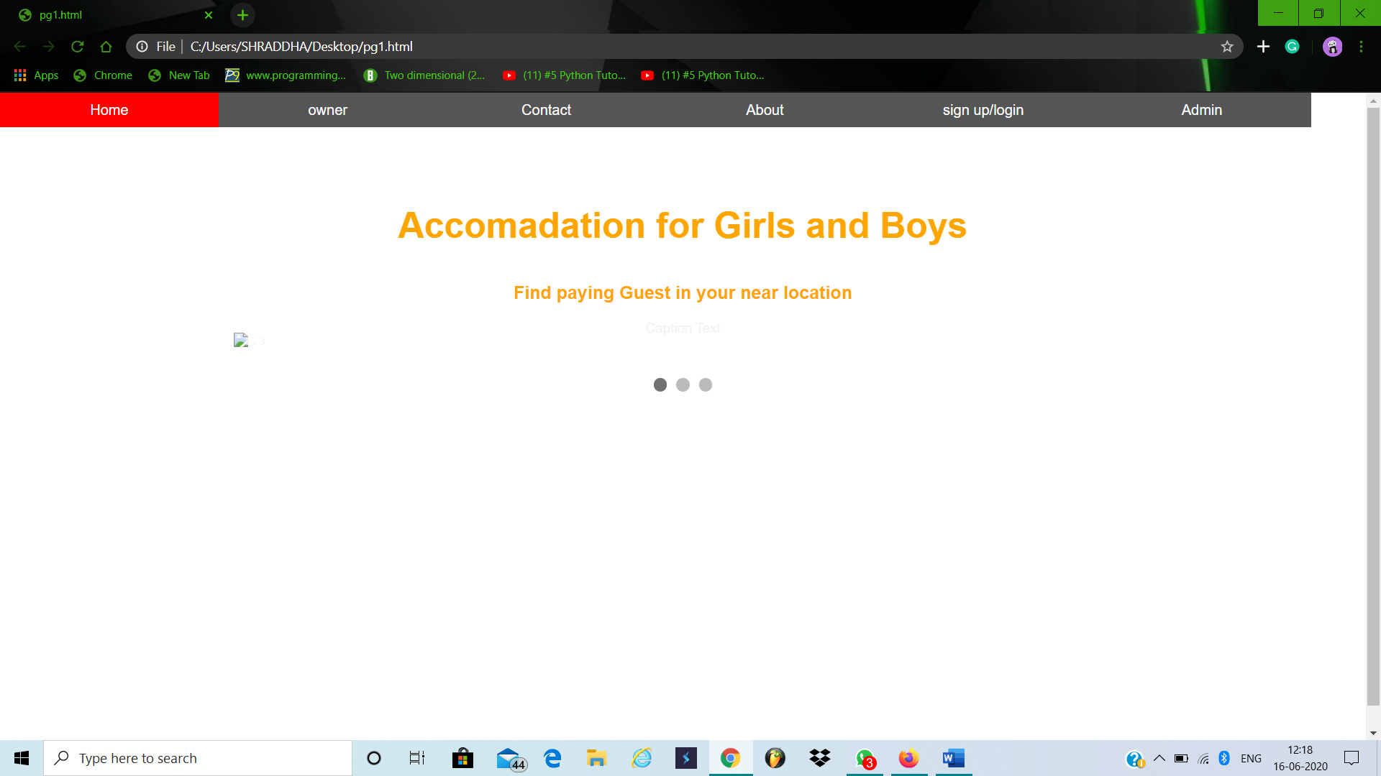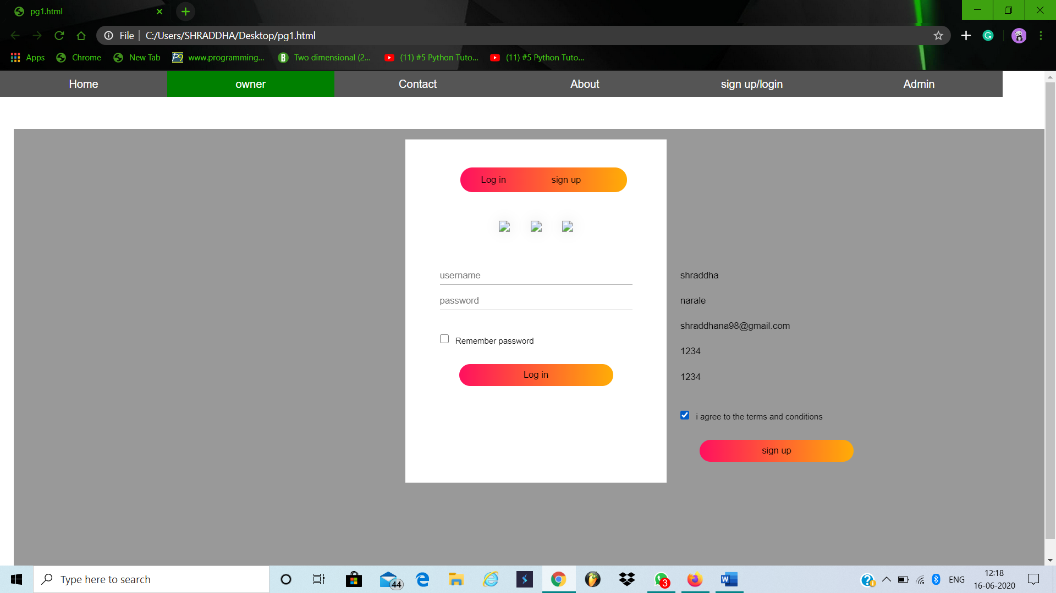
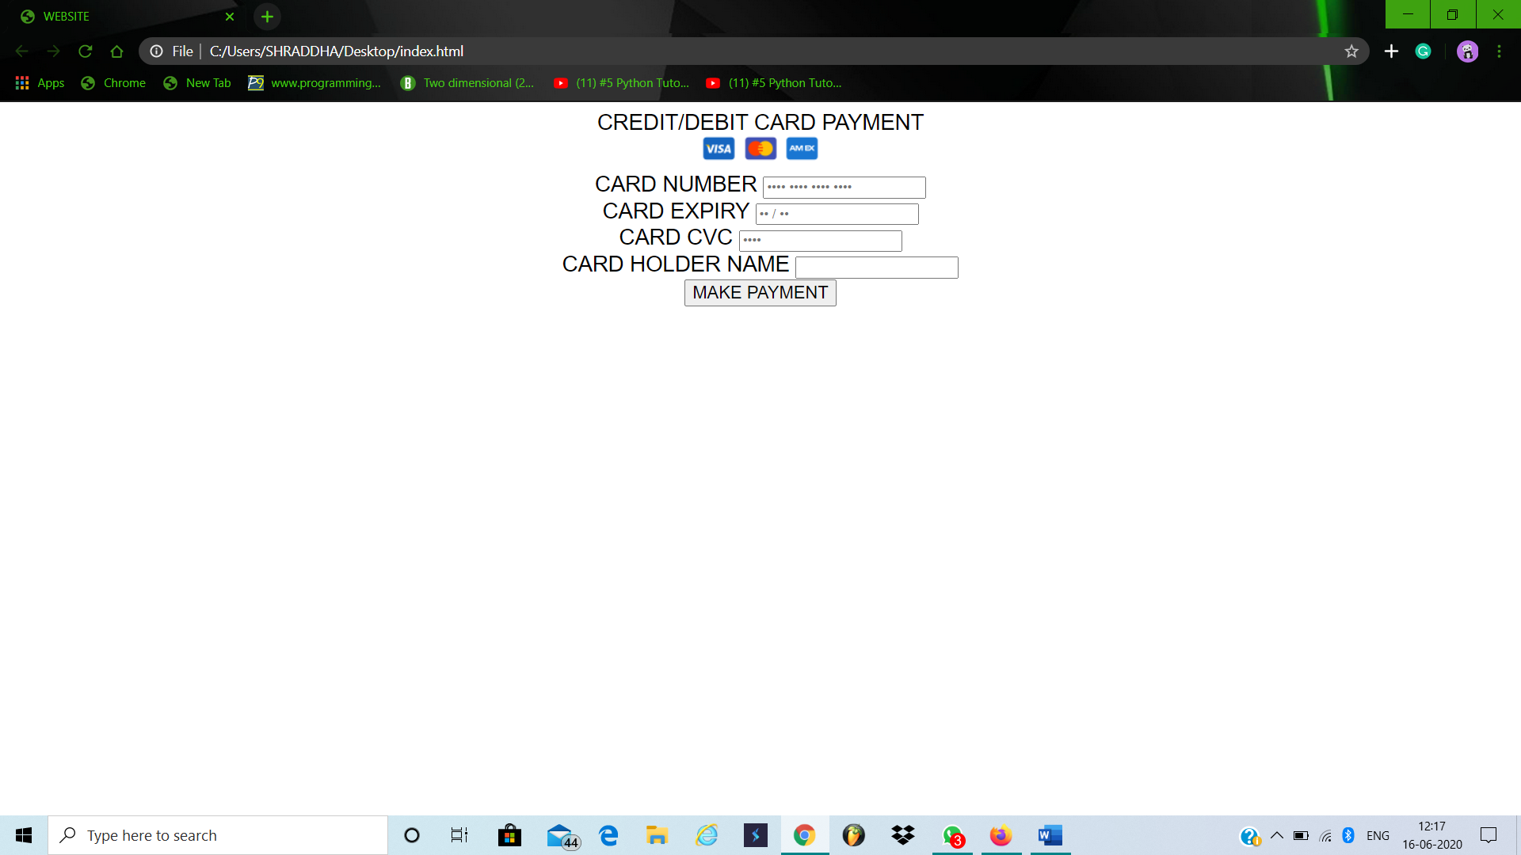
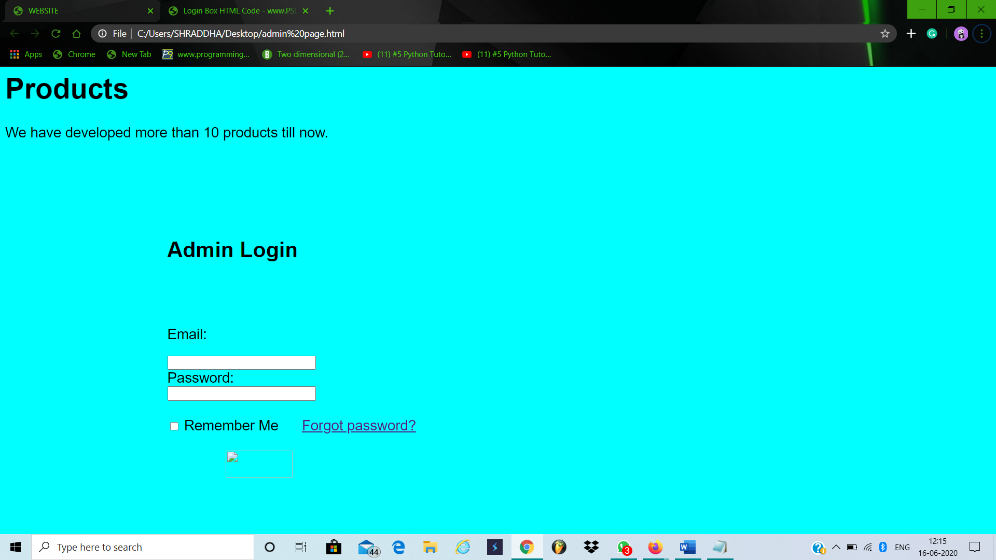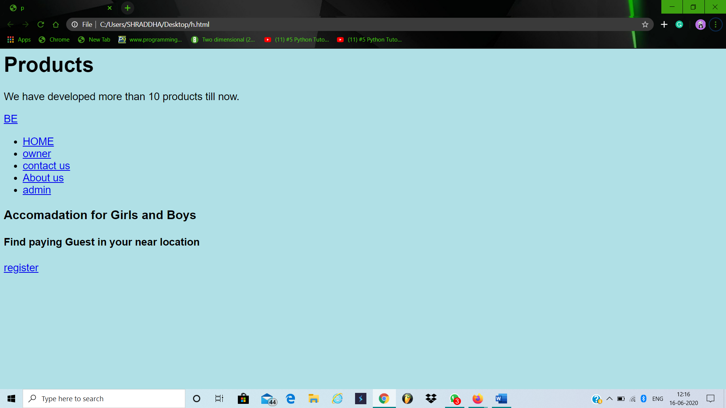

- Conclusion:

This website provides a web portal that is a online accommodation system which will benefit the students as well as the parents. It makes entire process online where student and parents can search room online just by few clicks. It also has a facility for admin login where admin can login and can see status of flats and room issued as well change there status or give some suggestions. It has a facility of services form where anyone can search for their accommodation and a mesmerizing collection of pictures so that the overview of the PG can be collected. Overall this website will help the students as well Parents and will make management of the accommodation very easy very easy.

- References:

  - Elmasri and Navathe: Fundamentals of Database Systems, Addison-Wesley, , McGraw Hill, 1999

  - NIIT, Basics of Software Project Management, PHI, 2005

  - Anany Levitin, Introduction to The Design & Analysis of Algorithms, Pearson Education

  - IEEE SRS format

    - Michael Blaha, James Rumbaugh: Object-Oriented Modeling and Design with UML, Pearson Education, 2nd Edition .
    - https://www.wikipedia.org/

