**Name-Shraddha Suresh**

**Q1) WAP to find SI also display total amount to be paid after Loan duration ends.(Take Static Initialization of various Variabes)**

**package** com.lulu.assesment1;

**public** **class** SimpleIntrest {

**public** **static** **void** main(String[] args) {

// **TODO** Auto-generated method stub

**float** p=23000;

**float** t= 3;

**float** r= 3;

**float** amt;

**float** si=p*t*r/100;

amt=p+si;

System.***out***.println("Total amount to be paid after loan duration ends:"+ amt);

}

}

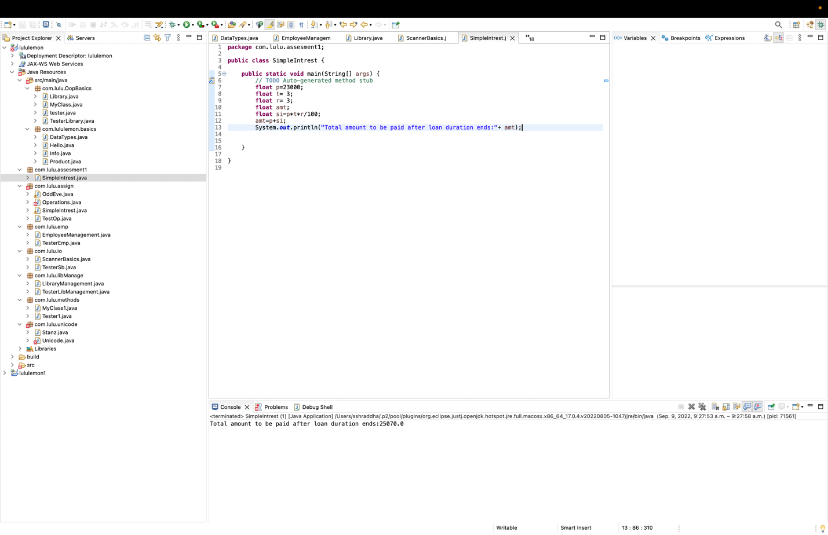

Q2) WAP to create Class "SchoolRecords" create 3 data members as school name ,School ID ,School Address to create records of schools in chennai,Create Method to add all records[ddRecords()] and display all records[dispRecords()]

**package** com.lulu.assesment1;

**public** **class** SchoolRecords {

String schoolName;

**int** schoolId;

String schoolAddress;

**void** addRecords() {

System.***out***.println("The records are added");

}

**void** dispRecords() {

System.***out***.println("The recprds are displayed");

}

}

Tester class

**package** com.lulu.assesment1;

**public** **class** TesterSchoolRecords {

**public** **static** **void** main(String[] args) {

// **TODO** Auto-generated method stub

SchoolRecords sr =**new** SchoolRecords();

sr.addRecords();

sr.dispRecords();

System.***out***.println("Thank you!");

}

}

Repo link- https://github.com/shraddhasuresh/lvds_codingassesment