Problem Statement
This dataset includes descriptions of hypothetical samples corresponding to 23 species of gilled mushrooms in the Agaricus and Lepiota Family Mushroom drawn from The Audubon Society Field Guide to North American Mushrooms (1981). Each species is identified as definitely edible, definitely poisonous, or of unknown edibility and not recommended. This latter class was combined with the poisonous one. The Guide clearly states that there is no simple rule for determining the edibility of a mushroom; no rule like "leaflets three, let it be'' for Poisonous Oak and Ivy.

Breakdown of the Problem Statement:
- Supervised machine learning problem.
- classification.
- The target value will be class.

Data Id 👨‍💻

columns:
This dataset is named Mushroom Classification. The dataset contains a set of 8,125 records under 23 attributes:
Column Name | Description | Values
class | Edible or poisonous | e = Edible, p = poisonous
cap-shape | The shape of the expanded, upper part of the mushroom | b= bell, c = conical, x = convex, f = flat, k = knobbed, s = sunken
cap-surface | The structure of the upper part of the mushroom | f = fibrous, g = grooves, y = scaly, s = smooth
cap-color | The color of the surface of the upper part of the mushroom | n = brown, b = buff, c = cinnamon, g = gray, r = green, p = pink, u = purple, e = red, w = white, y = yellow
bruises | Indicates of there are bruises on the mushroom | t = yes, f = no
odor | The smell the mushroom omits | a = almond, l = anise, c = creosote, y = fishy, f=foul, m = musty, n = none, p = pungent, s = spicy
gill-attachment | The way the gill is growing on the mushroom | a= attached, d = descending,f = free, n = notched
gill-spacing | The gap of space between each gill | c = close,w = crowded, d = distant
gill-size | The size of the gills | b = broad, n = narrow
gill-color | The color of the gills | k = black, n = brown, b = buff, h = chocolate, g = gray, r = green, o = orange, p = pink, u = purple, e = red, w = white , y = yellow
stalk-shape | The Stalk`s form | e = enlarging, t = tapering
stalk-root | The root of the mushroom | b = bulbous, c = club, u = cup, e = equal, z = rhizomorphs, r = rooted, ? = missing
stalk-surface-above-ring | The surface of the stalk above the mushrooms ring | f = fibrous, y = scaly, k = silky, s = smooth
stalk-surface-below-ring | The surface of the stalk below the mushrooms ring | f = fibrous, y = scaly, k = silky, s = smooth
stalk-color-above-ring | The color of the stalk above the mushrooms ring | n = brown, b = buff, c = cinnamon, g = gray, o = orange, p = pink, e = red, w = white, y = yellow
stalk-color-below-ring | The color of the stalk below the mushrooms ring | n = brown, b = buff, c = cinnamon, g = gray, o = orange, p = pink, e = red, w = white, y = yellow
veil-type | The type of the mushroom`s veil | p = partial, u = universal
veil-color | The color of the mushroom`s veil | n = brown, o = orange, w = white, y = yellow
ring-number | The amount fo rings the mushroom has | n= none, o = one, t = two
ring-type | The type of the mushroom`s ring | c = cobwebby, e = evanescent, f = flaring, l = large ,n = none, p = pendant, s = sheathing, z = zone
spore-print-color | The color of the mushromm`s spore | k = black, n = brown, b = buff, h = chocolate, r = green, o = orange, u = purple, w = white , y = yellow
population | The populaotion spread | a = abundant, c = clustered, n = numerous, s = scattered, v = several, y = solitary
habitat | The mushroom`s environment | g = grasses, l = leaves, m = meadows, p = paths, u = urban, w = waste, d = woods

Definition
A mushroom or toadstool is the fleshy, spore-bearing fruiting body of a fungus, typically produced above ground, on soil, or on its food source

Features
For Better understanding of the columns and their values a picture based explanaition will be given to enhance the notebook readers understanding the anatomy of mushrooms.

Mushroom structure:
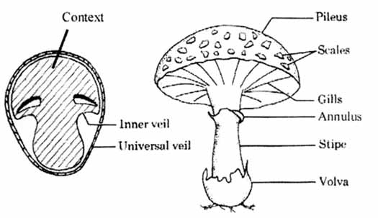

Mushroom cap shape:
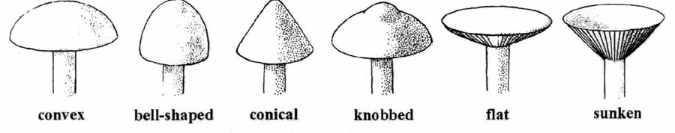

Mushroom cap surface:
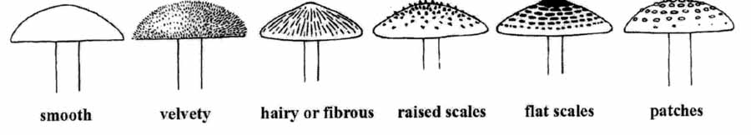

Mushroom gill attachment:
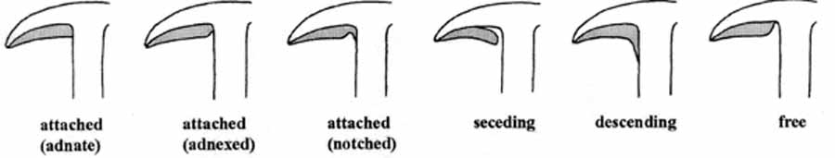

Mushroom gill spacing:
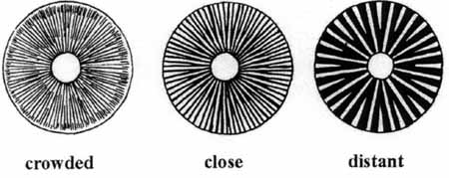

Mushroom gill tissue arrangement:
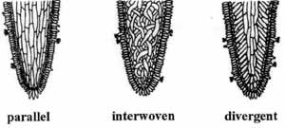

Mushroom stalk type:
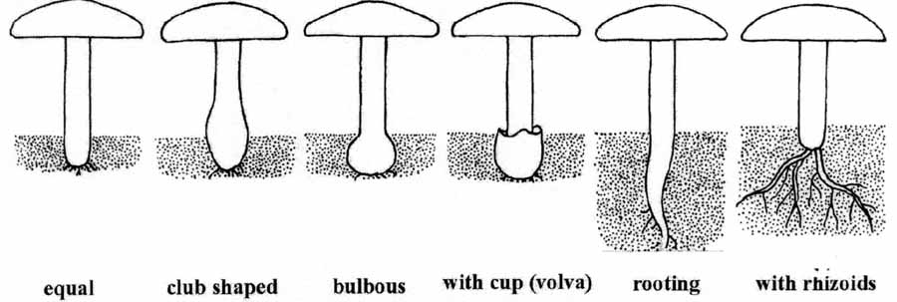

Mushroom ring type:
