**RabbitMQ**

• RabbitMQ is an open-source message-broker software that

originally implemented the Advanced Message Queuing

Protocol.

• It accepts messages from producers, and delivers them to

consumers.

• It acts like a middleman which can be used to reduce loads and

delivery times taken by web application servers.

• RabbitMQ Developed By PIVOTAL.

**PRODUCER/PUBLISHER**

The producer publishes a message to theexchange.

Producer is responsible to create or sent message to Queue via Exchange.

**Consumer/Subscriber**

• Consumer who receive messages from the Queue

• Consumer is responsible to handle the messages present in Queue

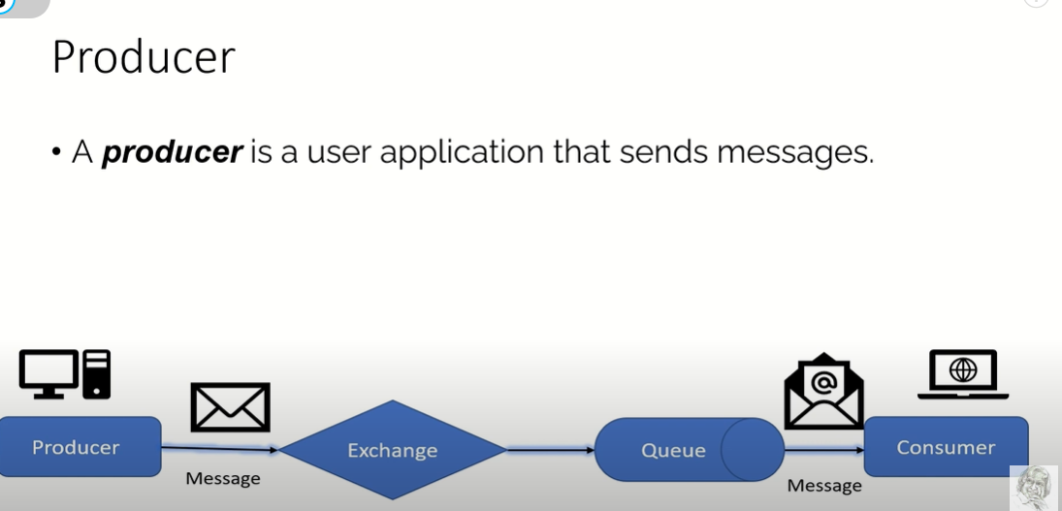

Routing Keys

Message Broker

**EXCHANGE**

. It's a message routing agents.

An exchange is responsible for routing the messages

to different queues with the help of header attributes, bindings, and routing keys.

. The exchange must know exactly what to do with a message it receives.

• The producer can only send messages to an exchange. An

exchange is a very simple thing. On one side it receives messages from producers and on the other side it pushes them to queues. The exchange must know exactly what to

do with a message it receives. Should it be appended to a particular queue? Should it be appended to many queues?

Or should it get discarded. The rules for that are defined by the exchange type.

There are a few exchange types

available: direct, topic, headers and fanout.

**Routing Keys**

RabbitMQ messaging system uses routing Key to determine who will receive your message.

It's a key that tell exchange exactly to which queue the message should be send .

**QUEUES**

Queues in RabbitMQ are ordered collections of

messages.

Messages are enqueued and dequeued (delivered

to consumers) in the FIFO manner

**Binding**

A binding is a "link" that you set up to bind a

queue to an exchange.

For Multiple Requests

