**A Report**

**On**

# Summer Internship Program 2021

# “An Internship On Human Resource Management of

# Rupali Electricals Nagpur.”

**Submitted to:**

**Rashtrasant Tukadoji Maharaj Nagpur University,**

**Nagpur**

In partial fulfilment of the requirement of the degree of

**Master of Business Administration**

Batch 2020-22

**Submitted by:**

**Miss. Shradha B. Deore**

Enrolment No. **20181038941011**

**Under the Guidance of:**

**Prof. Robin Ukey**

**C:\Users\HC1\Desktop\logo.png**

**Green Heaven Institute of Management and Research,**

**Nagpur 2021**

**C E R T I F I C A T E**

We hereby certify that

**Miss. Shradha B. Deore**

Enrolment No - **20181038941011**

A student of M.B.A. at

Green Heaven Institute of Management and Research, Nagpur

Has successfully completed her Summer Internship Program 2021

# “An Internship On Human Resource Management of

# Rupali Electricals Nagpur.”

From 28th Sept. 2021 to 28th Nov.2021

The student has submitted the Final Report and has completed the evaluation process.

Dr Anil Sharma Prof. Robin Ukey

Director Faculty

C:\Users\HC1\Desktop\logo.png

**Green Heaven Institute of Management and Research, Nagpur**

**2021**

**C E R T I F I C A T E**

This is to certify that

**Miss. Shradha B. Deore**

A student of M.B.A. at

Green heaven Institute of Management and Research, Nagpur,

Has successfully completed her Summer Internship Program 2021

On

# 

# “ Human Resource Management of

# Rupali Electricals Nagpur.”

From 28th Sept. 2021 to 28th Nov.2021

We wish her all success for the future.

(Stamp/Seal of the Company)

Date: ……………….

**D E C L A R T I O N**

# I Miss. Shradha B. Deore, hereby declare that the project report to be submitted for Rashtrasant Tukdoji Maharaj Nagpur University, Nagpur, Examination of Winter 2021 M.B.A. Sem III, Project entitled “An Internship On Human Resource Management

Rupali Electricals Nagpur**” From 28th Sept. 2021 to 28th Nov.2021** is the outcome of the own preliminary survey work based on personal study and has not been submitted by me previously for award of any degree or diploma to this university or any other university.

Date: 25/11/2021

Place: Nagpur Shradha B. Deore

**ACKNOWLEDGEMENT**

I would like to thank Rashtrasant Tukdoji Maharaj Nagpur University for giving me the opportunity to do this internship. I would like to thank Rupali Electricals for letting me do the internship at their HR Division Head office. I’d like to thank Prof. Rupali Thawale mam, my internship supervisor for guiding me with the completion of this report. I’d also like to thank Mr. Amol Wankhede sir from Rupali Electrical & HR Division for keeping me under their supervision and provide me with all the necessary information which has helped me in the completion of this report. I would also like to thank all the officials of Rupali Electrical HR Department for allowing me to be an internee at their organization and help with necessary information.

**Name of the Student Signature of Student**

Shradha B. Deore

**Declaration**

I, Shradha Deore by declare that the project entitled **“The study of Human Resource Management with special reference to Rupali Electricals”** With special reference to MSEB has been carried out by me under the guidance of CE. Anil Wankhede This project is submitted to **Rashtrasant Tukadoji Maharaj Nagpur University, Nagpur** in partial fulfilment of the academic requirement for Master of Business Administration during the academic year 2020-21 This is the outcome of my own research work based on personal study and has not been submitted previously for award of any degree or diploma to this university or any other university.

**Pro-forma A**

**SIP Project details**

**Trainee Miss. Shradha Babanrao Deore**

**Batch 2020-2022**

**Email ID shradhadeore21@gmail.com**

**MBA Specialization Human Resource Management / Business Analytics**

**University Enrolment No 20181038941011**

**Institute Green Heaven Institute of Management and Research**

**Address rui village sahara city nagpur**

**Website ghimr.edu.in**

**Email ID info@ghmir.edu.in**

**Contact no. 18001216532**

# Project Title Human Resource Management of

# RUPALI ELECTRICALS NAGPUR

**Duration 60 Days**

**Project Guide Prof. Robin Ukey**

# Company Name RUPALI ELECTRICALS NAGPUR

**Supervisor’s Email ID sureshdeore82@gmail.com**

**Joining Reference ONLINE**

**(SIP Fair/ Other) SELF**

**Date of presentation ---------------------------------------------------**

**Pro-forma B**

**Company Profile**

**Company Name RUPALI ELECTRICALS.**

**Headquarters Address FLAT NO 129 G FLOOR GULMOHAR APARTMENT, Thana Road, Bhiwandi, Bhiwandi – 421302**

**Training office Address A 10/20, MIDC Area, Buttibori,**

**Near Prashant Pipe. Nagpur**

**District and State Nagpur/Maharashtra**

**Website https://m.indiamart.com/**

**Email Id, Contact sureshdeore82@gmail.com**

**Status of Incorporation or type Sole Proprietorship**

**Sector/ Industry Transformer Manufacturer**

**Scale of Operations SMALL**

**(Small / Medium/ Large)**

**Founder/ Promoter Shubham Deore**

**Incorporation/ Foundation year 2001**

**Products and services Manufacturer/ Repairing/Maintenance**

**No. of Employees 20**

**Listing on stock exchanges Not Listed**

**(Listed / Not listed)**

**INDEX**

|  |  |  |
| --- | --- | --- |
| **SR.NO.** | **PARTICULAR** | **PAGE NO.** |
| 1 | Introduction |  |
| 2 | Company Profile |  |
| 3 | Sector Overview |  |
| 4 | Job Profile |  |
| 5 | Learnings |  |
| 6 | Findings and Learnings |  |
| 7 | Recommendations |  |
| 8 | Conclusion |  |

**INTRODUCTION**

I have select the topic of this report is “Human Resource Management of Rupali Electrical”. I tried to integrate my theoretical knowledge of HR and combine it with practical examples as observed during my internship. I have tried to cover all the major functions of Human Resource Management- recruitment, selection, compensation and benefits, training and development and convey my understandings of the different functions of Human Resource Management through this project. At the end of the report I have done a SWOT Analysis on the HRM Practice of Rupali Electrical followed by discussing critical points. I have also tried to provide some recommendations based on my knowledge followed by the conclusion which I gathered during my internship.

**Company Profile**

|  |  |
| --- | --- |
| Company name | RUPALI ELECTRICALS NAGPUR |
| Ownership Type | private |
| Primary Business type | Manufacturer/ Repairing/Maintenance |
| Category | PRIVATE |
| Sub Category | Indian Non-Government Company |
| Main Language | English |
| Primary Location | HEAD OFFICE – Dattawadi Nagpur. BRANCH AT – Nagpur, Gondia,Sakoli, Tivsa |
| Year of Establishment | 1-01-2001 |
| Age of Company | 9 Years 5 Months 29 Days |
| No. of Employees | 20 |

# SERVICES

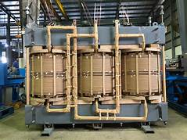

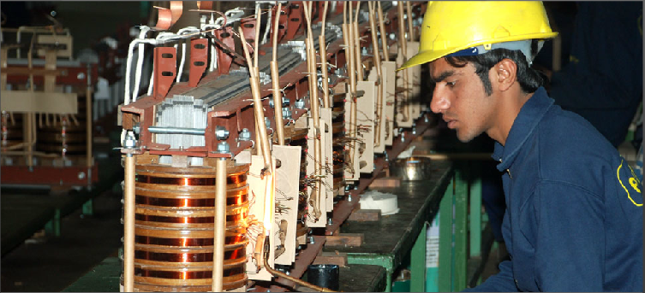

### **Electric Transformer**

A transformer is a static device (means that has no moving parts) that consists of one, two or more windings which are magnetically coupled and electrically separated with or without a magnetic core. It transfers the electrical energy from one circuit to the other by electromagnetic induction principle.

The winding connected to the AC main supply is called primary winding and the winding connected to the load or from which energy is drawn out is called as secondary winding. These two windings with proper insulation are wound on a laminated core which provides a magnetic path between windings.

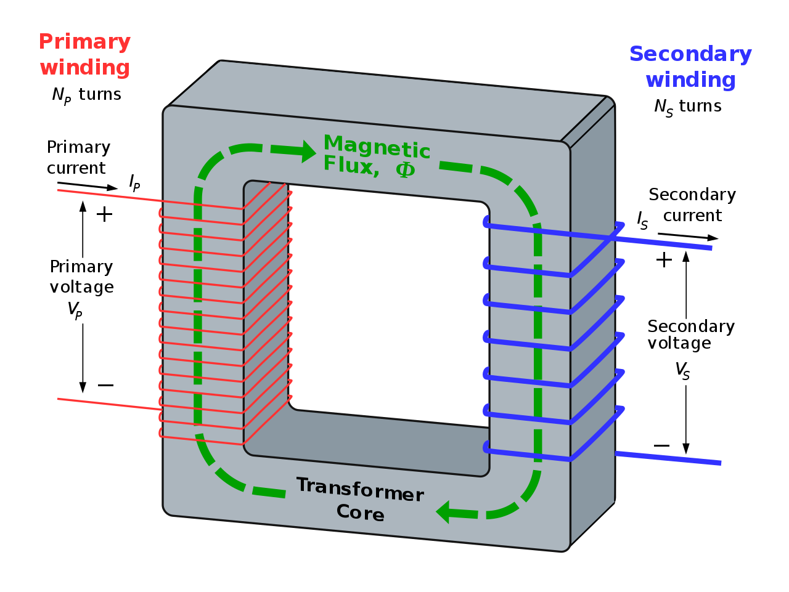

When the primary winding is energized with alternating voltage source, an alternating magnetic flux or field will be produced in the transformer core. This magnetic flux amplitude depends on the applied voltage magnitude, frequency of the supply and the number of turns on the primary side.

This flux circulates through the core and hence links with the secondary winding. Based on the principle of electromagnetic induction, this magnetic linking induces a voltage in the secondary winding. This is called as mutual induction between two circuits. The secondary voltage depends on the number of turns on the secondary as well as magnetic flux and frequency.

Transformers are extensively used in electrical power systems to produce the variable values of voltage and currents at the same frequency. Therefore , by an appropriate primary and secondary turns proportion desired voltage ratio is obtained by the transformer.

### **Transformer Construction**

The main parts of a transformer are core, windings, container or tank, bushings and conservator and radiators.

#### **Core**

For high power applications, transformer core is made with high permeability material which provides the low reluctance path for the magnetic flux. The cross section of the core would be square or rectangular.

Generally the iron core transformers provide better power transformation compared with air core transformers. Air core transformers are used for high frequency application (above 2 KHz) whereas , for low frequency applications (below 2 KHz) iron core transformers are employed.

In all types of transformers, core is made up of silicon steel or sheet steel laminations which are assembled to provide a continuous magnetic path for the flux. With this laminated core eddy current losses are minimized.

The thickness of these laminated sheets of steel are 0.35 to 5 mm and are insulated with a varnish, or oxide, or phosphate and then formed as a core.

For a better magnetic properties, Hot rolled grain oriented (HRGO) steel, or Cold Rolled Grain Oriented (CRGO) steel, or High B (HiB) laminations are used. In case of small transformers, core is constructed with hot rolled silicon steel laminations in the form of E and I, C and I or O are used.

#### **Windings**

Generally, the (two winding) transformer has two windings namely primary and secondary windings which are made up of high grade copper.

The insulated stranded conductors are used as windings for carrying high currents. This insulation avoids turns contacting with other turns.

The voltage connected to the primary winding is called primary voltage whereas the induced voltage in the secondary is called as secondary voltage. If the secondary voltage is more than the primary, it is called as step-up transformer and if less, it is called as step-down transformer. Therefore, the windings are designated as HV and LV windings based on the voltage level.

Compared to the LV winding, HV winding needs more insulation to withstand high voltages, also needs more clearance to the core and the body.

The transformer coils can be concentric or sandwiched coils. Concentric coils are used in core type transformers whereas sandwiched coils are used in shell type transformers. In concentric arrangement, LV winding is placed near to the core and HV winding is placed around the LV winding for low insulation and clearance requirements. The most commonly used coils for the transformer include helical, sandwiched, disc and cross over coils.

Other necessary parts of the transformer are conservator tank which is used to provide the necessary oil storage such that the pressure of the oil under heavy loads settles down. When the oil in the transformer subject to the heat, naturally, oil expand and contract. Under this, oil is subjected to heavy pressure so without a conservator tank, there will be a chance of bursting the transformer.

The bushings provide the insulation to the output terminals to be taken from the windings of the transformer. These can be porcelain or condenser type bushing and based on the level of operating voltage these are selected. Because of simple, durable and rugged construction, transformers require a little maintenance. Because of no moving parts, the efficiency of the transformer is very high which may vary from 95% to 98%.

### **Classification of Transformers**

Transformers are classified into several types depends the various factors including voltage ratings, construction, type of cooling, number of phases of the AC system, the place where it is employed, etc. Let us discuss some of these types of transformers.

#### **Based on Function**

Transformers are classified into two types based on the conversion of voltage level. These are step-up and step-down transformers.

##### **Step-up Transformers**

In step-up transformer, the secondary voltage is more than the primary voltage. This is due to the lesser number of coils in the primary compared to the secondary. This type of transformer is used to raise the voltage to a higher level. These are used in transmission systems and are rated at higher power levels.

##### **Step-down Transformers**

In step-down transformer, secondary voltage is less than the primary voltage due to the less number of turns in the secondary winding. Hence, this type of transformer is used to reduce the voltage to specified levels of the circuit. Most of the power supplies use the step-down transformer to keep the circuit operating range to a specified safer voltage limit. These types of transformers are used in distribution systems (power transformers) and in electronic circuits (electronic transformers).

It is to be noted that the transformer is a reversible device, so it can be used as both step-up and step-down transformer. For example, if the circuit needs a high voltage we will connect the HV terminals to the load whereas the load or circuit needs a low voltage, we will connect the LV terminals to the load.

[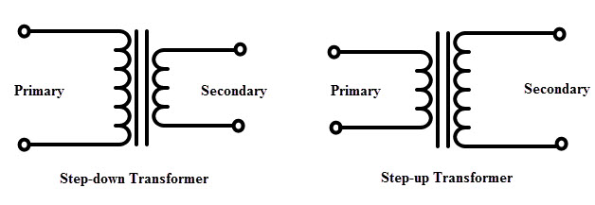](https://www.electronicshub.org/wp-content/uploads/2015/05/Stepup-and-Stepdown-TF.jpg)

## Sector Overview

The Human Resources Division (HRD) was established under Section 4A of Chapter 7 of the Massachusetts General Laws, as amended by Section 23 of Chapter 46 of the Acts of 2015. HRD is a division of the Executive Office for Administration and Finance that provides human-resources (HR) services to the Commonwealth’s executive branch and is its central personnel department. In addition, HRD administers the Commonwealth’s civil service system for state agencies and many local governments. According to HRD’s website,

*Our programs and services include:*

* *Recruiting new employees*
* *Delivering learning and development opportunities for existing employees*
* *Administering HR policy, employee benefits, and compensation*
* *Offering employee self-service HR related support*
* *Administration of collective bargaining agreements and contracts*
* *Ensuring an inclusive, safe and productive workplace*
* *Administering examinations for public safety and promotional opportunities*

## Affirmative Action Plans

HRD’s “Guidelines for Implementing Executive Order 526” define affirmative action as follows:

A policy or program that seeks to redress past discrimination by increasing opportunities for under-represented groups. For example, in the area of employment, affirmative action is accomplished by taking specific steps to identify, recruit, hire and/or develop for advancement, persons who are identified as part of a specific protected class.

EO 526 requires each executive branch agency to create an affirmative action plan every two years to develop strategies and incorporate goals and analytics to monitor progress toward the goals.

The “Guidelines for Implementing Executive Order 526” state that affirmative action plans must include the following:

(1) Statement of policy, (2) Statement of dissemination, (3) Designation of Diversity Officer (affirmative action and equal opportunity) responsibilities, (3a) Assessment of Employment Practices, (4) Identification of Problem areas, (5) Organizational Profile, (6) Development and execution of Equal Opportunity and Affirmative Action oriented programs, (7) Resolution process, and (8) Outline recruitment efforts and strategies for Persons with disabilities and Vietnam Era Veterans.

## Diversity Plans

The “Guidelines for Implementing Executive Order 526” define diversity as follows:

A policy or program that values differences among the Commonwealth’s employees and all those with whom it does business. These differences include but are not limited to race, gender, gender identity or expression, color, national origin and ancestry, religion, age, mental/physical disabilities, sexual orientation, veteran’s status, organizational level, economic status, geographical origin, marital status, communication and learning styles, and . . . other characteristics and traits. The goal of this policy is to develop an inclusive environment that capitalizes on each individual’s talents, skills and perspectives in order to increase organizational productivity and effectiveness.

The guidelines further state that diversity plans must contain (1) an agency vision, (2) an agency mission statement, and (3) diversity goals with a written strategy and measures. EO 526 requires each executive branch agency to create a diversity plan every two years to develop strategies and incorporate goals and analytics to monitor progress toward the goals.

## Progress Reports

Progress reports allow HRD to evaluate an agency’s progress toward established goals outlined in its affirmative action and diversity plans, including the agency’s assessment of whether its goals were ultimately met and what steps it took toward meeting its goals. Periodic reporting is also done in an effort to identify and remove artificial barriers to equal opportunity in hiring, training, promotion, transfer, and reasonable accommodation. Reports help agencies create inclusive and diverse workforces. These reports must be submitted to HRD 60 days after the end of each fiscal year, on August 30.

**Job Profile**

Due to continued expansion, we are now looking for a HR co-ordinator to support our small HR team with the day-to-day operations of recruitment, staff development, payroll, and help us to support a happy, healthy and productive team — reports to the HR manager.

* Managing all day-to-day HR administration tasks; ensuring that all employee and HR records are accurate and up to date
* Assisting with the end-to-end recruitment process
* Creating employee training materials under the guidance of the learning and development manager
* Assisting with monthly payroll and resolving payment issues
* Preparing job offer emails and employment offer contracts
* Supporting the development of performance review processes and reward schemes
* Taking full responsibility for all annual leave and attendance records
* Inducting new staff and overseeing probationary periods

# Learnings

* + Corporate Culture
  + Reporting Process
  + Learnt practically marketing Strategies
  + How can we use marketing for our business & branding .
  + Time Management
  + You can learn by observing more than asking
  + Deadlines are very important

**Findings and Learnings**

* Compensation and Benefits: Compensation basically consists of direct and indirect compensation and Rupali Electrical is very much concerned about both these types of compensation. They offer attractive package that is in per with current market practice in similar sector. They also offer bonuses and yearly incremental. For long term benefits, Rupali Electrical has provision of Gratuity, Provident Fund. They also have leave planning for employees consisting of different kind of leaves according to employee needs.
* Performance Evaluation: The evaluation of employee’s performance of Rupali Electrical is not properly done by the HR division.
* Officers of the organization are competent even though many of them simply know the working procedure of what they are doing but don’t know the philosophy behind doing those.
* Service quality of Rupali Electrical is commendable. It is very important for every organization serve its customers so that it create a loyal customer base who will repeatedly buy its products and carry a long time relationship with the company as well as work as a spoken person to promote the products of the company to peers, friends, relatives, etc. This organization is really good at its service quality.

**Recommendations**

* The organization should practice proper Rupali Electrical guideline. The purpose of Human Resource Management is to improve the productive contribution of people.
* To get effective and efficient employee, the organization should arrange proper training and development programs.
* The entire HR department should be well

informed regarding the employment personal.

* The organization should provide well direct

compensation as well as direct to its staffs.

* The management should have job evaluated salary structure, which is most competitive than other organizations in the country.
* To evaluate employee’s performance; the management should follow promotion policy properly.
* In order to get competitive advantage and to deliver quality service, top management should try to modify the services.
* Periodical performance appraisal and giving recognition and rewards to the qualified employees to keep motivating them.
* Proper training needed for ensuring efficient

performance of the employees.

* Rupali Electrical Asset Management should

hire specialist for each individual sector.

* The management should create customers database and continuously informing the investors about the available facilities or opportunities which will work to achieve twin goal at a time; one is direct marketing and another is large pool of customers database.

## Reference

* + - [*www.acaml.com*](http://www.acaml.com/)
    - *hrcouncil.ca/home.cfm*
    - [*www.wikipedia.com*](http://www.wikipedia.com/)
    - *Books:*

*Human Resource Management: Fisher, Schoenfeldt, Shaw 6th Ed*

**Conclusion**

From the above discussion it can conclude such a way that since human resource management is a continuously practicing issue so it plays a significant role on organizations overall performance. If an organization wants to gain full benefit from human resource management it should follow all the sections of HRM. As a small AMC few persons are recruited for its operations and performances. But it will expand soon or later and then the number of HR employee may not be enough to run the company.

Committed and trustworthy employees are the most significant factors to becoming an employer of choice, it is no surprise that companies and organizations face significant challenges in developing energized and engaged workforces. However, there is abundance of research to demonstrate that increased employee commitment and trust in leadership can positively impact the company’s bottom line. In fact, the true potential of an organization can only be realized when the productivity level of all individuals and teams are fully aligned, committed and energized to successfully accomplish the goals of the organization. Thus, the objective of every company should be to improve the desire of employees to stay in the relationship they have with the company.