- With vibe coding implement the playwright/typescript or any other tool which you work say Selenium/Python
- Feature: Search functionality on Myntra

- Scenario Outline: Successful search with valid products
- Given I open the Myntra homepage
- When I type "<product>" into the Search field
- And I click the Search button
- Then I should see search results for "<product>"

- Examples:
- | product |
- | "Kurta" |
- | "Saree" |
- | "Lehenga" |

- Scenario Outline: Unsuccessful search with invalid products
- Given I open the Myntra homepage
- When I type "<product>" into the Search field
- And I click the Search button
- Then I should see no search results for "<product>"

- Examples:
- | product |
- | "Invalid" |
- | "NonExistent" |
- | "NotAvailable" |

- package com.myntra.stepdefs;

- import io.cucumber.java.en.*;
- import org.openqa.selenium.By;
- import org.openqa.selenium.Keys;
- import org.openqa.selenium.WebDriver;
- import org.openqa.selenium.WebElement;
- import org.openqa.selenium.chrome.ChromeDriver;
- import org.openqa.selenium.support.ui.ExpectedConditions;
- import org.openqa.selenium.support.ui.WebDriverWait;

- import java.time.Duration;

- public class SearchStepDefinitions {
- private WebDriver driver;
- private WebDriverWait wait;

- @io.cucumber.java.Before
- public void setUp() {
- driver = new ChromeDriver();
- wait = new WebDriverWait(driver, Duration.ofSeconds(10));
- driver.manage().window().maximize();
- }

- @io.cucumber.java.After
- public void tearDown() {
- if (driver != null) driver.quit();
- }

- @Given("I open the Myntra homepage")
- public void openMyntraHomepage() {
- driver.get("https://www.myntra.com/?utm_source=dms_google&utm_medium=dms_searchbrand_cpc&utm_campaign=dms_google_searchbrand_cpc_Search_Brand_Myntra_Brand_India_BM_TROAS_SOK_New&gad_source=1&gad_campaignid=20443628324&gbraid=0AAAAADoxBh5mxnhx6B-1vOghKJajkomoc&gclid=Cj0KCQiAg63LBhDtARIsAJygHZ6JkRGXbNFSHsWBE7z6uRB-ytn19JggtawpVvgKEH2Yeun6Y9liiCQaAslKEALw_wcB");
- }

- @When("I type {string} into the Search field")
- public void enterSearchTerm(String searchTerm) {
- WebElement searchField = wait.until(ExpectedConditions.elementToBeClickable(By.className("desktop-searchBar")));
- searchField.sendKeys(searchTerm);
- }

- @When("I click the Search button")
- public void clickSearchButton() {
- WebElement searchField = driver.findElement(By.className("desktop-searchBar"));
- searchField.sendKeys(Keys.RETURN);
- }

- @Then("I should see search results for {string}")
- public void verifySearchResults(String searchTerm) {
- WebElement searchResults = wait.until(ExpectedConditions.visibilityOfElementLocated(By.xpath("//h4[contains(text(), '" + searchTerm + "')]")));
- assert searchResults.isDisplayed();
- }

- @Then("I should see no search results for {string}")
- public void verifyNoSearchResults(String searchTerm) {
- try {
- wait.until(ExpectedConditions.visibilityOfElementLocated(By.xpath("//h4[contains(text(), '" + searchTerm + "')]")));
- assert false;
- } catch (Exception e) {
- assert true;
- }
- }
- }

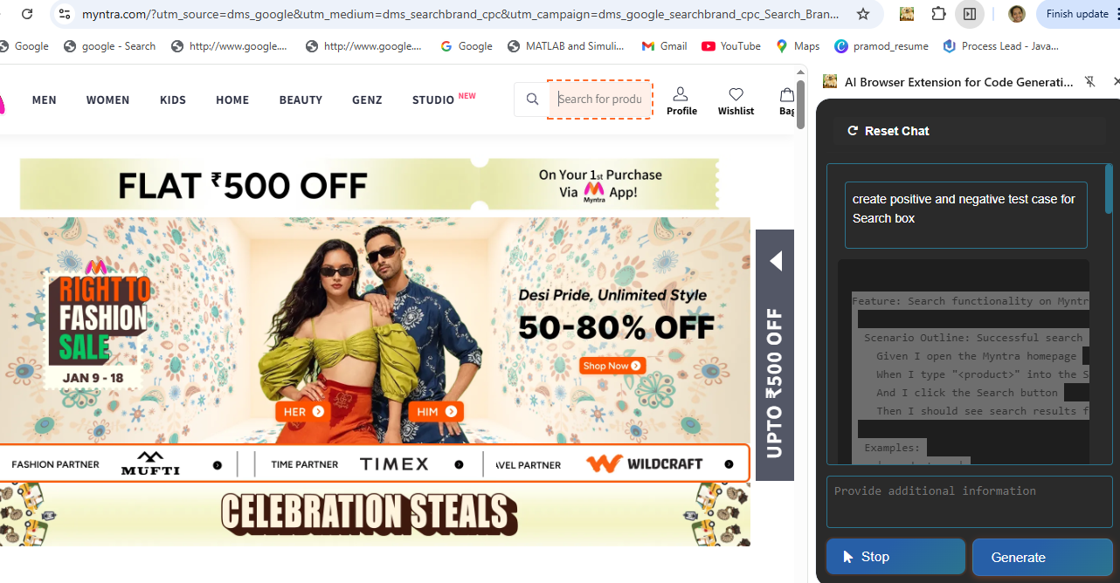

2) Use Bugmagnet extension for form filling
Found one issue or bug
On right clicking on dropdown element bug magnet extension is not available

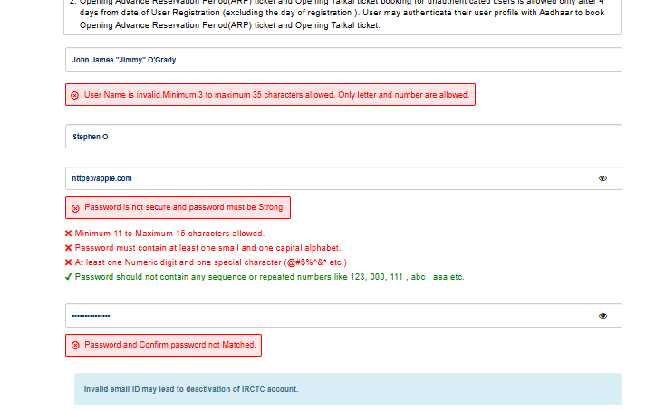
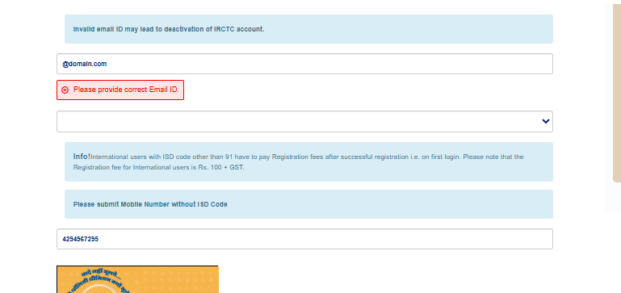
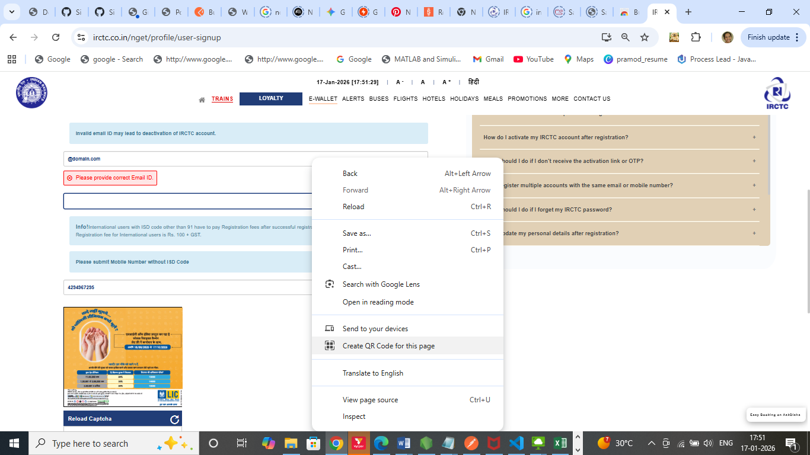
3) Use grammarly extension to correct the mistakes in your content
