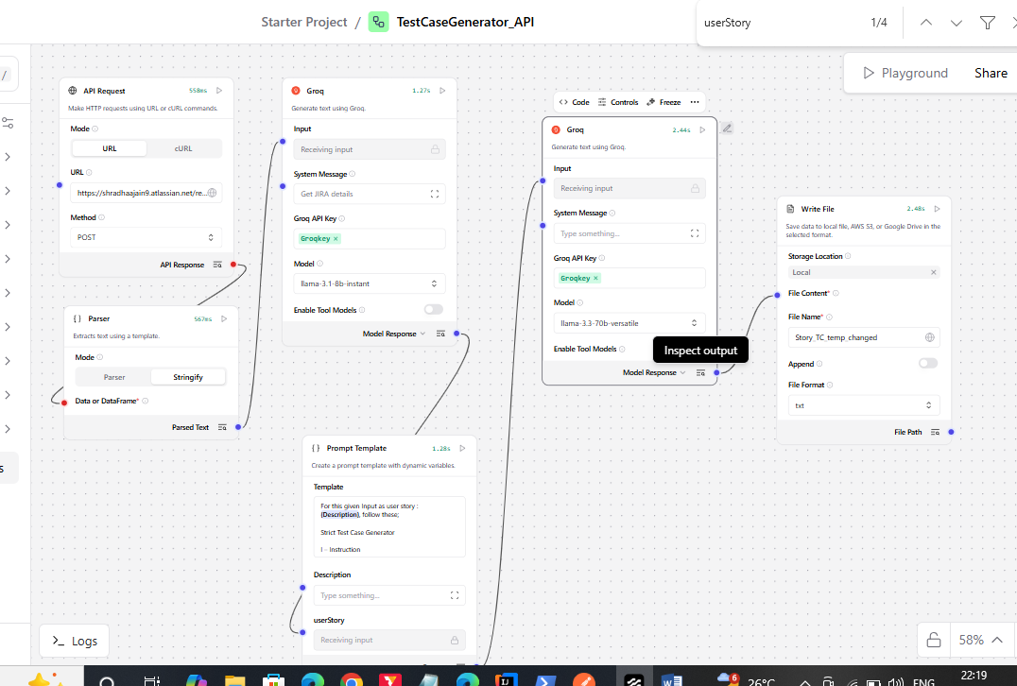

The above langflow is a prototype where using API request fetches user story from jira, returns summary, description which is consumed by prompt and generate test cases referring the description of the user story. Final output is text file which has the test cases generated by the groq model.

